**데이터분석 처리**

* **ETL(Extract - Transform - Load)**

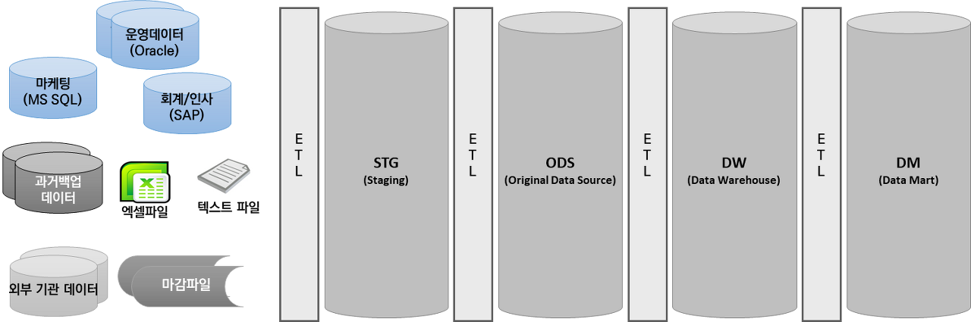

<https://bommbom.tistory.com/entry/%EB%8D%B0%EC%9D%B4%ED%84%B0%EC%9B%A8%EC%96%B4%ED%95%98%EC%9A%B0%EC%8A%A4DW-%EC%96%B4%EB%96%BB%EA%B2%8C-%EC%B2%98%EB%A6%AC-%ED%95%A0%EA%B9%8C-STG-ODS-DW-Mart>

* **최근에는 ELT**

**정형 비정형데이터**

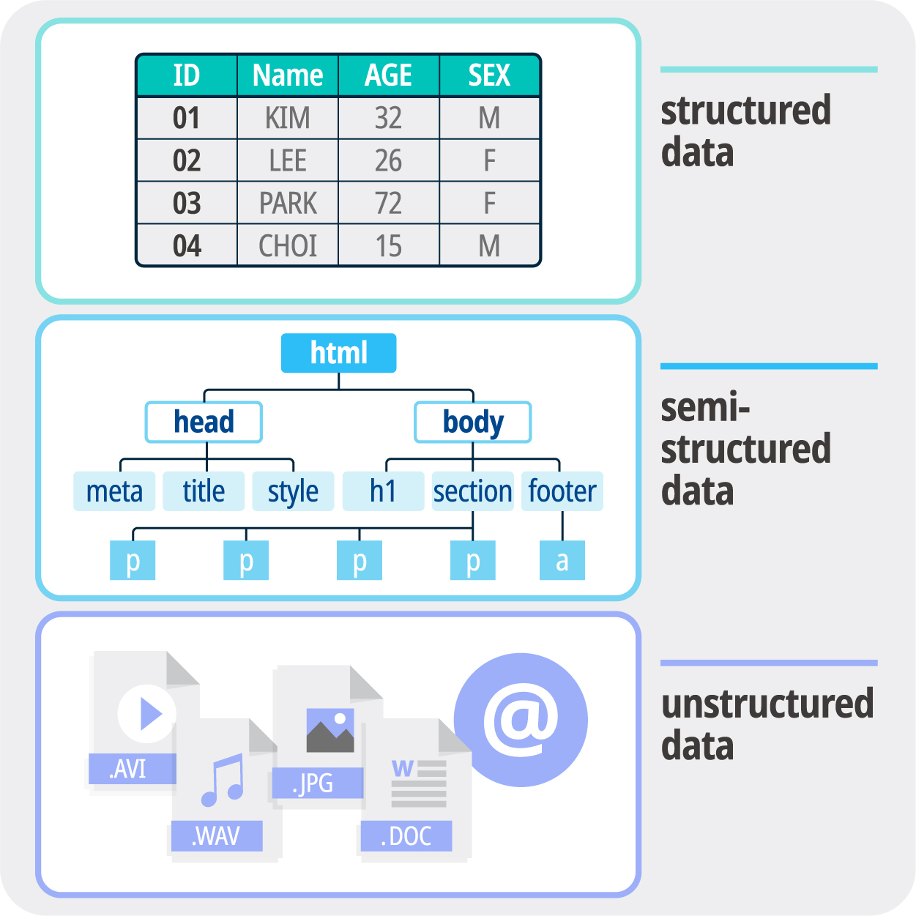

**EDA, 기술통계, 추론통계**

**-** [**EDA (Exploratory Data Analysis) 탐색적 데이터 분석**](https://eda-ai-lab.tistory.com/13)

