|  |  |  |  |
| --- | --- | --- | --- |
| **일자** | **시험과목(학습지)** | **강의 준비 자료** | **학습지 해당 문제** |
| **7.15(월)** | **3과목 통계분석**  **(03. 데이터분석**  **제 4장 통계분석)** | [**1_1_결측치와이상치.ipynb**](https://drive.google.com/open?id=1n24X5DOJNXmHJQomXXYDbF0EUtzVhAfH&usp=drive_copy)**,** [**1_1_결측치와이상치.pptx**](https://drive.google.com/open?id=1Lrv9axwoIKIqOHIJdHmW8hTxEcf87B3a&usp=drive_copy)  [**1_2_통계분석.pptx**](https://drive.google.com/open?id=1fPzHA2FmdF-OkkNUi2jHE95vyFZz0A62&usp=drive_copy)**,** [**1_3_확률.ipynb**](https://drive.google.com/open?id=1JaxFfB64mc4IIiKGtcAd1TA-yFL5SA5v&usp=drive_copy)  [**1_3_확률.ipynb**](https://drive.google.com/open?id=1z1PFsUa9_0d9cYPs6KVazQHcufOOzN-o&usp=drive_copy)**,** [**1_3_확률.pptx**](https://drive.google.com/open?id=1XC-0bC5RMzsiRgzOrASvS6CT7TReY6TK&usp=drive_copy)  [**1_4_추정.pptx**](https://drive.google.com/open?id=1ebEPugQiQTEbw0atVo7okRxGPtLzXuba&usp=drive_copy)**,** [**1_5_검정.ipynb**](https://drive.google.com/open?id=1MO6BkutsS0YYRcu6x1g2j7AFrM4iK-vP&usp=drive_copy)**,** [**1_5_검정.pptx**](https://drive.google.com/open?id=1IyTEKPi5B5YcrDwg5NZIkBx13KUoQ8pb&usp=drive_copy)  [**1_6_기초통계분석.pptx**](https://drive.google.com/open?id=1CoZ2ijKymt_Kr2XvwZU5e6uGpE-a2toh&usp=drive_copy) | **1번 ~ 40번 (380p ~414p)** |
| **7.16(화)** | [**1_7_Regression.ipynb**](https://drive.google.com/open?id=1Mr_jC4fUNRAje1vW0-d0LEd35hnua6fM&usp=drive_copy)**,** [**1_7_단순선형회귀분석.pptx**](https://drive.google.com/open?id=1DWY5TBUnMTITLpHbCkiqk4S2UPev4SuY&usp=drive_copy)  [**1_8_다중선형회귀분석.pptx**](https://drive.google.com/open?id=1y4Tm8iHGaBGYBxUkr8bXnAd0-RwdPvTB&usp=drive_copy)  [**1_9_분산과편향_variance_bias.ipynb**](https://drive.google.com/open?id=1U4lTHLUHaTZnNsyCuHWbBIQurvuJzr4H&usp=drive_copy) | **41번 ~ 75번 (380p ~414p)** |
| **7.17(수)** | [**1. 시계열분석.ipynb**](https://drive.google.com/open?id=1a_t2R269e42vMJ49kYoR9F0tKv-GXEIJ&usp=drive_copy)**,** [**2. 이동평균과 지수평활법.ipynb**](https://drive.google.com/open?id=16urOfOFQt3wtto8pSAVFf6DnmDX_kuvm&usp=drive_copy)**,**  [**3. ARIMA(p,d,g).ipynb**](https://drive.google.com/open?id=1edeJc7UBYgZBTuzV1FTSMtZ82hvtuCqr&usp=drive_copy)  [**4. decomposition.ipynb**](https://drive.google.com/open?id=1jLu5Km2OfT7UtUxVjNsX3KSF5GUjbTrc&usp=drive_copy)  [**5. 다차원척도법(MDS).ipynb**](https://drive.google.com/open?id=1QGa3ejhBo309HOoptAzhbDVpBgfzvuHI&usp=drive_copy)**,** [**6. 주성분분석(PCA).ipynb**](https://drive.google.com/open?id=13S_astEUOfPkAfKXmUKd3Iugm8bnv-pd&usp=drive_copy) | **1회 모의고사 (3과목 일부, 21~36번)**  **2회 모의고사 (3과목 일부, 21~37번)** |
| **7.18(목)** | **1과목 데이터이해**  **(01. 데이터 이해)** | **3과목 통계분석 복습**  **자습하여 문제 풀기** | **틀린문제 다시 풀기**  **문제풀이(108p ~ 123p)** |
| **7.19(금)** | **3과목 통계분석**  **(03. 데이터분석**  **제 5장 정형데이터마이닝)** | [**1. 머신러닝소개 .ipynb**](https://drive.google.com/open?id=10dfGntZ1HTwxYmxZBu-NKTC8RPvIHyLB&usp=drive_copy)**,** [**1. 머신러닝소개.pptx**](https://drive.google.com/open?id=1jGN-8c_sgk0HRkJM1dBpqOuiFWuwaL41&usp=drive_copy)  [**1. 통계_머신러닝.ipynb**](https://drive.google.com/open?id=1rA-kUxBuAicgnf6qbLZAnlxY1g_xaQmd&usp=drive_copy)  [**2. 분산과편향_L1L2.pptx**](https://drive.google.com/open?id=1oJgdsiSwPVZH2qXja7qyCTIcylcs4A4m&usp=drive_copy)**,** [**2. 분산과편향_Lasso_Ridge_regression.ipynb**](https://drive.google.com/open?id=1C3r4HTmUTu87cdD38l8d6H9XdQtf8zVj&usp=drive_copy)  [**3. Nearest Neighbors_분류_회귀_군집.pptx**](https://drive.google.com/open?id=1CdMMfdW0zebCkG0zcFCYTAQ1RNQ_5SW7&usp=drive_copy)**,** [**3. Nearest Neighbors.ipynb**](https://drive.google.com/open?id=1N6z9rziajjT1ARCnasMp5Y1g8g0SMbNp&usp=drive_copy)  [**4. 모델선택과 평가.pptx**](https://drive.google.com/open?id=106phAorEj1F6ggWUwviEG2NBUtgWFk51&usp=drive_copy)**,** [**4. 모델선택과평가.xlsx**](https://drive.google.com/open?id=1kWHi7W7B4DCW_T3aZceBaSK8R0U5D_gf&usp=drive_copy)  [**5. Tree_Based_Model.pdf**](https://drive.google.com/open?id=1BESwaQ3PaE_IinrECgttK1ILgBVVvnBQ&usp=drive_copy)  [**5. 의사결정나무.ipynb**](https://drive.google.com/open?id=1h0ri8F4vXzY4npXdLF5JKjv4nSEee7-F&usp=drive_copy) | **1번 ~ 70번 (482p ~509p)** |
| **7.22(월)** | [**6. Unsupervised_clustering_Kmeans_DBSCAN.ipynb**](https://drive.google.com/open?id=1GBhloh0jvLqB8cRJFzVjfYUQEFu_BALq&usp=drive_copy)  [**7. SOM.ipynb**](https://drive.google.com/open?id=1aZXLkXzqHFzEp_blbXj958aGcLYPf_dP&usp=drive_copy)  [**1_odds ratio_logit_softmax.ipynb**](https://drive.google.com/open?id=14G499TYgEQxipEYgp5w5Twn4wKb0upM-&usp=drive_copy)  [**2_logistic_regression.ipynb**](https://drive.google.com/open?id=1n2ucv5xhJ23MnPCQ82Z9NMyVC8yrRx2_&usp=drive_copy) | **1번 ~ 70번 (482p ~509p)** |
| **7.22(화)** | **3과목 통계분석 전체 복습하고 문제 풀기** | **1회 모의고사 (3과목)**  **2회 모의고사 (3과목)** |
| **7.22(수)** | **2과목 데이터분석 기획** | **이론강의 및 문제풀이** | **문제 풀이(188p ~205p)** |
| **7.23/24(목, 금)** | **실전테스트** | **ADsP 기출문제 풀이**  **(Q&A)** | **제34회 , 제35회, 제36회, 제37회 , 제38회, 제39회 ADsP 기출문제 풀** |

**(실행)**

**7.15(월)**

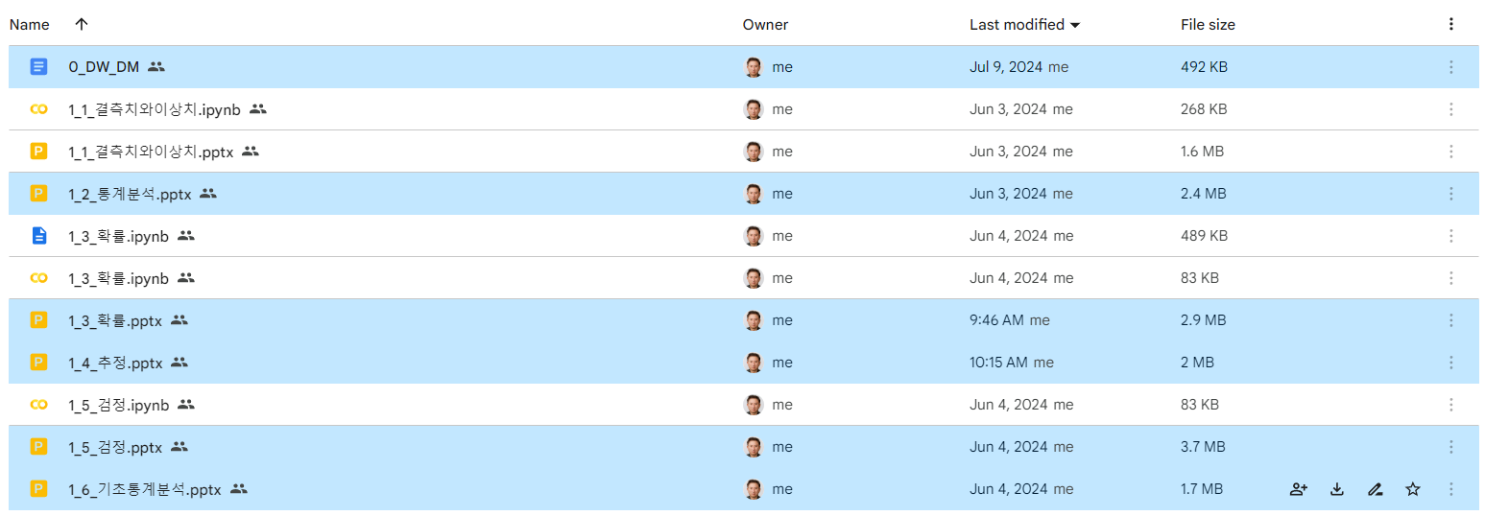

결측치와 이상치는 머신러닝에서 공부하기….요기서는 파생변수의 의미만……