HTML Assignment 1 FBS

1. Create html page with heading, sub heading and sub-sub heading. Which tags will you use?

Ans: - **Heading Tag** for Heading(H1)

**Heading Tag** for Sub Heading(H2)

**Paragraph Tag** for Sub-Sub Heading(P)

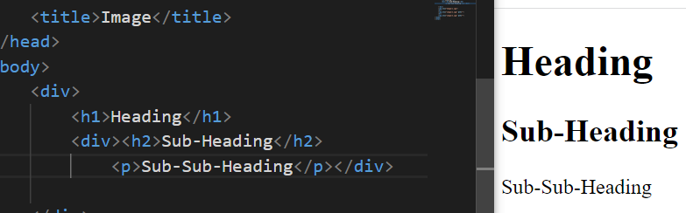

1. Create a page with 3 wallpapers from internet. Display a line after each wallpaper.

Ans: -

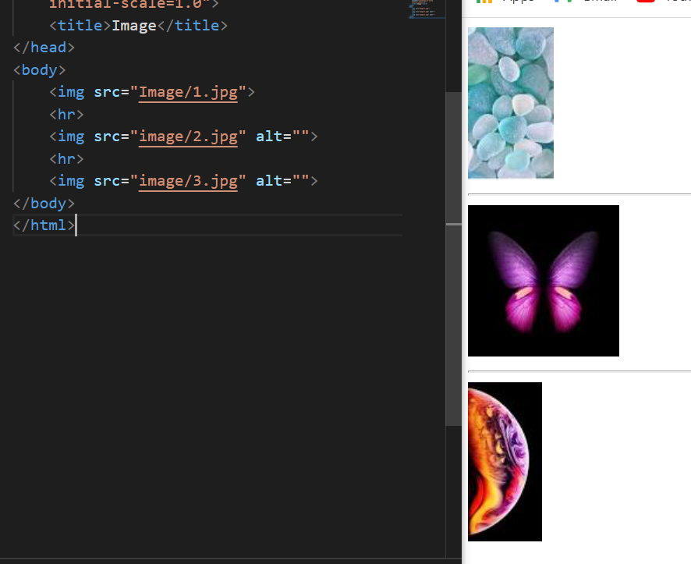

3.Write code to print following formula on web page (a+b)2 = a2 + 2ab + b

Ans: -

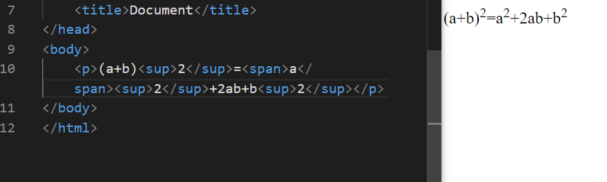

4.Insert an image inside anchor tag. such that clicking the image takes you to the website

Ans: -



5. Create a web page with different images and apply height, width border attributes to the same.

Ans: -

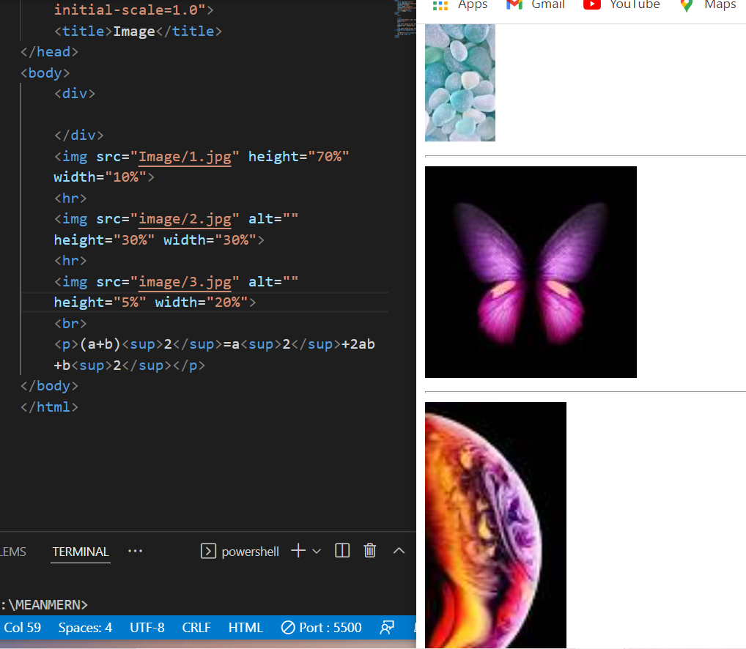

6. Create a web site with following pages : a. Home.html: It will contain general information about sports and four hyperlinks as Football, Cricket, Hockey, About Us. Clicking on these hyperlinks will open the respective pages in the same browser window but about us section should open in different Window or tab. b. Football.html : Contains images of football and overall information of football. c. Cricket.html : Contains images of cricket and overall information of cricket. This page also contains a set of hyperlinks with names of Players like Rohit Sharma Virat Kohli KL Rahul Jaspeet Bumrah Every name on this page should be linked to the player’s profile on cricbuzz website. So when a name a clicked, it should open the cricbuzz profile page in a new tab/windows d. Hockey.html: Contains images of hockey and overall information of hockey. e. AboutUs.html: Contains contain details of the organization.

Ans: -