**Anchal Bansal 10478699 CS-524 A Final Project**

**AWS:**

I signed into my AWS account and searched for Lambda. Choose Create function in the Functions.

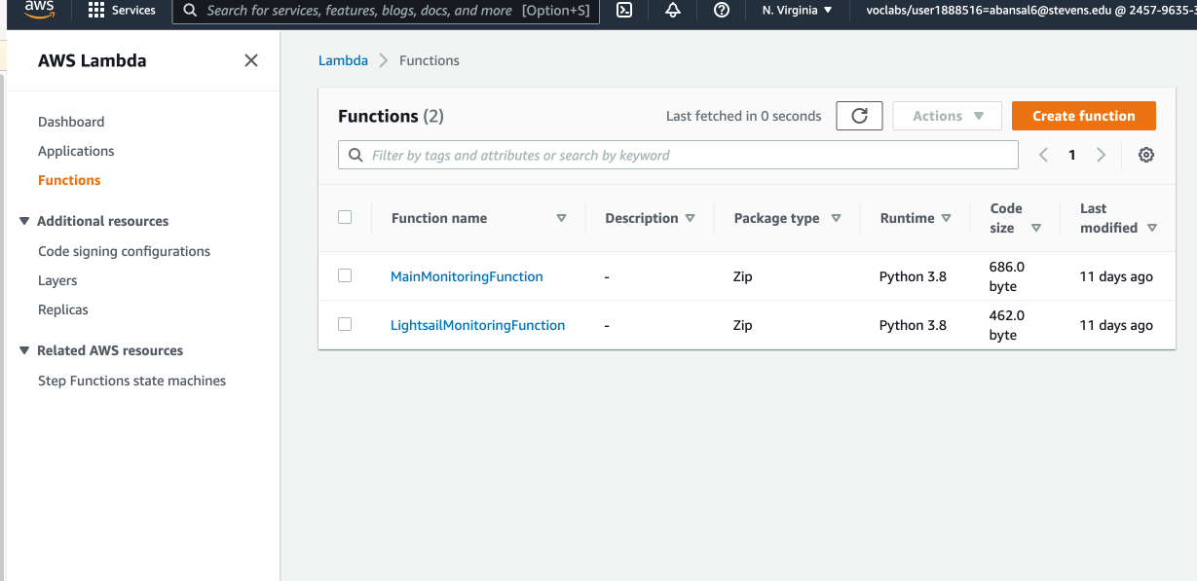

Under the create functions I entered the name of my function as Avengers and created a role for execution and named it as ‘GetStartedLambdaProxyExecution’. Click on Create Function option.

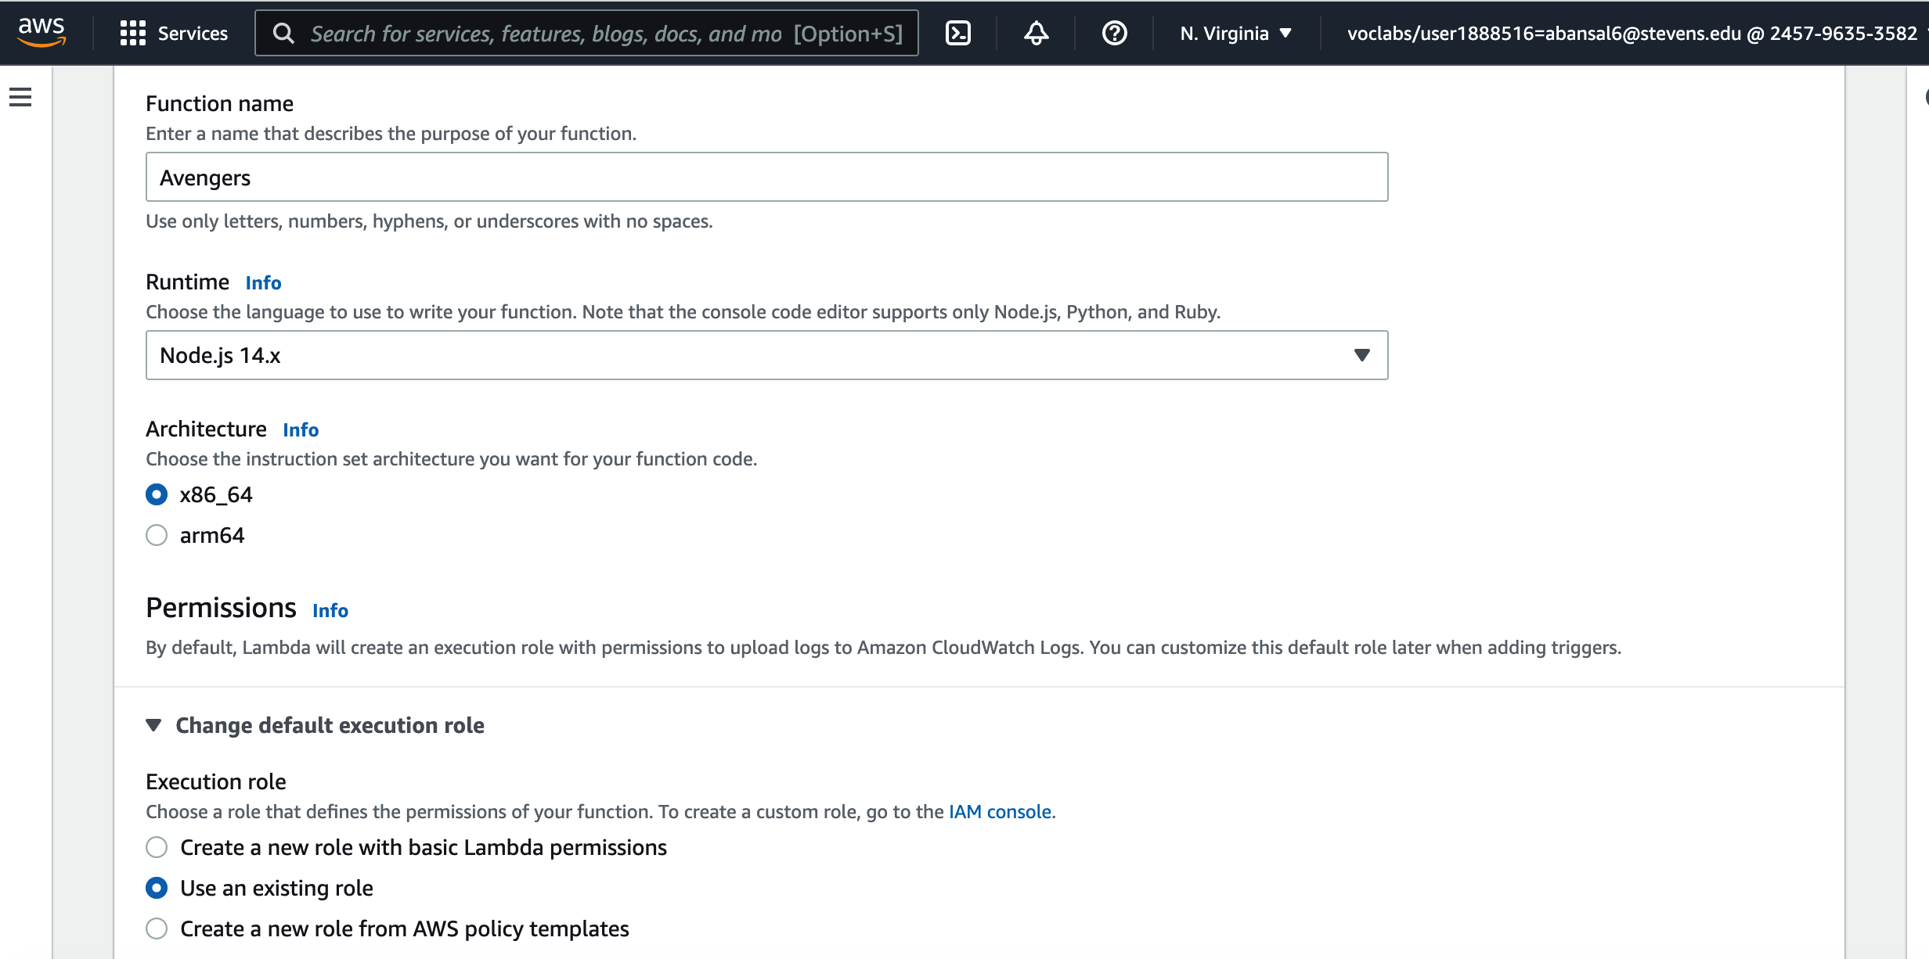

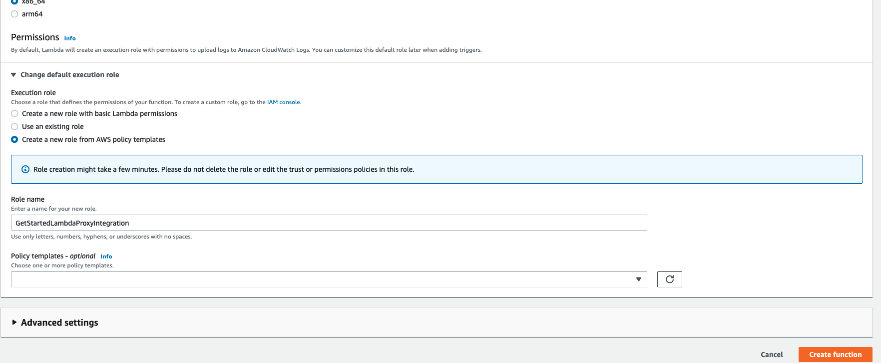

On the next page, I entered the following code on the code editor and clicked on Deploy:

*var json = { "service":   
"lambda",   
"reference": "https://aws.amazon.com/lambda/avengers/", "questions": [{   
"q": "What is the real name of the Scarlet Witch?",   
"a": "Wanda Maximoff" },{   
"q":"Which film did The Aether first appear in?",   
"a":"Thor: The Dark World" },{   
"q":"Which of the infinity stones is hidden on Vormir?",   
"a":"Soul Stone" },{   
"q":"What is Captain America's shield made of?",   
"a":"Vibranium" },{   
"q":"Which country is Black Panther next in line to be king of?",   
"a":"Wakanda" },{   
"q":"What is the real name of Black Widow?",   
"a":"Natasha Romanoff" },{   
"q":"What is the name of the axe created for and then used by Thor in Avengers: Infinity War?",   
"a":"Stormbreaker" },{   
"q":"What is Loki's title?",   
"a":"God of Mischief" },{   
"q":"What is the name of the organisation which is revealed to have infiltrated S.H.I.E.L.D. in Captain   
America: The Winter Soldier?",   
"a":"Hydra" },{*

*"q":"What nickname does Captain America know the Winter Solider as?", "a":"Bucky"   
},{   
"q":"What food do the Avengers go to eat after the Battle of New York in the first Avengers film at Tony   
Stark's suggestion?",   
"a":"Shawarma" },{   
"q":"What type of radiation caused Bruce Banner to become the Hulk?",   
"a":"Gamma rays" },{   
"q":"What is the name of the treaty the Avengers are asked to sign which divide the Avengers, bringing us   
to Captain America: Civil War?",   
"a":"The Sokovia Accords" },{   
"q":"Who has directed the most MCU movies?",   
"a":"The Russo Brothers" }   
] }   
exports.handler = function(event, context) {   
var rand = Math.floor(Math.random() * json.questions.length); console.log("Quote selected: ", rand); var   
response = {   
body: JSON.stringify(json.questions[rand])   
};   
console.log(response); context.succeed(response);   
};*

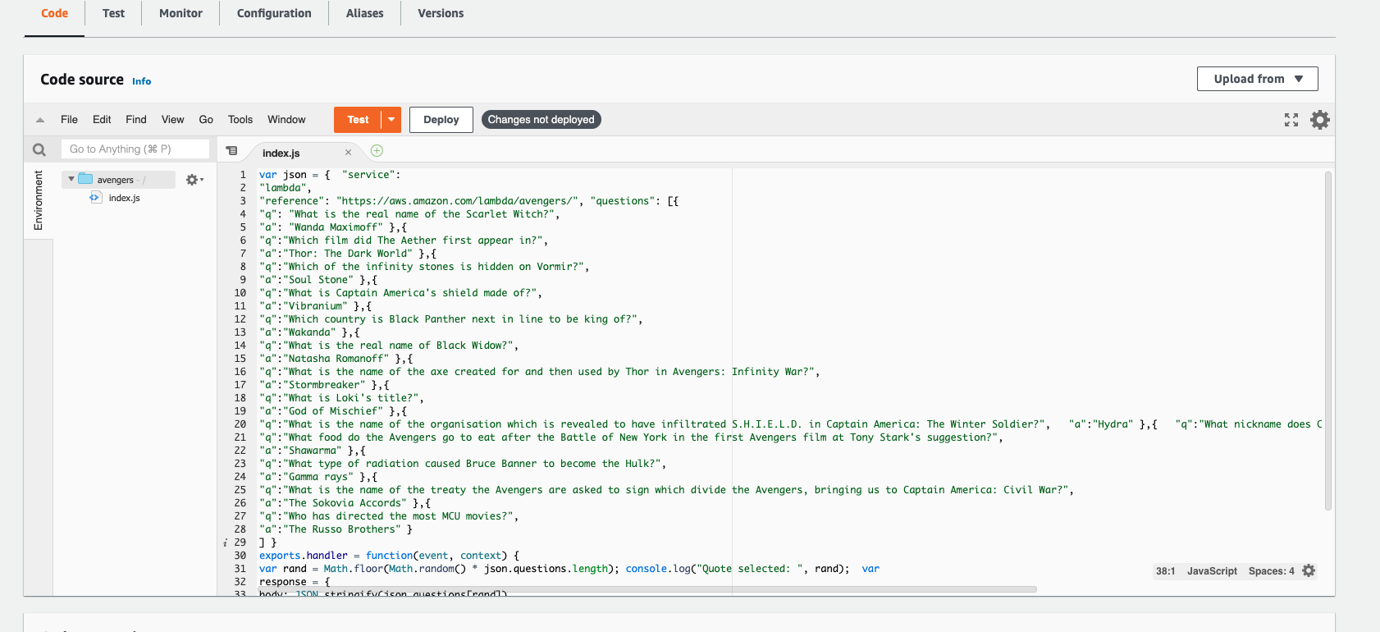

After deploying, I get the message of successful deployment. I click on Add Trigger button under Function Overview.

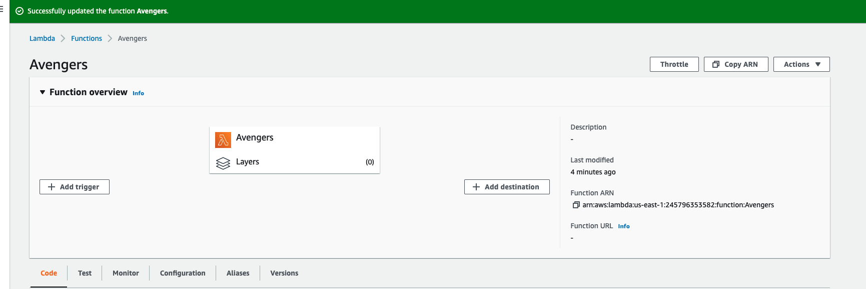

On this Add Trigger Page, I chose API Gateway and chose ‘Create an API’ option. Then under API type I chose ‘REST API’ and chose Security to be Open. I chose the additional settings as shown below and clicked on Add.

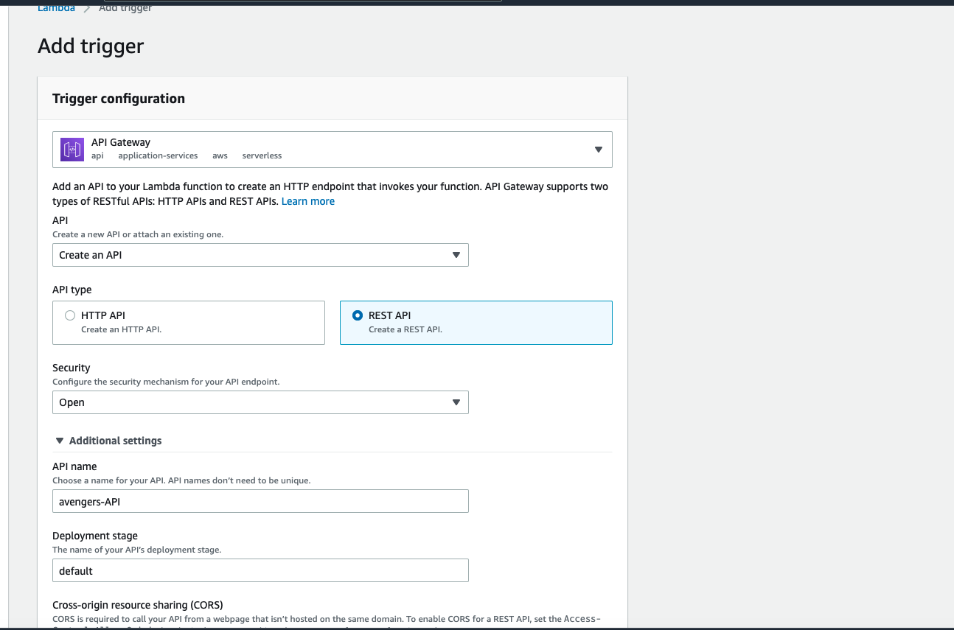

Under the configuration, I can see Trigger created with the end point as

<https://6017nk31aa.execute-api.us-east-1.amazonaws.com/default/avengers>

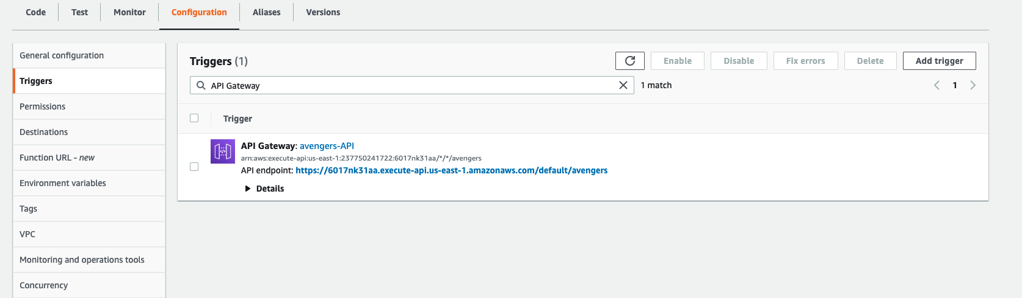

I clicked on the endpoint and opened it in the new tab. I can see the data as below.

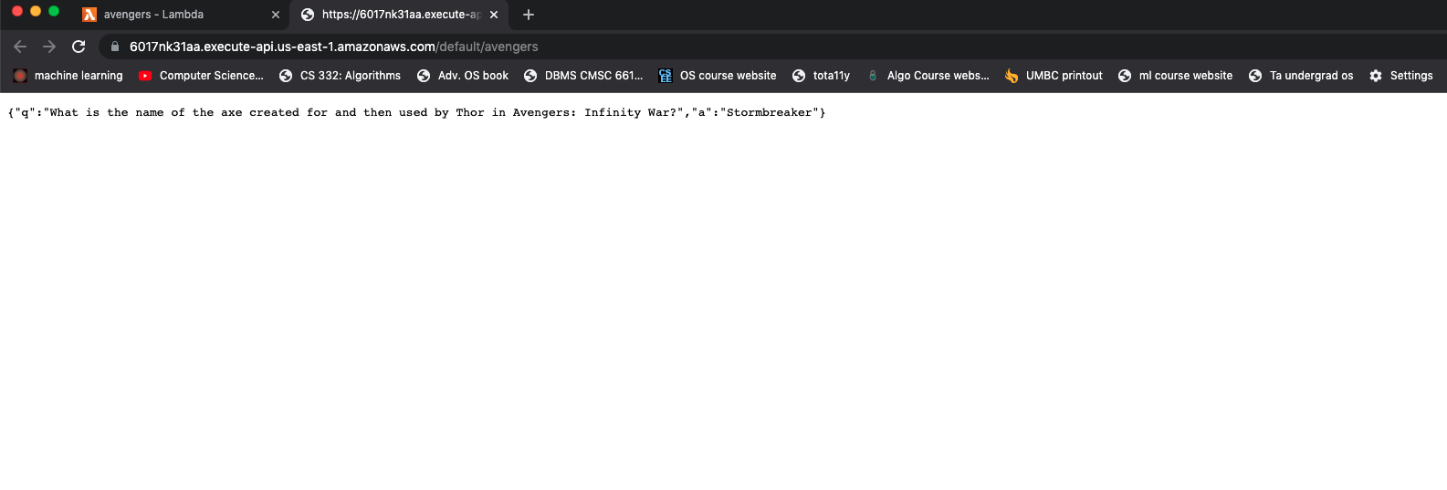

Since the code chooses random question answer pair so when I refreshed the url it showed me a new pair.

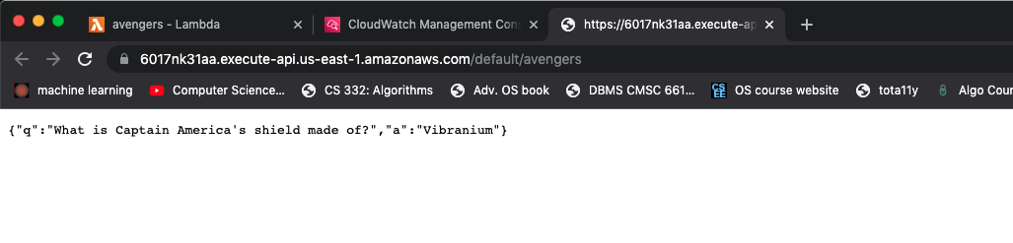

In my lambda function, under Monitor tab , I clicked on View logs in CloudWatch:

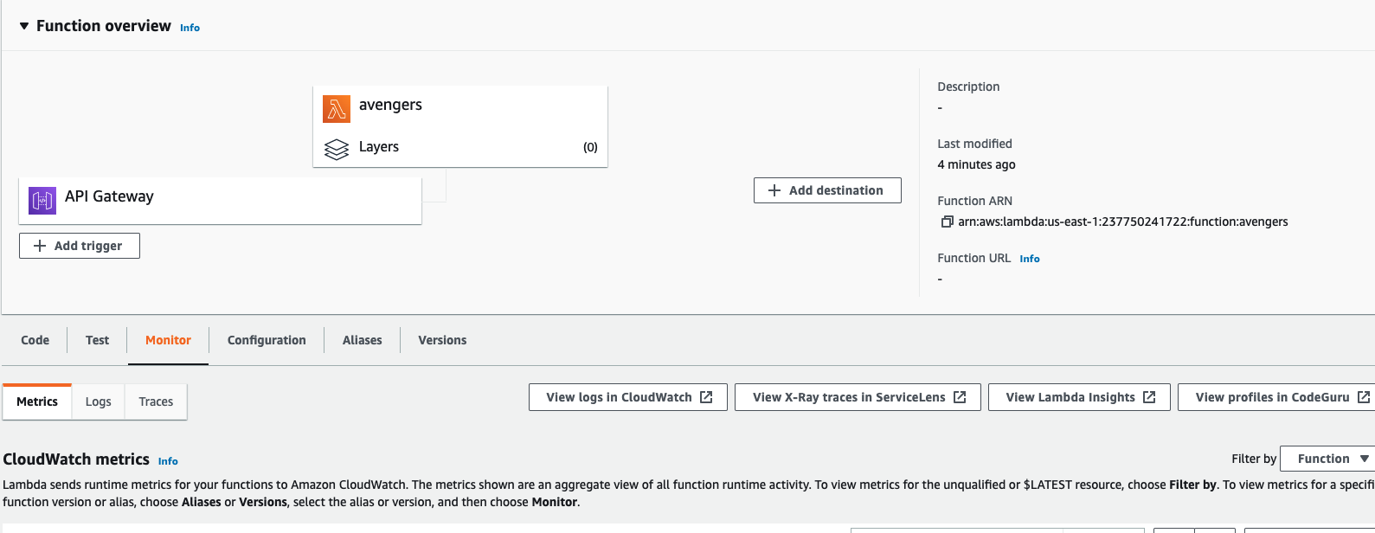

In the CloudWatch I found the following logs:

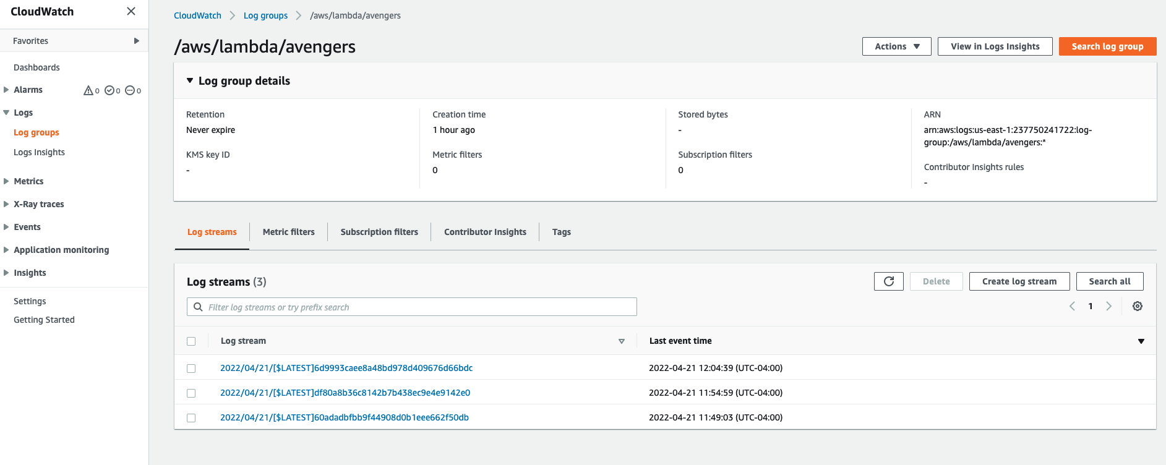

I clicked on the first log result and it displays the following results:

The logs display the message as well as the timestamp. It displays the start request , the response message, request id:

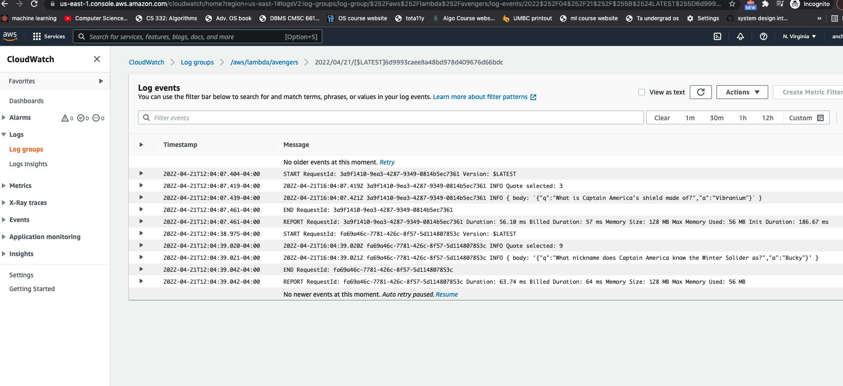

Under the monitor , I can view the metrics for my function as below:

