**Anchal Bansal 10478699 CS-524 A Final Project**

**Salesforce:**

1. **Creating custom field on Account Object:**

Find fields under accounts in quick find tab and click on it.

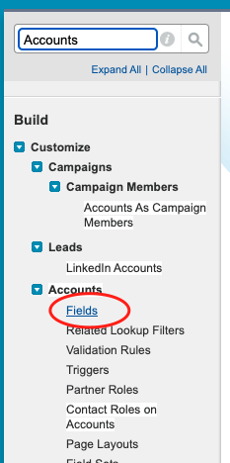

Below shows Account Custom Fields &Relationships and click on New

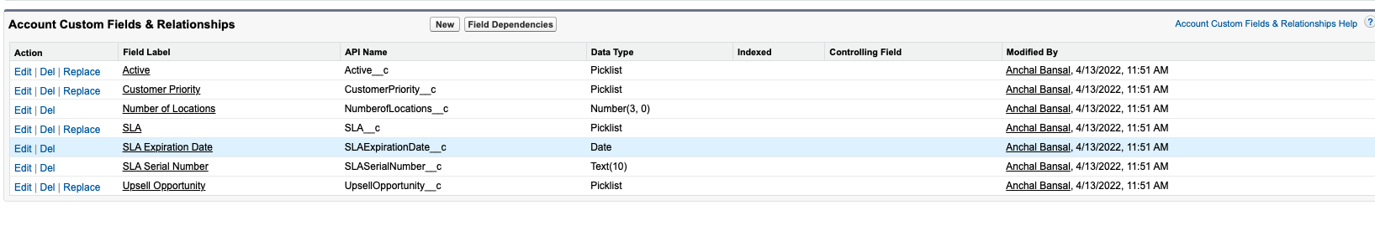

On the next page, I select field type as Checkbox and click on Next:

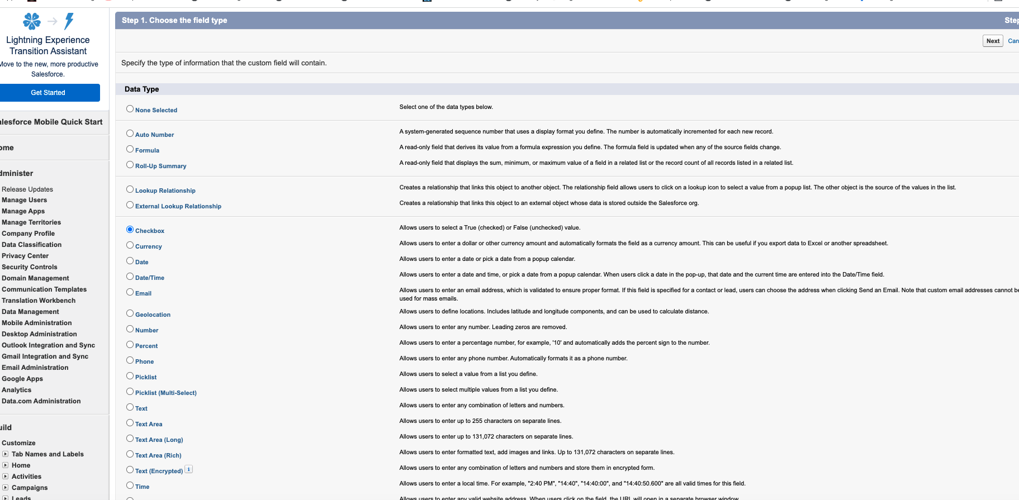

On the next page I enter the Field Label as Field Update, default value as Unchecked and Field Name as Field_Update and click on Next.

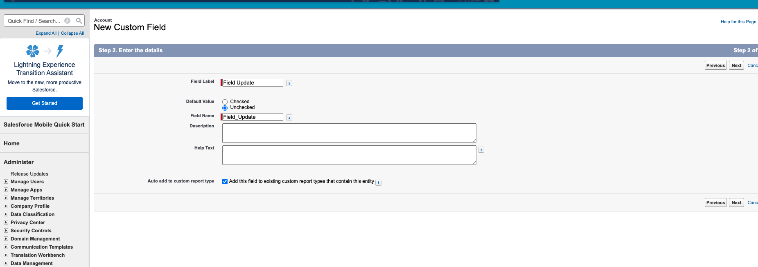

On next page, I check the Visible option and click on next .

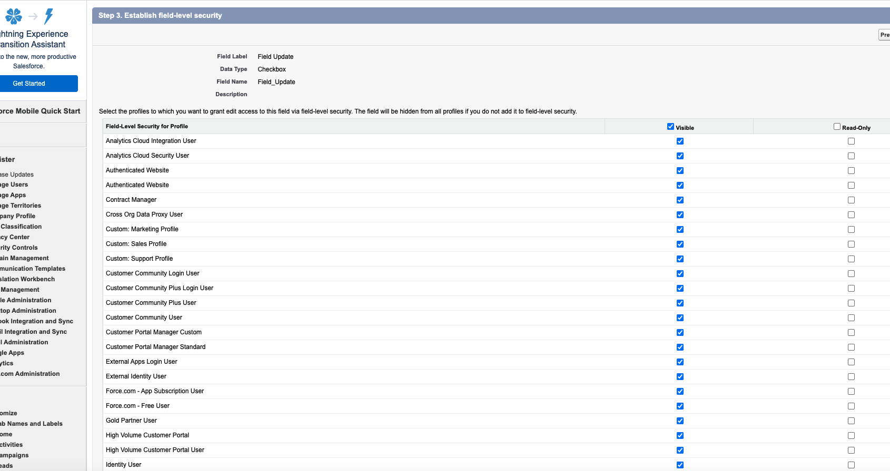

On the next Page , I choose all the checkboxes for Add to Page layouts. Click on Save.

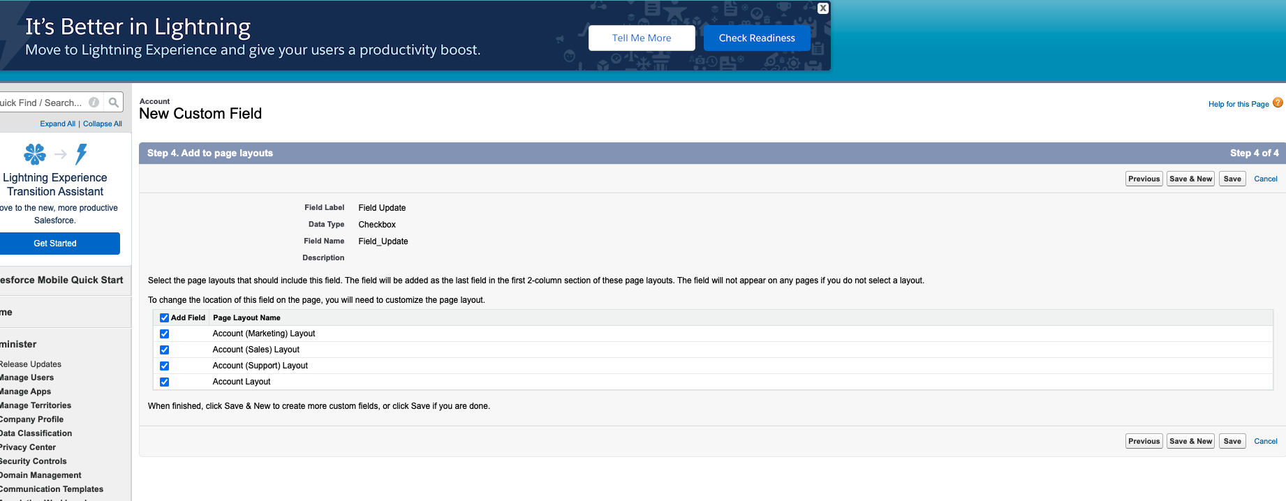

After saving, the newly created custom field can be seen as below:

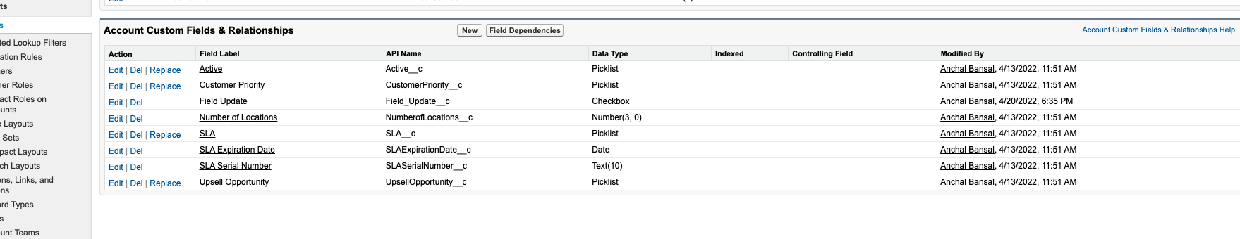

1. **Creating Apex Trigger on Contact Object:**

In the Quick Find bar, I searched for Contacts and under Contacts, I clicked on Triggers:

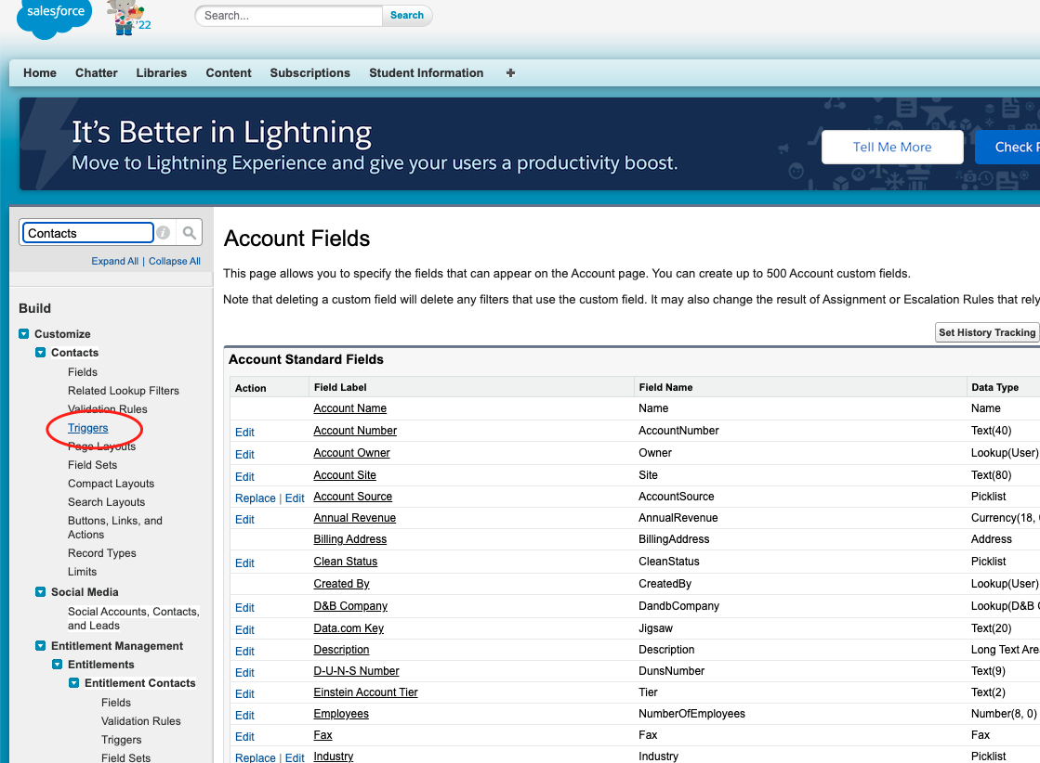

Now on the triggers page, I click on New

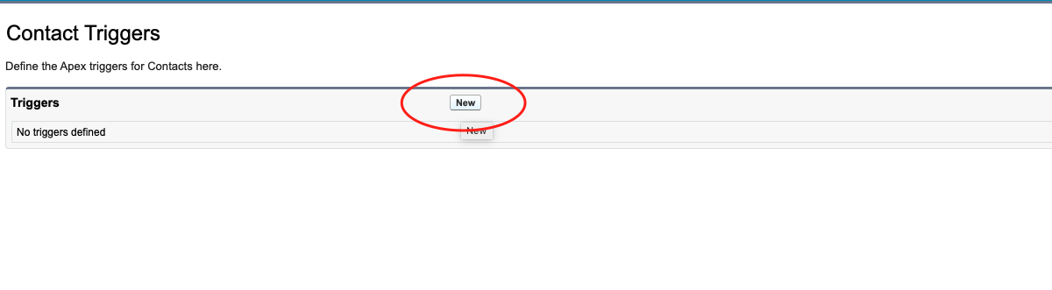

On this page, I enter the following code in console and click on Save:

**Code:**   
*trigger updateAccount on Contact (after insert, after update) {   
 Set <String> accID = New Set <String> ();   
 For (Contact con: Trigger.new) {   
if (con.AccountId != Null ) {   
 accID.add (con.AccountId);   
 }*

*}   
 if (accID.size ()> 0) {   
 List <Account> upAccList = new List <Account> ();   
For (Account ac:   
 [SELECT Id, Field_Update__c   
 FROM Account   
 WHERE id in: AccID   
 AND Field_Update__c != True]) {   
ac.Field_Update__c = true;   
 UpAccList.add (ac);   
 }   
 if (upAccList.size ()> 0)   
 update upAccList;   
 }   
}*

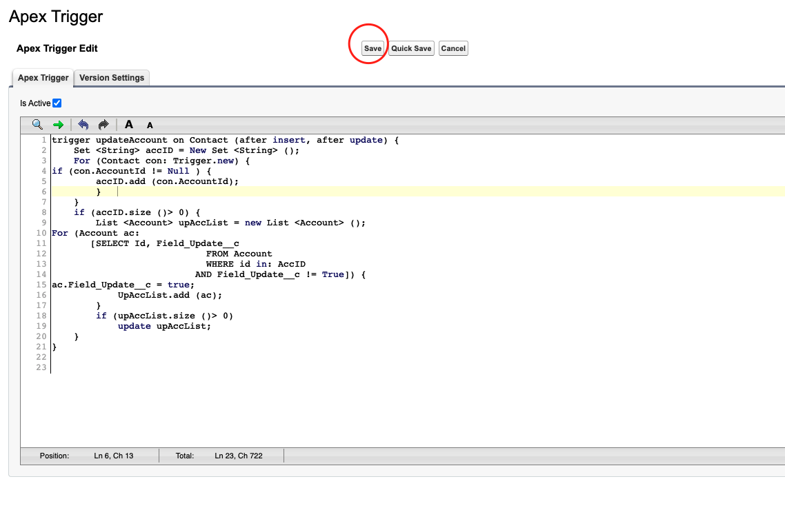

After clicking on Save, I can see the trigger details as below and Status as Active:

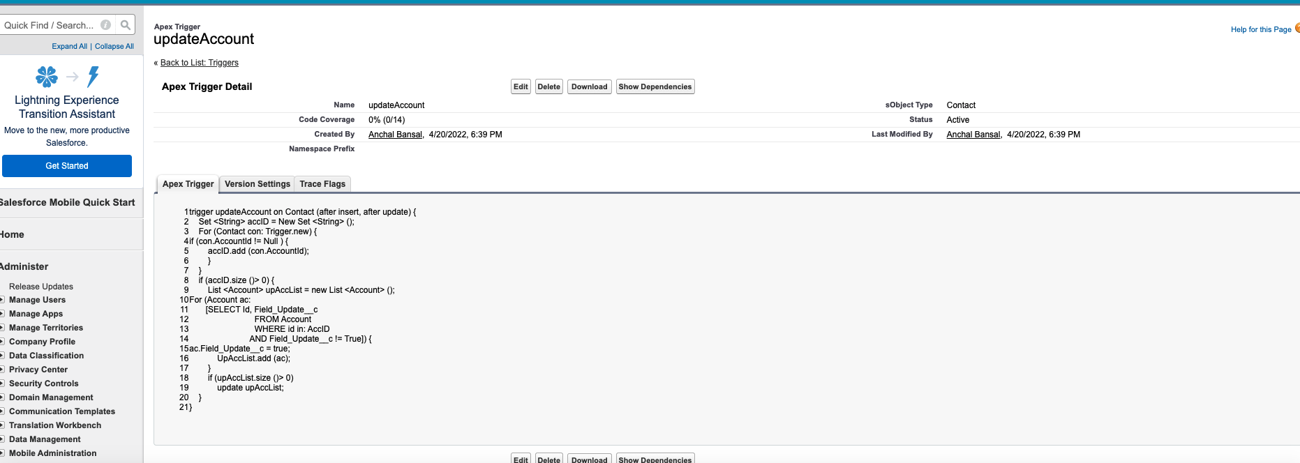

1. **Creating a Contact Record:**

Click on the ‘+’ button and click on Accounts:

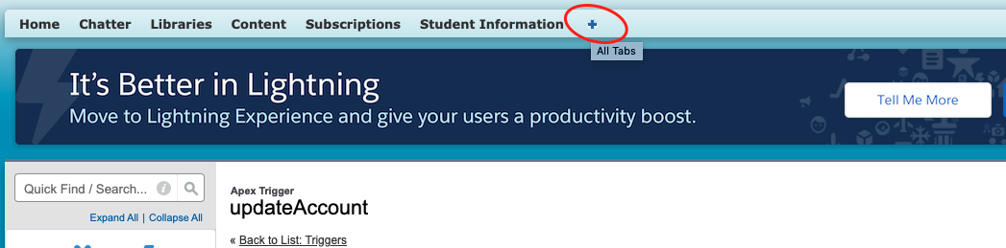

Under the accounts, I can see my account which I created previously with my name.

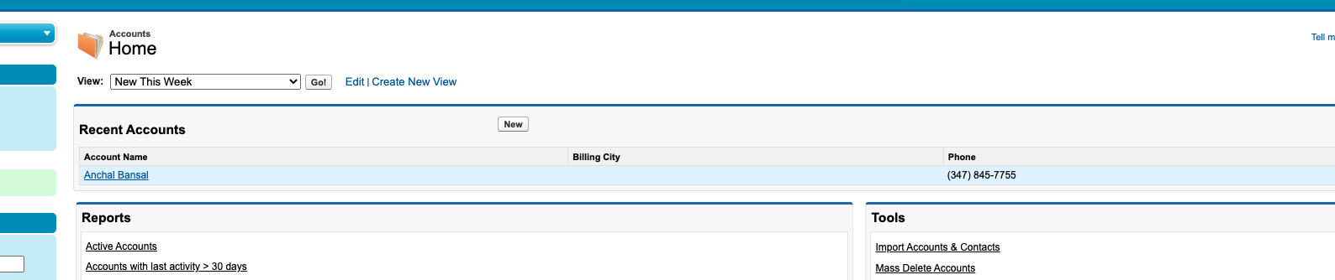

On clicking my account, I can see Field Update field and Contact object with no records as highlighted below. I click on New Contact in the Contacts:

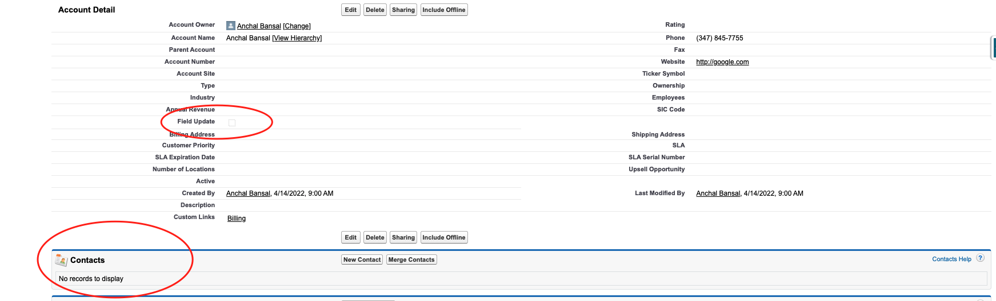

On clicking on New, I update my contact information as below and Save:

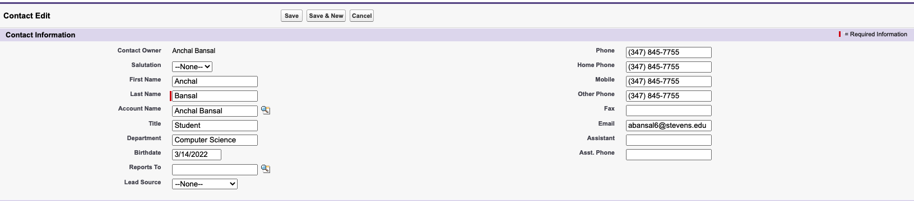

After creating my Contact, I go back to my account and view the details and I can the Field Update as Checked and My Contact information added in Contacts as shown below:

