1.How are inline and block elements different from each other?
Ans 1.
A block-level element always starts on a new line and takes up the 100% width available .By default, will be placed below previous elements in the markup.Will iperform any margin settings, and any padding
Examples of block-level elements:
- <div>
- <h1> - <h6>
- <p>
- <form>
- <ul>
An inline element does not start on a new line and only takes up as much width as necessary.Will not clear previous content to drop to the next line like block elements.Will ignore top and bottom margin settings, but will apply left and right margins, and any padding.Will ignore the width and height properties
Examples of inline elements:
- <span>
- <a>
- <img>
2.Explain the difference between visibility:hidden and display:none
Ans 2.
display:none means that the tag in question will not appear on the page at all (although you can still interact with it through the dom). There will be no space allocated for it between the other tags.removes the element from the normal flow of the page, allowing other elements to fill in.
Eg:
<div id=”p” style=”display:none”>
<div id="c" style="display:block;"></div>
</div>
Here none of the divs are visible
visibility:hidden means that unlike display:none ,the tag is not visible, but space is allocated for it on the page. The tag is rendered, it just isn't seen on the page.
Eg:
<div id=”p” style=”visibility:hidden”>
<div id="c" style="visibility:visible;"></div>
</div>
Here p div will be hidden but c div will be shown

3. Explain the clear and float properties.
Ans 3. Float is a CSS positioning property .When applied they remain a part of flow of the webpage.There are four valid values for the float property. Left and Right float elements those directions respectively. None (the default) ensures the element will not float and Inherit which will assume the float value from that elements parent element.it can be used to create entire web layouts.
Clear specifies on which sides of an element floating elements are not allowed to float.An element that has the clear property set on it will not move up adjacent to the float but will move itself down past the float. Clear has four valid values as well. Both is most commonly used, which clears floats coming from either direction. Left and Right can be used to only clear the float from one direction respectively. None is the default.
4. explain difference between absolute, relative,fixed and static.
Ans 4.
Static. This is the default for every page. it just means that the element will flow into the page as it normally would. Used when we want to forcefully-remove some positioning that got applied to an element outside of our control.
Relative. It means is "relative to itself". if we give some other positioning attribute on an element, say, top:10px , it will shift it's position 10 pixels DOWN from where it would be. it also introduces the ability to use z-index on that element,Even if you don't set a z-index value, this element will now appear on top of any other statically positioned element. Any element that is a child of the relatively positioned element can be absolutely positioned within that block. (elements are positioning themselves in relation to the body element instead of their direct parent when parentdiv is relative and other divs has absolute positioning)
Absolute. It is use to place any page element exactly where you want it. Remember that these values will be relative to the next parent element with relative (or absolute) positioning. If there is no such parent, it will be placed relatively to the page itself.An element with this type of positioning is not affected by other elements and it doesn't affect other elements.
Fixed. It is positioned relative to the viewport, or the browser window itself. The good is that it keeps the navigation present at all times on the page and it creates and interested effect on the page. The dsadvantages are :On small laptop, the content in the sidebar is cut off and there is no way from me to scroll down to see the rest of that content. Also if I scroll all the way down to the footer, it overlaps the footer content not allowing me to see all of that.
5. Write the HTML code to create a table in which there are 4 columns( ID , Employee Name, Designation, Department) and at least 6 rows. Also do some styling to it.
Ans 5.
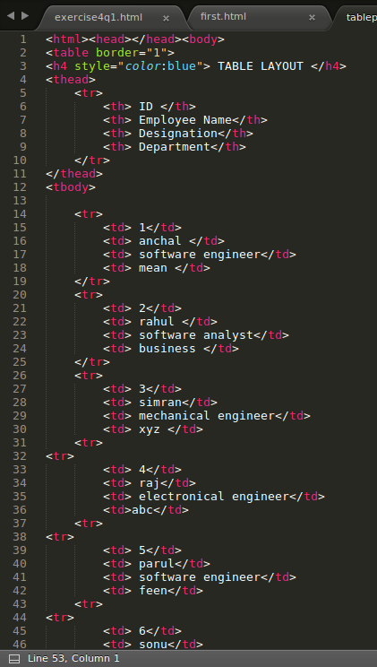

6. Why do we use meta tags?
Ans 6.
The <meta> tag provides metadata about the HTML document. Metadata will not be displayed on the page, but will be machine parsable.
Meta elements are typically used to specify page description, keywords, author of the document, last modified, and other metadata. Also, it helps to improve the SEO( Search Engine Optimization) of a web page by using certain keywords related to the web page. <meta> tags always go inside the <head> element.
Examples of <meta> tag with different attributes :
1.<meta name="keywords" content="HTML, CSS, XML, XHTML, JavaScript"> (For Search engines)
2.<meta name="description" content="Free Web tutorials on HTML and CSS"> ( Description of web page)
3.<meta name="author" content="John Doe"> (Author of web page)
4.<meta name="viewport" content="width=device-width, initial-scale=1.0"> (Responsiveness)

7. Explain box model.
Ans 7.
All HTML elements can be considered as boxes. In CSS, the term "box model" is used when talking about design and layout.The CSS box model is essentially a box that wraps around every HTML element. It consists of: margins, borders, padding, and the actual content.
Total element width = width + left padding + right padding + left border + right border + left margin + right margin
It has 4 layers:
1.Content - The content of the box, where text and images appear
2.Padding - Clears an area around the content. The padding is transparent
3.Border - A border that goes around the padding and content
4.Margin - Clears an area outside the border. The margin is transparent
8. What are the different types of CSS Selectors?
Ans 8.
There ar different types of css selectors -
a.Universal Selector -It will selects all elements on a page.
Eg: *{color:green;
width:100px; } // Every tag on HTML page will have these properties
b.Elemen type t/Type Selector -This selector matches one or more HTML elements of the same name.
Eg: p{
background:red; }// All <p> in HTML page will have this property in common
c.ID Selector -It starts with hash(#)sign.This selector matches any HTML element that has an ID attribute with the same name.An ID element on a web page should be unique.
Eg: id1{margin :0 auto;
}
<div id=”id1”></div>
d. Class Selector -It starts with dot(.) sign. This selector matches all elements on the page that have their class attribute set to the same value . We can put the same clas selector on multiple HTML elements .
Eg: .divcls{padding:10px;
background:grey;}
<div class=”divcls”></div>
<header class=”divcls”<header>
e.Descendant Selector- This will combine two or more selectors.
Eg: #id1 .divcls{ float :right;
} //This will apply to all elements that have a divcls class that are inside an element with an ID of id1.

<div id=”id1”> <div class=”divcls”></div> //This will be affected
<div class=”newcls”></div></div>

.class | .intro | Selects all elements with class="intro"
#id | #firstname | Selects the element with id="firstname"
* | * | Selects all elements
element | p | Selects all <p> elements
element,element | div, p | Selects all <div> elements and all <p> elements
element element | div p | Selects all <p> elements inside <div> elements

9. Define Doctype.
Ans 9.The <!DOCTYPE> declaration must be the very first thing in HTML .The <!DOCTYPE> declaration is not an HTML tag; it is an instruction to the web browser about what version of HTML the page is written in. In HTML5 we simply write <!DOCTYPE html>
.Always add the <!DOCTYPE>declaration to your HTML documents, so that the browser knows what type of document to expect and helps SEO in effective searching .
10. Explain 5 HTML5 semantic tags.
Ans 10. A semantic element clearly describes its meaning to both the browser and the developer.
a.<section>-It defines a section in a document.A home page could normally be split into sections for introduction, content, and contact information.
b.<article>-defines an article in the document.It should make sense on its own, and it should be possible to read it independently from the rest of the web site.
c.<aside>-Defines a content aside from the page like sidebar.
d.<footer>-Defines a footer of the document or a section.
e.<nav>-Defines navigation links in the document.

11. Create HTML for web-page.jpg (check resources, highest weightage for answers)
12. Create HTML for form.png (check resources, highest weightage for answers)

