Que 1. Create a directory "exercise" inside your home directory and create nested(dir1/dir2/dir3) directory structure inside "excerise" with single command.
Ans 1. anchal@anchal-jain:~$ mkdir -p exercise/dir1/dir2/dir3

Que 2. Create two empty files inside dir1: emptyFile1,emptyFile2 in single command and Remove the dir2 direcroty
Ans 2. touch emptyFile1 emptyFile2;rm -rf dir2

Que 3. Create one file file.txt containing text "hello world" and save it.
Ans 3. anchal@anchal-jain:~/exercise/dir1$ cat > file.text
hello world
^C

Que 4. Find a "passwd" file using find command inside /etc. copy this files as passwd_copy and then rename this file as passwd_backup.
Ans 4.
anchal@anchal-jain:~$ find /etc -name passwd
anchal@anchal-jain:~$ cp /etc/passwd /home/anchal/exercise/passwd_copy
anchal@anchal-jain:~$ cd exercise
anchal@anchal-jain:~/exercise$ ls
dir1 passwd_copy
anchal@anchal-jain:~/exercise$ mv passwd_copy passwd_backup
anchal@anchal-jain:~/exercise$ ls
dir1 passwd_backup

Que 5. Try reading passwd_backup file in multiple tools: less,more,cat,strings etc and find the difference in their usage.
Ans 5.
anchal@anchal-jain:~/exercise$ less passwd_backup
We can navigate the page up/down using the less command and not possible in more command.We can search a string in less command. (use /keywordto search)
anchal@anchal-jain:~/exercise$ more passwd_backup
It is use to view a file one page at a time, press spacebar to go to the next page and cannot be use for navigation and shows the result according to the page size .
Eg: more -5 passwd_backup // It will show 5 lines at a time and the percentage describing how many lines are displayed

anchal@anchal-jain:~/exercise$ cat passwd_backup
It can be used to join multiple files together and print the result on screen (it will not show page by page)
Eg: cat >> passwd1 // It will be use for appending in existing file
Eg: cat > passwd1 // It will create a new file
anchal@anchal-jain:~/exercise$ strings passwd_backup
Using strings command, we will be able to view all the printable strings from the binary file.By default strings command will be looking for sequences of at least 4 printable characters that are terminated by a NULL character.

Que 6. Find out the number of line in password_backup containing "/bin/false".
Ans 6. grep -c /bin/false passwd_backup
21

Que 7. Redirect the output of the above commands into file "output".
Ans 7. grep -c /bin/false passwd_backup | cat > output

Que 8.Create a "test" user,create its password and find out its uid and gid.
Ans 8.
anchal@anchal-jain:~$ sudo -i
root@anchal-jain:~# adduser test
anchal@anchal-jain:~$ sudo -i
root@anchal-jain:~# passwd test
Enter new UNIX password:
Retype new UNIX password:
passwd: password updated successfully
root@anchal-jain:~# id -u test
1004
root@anchal-jain:~# id -g test
1004

Que 9. Login as test user and edit the "output" file created above. Since the permission wont allow you to save the changes.
Ans 9.
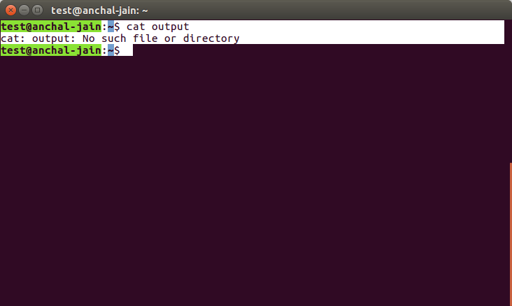

Que 10. Configure such that test user can edit it.
- Add group owner of the "output" file as the secondary group of testuser and check/change the "output" file permission if it is editable by group. Once done revert the changes.
- Make the file editable to the world so that test user can access it. Revert the changes after verification
- Change the ownership to edit the file. Try all the options and recommend best of them.
Ans 10.
- sudo usermod -G test,anchal test
test@anchal-jain:~$ vi /home/anchal/output
test@anchal-jain:~$ cat /home/anchal/output
g21
- anchal@anchal-jain:~$ sudo chmod u+rwx output

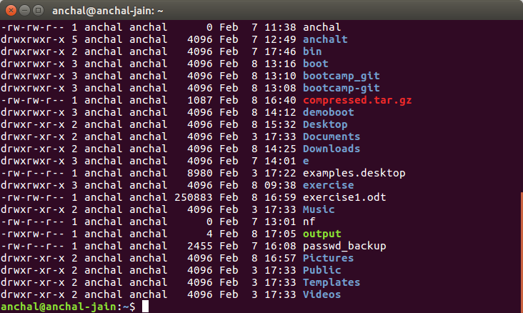
anchal@anchal-jain:~$ sudo chmod u-w output

- anchal@anchal-jain:~$ sudo chown test output
anchal@anchal-jain:~$ sudo chown root output

Assigning priviledge to root user will be a best option

Que 11. Create alias with your name so that it creates a file as "/tmp/aliastesting".
Ans 11.
anchal@anchal-jain:~$ PATH=$PATH:/home/anchal/bin
anchal@anchal-jain:/bin$ vi anchal
anchal@anchal-jain:/bin$ chmod 777 anchal
anchal@anchal-jain:~/bin$ cat < anchal
#!/bin/bash
touch /tmp/aliastesting
anchal@anchal-jain:/$ cd tmp
anchal@anchal-jain:/tmp$ ls
aliastesting
config-err-BPydfE

Que 12.Edit ~/.bashrc file such that when you change to "test" user it should clear the screen and print "Welcome".
Ans 12.
anchal@anchal-jain:~$ su - test
Password:
test@anchal-jain:~$ vi ~/.bashrc
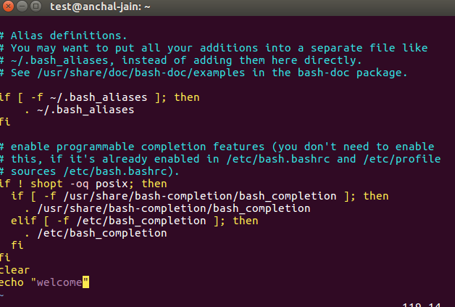
welcome
test@anchal-jain:~$

Que 13. Install zip package.
Ans 13.
anchal@anchal-jain:~$ sudo apt-get install zip
[sudo] password for anchal:
Reading package lists... Done
Building dependency tree
Reading state information... Done
zip is already the newest version (3.0-11).
zip set to manually installed.
0 upgraded, 0 newly installed, 0 to remove and 323 not upgraded.
anchal@anchal-jain:~$

Que 14. Compress "output" and "password_backup" files into a tar ball. List the files present inside the tar created.
Ans 14.
anchal@anchal-jain:~$ cd exercise
anchal@anchal-jain:~/exercise$ ls
dir1 output passwd_backup
anchal@anchal-jain:~/exercise$ tar -czvf compressfile.tar.gz output passwd_backup
output
passwd_backup

Que 15. scp this file to test user
Ans 15.
root@anchal-jain:~# apt-get install openssh-server

Que 16.Unzip this tar bar by logging into the remote server.
Ans 16.
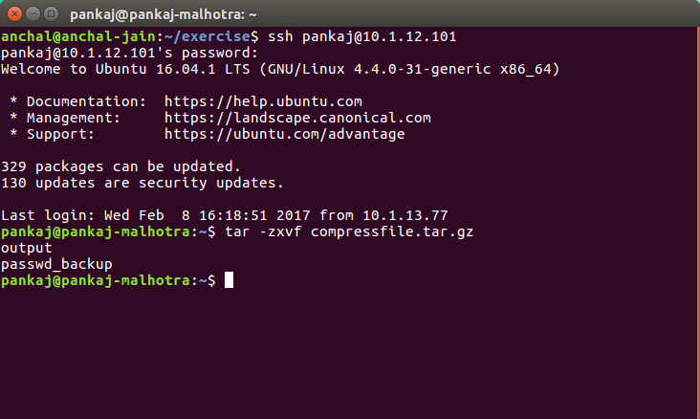
Que 17.Download any image from web and move to desktop
Ans 17.
