Que 1.
Ans 1.
anchal@anchal-jain:~/exercise_git$ ssh-keygen -t rsa -C "jain.anchal1493@gmail.com"
anchal@anchal-jain:~/.ssh$ cat id_rsa.pub
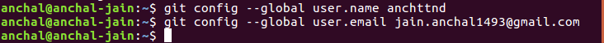

Que 2. Initialize a Git Repository
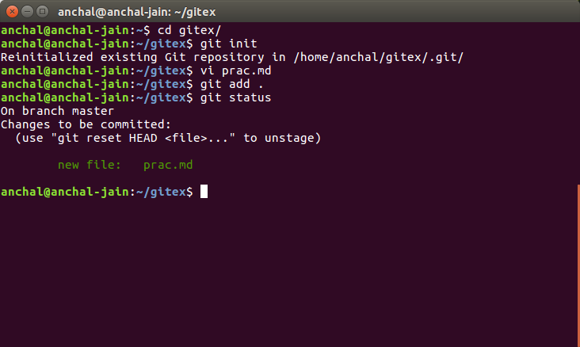
Ans 2.

Que 3. Add files to the repository
Ans 3.

Que 4.Unstage 1 file
Ans 4.
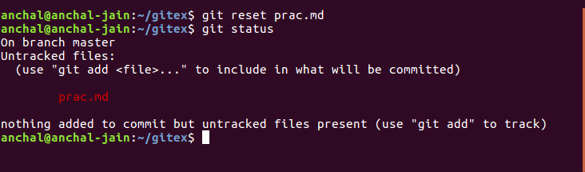
Que 5. Commit the file
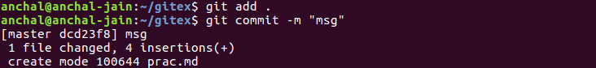
Ans 5.

Que 6.Add a remote
Ans 6.
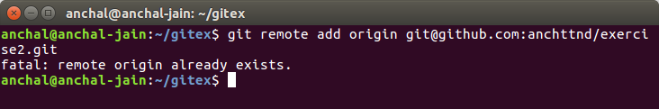

Que 7. Undo changes to a particular file
Ans 7.
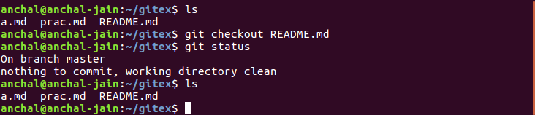
Que 8.
Ans 8.
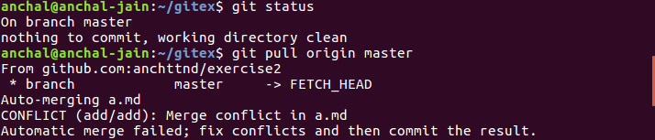
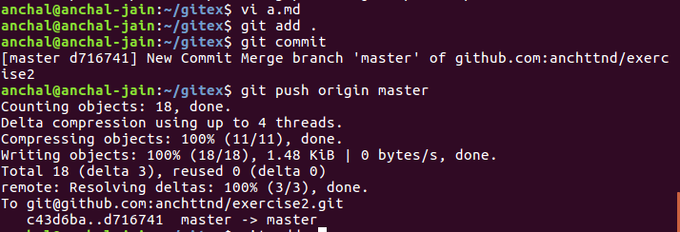
Que 9.Clone the repository
Ans 9.
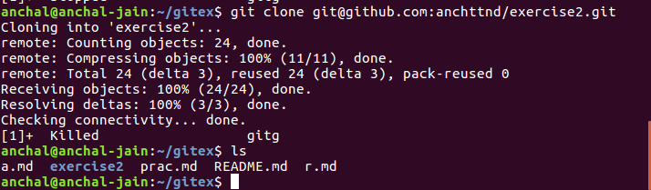
Que 10.Add changes to one of the copies and pull the changes in the other.
Ans 10.
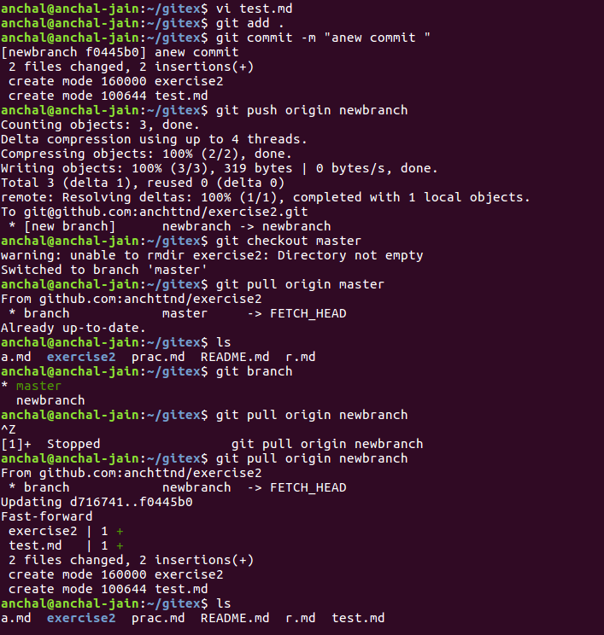

Que 11. Check differences between a file and its staged version
Ans 11.
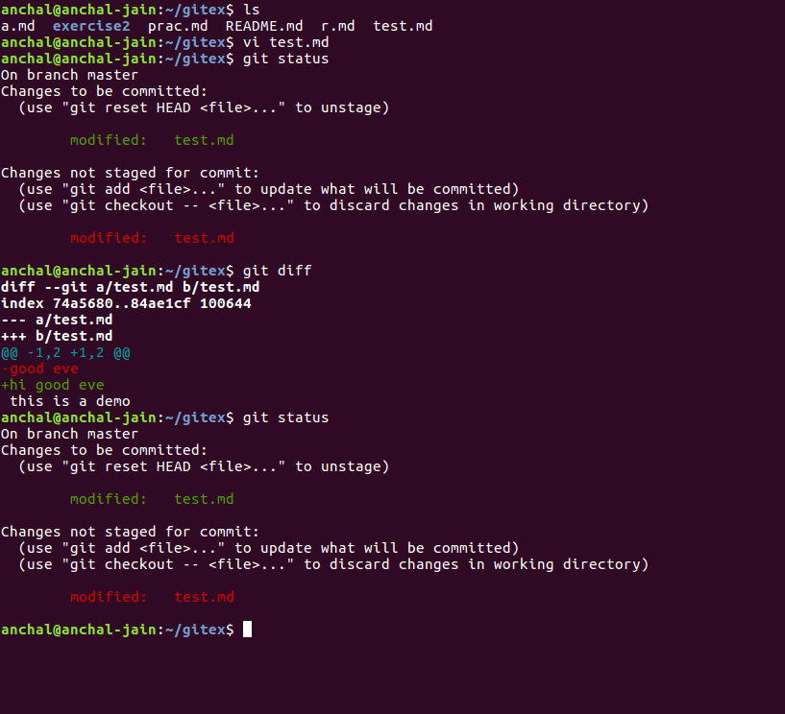

Que 12. Ignore a few files to be checked in
Ans 12.
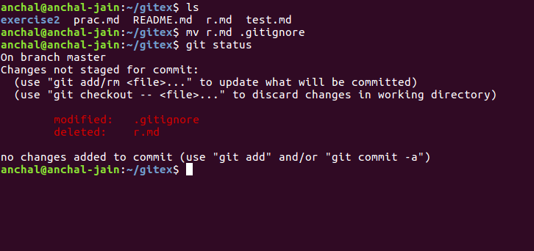

Que 13. Create a new branch.
Ans 13.

Que 14. Diverge them with commits
Ans 14.
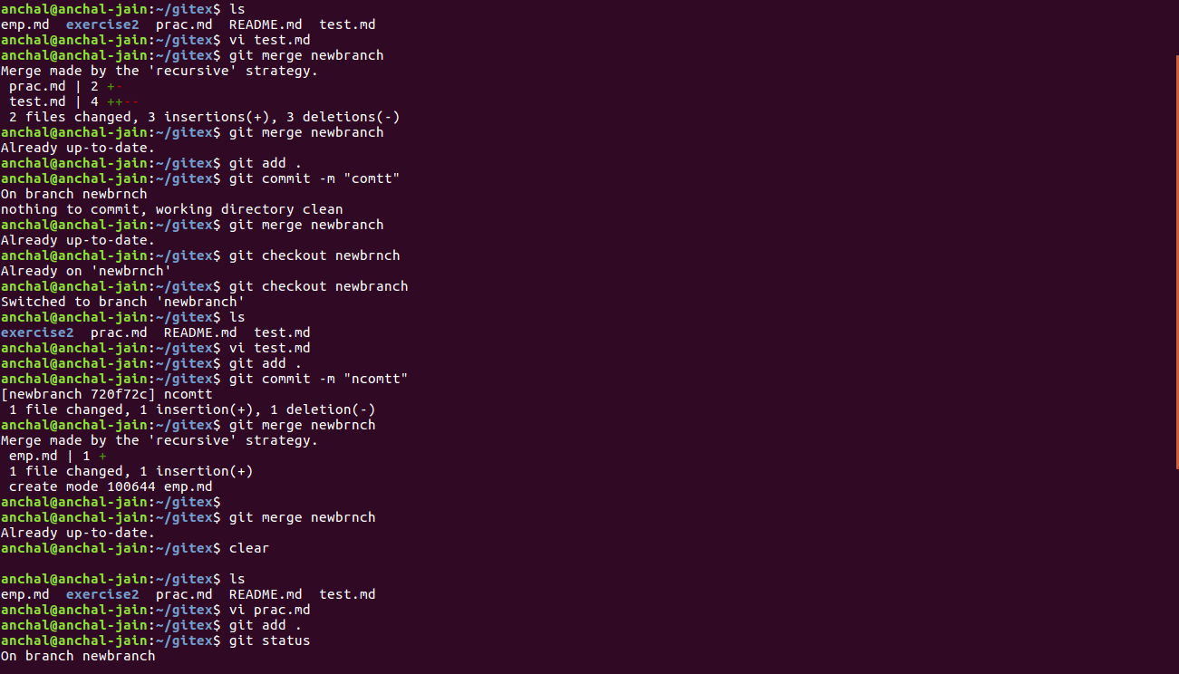

Que 15.Edit the same file at the same line on both branches and commit
Ans 15.

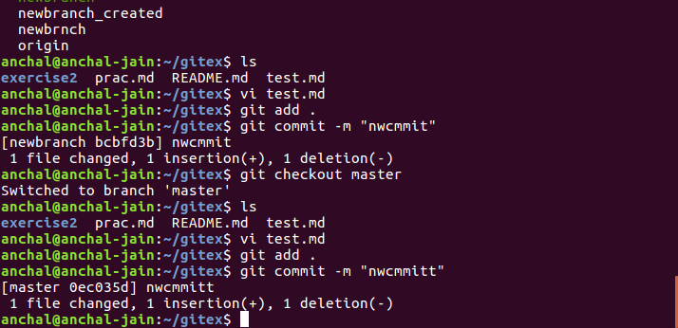

Que 16. Try merging and resolve merge conflicts
Ans 16.
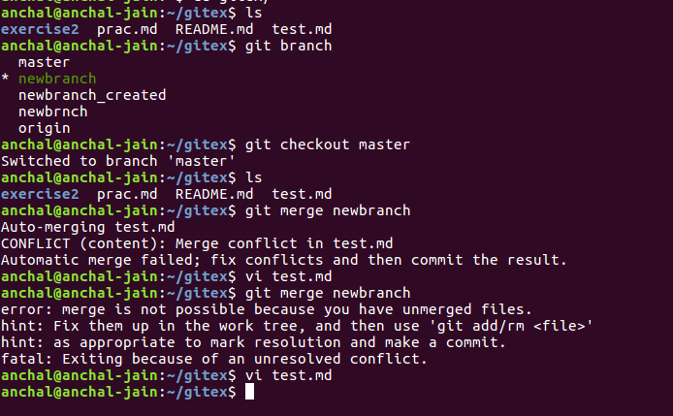



Que 17 . Stash the changes and pop them
Ans 17.

