**Amazon Web Services**

Andy Jesse ( CEO of AWS ) once said invention requires two things.

Number one the ability to try a lot of experiments and number two not having to live with the collateral damage of failed experiments.

If we wanted to go in and build out a whole bunch of web servers or an application we had to literally order physical bits of kit and these would take anywhere from 10 to 20 days to arrive.We then had to rack and stack them. We had to put all the networking gear in we had to go and install the operating systems configure them etc etc, and it would just take an awful lot of time.

Now think about cloud is that you don't have to worry about that anymore.You can literally provision really complex environments within a couple of minutes using scripted infrastructure.

If you wanna apply for aws certifications which you should if you wanna start of your career in this domain , you may get all the necessary guidelines on :

<https://aws.amazon.com/certification/certified-solutions-architect-associate/>

Getting an AWS certificate can boost your salary by 26 percent and the actual salary ranges you know differ depending on the certificates but they're anywhere from 108 thousand US dollars all the way up to a hundred nineteen thousand US dollars.But as you go on and get professional levels certification you can definitely expect a much higher rate of pay.

A brief idea of services provided on AWS platform:

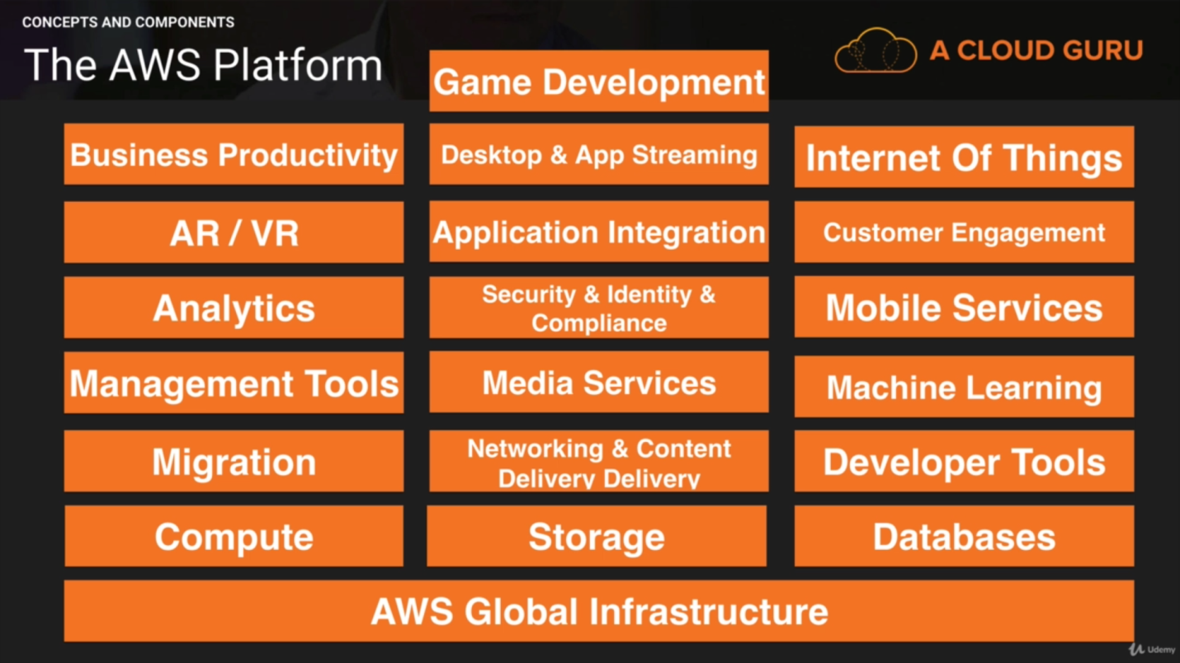

So let's have a brief timeline of AWS :

So it all started in 2003 when Chris Pinkman and Benjamin Black presented a paper on what Amazon's own internal infrastructure should look like. And they basically suggested selling it as a service and prepared a business case for it.And then what happened was Amazon actually launched SQS and that was launched in 2004 and that was the very first AWS service

AWS became an official sort of brand in 2006 and that's when it officially launched. And by 2007 it had over 180000 developers on the platform so developers took to it really really quickly.

by 2010 all of Amazon.Com had moved over to AWS.And 2012 was the very first reinvent conference and back then it was small. Reinvent 20:17 was around 44000 people.

2015 : Finally broke out its revenue and they were doing 6 billion U.S. dollars per annum and they were growing close to 90 percent year on year.

In 2016 AWS had a run rate of 13 billion U.S. dollars.

And by 2017 they released a whole host of artificial intelligence services as well as virtual reality services.

So this gives you a brief timeline of AWS it has grown massively in the last 14 years as you can see.