**Regions, Availability zones and Edge Locations**

So we've got regions all around the world and inside each region is available our availability zones and there's always at least two availabilities zones per region and an availability zone is simplya data center of the data centers geographically isolated.

So one availability zone if that gets flooded the other availabilities zones is far enough away from that first availability zone so that that flood shouldn't affect the other availabilities zones.They are engineered to be far enough away so that random disasters in one area won't affect the other availabilities.But then they're not far enough away to be like regions. So that gives you an idea of the difference between a region and availabilities in a region is geographically distinct area and then availability zones are basically data centers within a region.You have two availabilities zones per region.

And finally we have edge locations locations . Depending on where you are from in the world your data typically you would use this using cloud front. Cloud front is Amazon's content delivery network .

An edge location is where end users access services located at AWS. They are located in most of the major cities around the world and are specifically used by CloudFront (CDN) to distribute content to end user to reduce latency. It is like frontend for the service we access which are located in AWS cloud.

##################*********************************#####################

**COMPUTE**

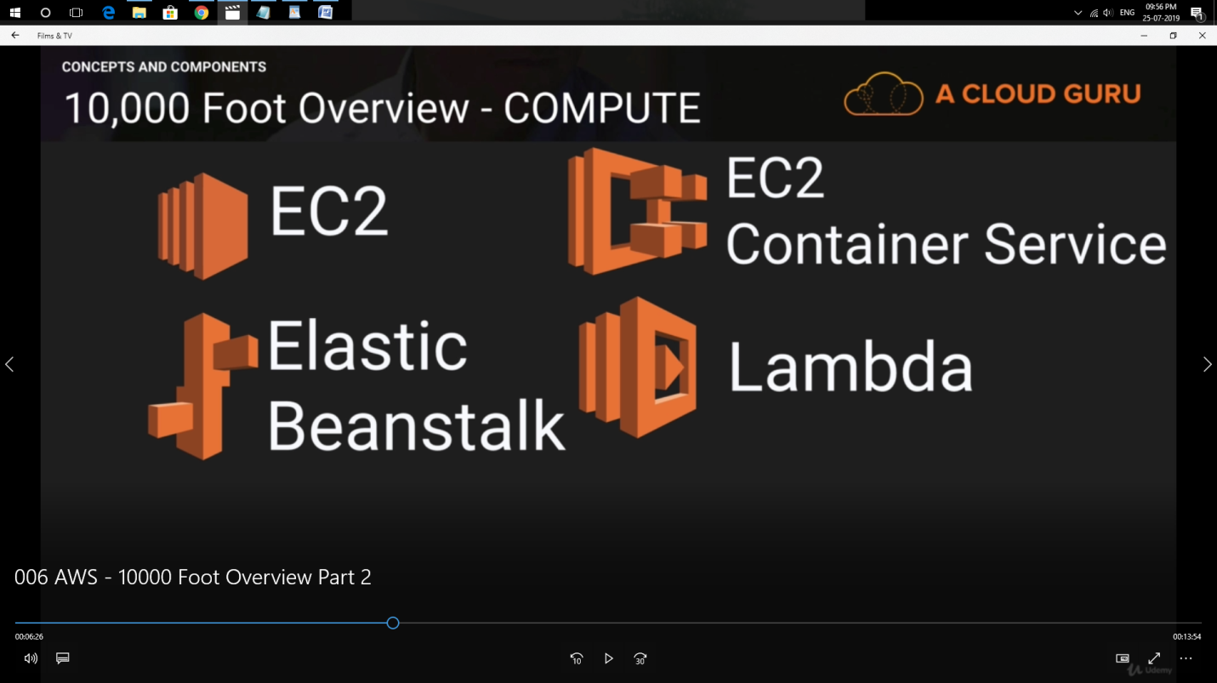

In terms of compute the very first service that compute ever offered was **EC2** which stands for **Elastic Compute Cloud**. And these are essentially just virtual machines inside the platform. Yes you can have a physical dedicated machines under this as well.

EC2 Container Service : where you run and manage docker container.

Moving onto **elastic beanstalks** : It is basically for developers who don't understand AWS and who just upload de-code elastic bean stalk then go through and provision things like orders scaling groups or load balances or two instances etc..So literally all the developers have to focus on is their code.

Moving on to **Lambda** : Lambda is code that you upload to the cloud and then you control when it executes and you don't have to worry about any underlying physical or virtual machines. Literally there's nothing to manage there's no operating systems or anything. All you worry about is your code.

So to give you an example, you might have seen a web site where people upload images and then want to overlay text on top of it.What you do is you could basically create a lambda function that puts the text over the top and it's triggered as soon as somebody uploads an image to your Web site. It then senses that this image has been uploaded and then based on the inputs that they give you would try to take over that image and output it.

##################*********************************#####################

PS : This is just an introductory file will write more as i move forward with my notes.

Thank you for reading.