**Objectives**

* Demonstrate the navigation in Azure to create a resource
  + Resource - What is a resource, what is a resource group & its significance, all resources mapped to it, deletion of it deletes all the resources;
* Demonstrate the navigation in Azure to create a container
  + Containers - what is a container, how is it used, why is it needed, Container registry;

1. **Azure resource group creation**

Logon to the Azure portal. Click on ‘Create a resource’

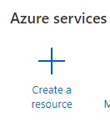

Search for ‘Resource group’ in the textbox to search. Select the ‘Resource group’ option. Click the ‘Create’ button.

In the create screen, the subscription details will be auto-populated. Provide the name of the resource group to be ‘**DNAzure_ResGrp’**

Let the region be the default listed.

Click on ‘Review + Create’. On clicking this, a page will load with ‘Create’ button. Click it to complete the process.

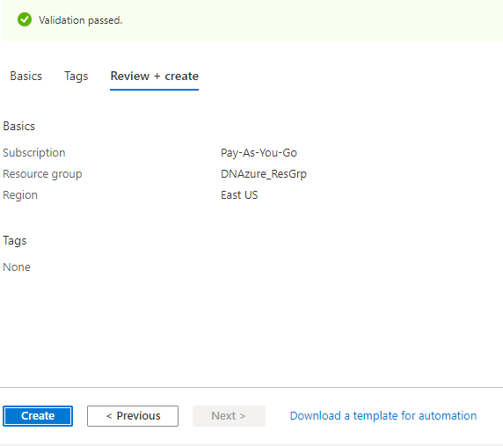

There will be a notification on the resource creation on the top blue navigation bar on the right side.

Click the ‘bell’ icon to view that and navigate to the resource group.



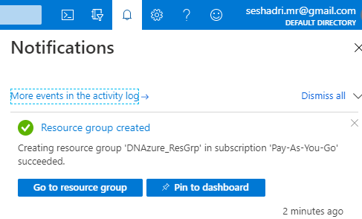

**This will be the group where all the resources be created for the Hands-on in this module.**

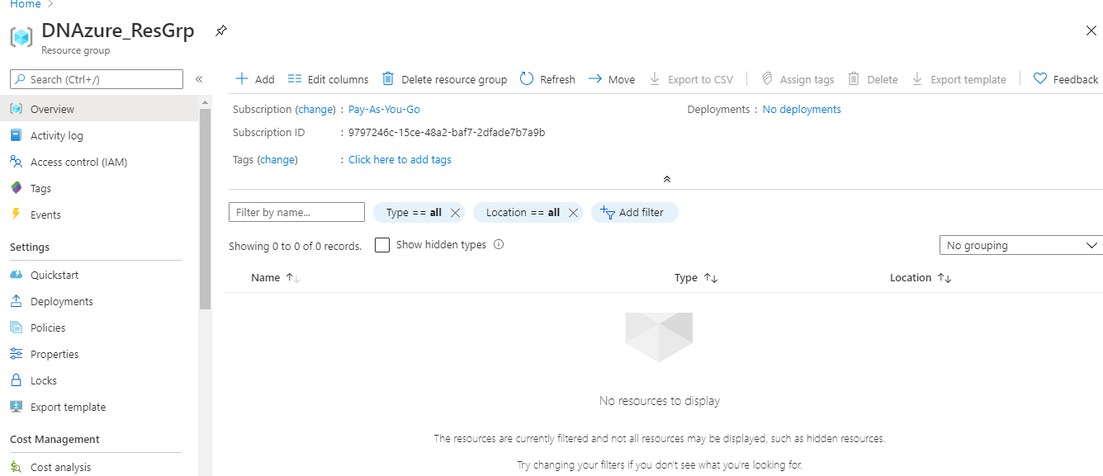

1. **Navigation to Container registry**

Logon to the Azure portal. Click on ‘Create a resource’



On the left navigation, there will be sections with grouped items. Click the item ‘Containers’. Select the item ‘Container registry’ on the right side listing.

