PRACTICAL NO : 1

1. Implementation of Logic programming using PROLOG DFS for water jug problem

Code:
water_jug(X,Y):- X>4,Y<3,write('4L jug overflow'),nl.
water_jug(X,Y):- X<4,Y>3,write('3L jug overflow'),nl.
water_jug(X,Y):- X>4,Y>3,write('Both jug overflow'),nl.
water_jug(X,Y):-
(X=:=0, Y=:=0,nl,write('4L:0 & 3L:3 (Action : Fill 3L jug.)'),YY is 3, water_jug(X,YY));
(X=:=0, Y=:=0,nl,write('4L:4 & 3L:0 (Action : Fill 4L jug.)'),XX is 4, water_jug(XX,Y));
(X=:=2, Y=:=0,nl,write('4L:2 & 3L:0 (Action : Goal Stage reached...)'));
(X=:=4, Y=:=0,nl,write('4L:1 & 3L:3 (Action : Pour water from 4L to 3L jug.)'),
XX is X-3, YY is 3, water_jug(XX,YY));
(X=:=0, Y=:=3,nl,write('4L:3 & 3L:0 (Action : Pour water from 3L to 4L jug.)'),
XX is 3, YY is 0, water_jug(XX,YY));
(X=:=1, Y=:=3,nl,write('4L:1 & 3L:0 (Action : Empty 3L jug.)'),
YY is 0, water_jug(X,YY));
(X=:=3, Y=:=0,nl,write('4L:3 & 3L:3 (Action : Fill 3L jug.)'),
YY is 3, water_jug(X,YY));
(X=:=3, Y=:=3,nl,write('4L:4 & 3L:2 (Action : Pour water from 3L jug to 4L jug untill 4L jug is full.)'),
XX is X+1, YY is Y-1, water_jug(XX,YY));
(X=:=1, Y=:=0,nl,write('4L:0 & 3L:1 (Action : Pour water from 4L jug to 3L jug .)'),
XX is Y, YY is X, water_jug(XX,YY));
(X=:=0, Y=:=1,nl,write('4L:4 & 3L:1 (Action : Pour water from 4L .)'),
XX is 4, water_jug(XX,Y));
(X=:=4, Y=:=1,nl,write('4L:2 & 3L:3 (Action : Pour water from 4L jug to 3L jug untill 3L jug is full.)'),
XX is X-2, YY is Y+2, water_jug(XX,YY));
(X=:=2, Y=:=3,nl,write('4L:2 & 3L:0 (Action : Empty 3L jug .)'),
YY is 0, water_jug(X,YY));
(X=:=4, Y=:=2,nl,write('4L:0 & 3L:2 (Action : Empty 4L jug .)'),
XX is 0, water_jug(XX,Y));
(X=:=0, Y=:=2,nl,write('4L:2 & 3L:0 (Action : Pour water from 3L jug to 4L jug.)'),
XX is Y, YY is X, water_jug(XX,YY)).

Output:

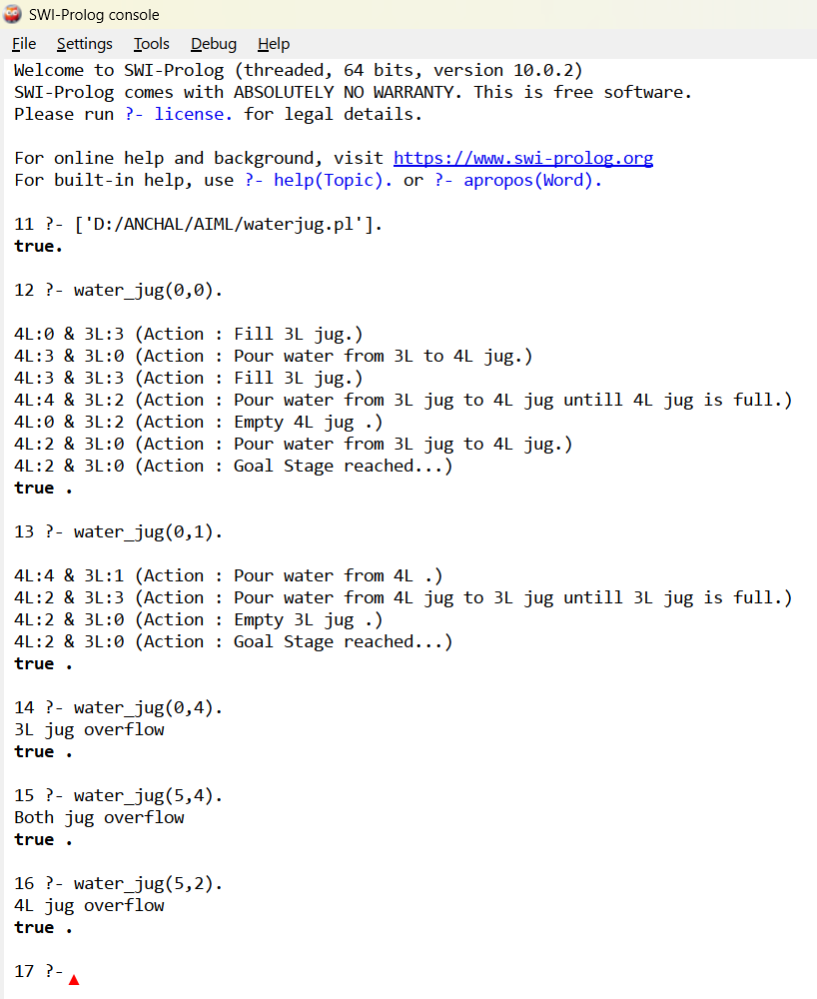

PRACTICAL NO : 2

Implementation of Logic programming using PROLOG BFS for tic-tac-toe problem

Code:
% Entry point when compiled
:- initialization(play).
% Initial empty board
board([' ',' ',' ',
' ',' ',' ',
' ',' ',' ']).
% Display the board
display_board([A,B,C,D,E,F,G,H,I]) :-
write(A), write(' | '), write(B), write(' | '), write(C), nl,
write('--+---+--'), nl,
write(D), write(' | '), write(E), write(' | '), write(F), nl,
write('--+---+--'), nl,
write(G), write(' | '), write(H), write(' | '), write(I), nl, nl.
% Replace helper
replace([_|T], 1, X, [X|T]).
replace([H|T], I, X, [H|R]) :-
I > 1,
I1 is I - 1,
replace(T, I1, X, R).
% Make a move (only if empty)
move(Board, Pos, Player, NewBoard) :-
nth1(Pos, Board, ' '),
replace(Board, Pos, Player, NewBoard).
% Win conditions
win(Board, Player) :-
member([A,B,C], [[1,2,3], [4,5,6], [7,8,9],
[1,4,7], [2,5,8], [3,6,9],
[1,5,9], [3,5,7]]),
nth1(A, Board, Player),
nth1(B, Board, Player),
nth1(C, Board, Player).
% Draw condition
draw(Board) :-
\+ member(' ', Board).
% Switch player
switch('X', 'O').
switch('O', 'X').
% Start game
play :-
board(B),
display_board(B),
play_turn(B, 'X').
% Alternate turns with validation
play_turn(Board, Player) :-
write(Player), write(' turn. Enter position (1-9): '),
read(Pos),
(
integer(Pos),
Pos >= 1, Pos =< 9,
move(Board, Pos, Player, NewBoard)
->
display_board(NewBoard),
(
win(NewBoard, Player) ->
write(Player), write(' wins!'), nl
;
draw(NewBoard) ->
write('Game is a draw!'), nl
;
switch(Player, Next),
play_turn(NewBoard, Next)
)
;
write('Invalid move! Try again.'), nl,
play_turn(Board, Player)
).

Output:

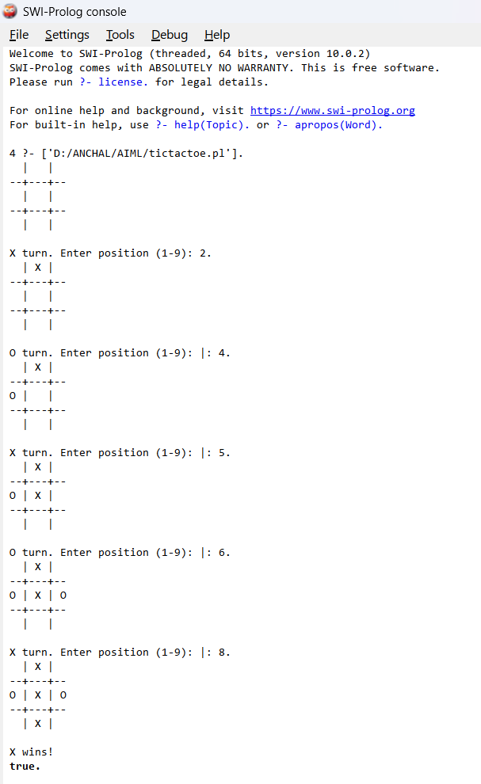

PRACTICAL NO : 3

Implementation of Logic programming using PROLOG Hill-climbing to solve 8- Puzzle Problem.

Code:
% Simple Prolog Planner for the 8 Puzzle Problem
test(Plan):-
write('Initial state:'), nl,
Init = [at(tile4,1), at(tile3,2), at(tile8,3),
at(empty,4), at(tile2,5), at(tile6,6),
at(tile5,7), at(tile1,8), at(tile7,9)],
write_sol(Init),
Goal = [at(tile1,1), at(tile2,2), at(tile3,3),
at(tile4,4), at(empty,5), at(tile5,6),
at(tile6,7), at(tile7,8), at(tile8,9)],
nl, write('Goal state:'), nl,
write(Goal), nl, nl,
solve(Init, Goal, Plan).
solve(State, Goal, Plan):-
solve(State, Goal, [], Plan).
is_movable(X1, Y1) :-
Diff is X1 - Y1,
member(Diff, [1, -1, 3, -3]).
solve(State, Goal, Plan, Plan):-
is_subset(Goal, State), nl,
write_sol(Plan).
solve(State, Goal, Sofar, Plan):-
member(at(X,Y), State),
X \= empty,
member(at(empty,Z), State),
is_movable(Y,Z),
act(Action, Preconditions, Delete, Add, X, Y, Z),
is_subset(Preconditions, State),
\+ member(Action, Sofar),
delete_list(Delete, State, Remainder),
append(Add, Remainder, NewState),
solve(NewState, Goal, [Action|Sofar], Plan).

act(move(X,Y,Z),
[at(X,Y), at(empty,Z)],
[at(X,Y), at(empty,Z)],
[at(X,Z), at(empty,Y)],
X, Y, Z).
is_subset([H|T], Set):-
member(H, Set),
is_subset(T, Set).
is_subset([], _).
delete_list([H|T], Curstate, Newstate):-
remove(H, Curstate, Remainder),
delete_list(T, Remainder, Newstate).
delete_list([], Curstate, Curstate).
remove(X, [X|T], T).
remove(X, [H|T], [H|R]):-
remove(X, T, R).
write_sol([]).
write_sol([H|T]):-
write_sol(T),
write(H), nl.
append([H|T], L1, [H|L2]):-
append(T, L1, L2).
append([], L, L).
member(X, [X|_]).
member(X, [_|T]):-
member(X, T).

Output:

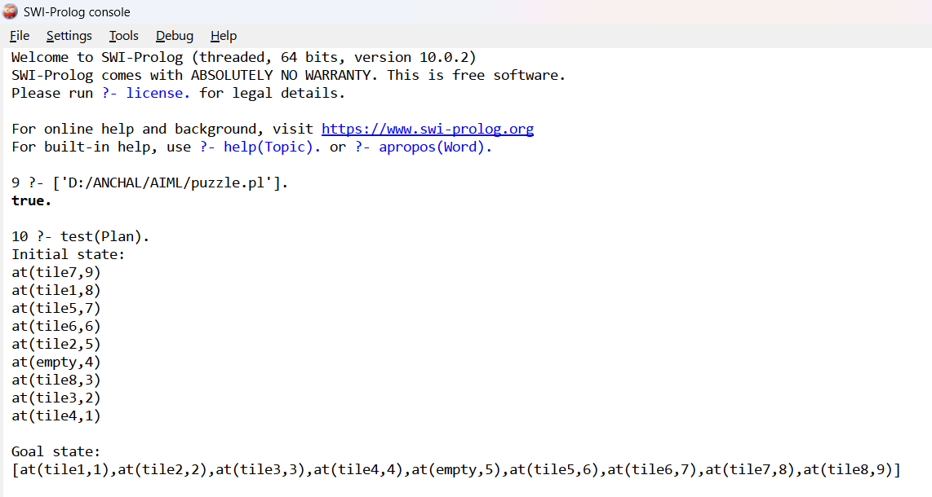

PRACTICAL NO : 4

Introduction to Python Programming: Basic libraries - NumPy, Pandas, SciPy, Matplotlib, Scikit Learn.

A. Introduction to Python Programming
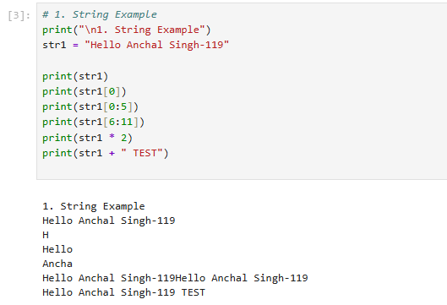

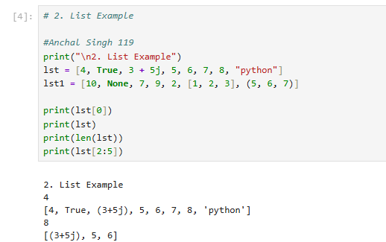
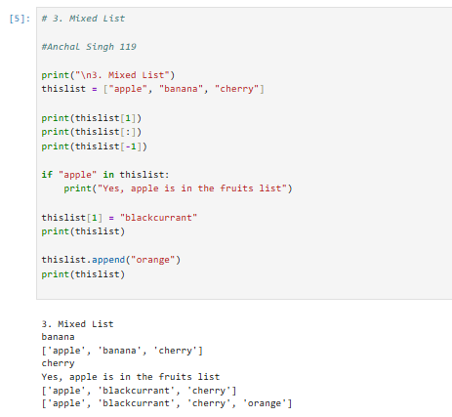
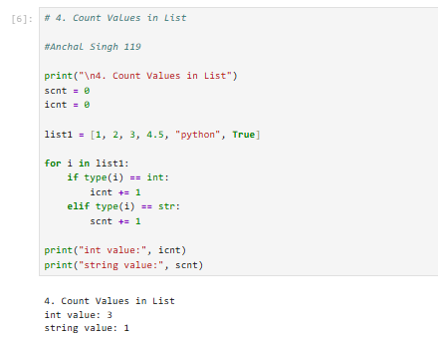

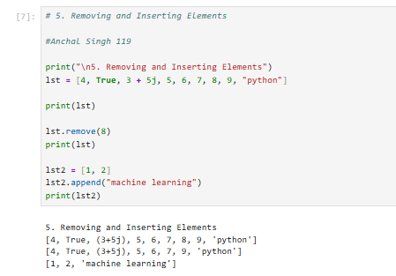
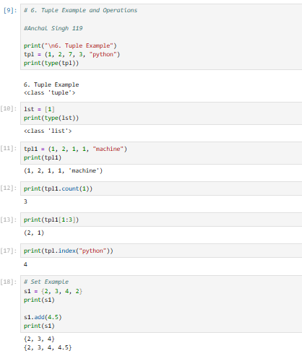

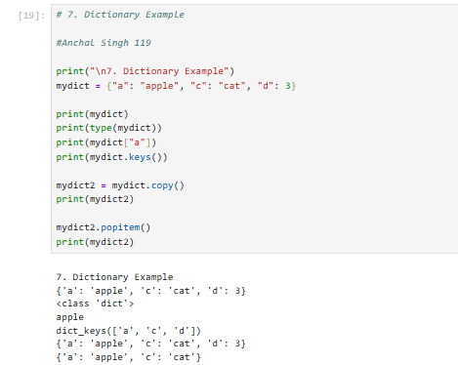

B. Numpy
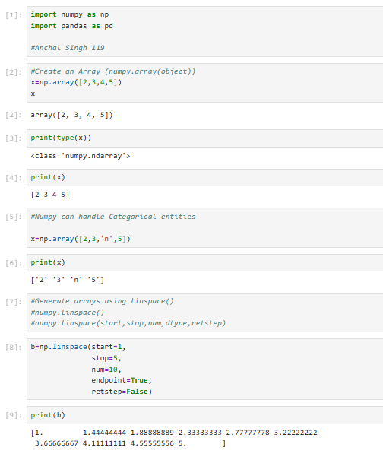
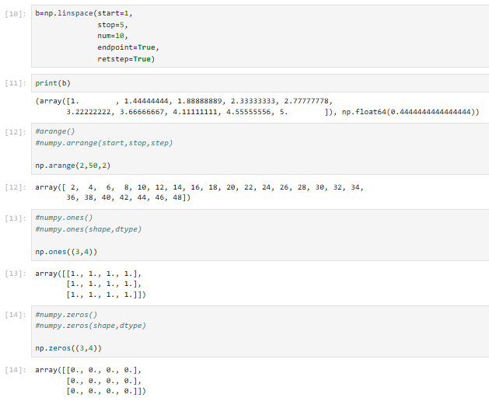

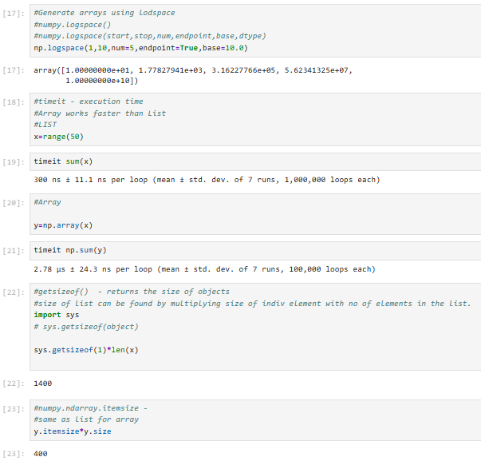
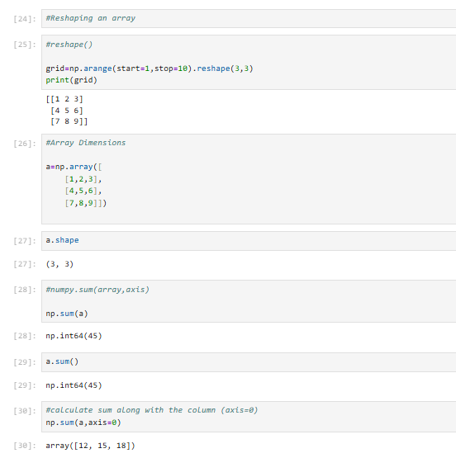
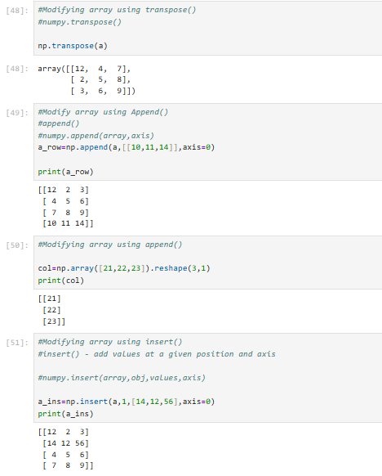

C.Pandas

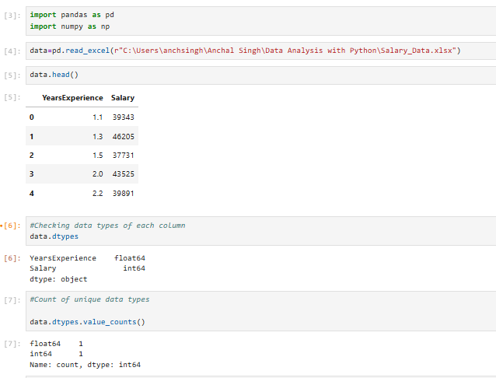
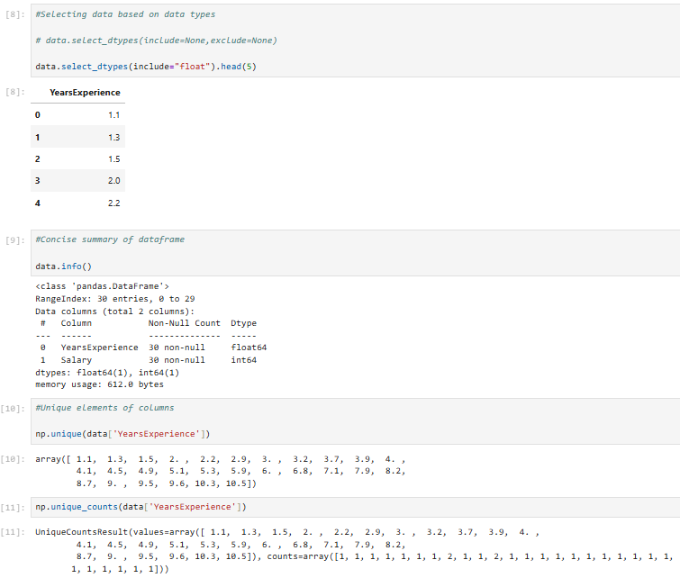
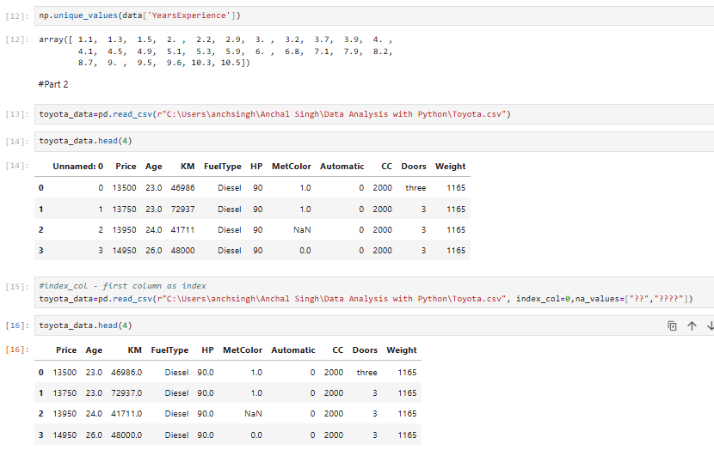
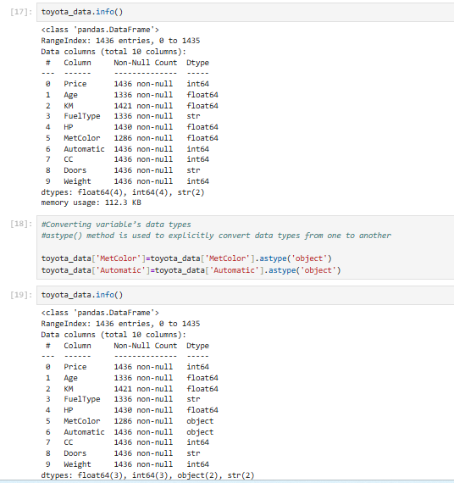
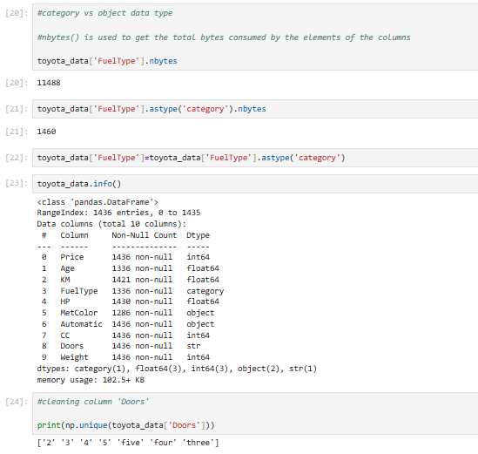
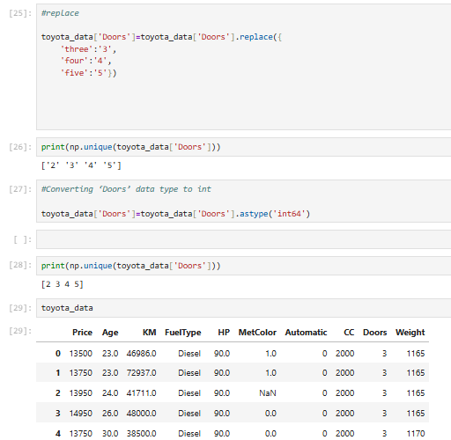
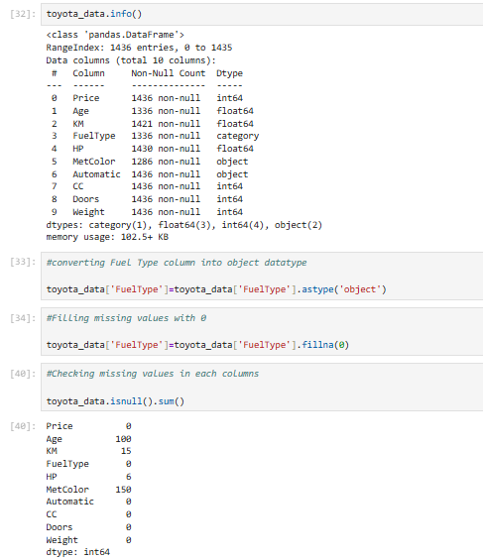

SciPy(Science Python) intro
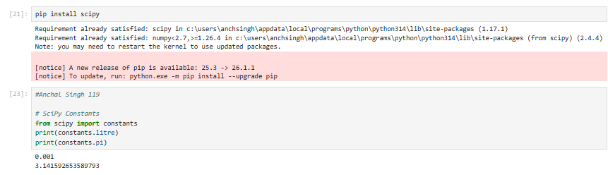
1. SciPy Optimizers (Roots of an Equation)
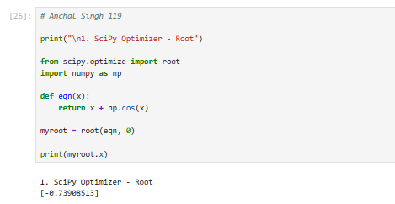
2. Finding Minima(SciPy Optimizer)
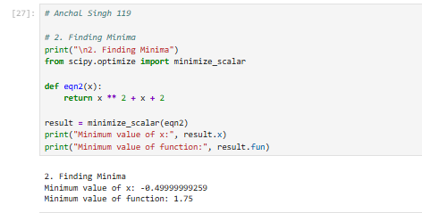
3. Triangulation (SciPy Spatial Data)
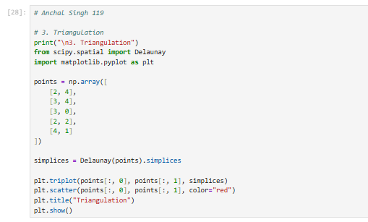
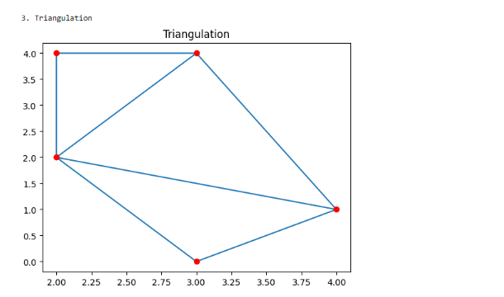

4. Import Data from Matlab Format (SciPy Partial Data)
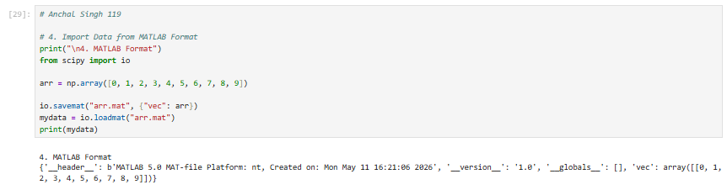

5. ID Interpolation (SciPy Interpolation
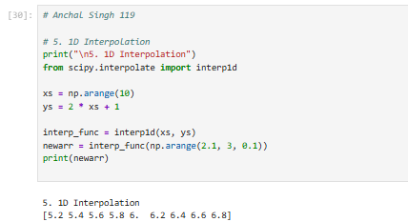
SkLearn_matplotlib

a. Iris Dataset Visualization (Pair Plot)
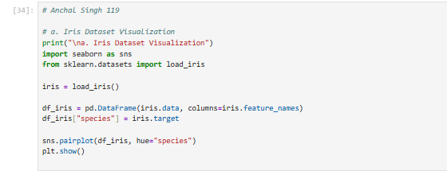

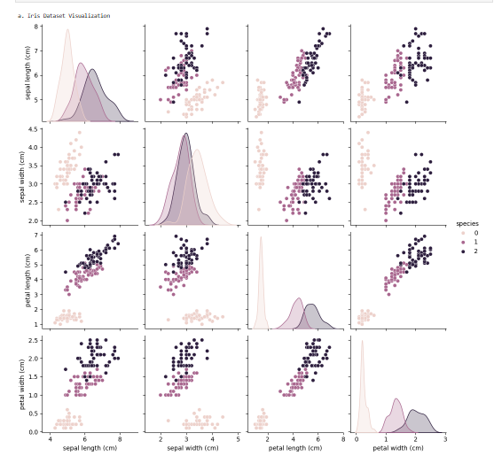

b. Digits Dataset Visualization
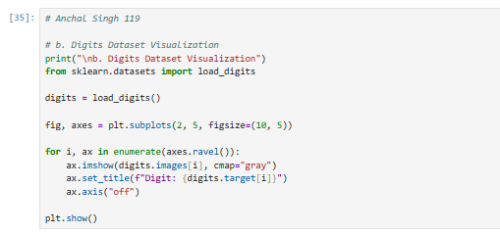

Matplotlib

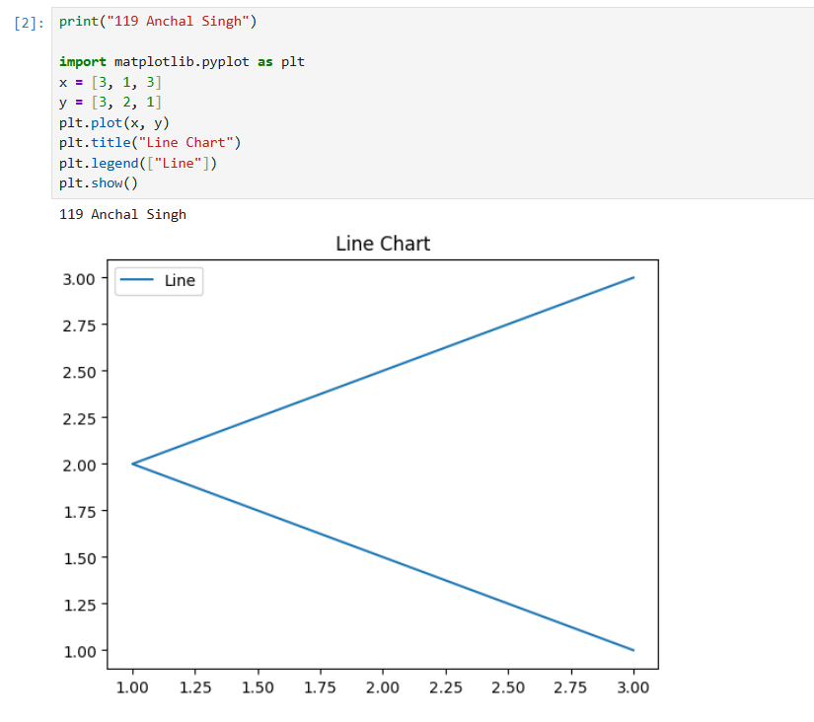
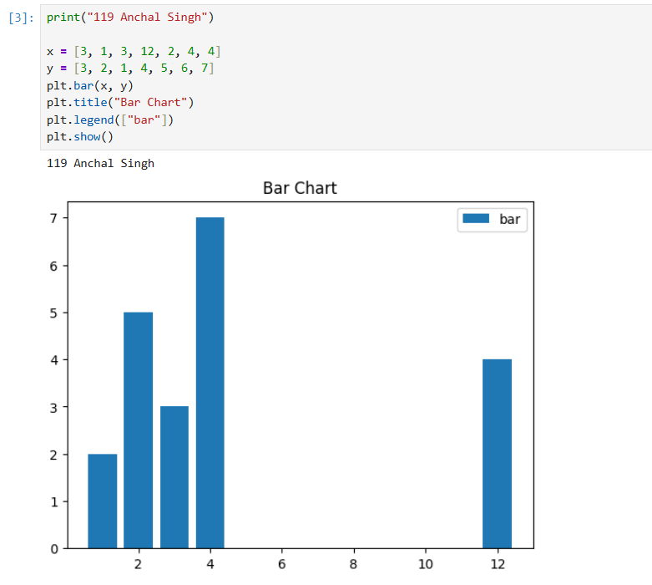

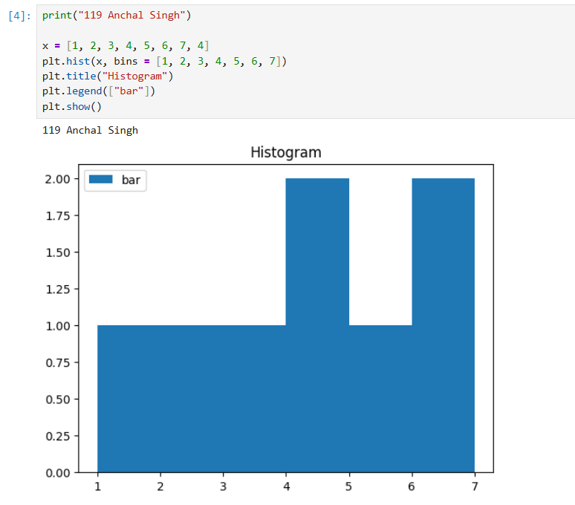

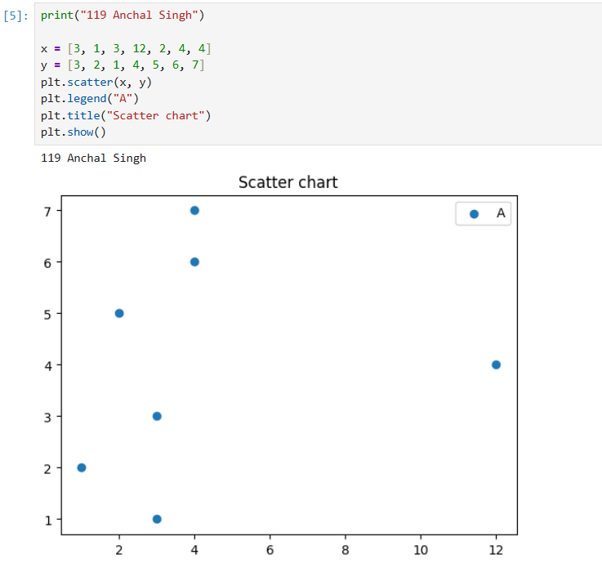

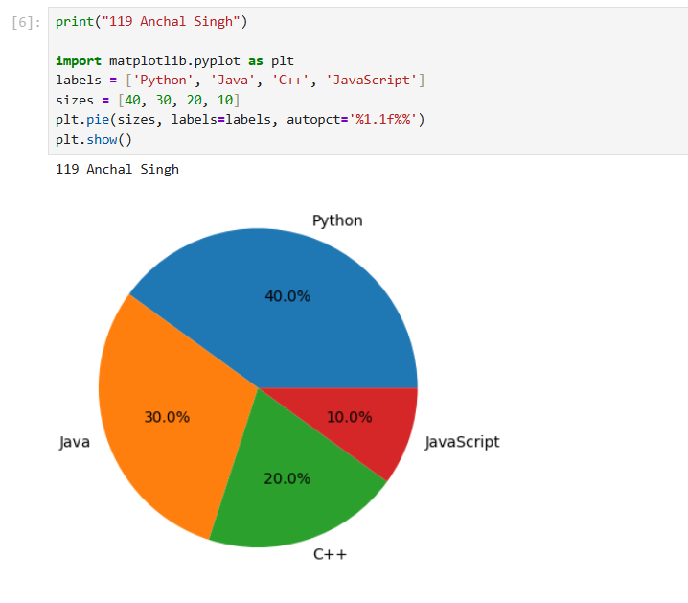

PRACTICAL NO : 5

Implement Perceptron algorithm for OR operation

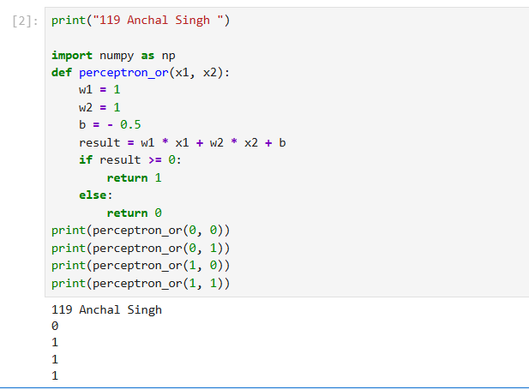

PRACTICAL NO : 6

Implement a stochastic gradient descent algorithm .(Perceptron)

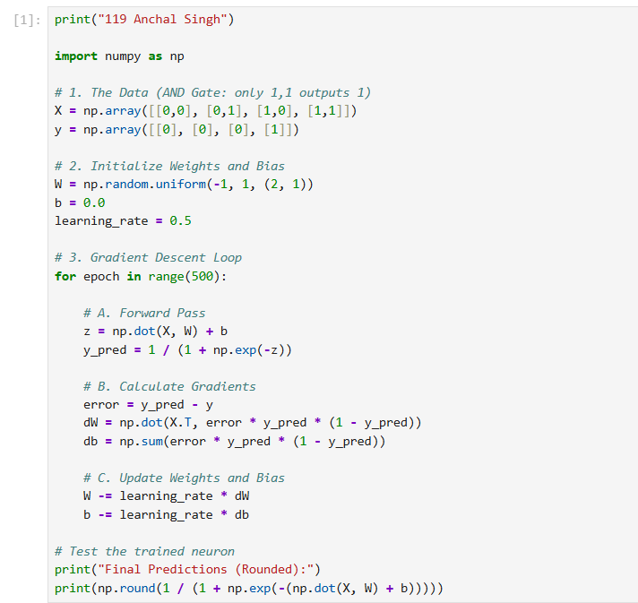

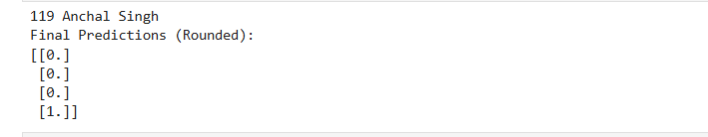

PRACTICAL NO : 7

Implement Adaline algorithm for AND operation.

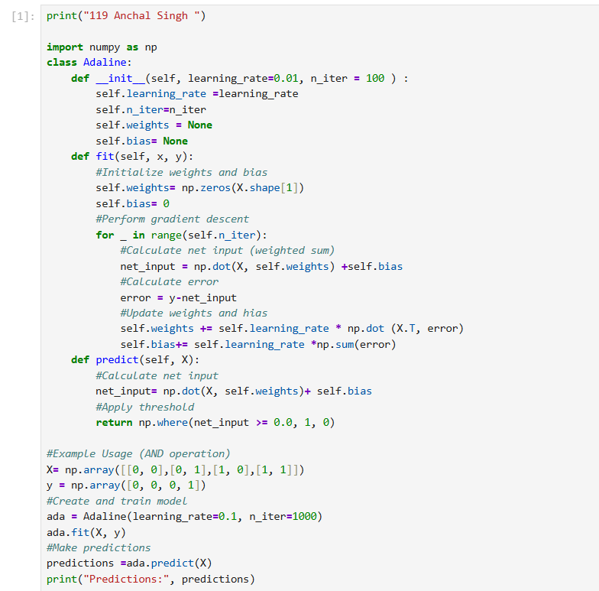

PRACTICAL NO : 8

Implementation of Features Extraction and Selection, Normalization, Transformation,
Principal Components Analysis.

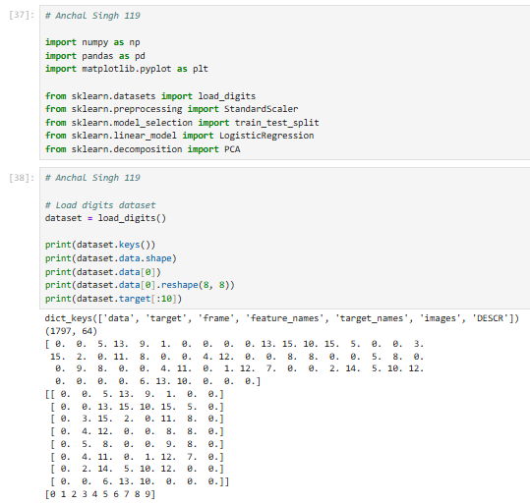

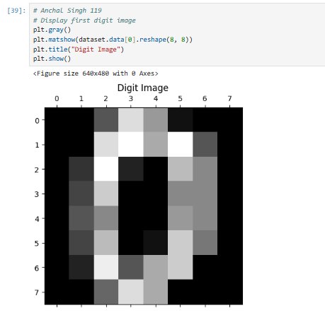
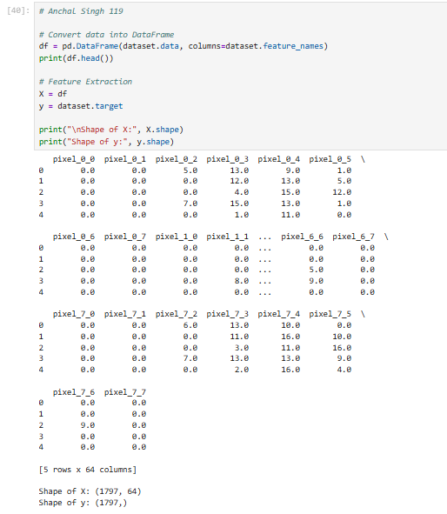
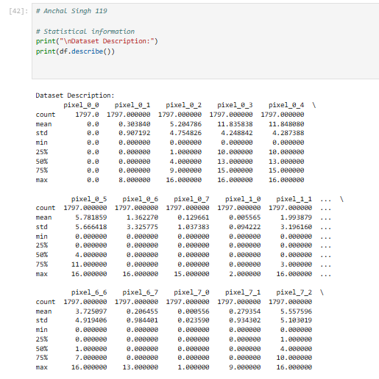
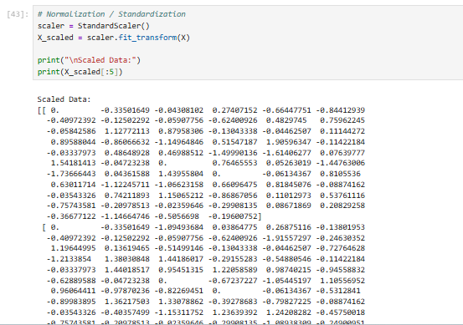
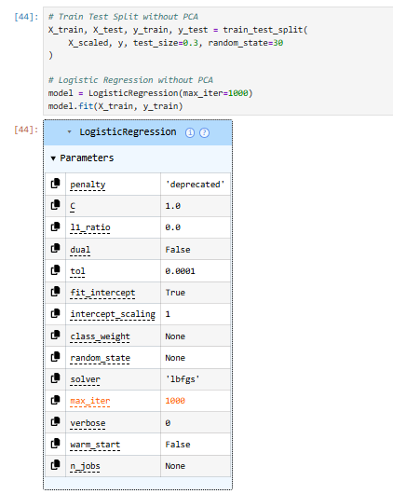
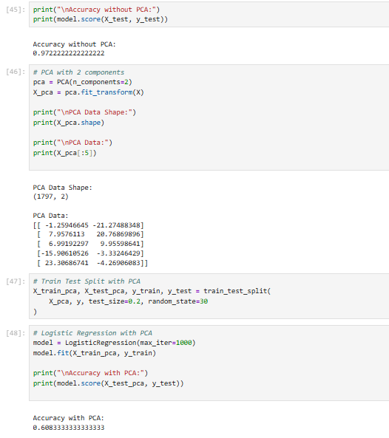
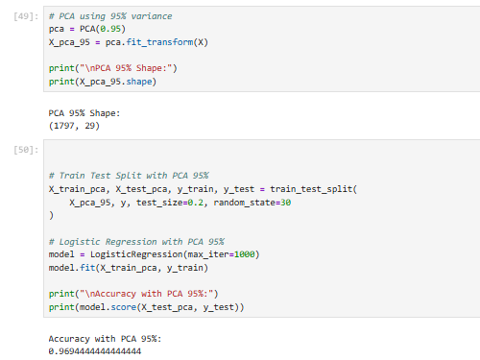

PCA

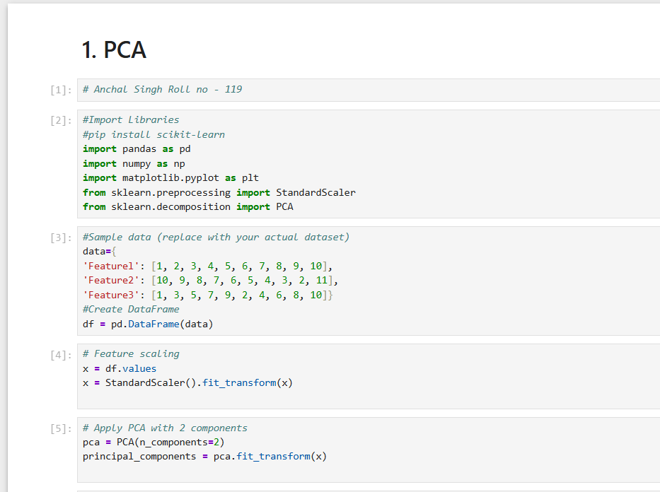

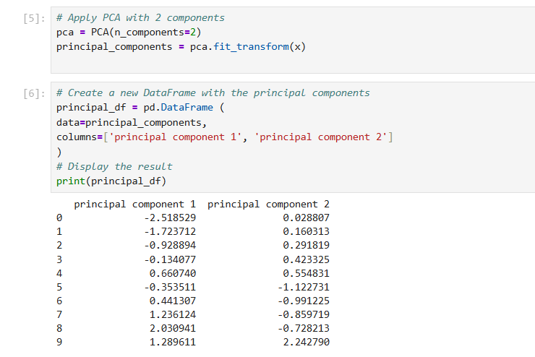

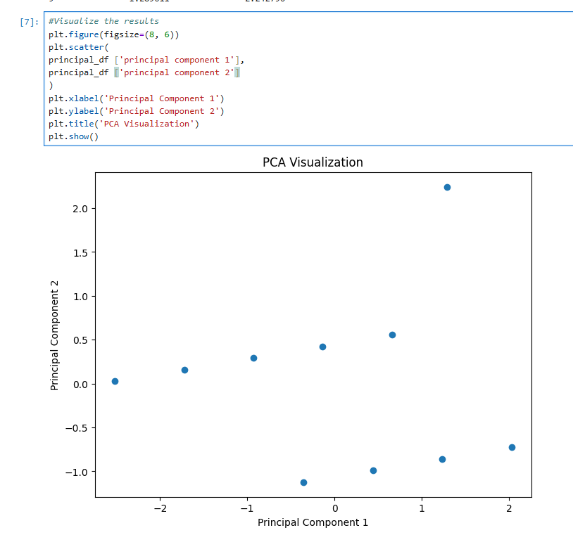

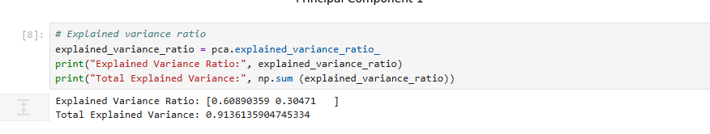

PRACTICAL NO : 9

Implementation of Logistic regression

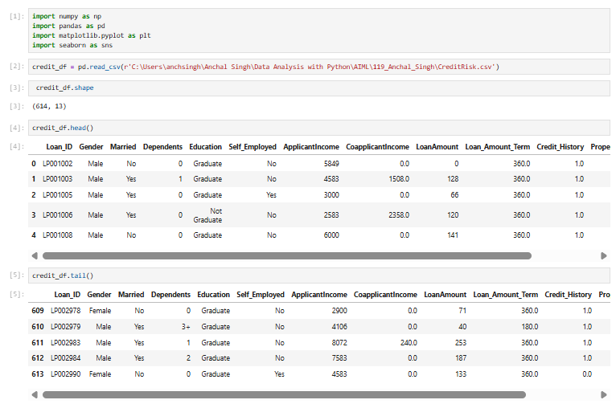

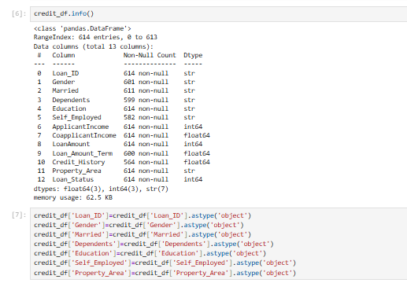
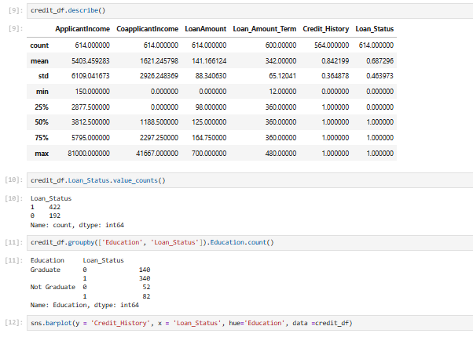
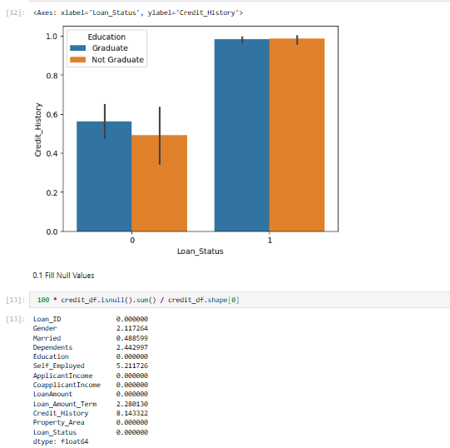
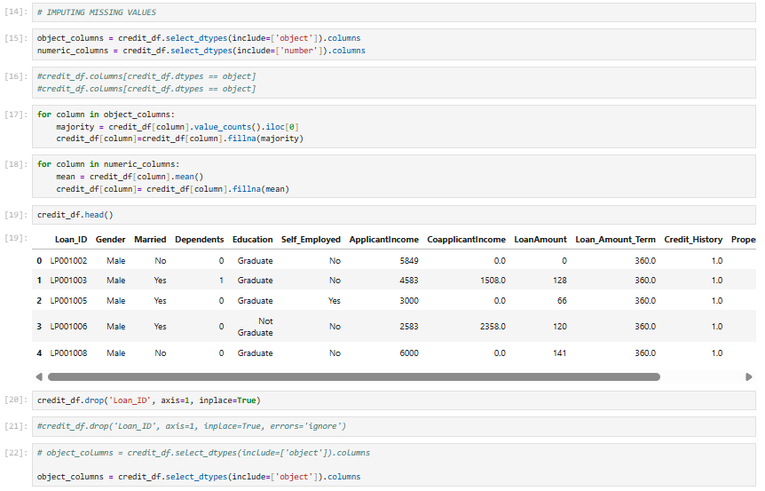
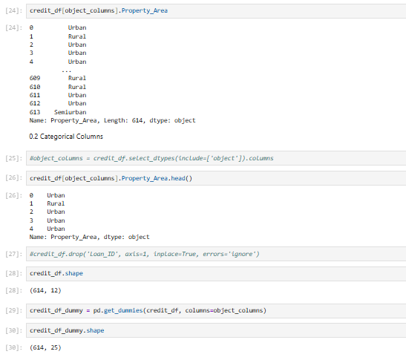
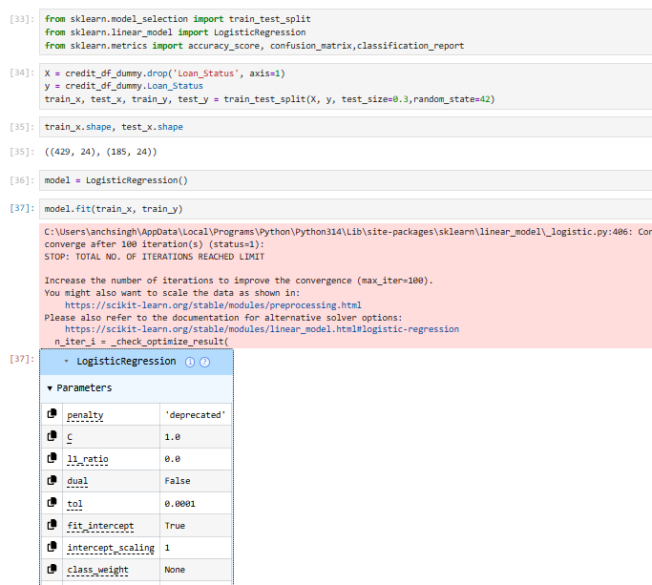
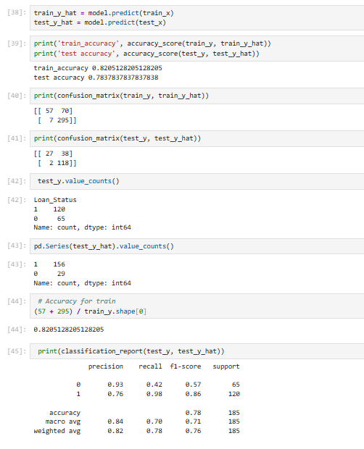
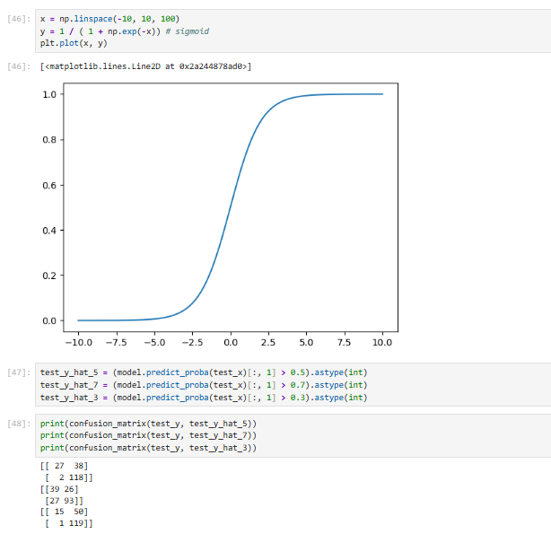
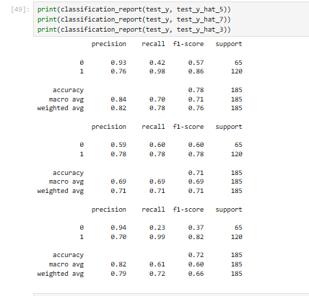

PRACTICAL NO : 10

Implementation of Classifying data using Support Vector Machine (SVM).

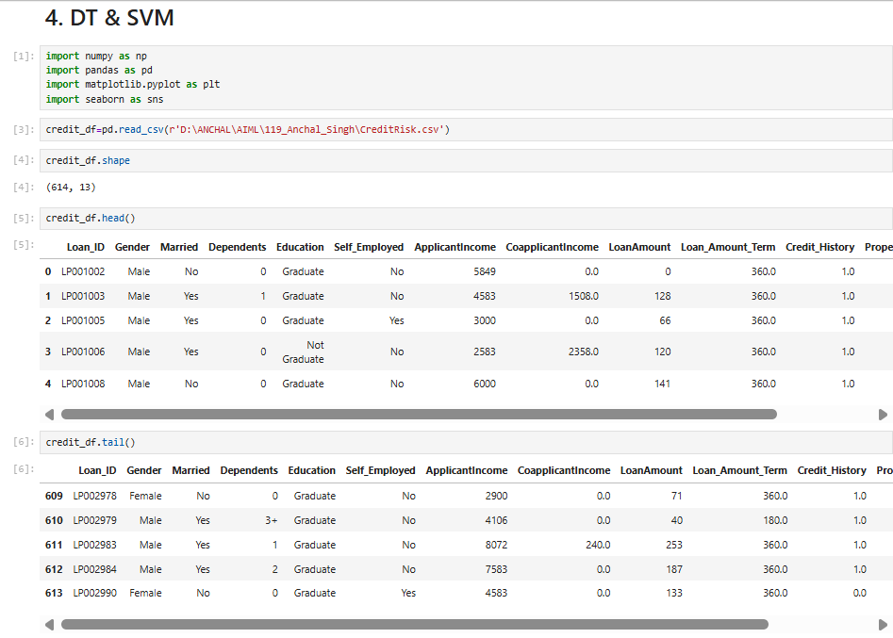
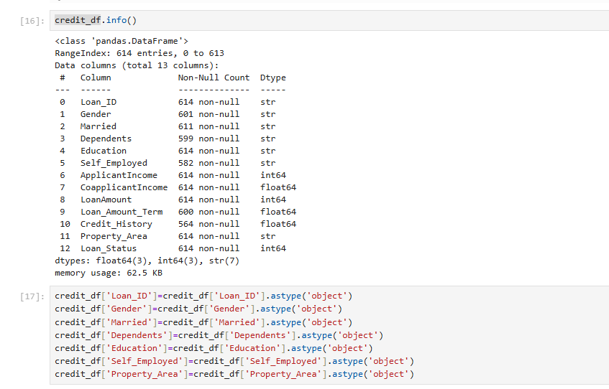
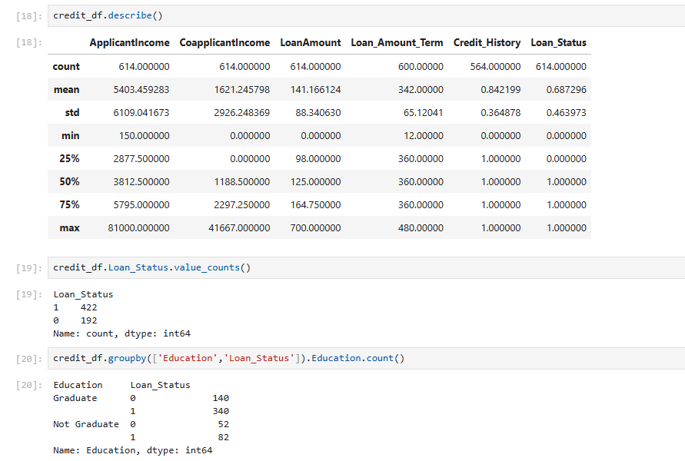

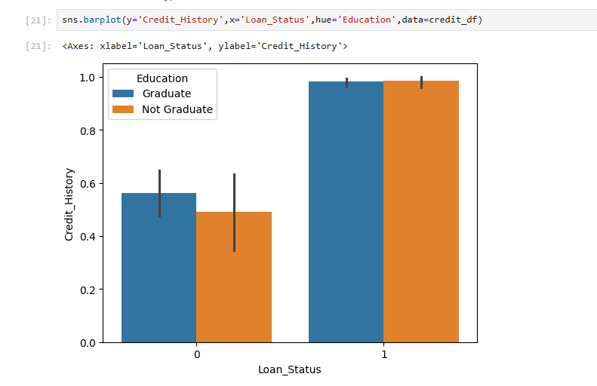
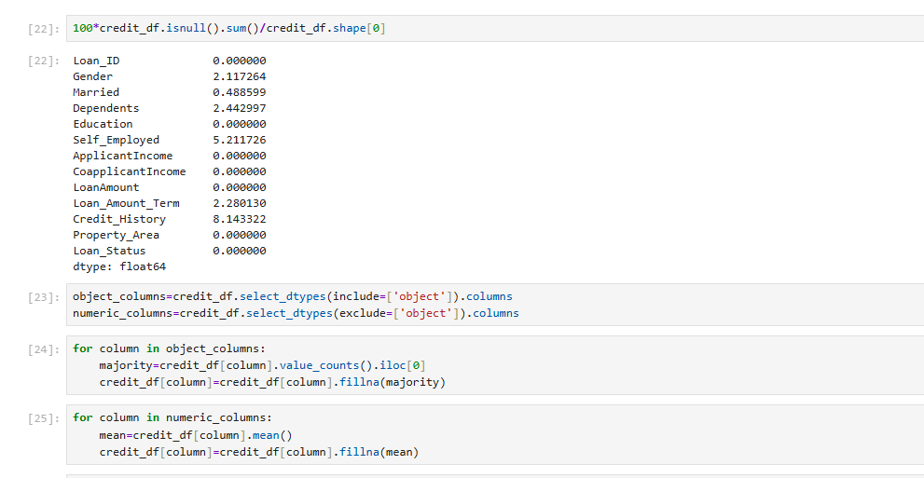

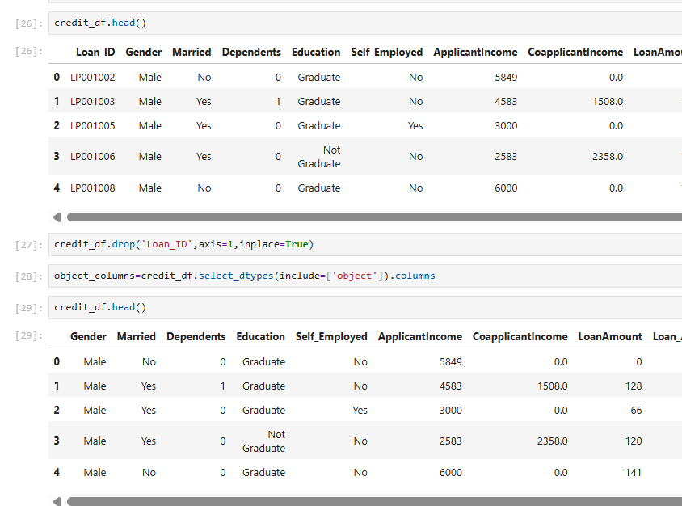

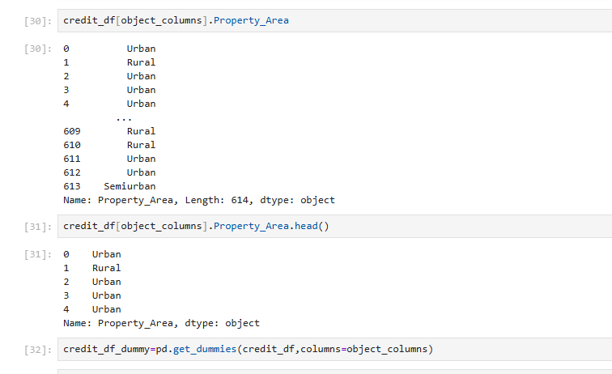

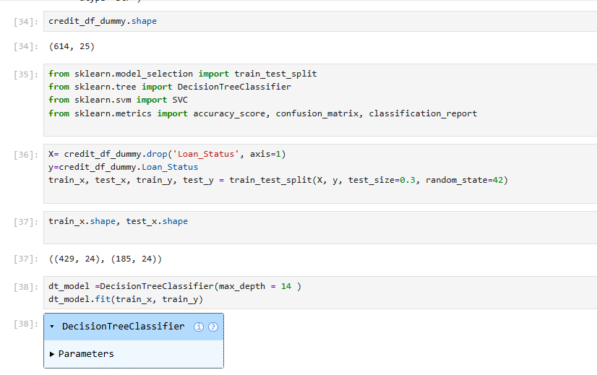

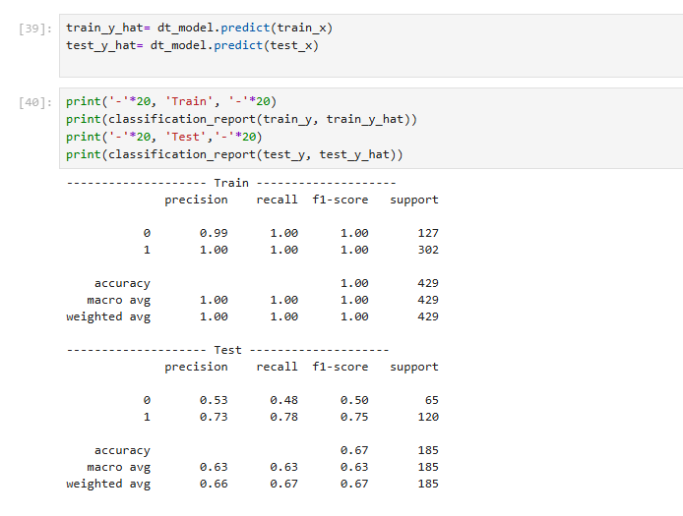

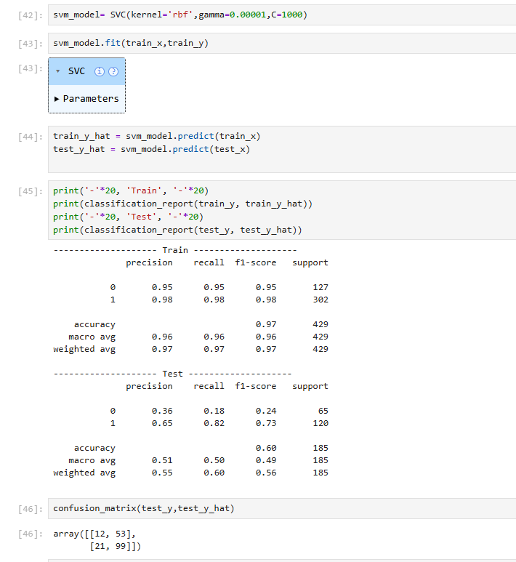

PRACTICAL NO : 11

Implement Elbow method for K means Clustering

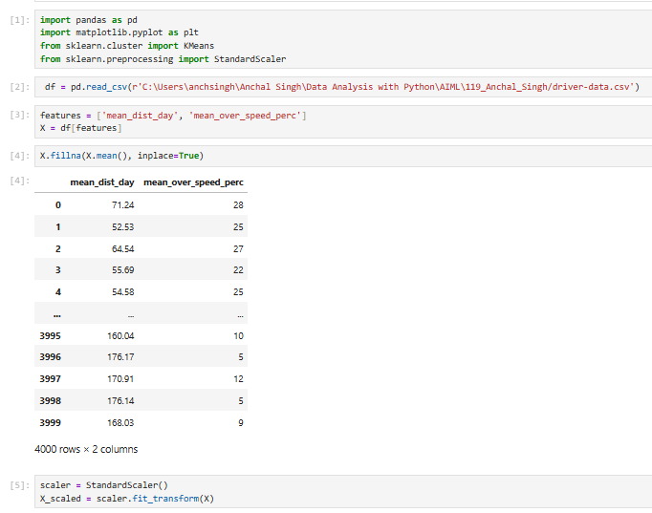
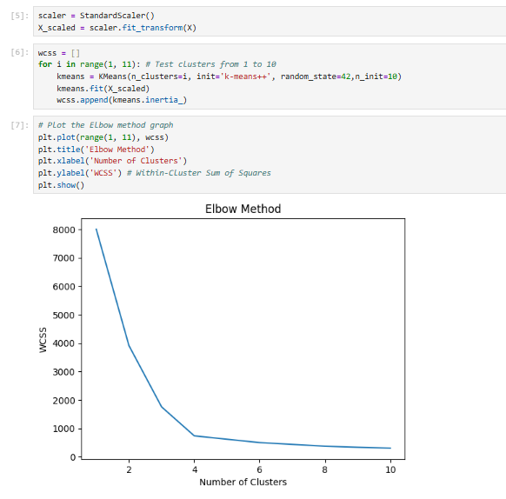

PRACTICAL NO : 12

Implementation of Bagging Algorithm: Random Forest

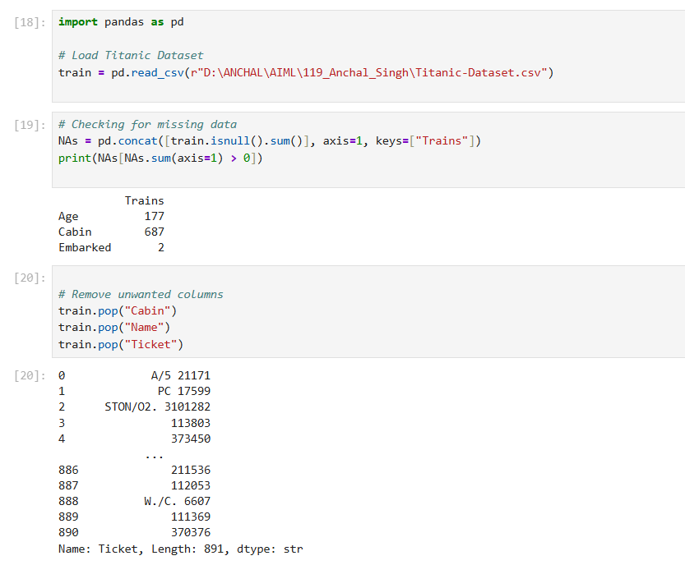
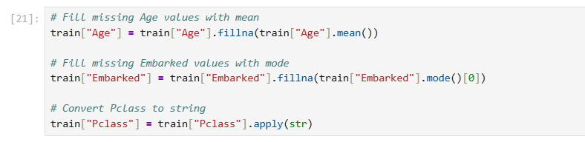

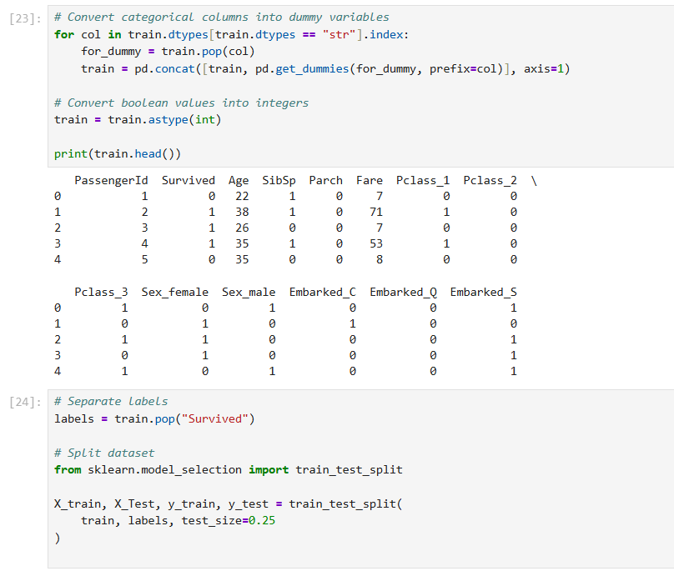

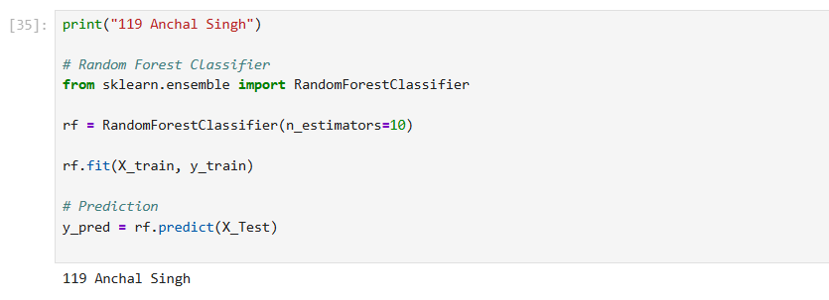

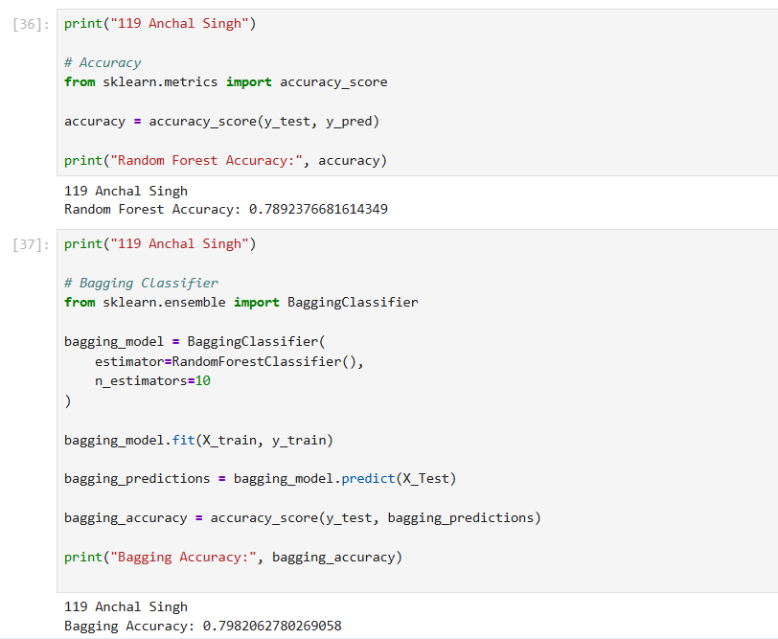

PRACTICAL NO : 13

Implementation of Boosting Algorithms: AdaBoost, Stochastic Gradient Boosting,
Voting Ensemble

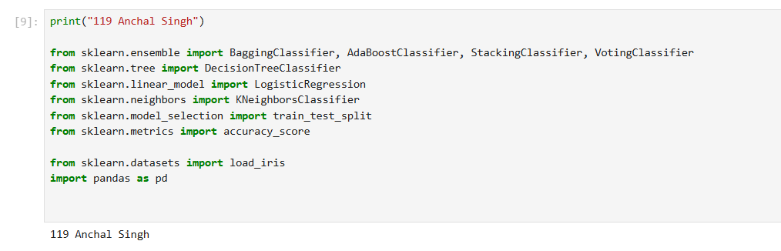
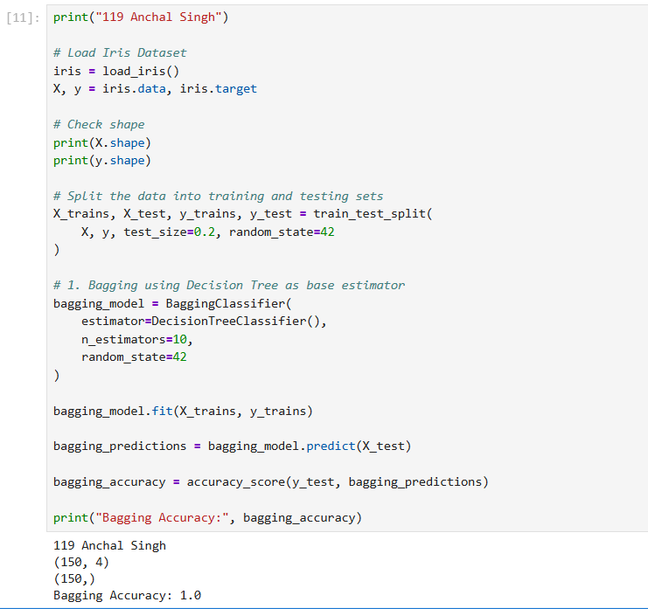

AdaBoost

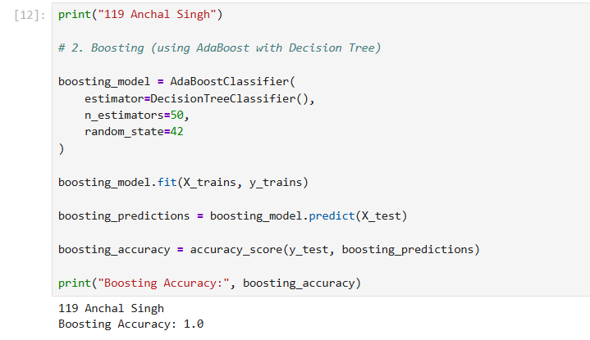
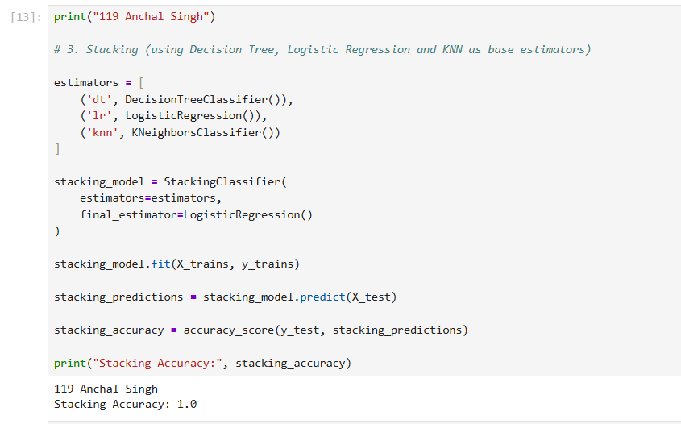

Stochastic Gradient Boosting

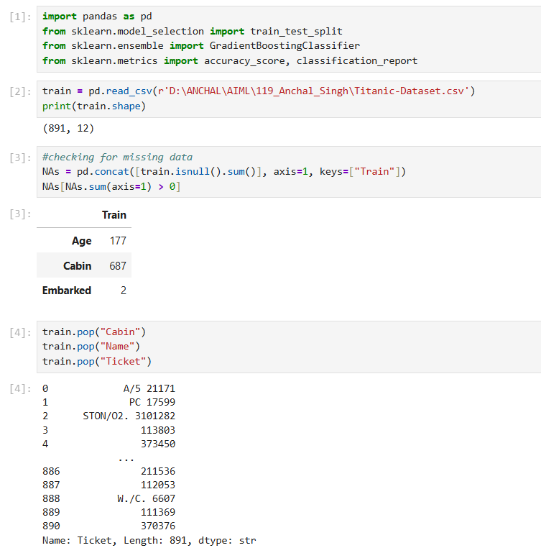

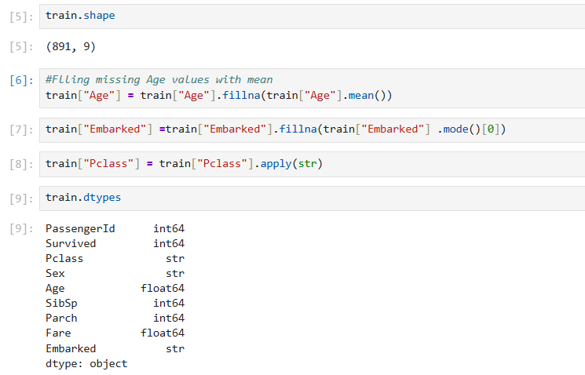

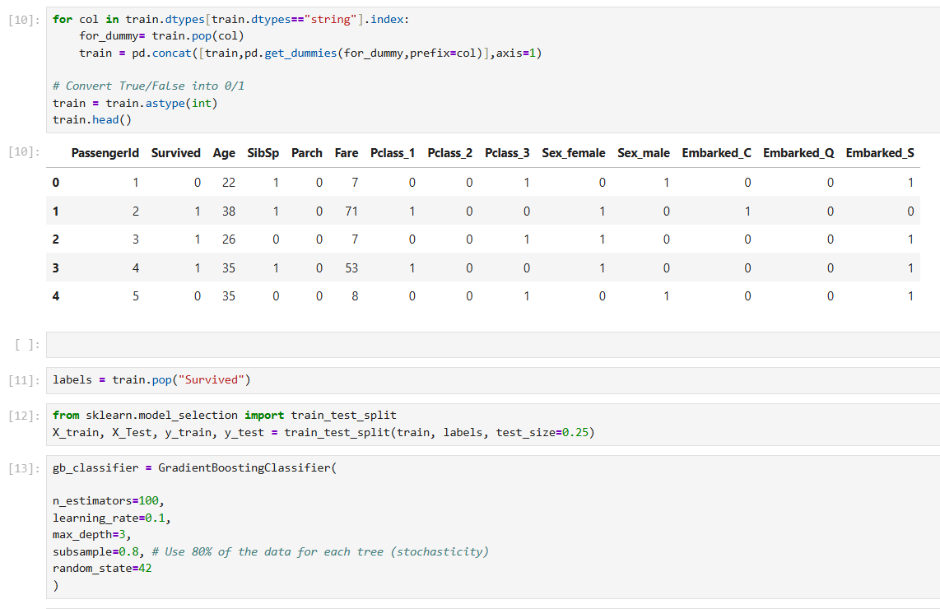

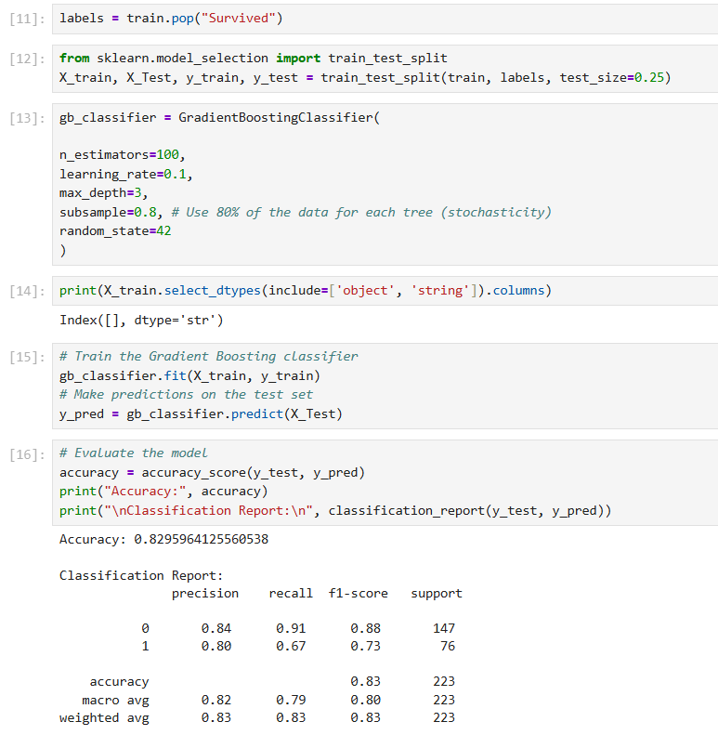

Voting Ensemble

