Practical 1
Installing Git on Windows
Step 1: Go to https://www.git-scm.com/. Click on Download [latest version] for Windows.
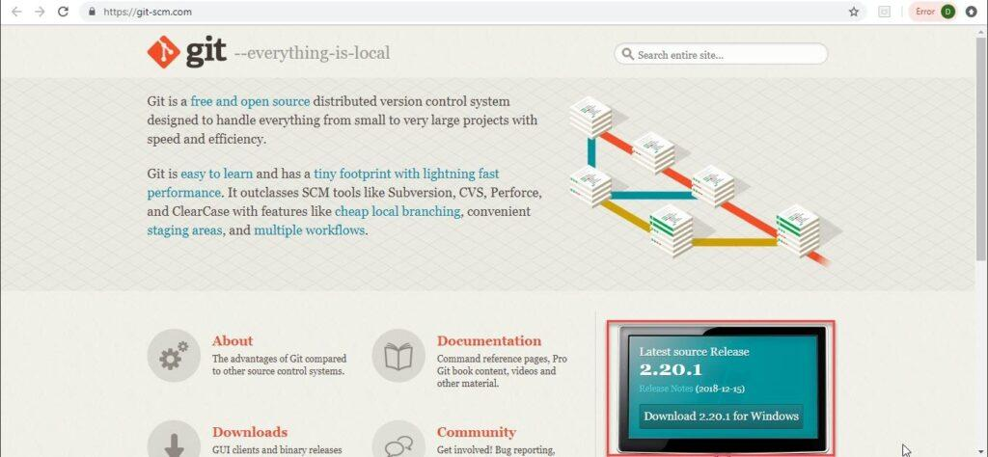
Step 2: You will view the below screen. Download has started and the .exe file is downloading.
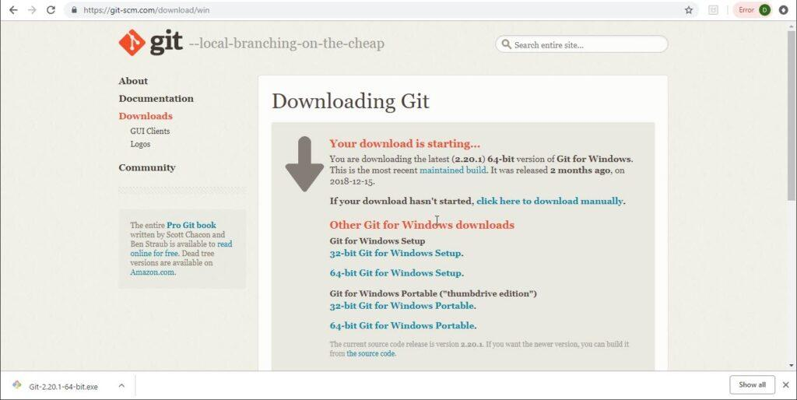

Step 3: Click on Next when this popup window opens.
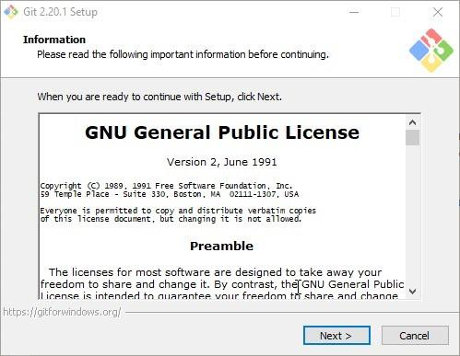

Step 4: Check the below options and click Next.
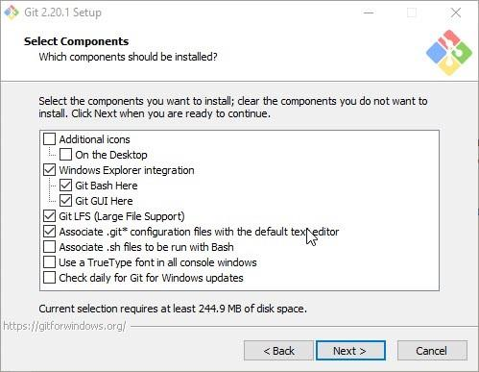

Step 5: The below screen comes. Click Next.
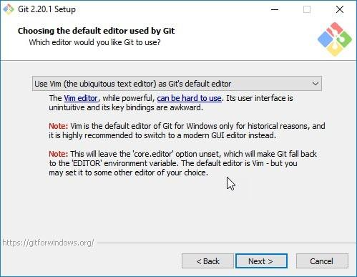

Step 6: Choose the appropriate option and click Next.
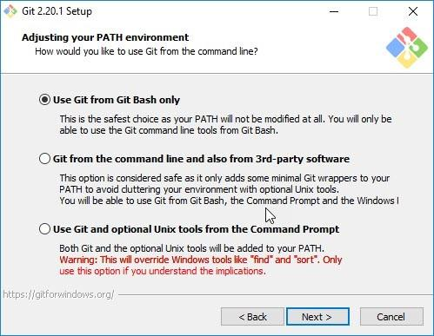

Step 7: Choose the library option and click on Next.
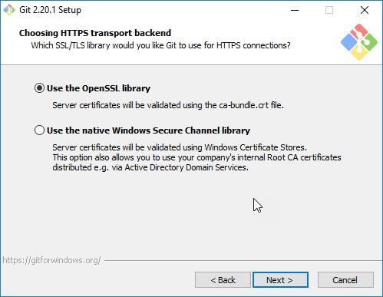

Step 8: Choose the checkout option and click Next.
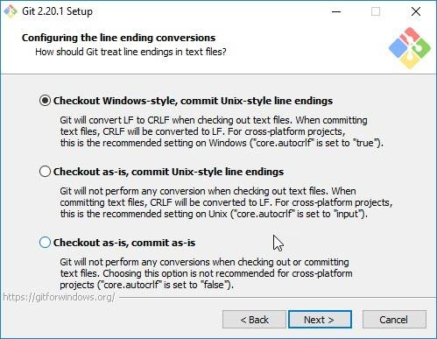

Step 9: Choose the emulator and click Next.
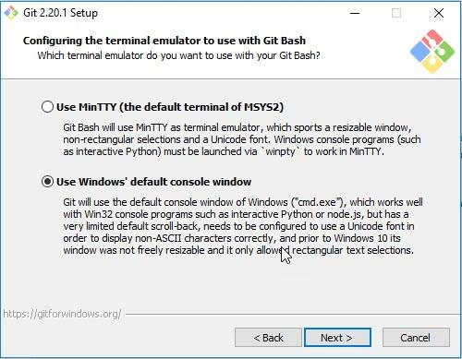

Step 10: Choose configuration options and click on Install.
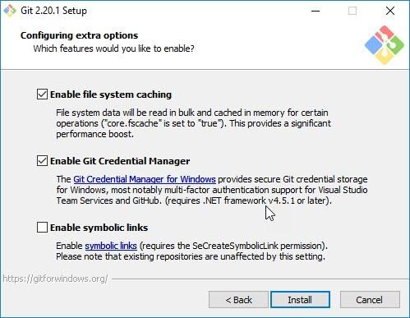

Step 11: Once the installation completes, the Git GUI opens.
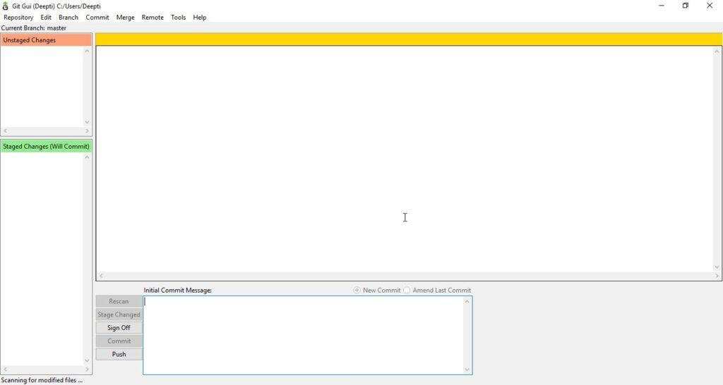
Checks if Git is installed.
git --version

Sets your identity (do this once).
git config --global user.name "Your Name"
git config --global user.email "you@example.com"

Creating & Cloning Repositories
Initializes a new Git repository.
git init

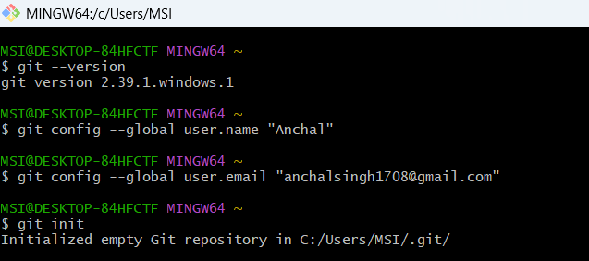
Copies an existing repository to your system.
git clone <repository_url>
Checking Status & History
Shows the current state of files (modified, staged, untracked).
git status
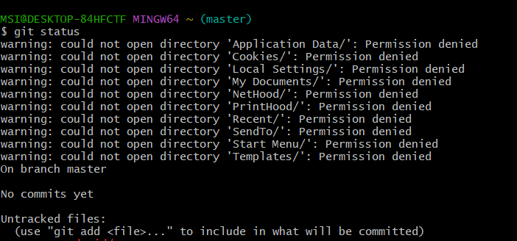

Displays commit history.
git log
Shows commit history in short form.
git log --oneline

Staging & Committing Changes
Stages a specific file.
git add <file_name>
Stages all changes.
git add .
Saves staged changes with a message.
git commit -m "Commit message"

Working with Branches
Lists all branches.
git branch

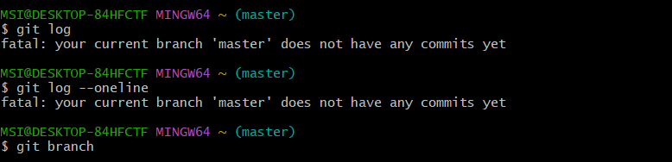

Creates a new branch.
git branch <branch_name>

Switches to another branch.
git checkout <branch_name>

Creates and switches to a branch.
git checkout -b <branch_name>
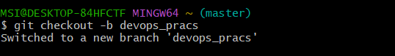

Merging Branches
Merges another branch into the current one.
git merge <branch_name>

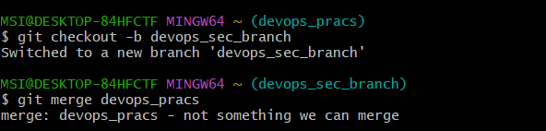
Remote Repositories (GitHub / GitLab)
Shows remote repository URLs.
git remote -v
Fetches and merges changes from remote.
git pull
Uploads local commits to remote repository.
git push
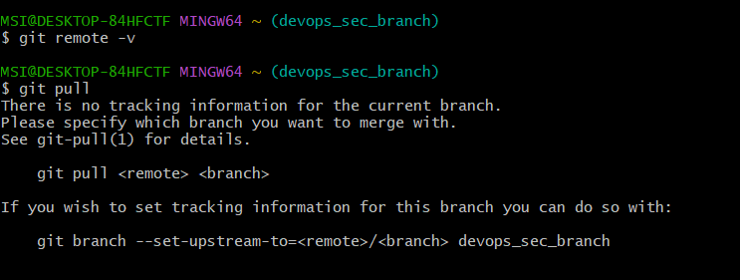

Undo & Fix Mistakes
Discards local changes in a file.
git restore <file_name>
Unstages a file.
git reset <file_name>
Discards all local changes (use carefully).
git reset --hard
Useful Shortcuts
Shows differences before staging.
git diff
Displays details of a commit.
git show

PRACTICAL :- 2
Create and Fork Repositories in GitHub – Branch, Merge, Rebase 1.
Create a GitHub account and log in.

2. Create a repository on GitHub (e.g., git-practice).

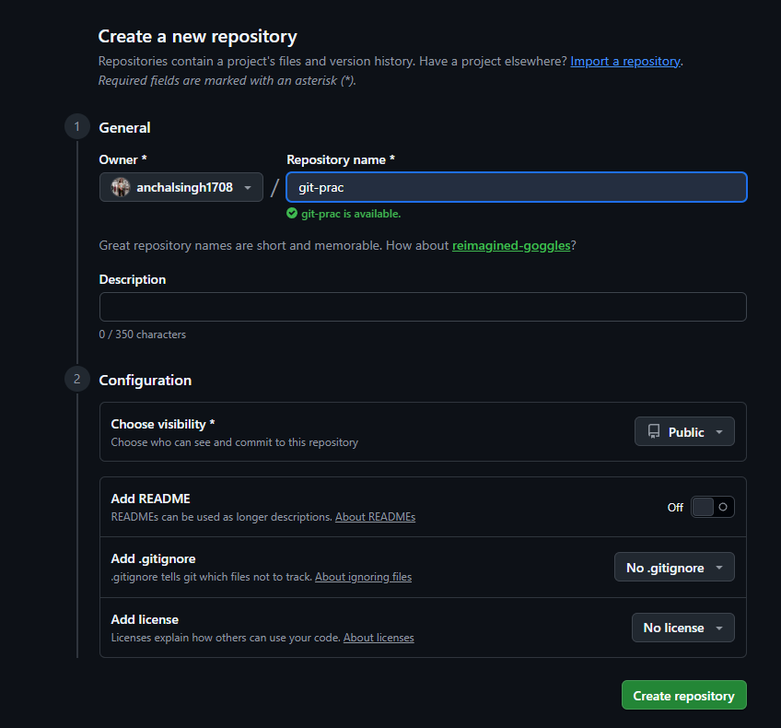
3. Fork any public repository or your own from another account.
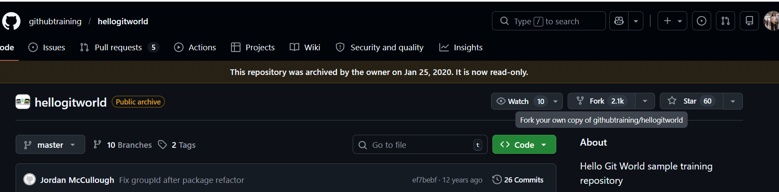
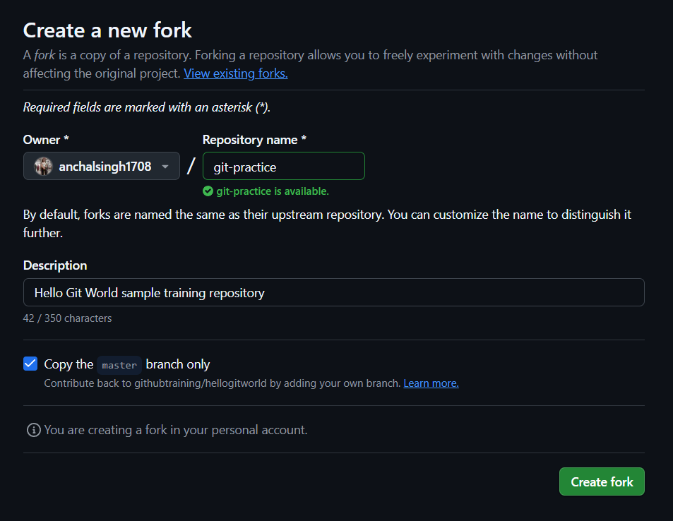

4.Clone the forked repo: git clone https://github.com/anchalsingh1708/git-practice.git
cd git-practice

5. Create a branch:
git checkout -b feature
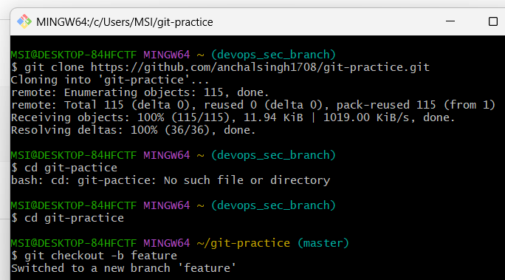

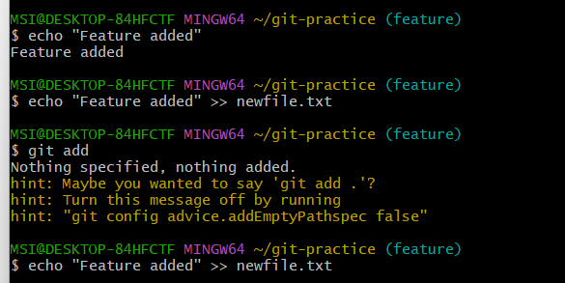
6. Make changes, then commit: echo "Feature added" >> newfile.txt git add . git commit
-m "Added new feature"

7. Merge branch into main:
git checkout master
git merge feature

8. Rebase branch (alternative to merge):
git checkout feature
git rebase master

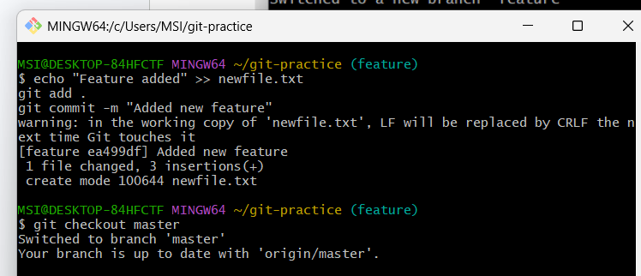

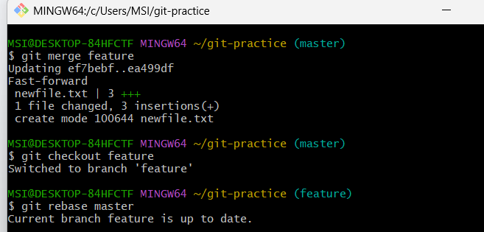

9. Push to GitHub: git push origin feature

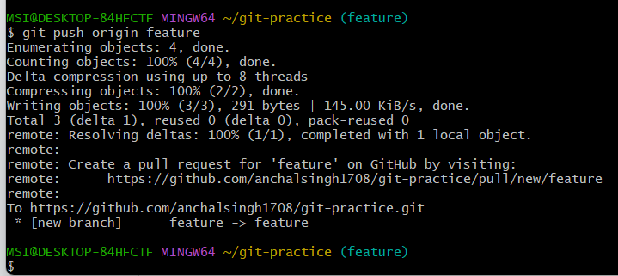

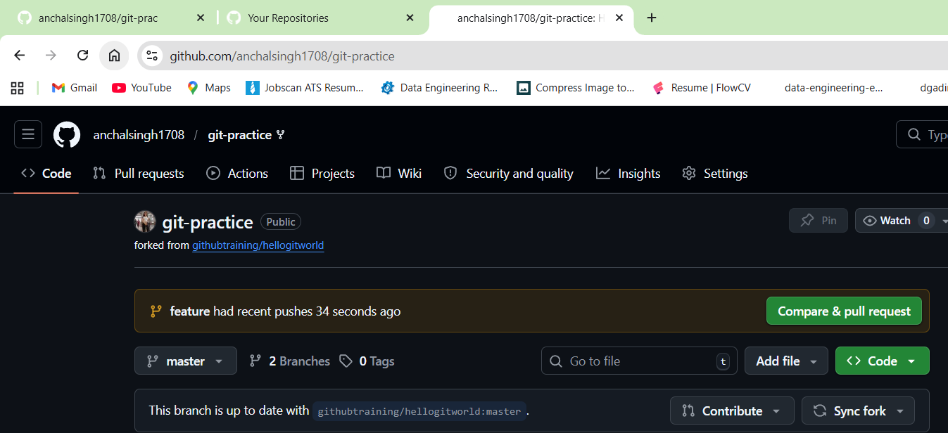

Practical 3

Using Git for Collaboration

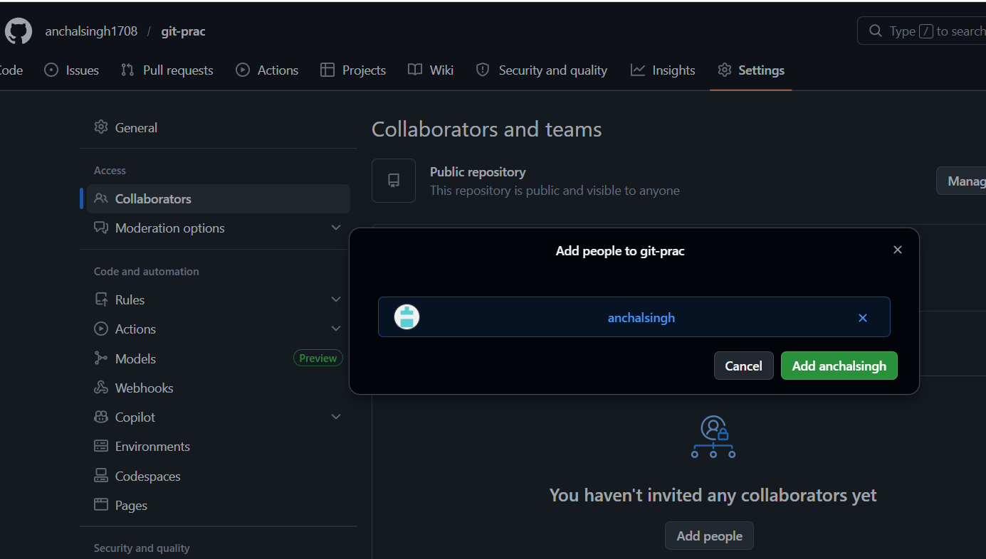

Friend clones the repo: git clone https://github.com/anchalsingh1708/git-prac.git
cd git-prac
git checkout -b bug-fix
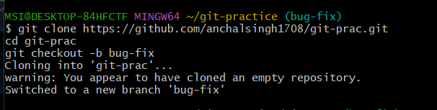
Friend makes changes and pushes:

echo "Bug fixed" >> bug.txt

git add
git commit -m "Fixed a bug"

git push origin bug-fix

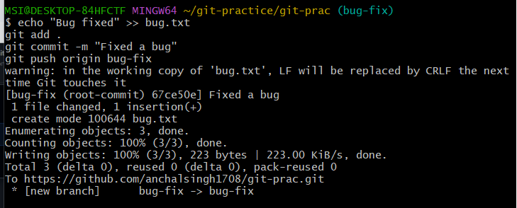

Pull Request

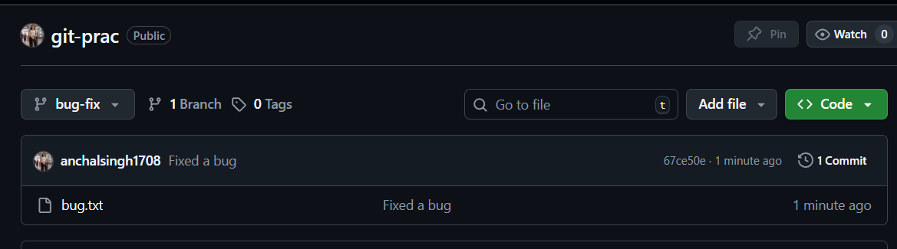

PRACTICAL :- 4
Collaborating and Cloning Using GitHub

Steps:1. Clone a public repository:
git clone https://github.com/anchalsingh1708/DATA-ANALYSIS-WITH-PYTHON.git
cd node

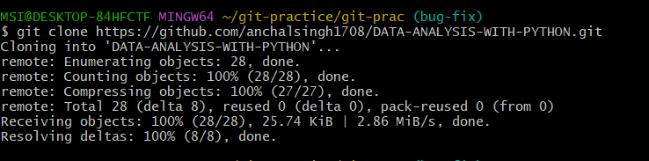
2. Create a branch:
git checkout -b update-readme

3. Edit and commit changes:
echo "Added a line" >> README.md
git add README.md
git commit -m "Updated README"

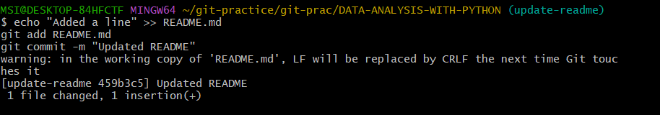

4. Push and open pull request:
git push origin update-readme
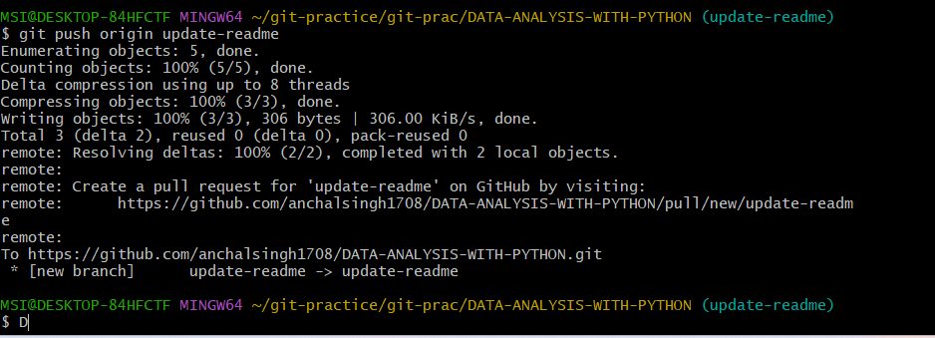
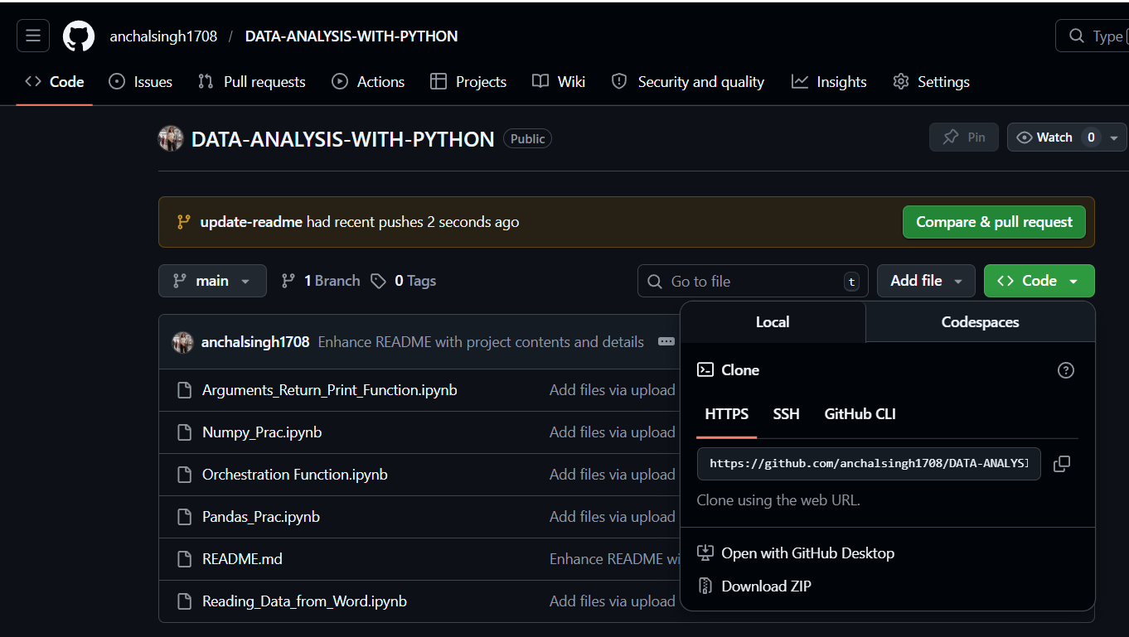

PRACTICAL :-5
Using GitLab Web IDE
GitLab Web IDE
Steps:1. Sign up at https://gitlab.com
2. Create a project.
3. Click on Web IDE in your repository.

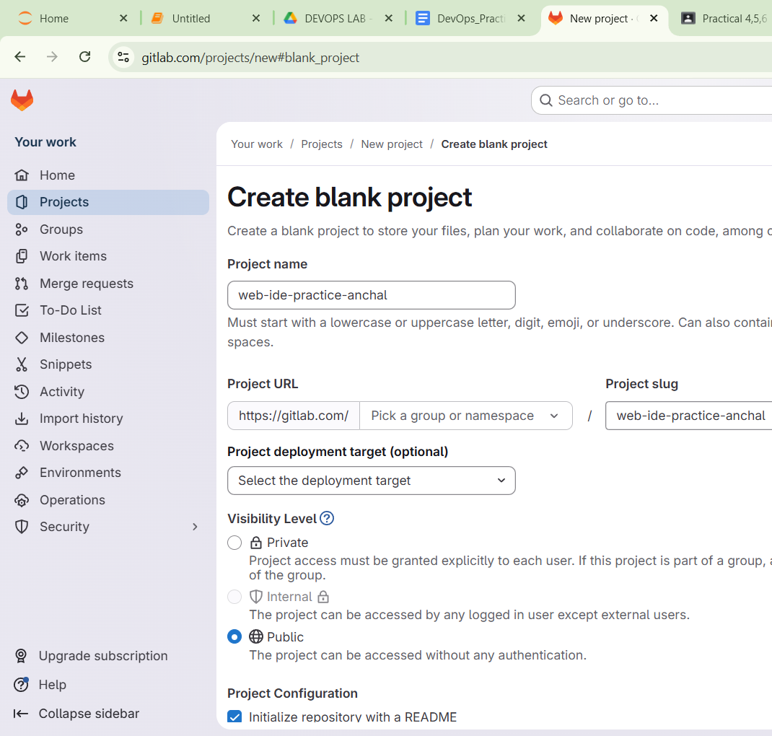

4. Create a file (index.html):
<html>
<body>
<h1>Hello from GitLab</h1>
</body>
</html>
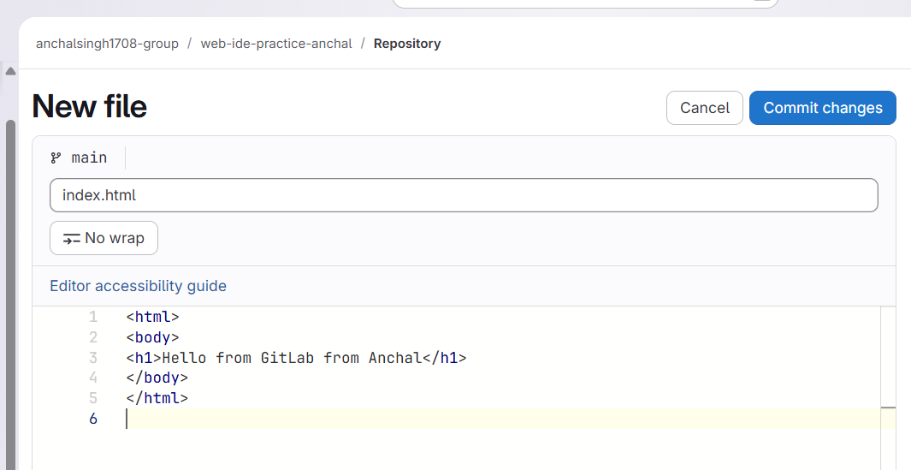
5. Click Commit and push changes.

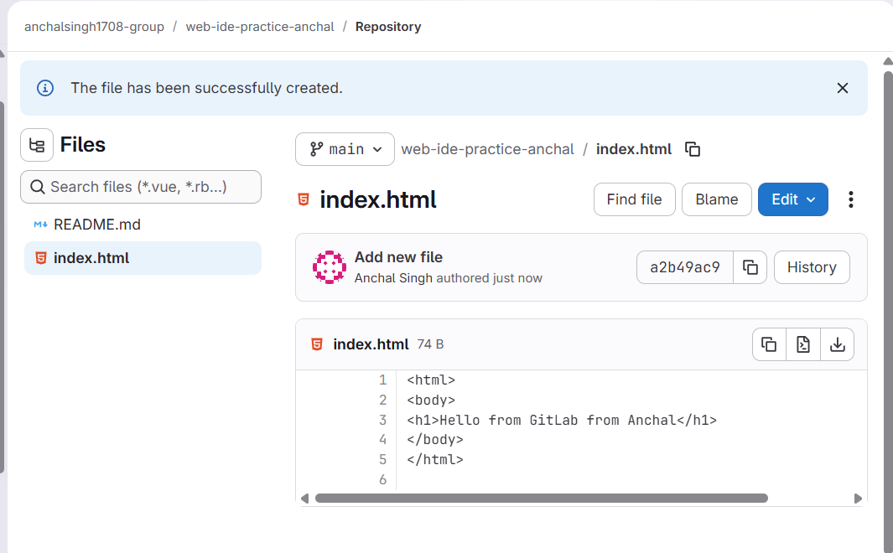

PRACTICAL :-6
Performing Merge Requests Using GitLab
Steps:1. Create a new branch in Web IDE.

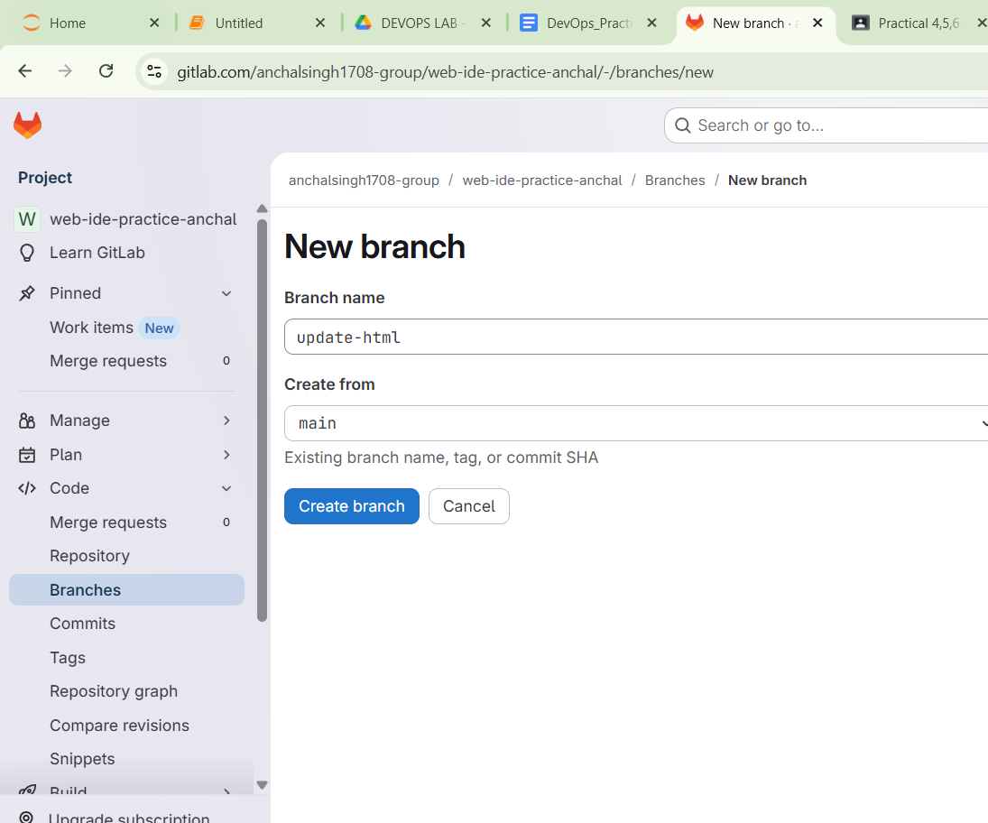
2.Add/edit a file and commit
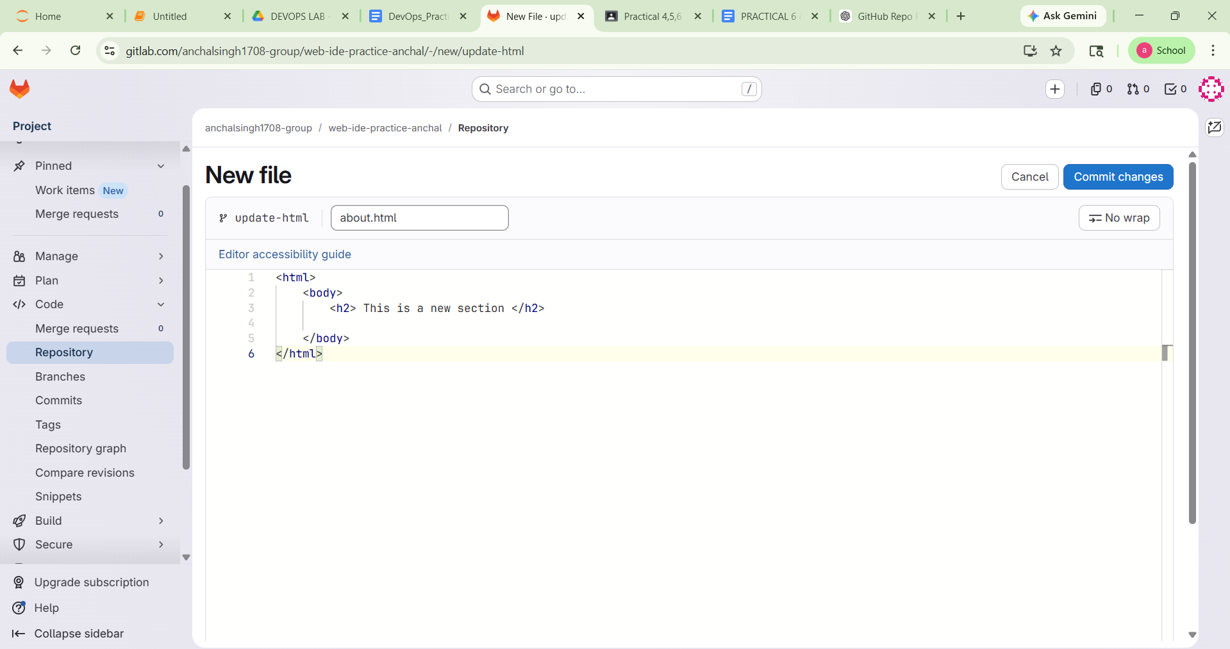
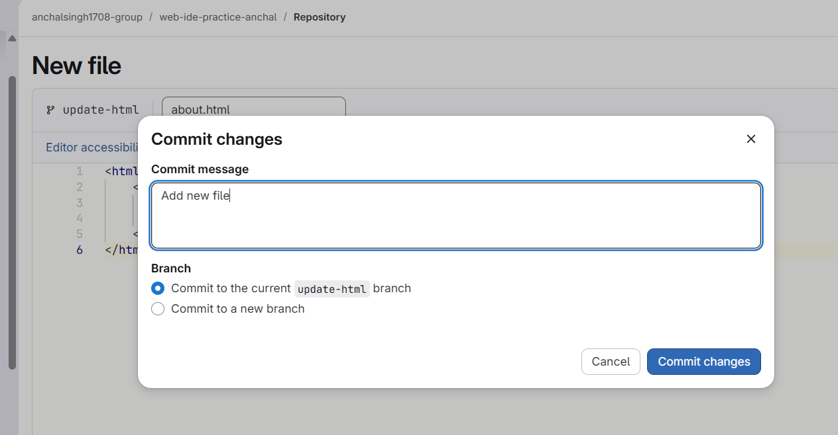
3. Click on Merge Requests > New Merge Request.

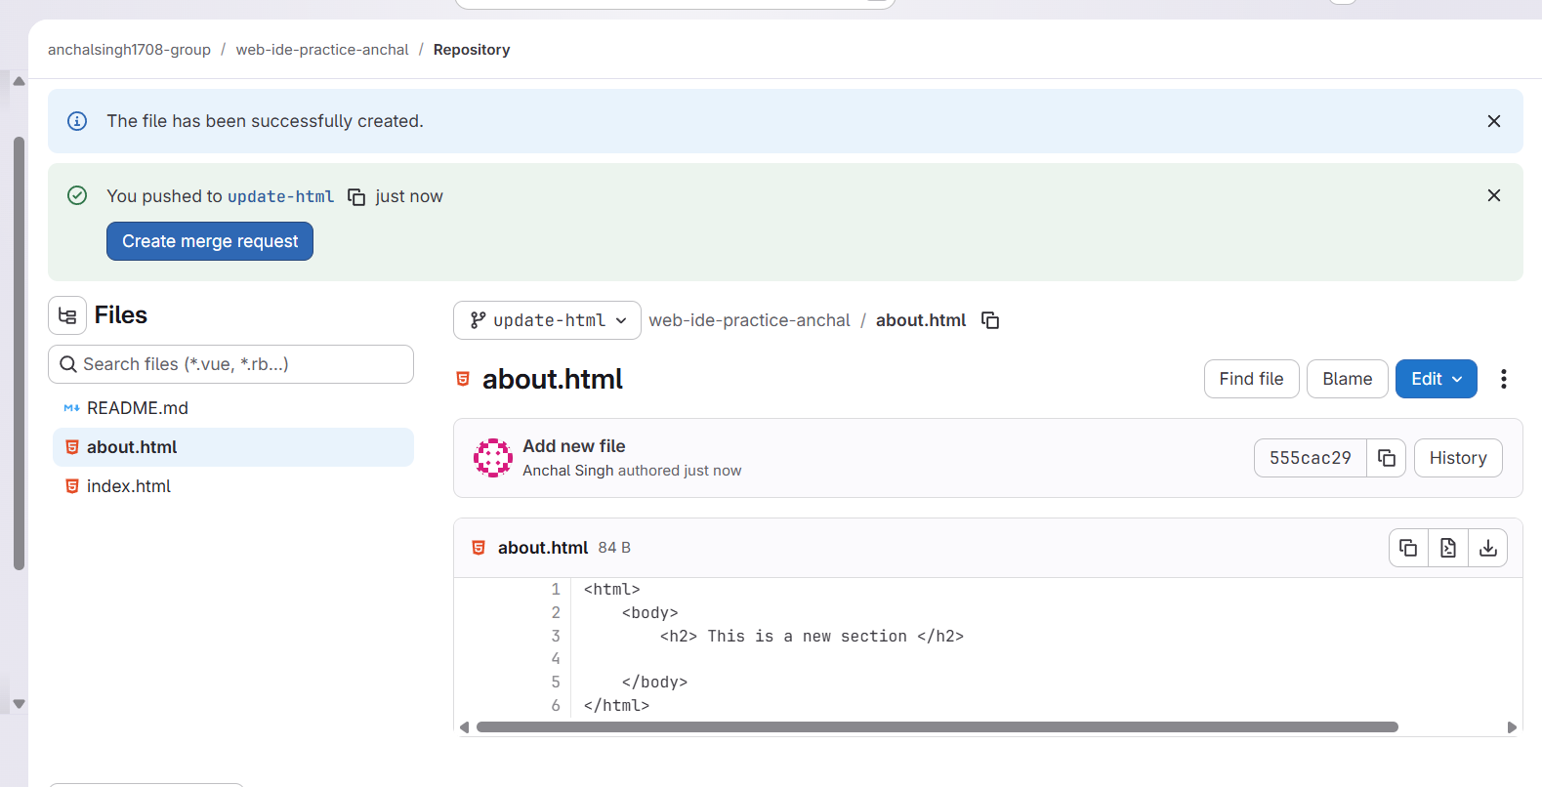

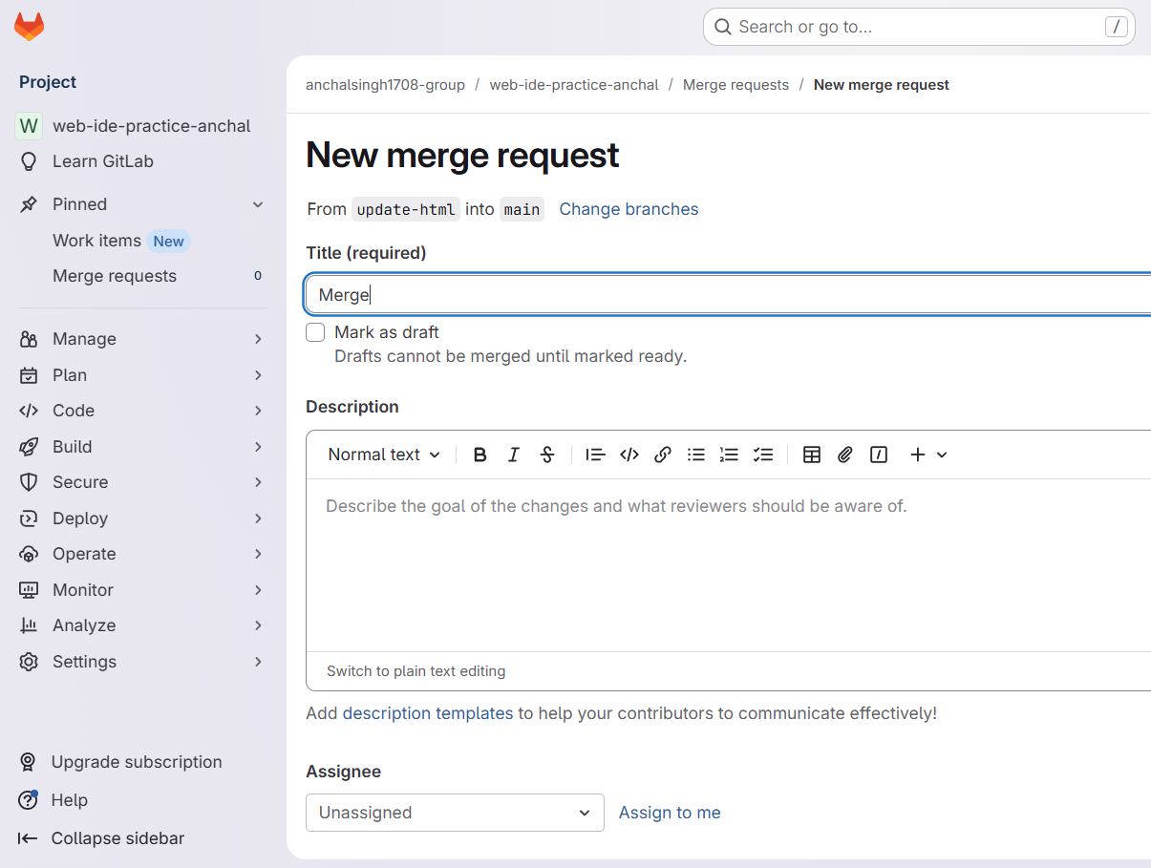
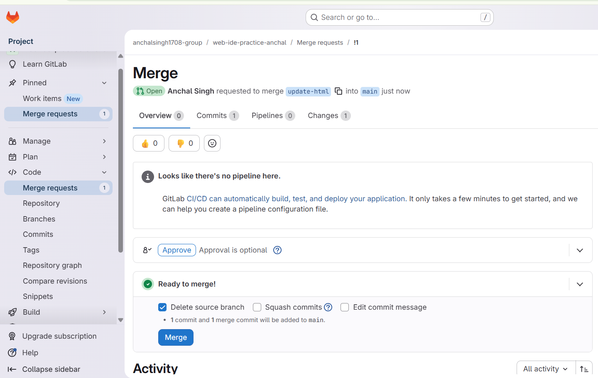
4. Select source and target branches.
5. Submit and merge after review.

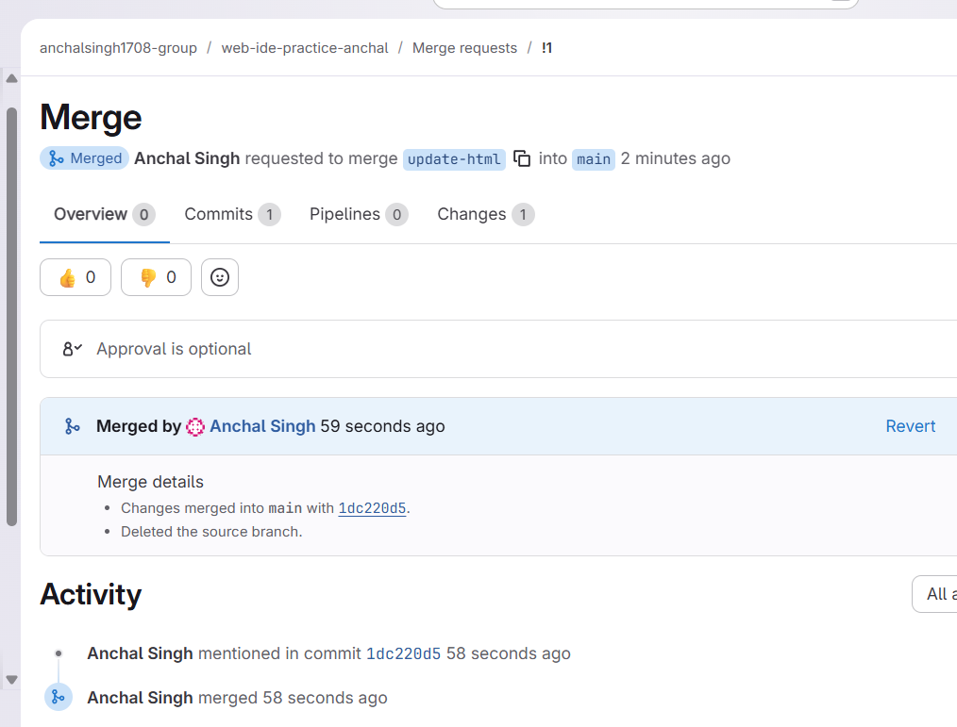

PRACTICAL :- 7
Workflow Management in GitLab
Steps:
1. In your repo, create .gitlab-ci.yml: stages:
-build
-test
build-job:
stage: build
script:
- echo "Building..."
test-job:
stage: test
script:
- echo "Testing..."

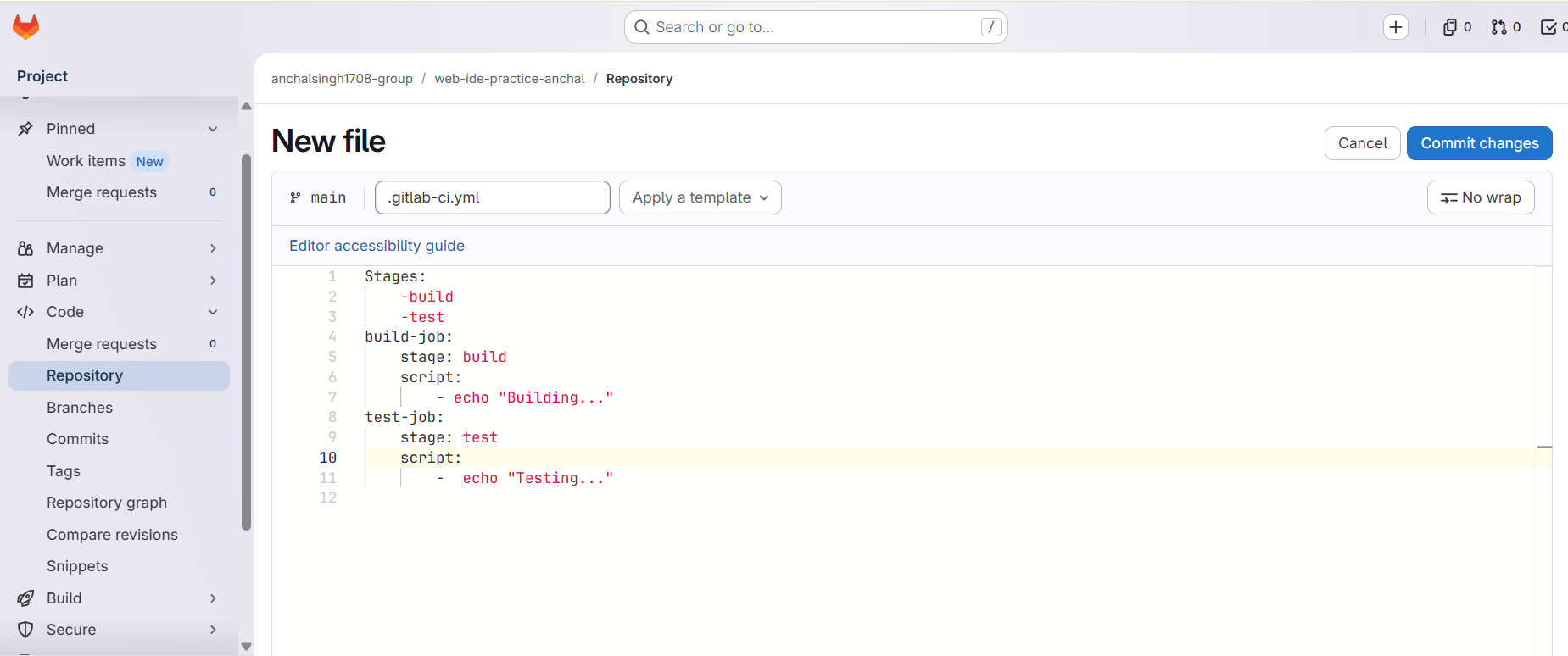
2. Commit and push.

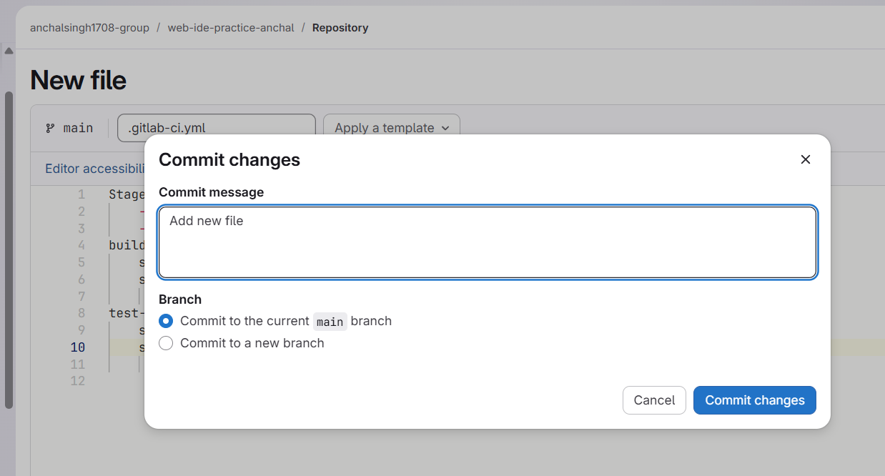
3. Go to CI/CD > Pipelines and view the build/test stages.

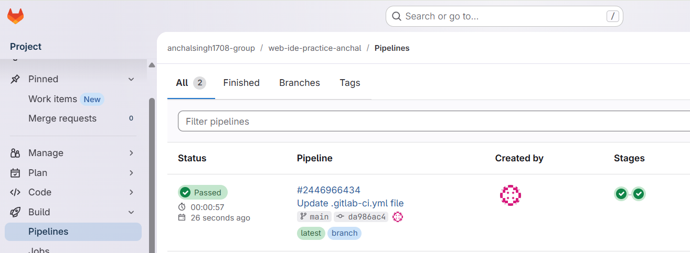

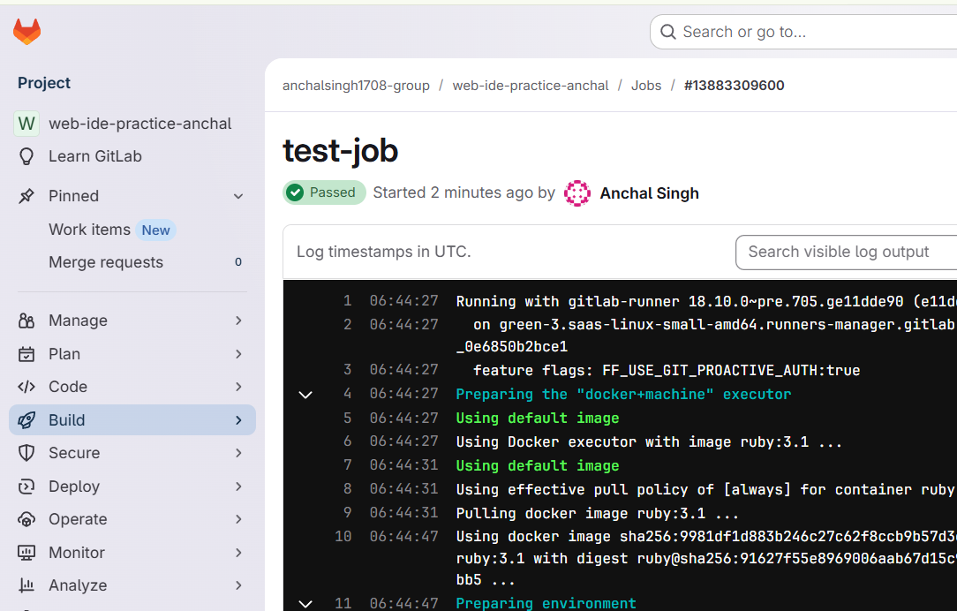

PRACTICAL :- 8.

Continuous Integration and Development Using Jenkins
Steps:
1. Install Jenkins (visit https://w w w.jenkins.io)
2. Run Jenkins: http://localhost:8080

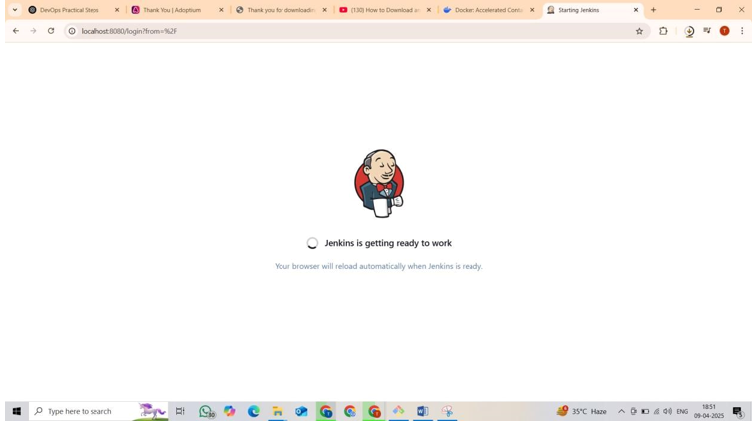

C7ce9ea3f8234ec4b0826a22fc23d2ab

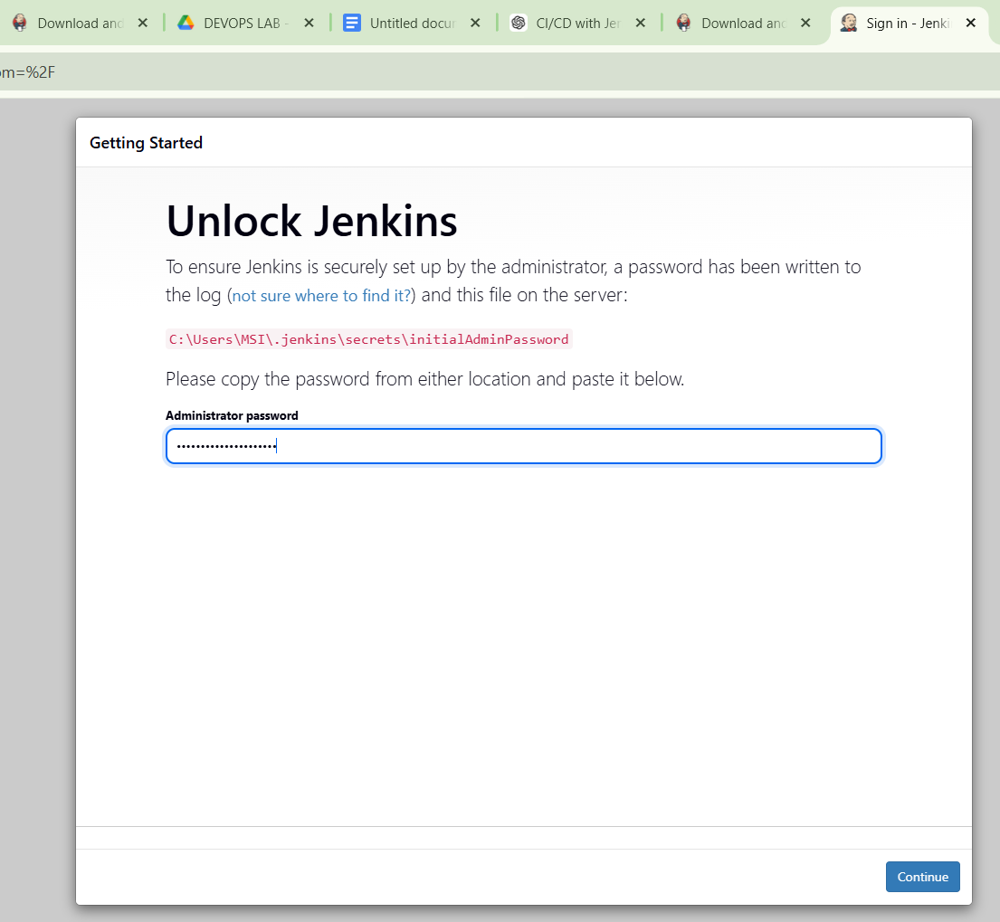

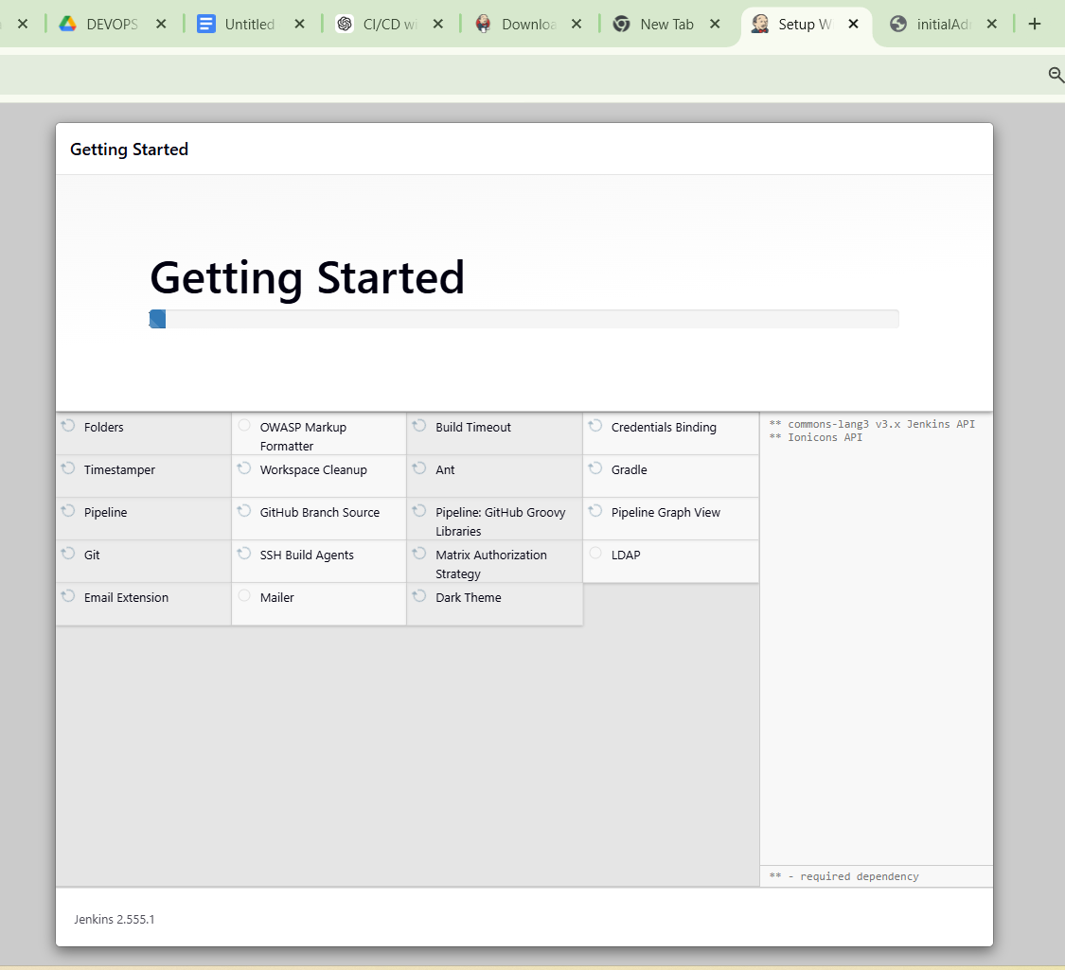
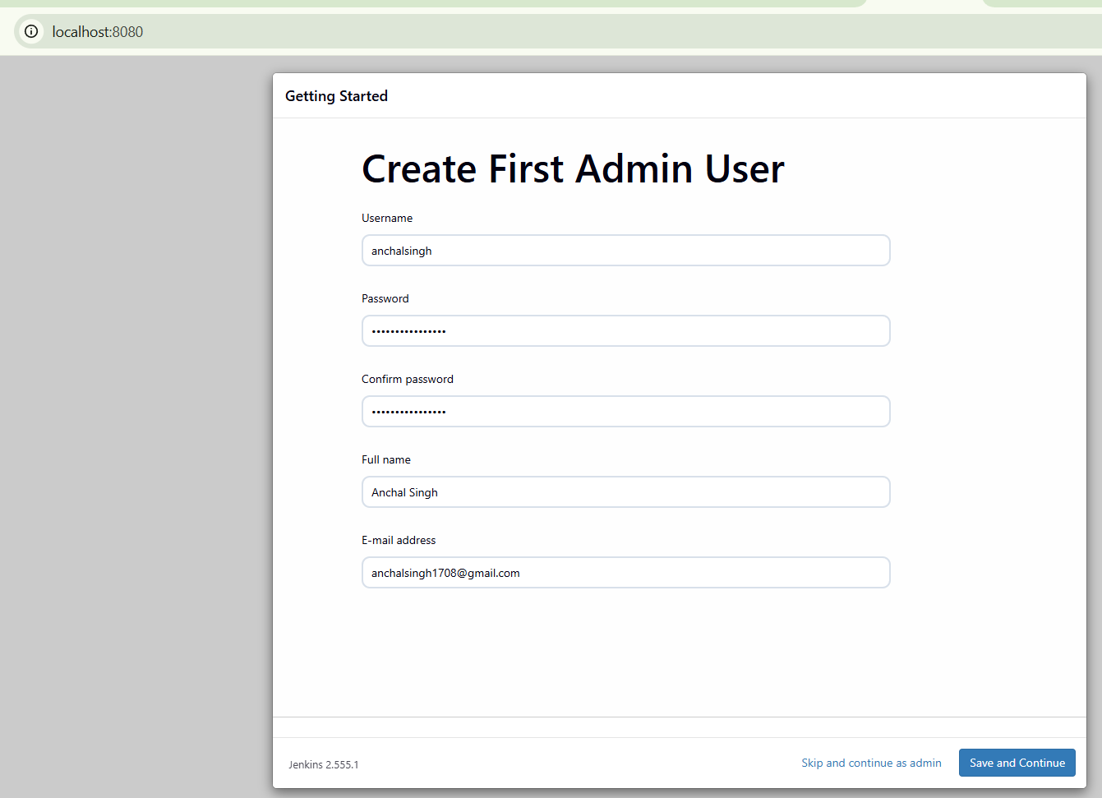

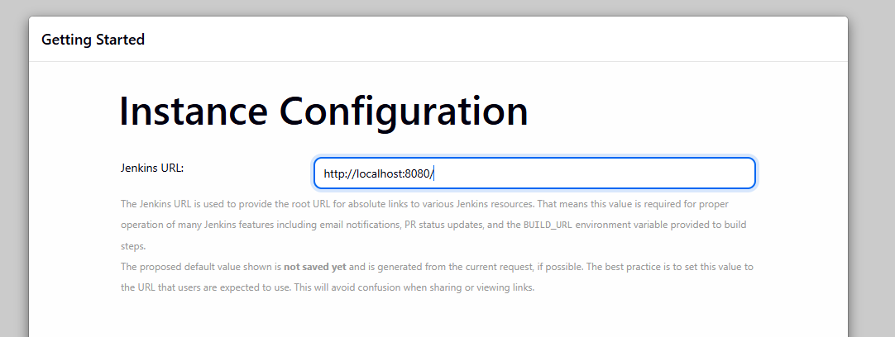
3. Create new Freestyle Project: CI-Demo
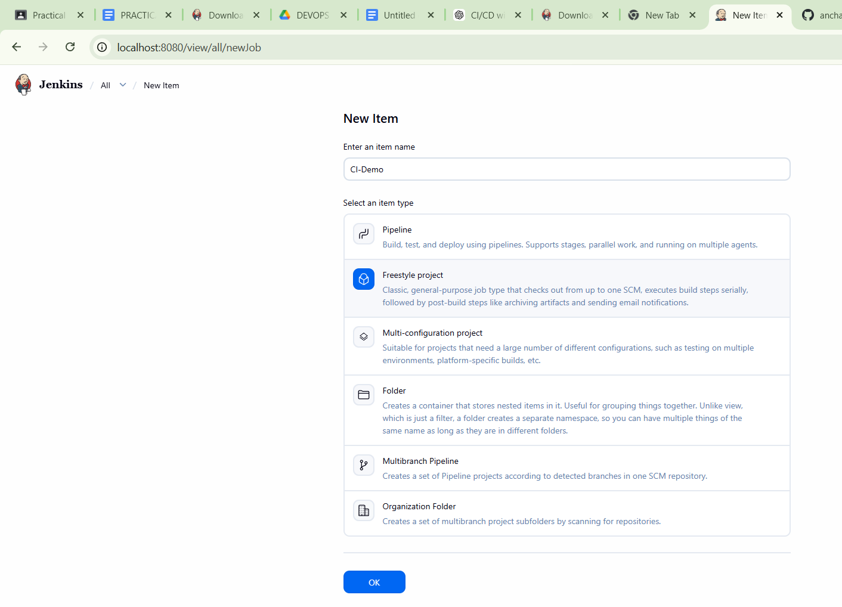
4. Under Source Code Management, choose Git and enter your repo URL.

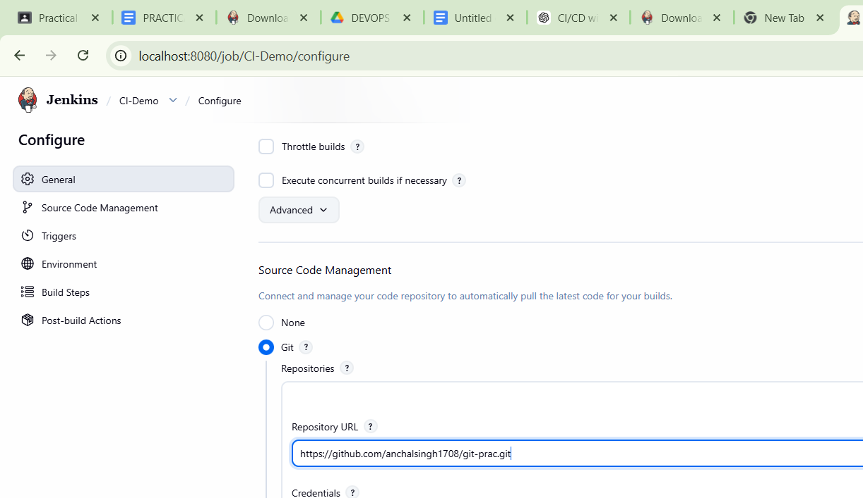
5. Add Build Step > Execute Shell:echo "Building Project...echo "Run tests..."

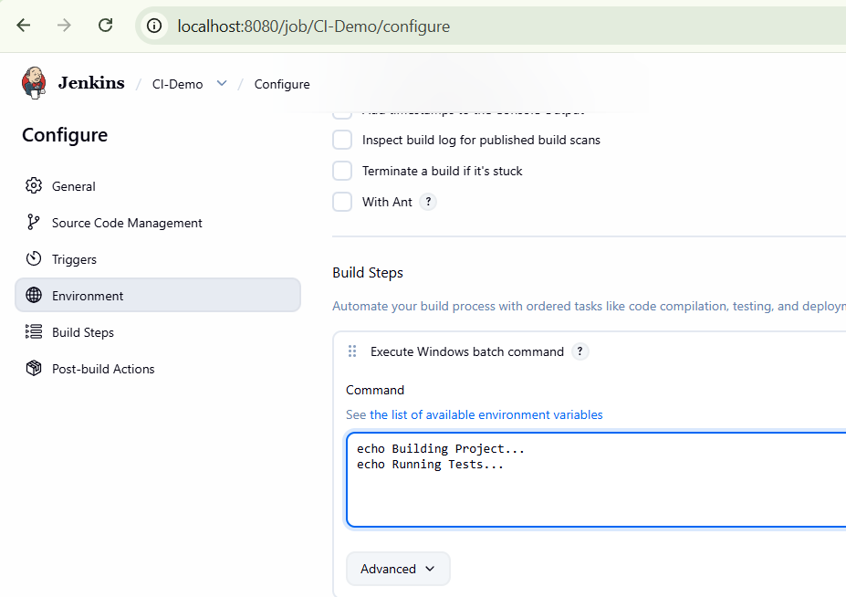
Clear Branches to build

6. Save and click Build Now.

7. Check output in Console Output.

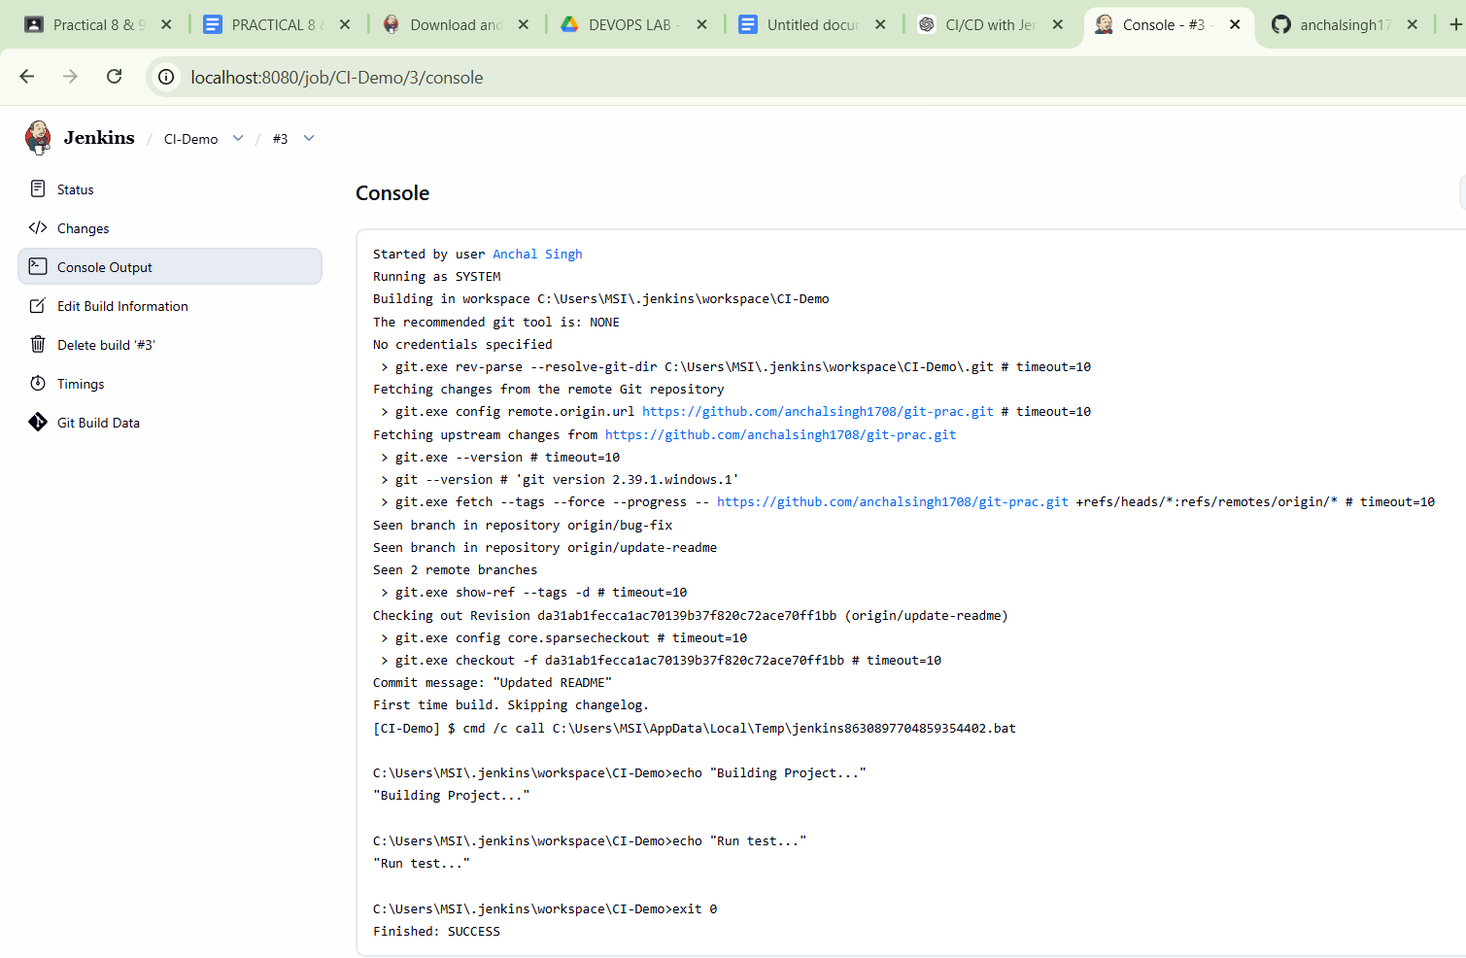

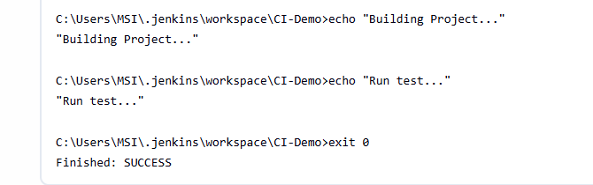

PRACTICAL :-9

Explore Docker Commands for Content Management
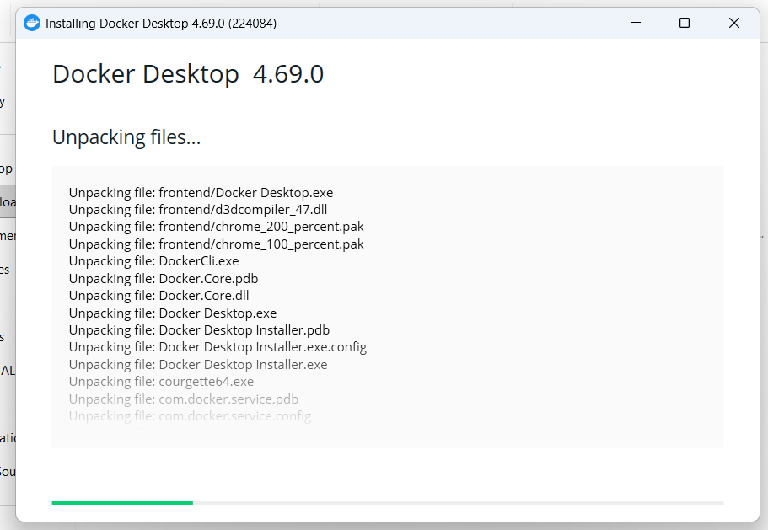

1. Check Docker version docker --version
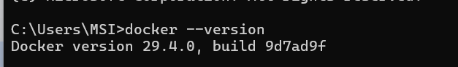
2. Pull a Docker image from
Docker Hub docker pull nginx
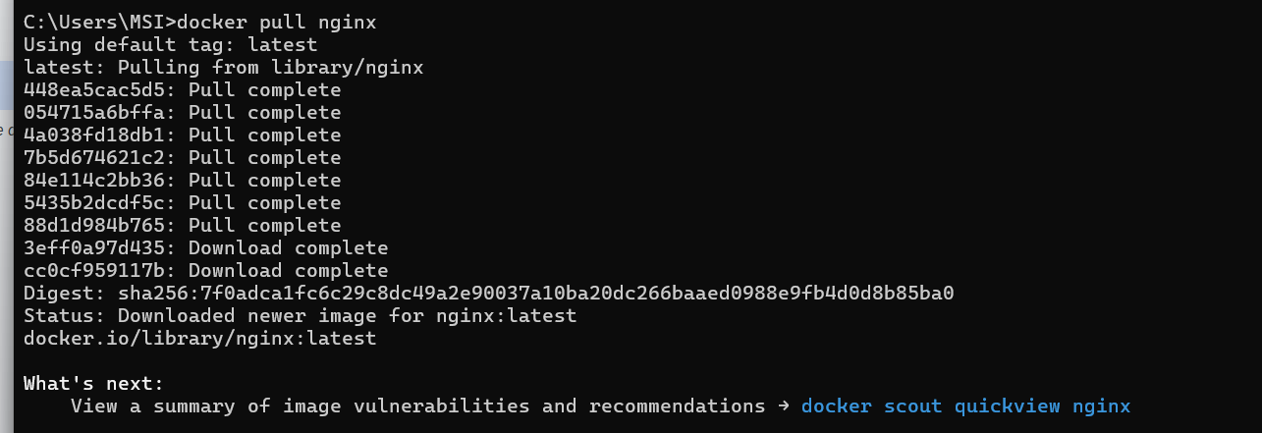
3. List all Docker images docker images

4. Run a container from an image docker run -d -p 8080:80
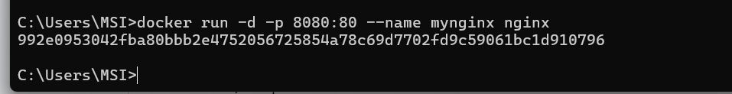
--name mynginx nginx
This will run the Nginx container and map port 80 (inside the container) to port 8080 (on your host).

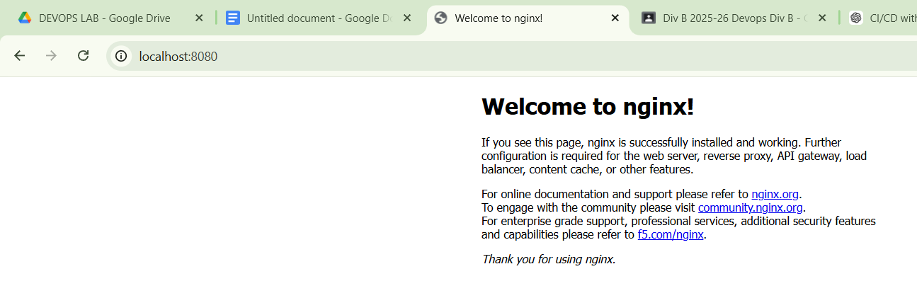
5. List all running containers docker ps

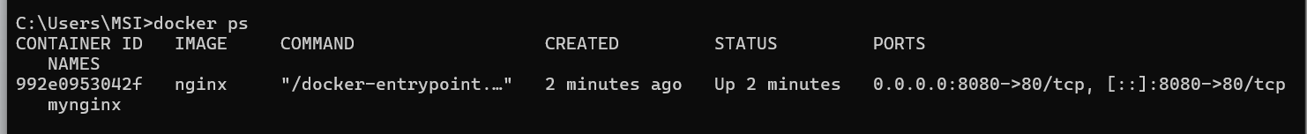
6. Copy content from host to container docker cp index.html mynginx:/usr/share/nginx/html/
Replace index.html with your actual file. This copies a file into the running container.
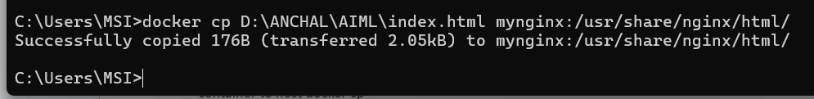
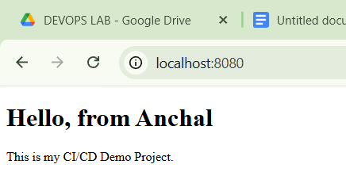
7. Copy content from container to host docker cp mynginx:/usr/share/nginx/html/ index.html .

8. Create and use Docker volume for persistent content docker volume create mydata
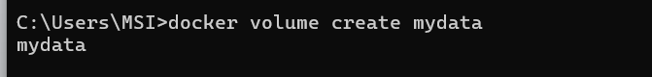
docker run -d -p 8081:80 --name nginx_vol -v mydata:/usr/share/nginx/html nginx

Now any data added to the /usr/share/nginx/html inside the container will persist even if the container is removed.

9. List Docker volumes docker volume ls
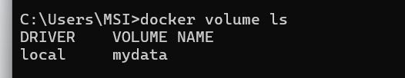
10. Remove a container docker rm -f mynginx
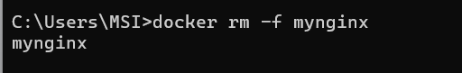
11. Remove an image docker rmi nginx

Practical 10

Develop a Simple Containerized Application using Docker

index.html
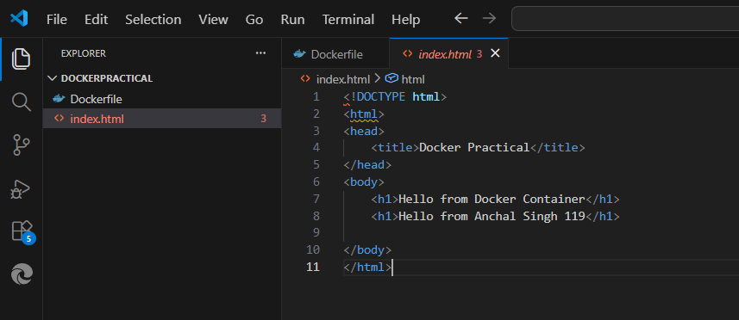
DockerfIle :-
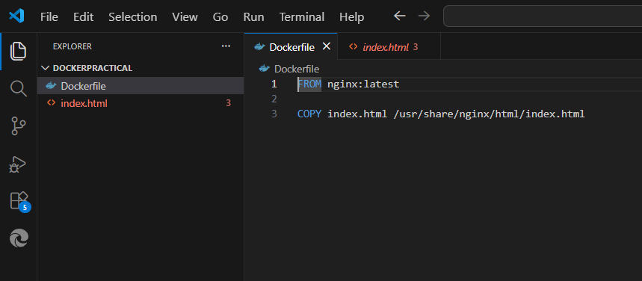
docker build -t my-docker-webapp .
docker run -d -p 8080:80 --name webapp-container

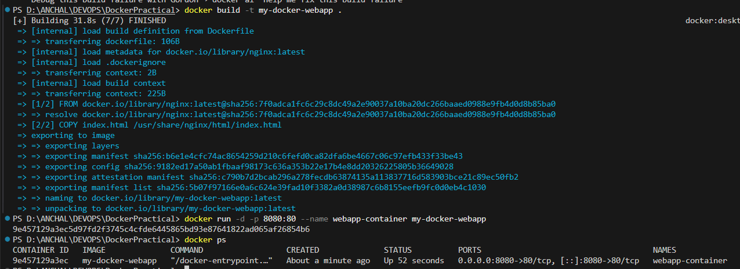

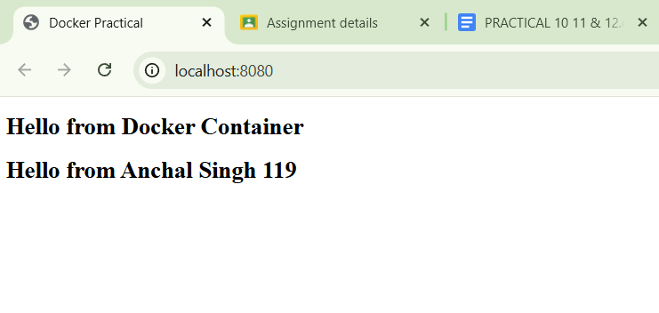

my-docker-webapp docker ps docker stop webapp-container docker rm webapp-container docker rmi my-docker-webapp

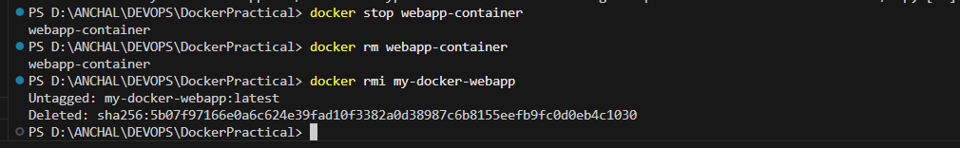

Practical 11

Ad-hoc Ansible Commands

Open PowerShell as Administrator -> wsl --install

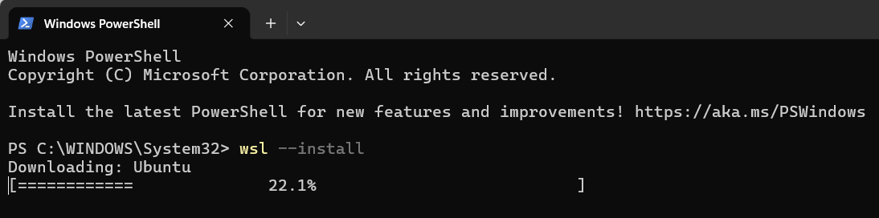

username:anchal
Password: 123

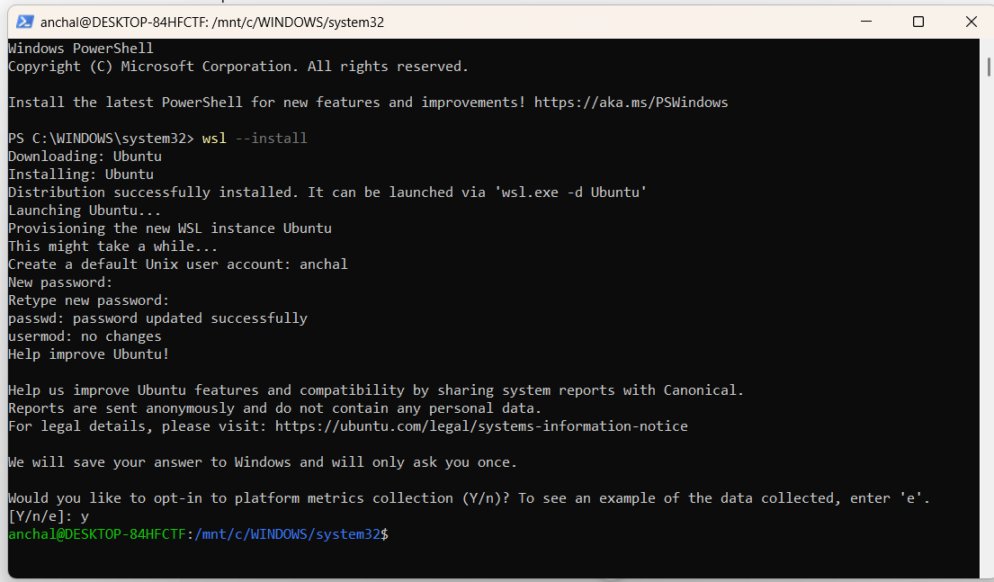
Step 1: Update your VM

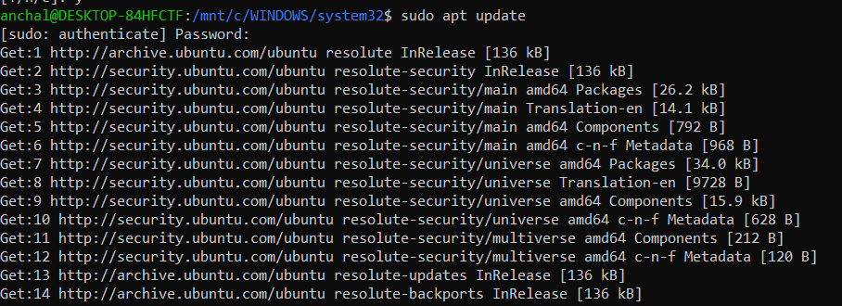

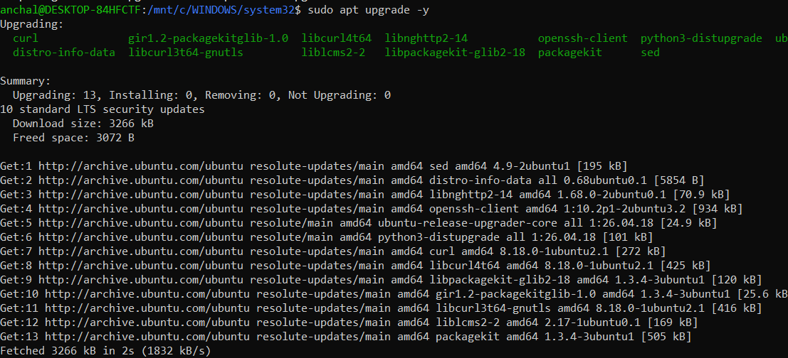
Step 2: Install Ansible

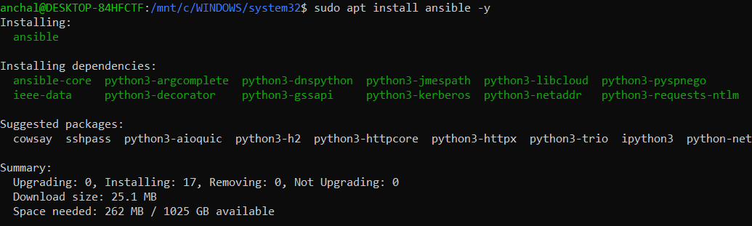
Step 3: Check version:

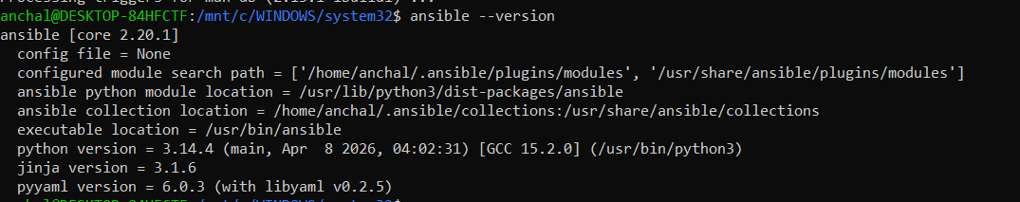

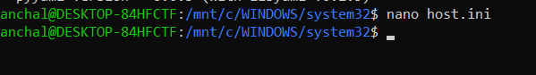
[local]
localhost ansible_connection=local

Save
- CTRL + O
- Enter
- CTRL + X
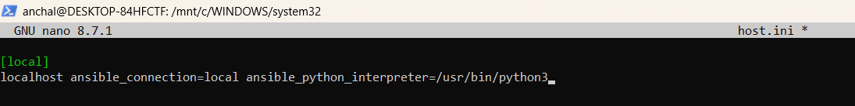

1. Ping the remote host ansible local -i host.ini -m ping

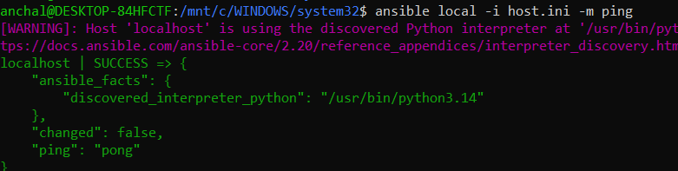
2. Check uptime ansible local -i host.ini -a
"Uptime"
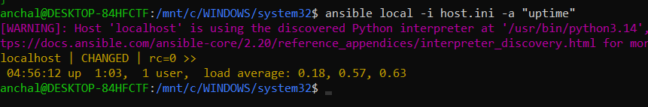
3. Install a package ansible local -i host.ini -m apt
-a "name=nginx state=present update_cache=yes"
–become

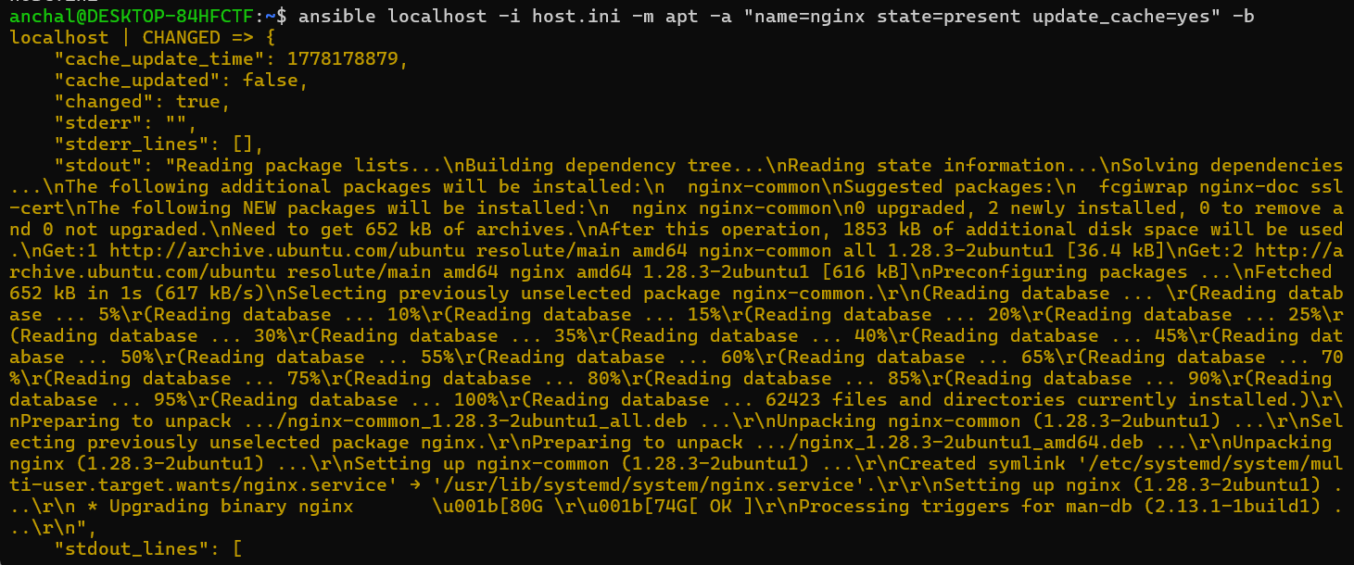

Practical 12
Using Ansible Playbook

Step 1: Create Playbook File

Create file:
install_nginx.yml
Run:
nano install_nginx.yml

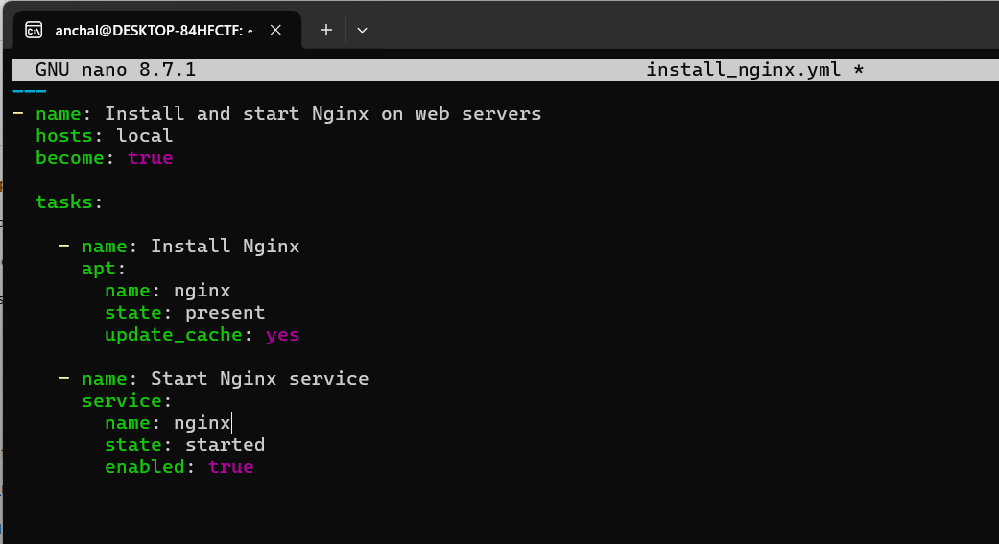
Save:
- CTRL + O
- Enter
- CTRL + X

Step 2: Run Playbook
Run:
ansible-playbook -i host.ini install_nginx.yml

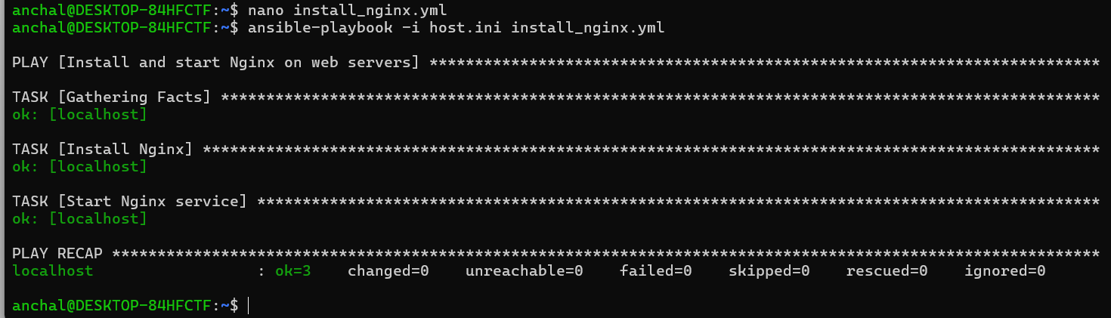
Step 3: Verify Nginx
Open browser:
http://localhost

