PRACTICAL NO. 1
AIM: WRITE A PROGRAM TO IMPLEMENT TOKENIZATION OF TEXT
Code:
import nltk
nltk.download()
print("Anchal Singh 119")
import nltk
from nltk.corpus import stopwords
from nltk.tokenize import word_tokenize
nltk.download('punkt', quiet=True)
nltk.download('stopwords', quiet=True)
stop_words = set(stopwords.words('english'))
data = "Machine learning and artificial intelligence are transforming the world"
tokens = word_tokenize(data)
filtered_data = []
for w in tokens:
if w.lower() not in stop_words:
filtered_data.append(w)
print("Tokens:", tokens)
print("Filtered Data:", filtered_data)

Output:
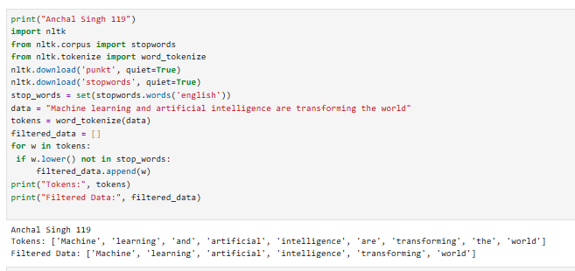

PRACTICAL NO. 2
AIM: WRITE A PROGRAM TO IMPLEMENT TOKENIZATION OF PARAGRAPH
Code:
print("Anchal Singh 119")
import nltk
from nltk.tokenize import sent_tokenize, word_tokenize
nltk.download('punkt')
paragraph = """Natural language processing enables computers to understand human language.
It is widely used in chatbots, translation systems, and voice assistants.
Many industries use NLP to analyze large amounts of text data efficiently."""
sentences = sent_tokenize(paragraph)
print("Sentence Tokenization:")
print(sentences)
words = word_tokenize(paragraph)
print("\nWord Tokenization:")
print(words)

Output:
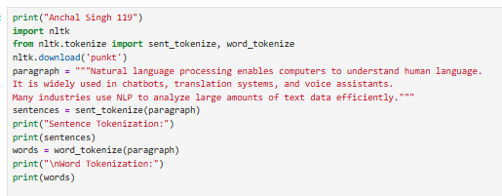
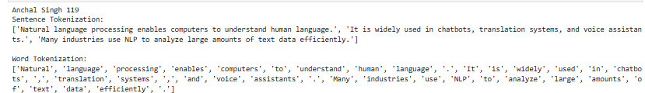

PRACTICAL NO. 3
AIM: WRITE A PROGRAM TO IMPLEMENT THE STOPWORD REMOVAL
Code:
print("Anchal Singh 119")
import nltk
from nltk.corpus import stopwords
from nltk.tokenize import word_tokenize
nltk.download('punkt')
nltk.download('stopwords')
text = "Artificial intelligence is improving healthcare and making systems more efficient"
words = word_tokenize(text)
stop_words = set(stopwords.words('english'))
filtered_words = []
for word in words:
if word.lower() not in stop_words:
filtered_words.append(word)
print("Original Words:", words)
print("After Removing Stopwords:", filtered_words)
Output:

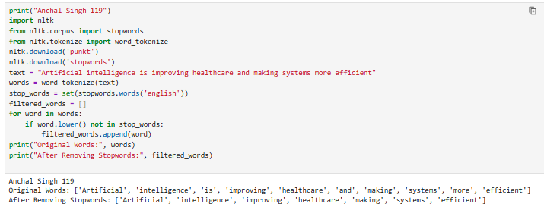

PRACTICAL NO. 4
AIM: WRITE A PROGRAM TO IMPLEMENT STEMMING OF TEXT
Code:
print("Anchal Singh 119")
import nltk
from nltk.stem import PorterStemmer
port_stemmer = PorterStemmer()
print(port_stemmer.stem("Programming"))
data = ["playing","played","plays","player",
"running","ran","runs","runner",
"writing","wrote","writes","writer",
"reading","read","reads","reader",
"speaking","spoke","speaks","speaker",
"driving","drove","drives","driver",
"teaching","taught","teaches","teacher",
"drawing","drew","draws","drawer",
"singing","sang","sings","singer",
"working","worked","works","worker"]
for words in data:
print(words, " : ", port_stemmer.stem(words))

Output:
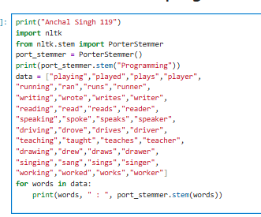
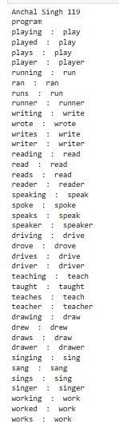

PRACTICAL NO. 5
AIM: WRITE A PROGRAM TO IMPLEMENT LEMMATIZATION.
Code:
print("Anchal Singh 119")
import nltk
from nltk.stem import WordNetLemmatizer
nltk.download('wordnet')
nltk.download('omw-1.4')
lemmati = WordNetLemmatizer()
print("Cars :", lemmati.lemmatize("cars"))
print("Houses :", lemmati.lemmatize("houses"))
print("Leaves :", lemmati.lemmatize("leaves"))
print("Mice :", lemmati.lemmatize("mice"))
print("Geese :", lemmati.lemmatize("geese"))
print("People :", lemmati.lemmatize("people"))
print("Feet :", lemmati.lemmatize("feet"))
print("Teeth :", lemmati.lemmatize("teeth"))
print("Children :", lemmati.lemmatize("children"))
print("Knives :", lemmati.lemmatize("knives"))
print("better :", lemmati.lemmatize("better", pos="a"))
print("running (verb) :", lemmati.lemmatize("running", pos="v"))
print("running (noun) :", lemmati.lemmatize("running", pos="n"))

Output:

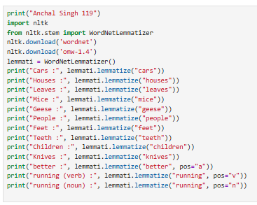

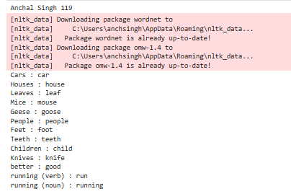

PRACTICAL NO. 6
AIM: WRITE A PROGRAM TO IMPLEMENT POS TAGGING
Code:
print("Anchal Singh 119")
import nltk
from nltk.corpus import wordnet
nltk.download('wordnet')
nltk.download('omw-1.4')
words = ['run', 'reading', 'teachers', 'faster', 'happily', 'computers']
for word in words:
synsets = wordnet.synsets(word)
if synsets:
pos = synsets[0].pos()
print(f"Word: {word}, POS: {pos}")
else:
print(f"Word: {word}, POS: Not found")
Output:
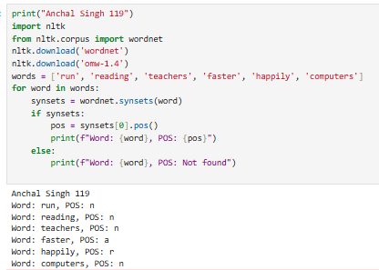

PRACTICAL NO. 7
AIM : WRITE A PROGRAM TO PERFORM NATURAL LANGUAGE PROCESSING (NLP) ON A GIVEN PARAGRAPH BY REMOVING STOPWORDS, TOKENIZING THE TEXT, AND IDENTIFYING THE PART-OF SPEECH (POS) TAGS FOR EACH WORD
Code:
print("Anchal Singh 119")
import nltk
from nltk.corpus import stopwords
from nltk.tokenize import word_tokenize
from nltk import pos_tag

nltk.download('punkt')
nltk.download('stopwords')
nltk.download('averaged_perceptron_tagger')
text = "Engineers are developing advanced systems to solve real world problems efficiently."
tokens = word_tokenize(text)
print("Tokenized words:\n", tokens)
stop_words = set(stopwords.words('english'))
filtered_tokens = []
for w in tokens:
if w.lower() not in stop_words:
filtered_tokens.append(w)
print("\nAfter removing stopwords:\n", filtered_tokens)
tagged_words = pos_tag(filtered_tokens)
print("\nPOS tagged words:\n", tagged_words)
for word, tag in tagged_words:
print(f"{word} : {tag}")
tree_obj = nltk.Tree("Sentence", [(word, tag) for word, tag in tagged_words])
tree_obj.pretty_print()

Output:
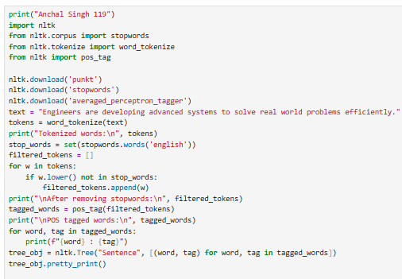

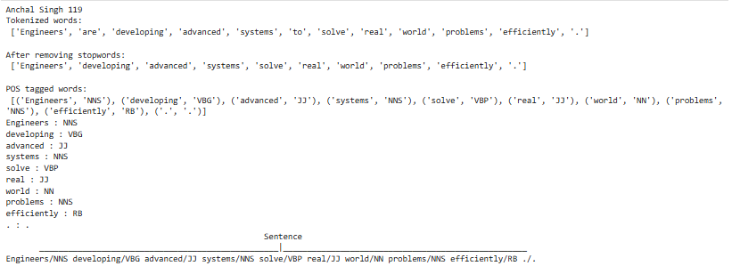

PRACTICAL NO. 8
AIM : WRITE A PROGRAM TO IMPLEMENT N-GRAM MODEL
Code:
print("Anchal Singh 119")
import nltk
from nltk.util import ngrams
from nltk.tokenize import word_tokenize
nltk.download('punkt')
data = "Artificial intelligence is changing industries with powerful automation tools"
tokens = word_tokenize(data)
trigram = ngrams(tokens, 3)
print("Trigram")
for gram in trigram:
print(gram)
bigram = ngrams(tokens, 2)
print("\nBigram")
for gram in bigram:
print(gram)

Output:

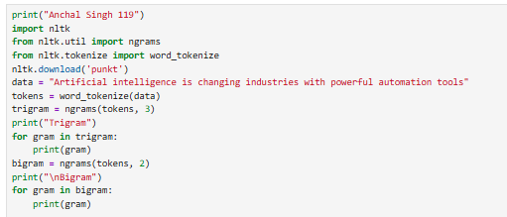

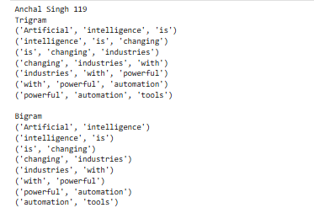

PRACTICAL NO. 9
AIM: WRITE A PROGRAM TO BUILD A CUSTOM NER SYSTEM
Code:
print("Anchal Singh 119")
from nltk.tokenize import word_tokenize
from nltk.tag import pos_tag
from nltk.chunk import ne_chunk
dataset = "Elon Musk founded SpaceX and leads innovative technology companies"
dataset_tag = pos_tag(word_tokenize(dataset))
data_ner = ne_chunk(dataset_tag)
print(data_ner)
data_ner.draw()

Output:
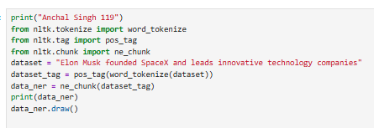
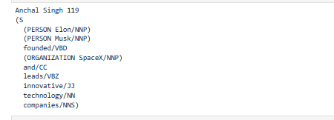

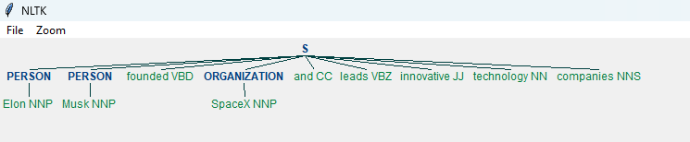

Code:
print("Anchal Singh 119")
import nltk
from nltk.tokenize import word_tokenize
from nltk.tag import pos_tag
from nltk.chunk import ne_chunk
nltk.download('punkt')
nltk.download('punkt_tab')
nltk.download('averaged_perceptron_tagger')
nltk.download('averaged_perceptron_tagger_eng')
nltk.download('maxent_ne_chunker')
nltk.download('maxent_ne_chunker_tab')
nltk.download('words')
text = "Bill Gates founded Microsoft and is a global technology leader"
tokens = word_tokenize(text)
tagged_tokens = pos_tag(tokens)
named_entities = ne_chunk(tagged_tokens)
print(named_entities)

Output:
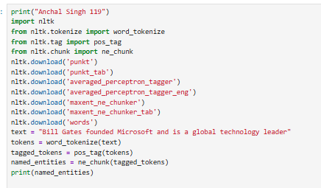

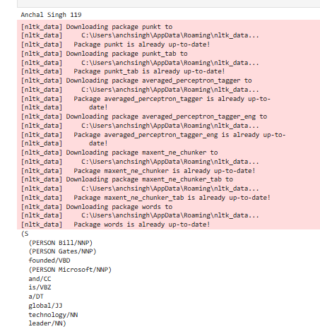

Code:
Using Spacy
print("Anchal Singh 119")
import spacy
from spacy import displacy
nlp = spacy.load("en_core_web_sm")
text = "Rohit Sharma, born on 30 April 1987 in Nagpur, is a successful Indian cricketer."
doc = nlp(text)
for ent in doc.ents:
print(ent.text, "->", ent.label_)
displacy.render(doc, style="ent", jupyter=True)

Output:
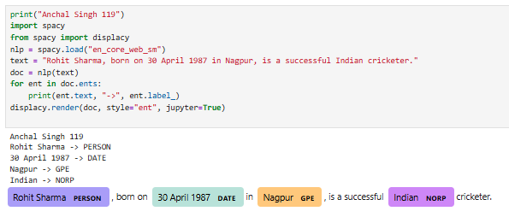

PRACTICAL NO. 10
AIM : WRITE A PROGRAM FOR TO CREATE DIFFERENT TEXT REPRESENTATIONS
Using BoW
Code:
print("Anchal Singh 119")
import nltk
import numpy as np
nltk.download('punkt')
texts = [
"Lionel Messi is one of the greatest football players",
"Lionel Messi is known for his amazing dribbling skills"
]
tokenized_texts = [nltk.word_tokenize(text.lower()) for text in texts]
vocabulary = sorted(set(word for text in tokenized_texts for word in text))
print("Vocabulary:", vocabulary)
def get_bow_representation(tokens, vocabulary):
return [tokens.count(word) for word in vocabulary]
bow_vectors = [get_bow_representation(text, vocabulary) for text in tokenized_texts]
print("\nBoW vectors:")
print(np.array(bow_vectors))
Output:
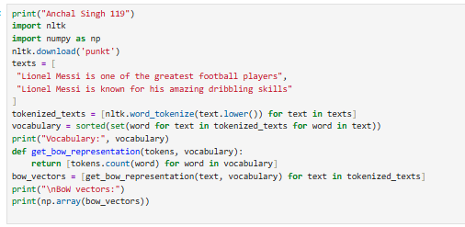
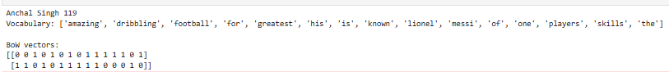

Using TF-IDF:
print("Anchal Singh 119")
import nltk
import numpy as np
from math import log
nltk.download('punkt')
texts = [
"Artificial intelligence is transforming modern technology",
"Artificial intelligence is widely used in smart applications"
]
tokenized_texts = [nltk.word_tokenize(text.lower()) for text in texts]
vocabulary = sorted(set(word for text in tokenized_texts for word in text))
print("Vocabulary:", vocabulary)
def get_tf(tokens, vocabulary):
return [tokens.count(word) for word in vocabulary]
def get_idf(vocabulary, docs):
num_docs = len(docs)
idf_vector = []
for word in vocabulary:
num_docs_with_word = sum(1 for doc in docs if word in doc)
idf_value = log(num_docs / (1 + num_docs_with_word)) + 1
idf_vector.append(idf_value)
return idf_vector
def get_tfidf(tokens, vocabulary, idf_vector):
tf_vector = get_tf(tokens, vocabulary)
return [tf * idf for tf, idf in zip(tf_vector, idf_vector)]
idf_vector = get_idf(vocabulary, tokenized_texts)
print("\nIDF vector:")
print(idf_vector)
tfidf_vectors = [get_tfidf(text, vocabulary, idf_vector) for text in tokenized_texts]
print("\nTF-IDF vectors:")
print(np.array(tfidf_vectors))

Output:

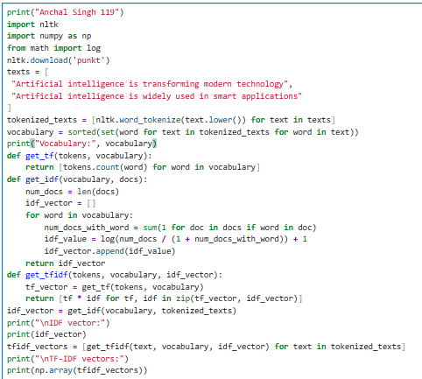

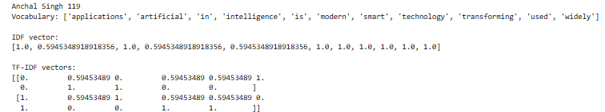

PRACTICAL NO. 11
AIM: WRITE A PROGRAM TO COMPARE BOW VECTOR WITH TF-IDF VECTOR USING COSINE SIMILARITY
Using BoW Cosine Similarity:
Code:
print("Anchal Singh 119")
import nltk
import numpy as np
from sklearn.metrics.pairwise import cosine_similarity
nltk.download('punkt')
texts = [
"Artificial intelligence improves many industries",
"Artificial intelligence is used in modern applications"
]
tokenized_texts = [nltk.word_tokenize(text.lower()) for text in texts]
vocabulary = sorted(set(word for text in tokenized_texts for word in text))
print("Vocabulary:", vocabulary)
def get_bow_representation(tokens, vocabulary):
return [tokens.count(word) for word in vocabulary]
bow_vectors = [get_bow_representation(text, vocabulary) for text in tokenized_texts]
print("\nBoW vectors:")
print(np.array(bow_vectors))
bow_similarity = cosine_similarity([bow_vectors[0]], [bow_vectors[1]])[0][0]
print("\nCosine Similarity:")
print(bow_similarity)

Output:

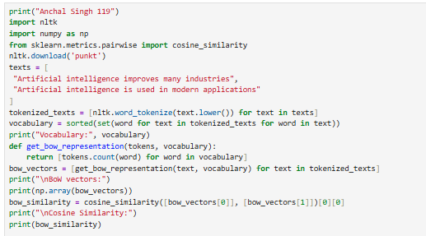

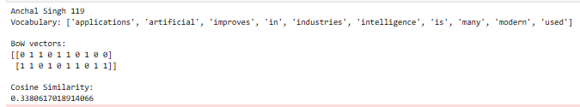

Using TF-IDF Cosine Similarity:
print("Anchal Singh 119")
import nltk
import numpy as np
from math import log
from sklearn.metrics.pairwise import cosine_similarity
nltk.download('punkt')
texts = [
"Machine learning improves data analysis",
"Machine learning is used in intelligent systems"
]
tokenized_texts = [nltk.word_tokenize(text.lower()) for text in texts]
vocabulary = sorted(set(word for text in tokenized_texts for word in text))
print("Vocabulary:", vocabulary)
def get_bow_representation(tokens, vocabulary):
return [tokens.count(word) for word in vocabulary]
bow_vectors = [get_bow_representation(text, vocabulary) for text in tokenized_texts]
def get_tf(tokens, vocabulary):
return [tokens.count(word) for word in vocabulary]
def get_idf(vocabulary, docs):
num_docs = len(docs)
idf_vector = []
for word in vocabulary:
num_docs_with_word = sum(1 for doc in docs if word in doc)
idf_value = log(num_docs / (1 + num_docs_with_word)) + 1
idf_vector.append(idf_value)
return idf_vector
def get_tfidf(tokens, vocabulary, idf_vector):
tf_vector = get_tf(tokens, vocabulary)
return [tf * idf for tf, idf in zip(tf_vector, idf_vector)]
idf_vector = get_idf(vocabulary, tokenized_texts)
tfidf_vectors = [get_tfidf(text, vocabulary, idf_vector) for text in tokenized_texts]
similarity1 = cosine_similarity([bow_vectors[0]], [tfidf_vectors[0]])[0][0]
print("\nCosine Similarity between doc1 (BoW) and doc1 (TF-IDF):", similarity1)
similarity2 = cosine_similarity([bow_vectors[1]], [tfidf_vectors[1]])[0][0]
print("Cosine Similarity between doc2 (BoW) and doc2 (TF-IDF):", similarity2)

Output:

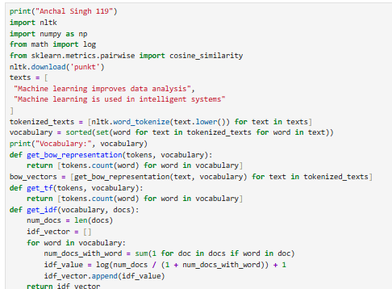

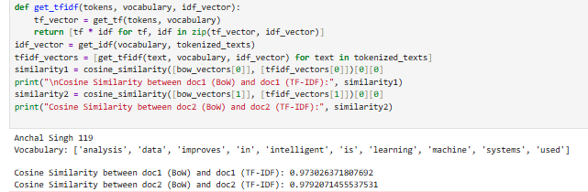

PRACTICAL NO. 12
AIM: WRITE A PROGRAM FOR TRAINING AND USING WORD EMBEDDINGS
Code:
Using Word2Vec:
print("Anchal Singh 119")

from gensim.models import Word2Vec

def train_word_embeddings(sentences):
tokenized_sentences = [sentence.lower().split() for sentence in sentences]
model = Word2Vec(sentences=tokenized_sentences, vector_size=100, window=5, min_count=1, workers=4)
return model

def show_similar(model, word):
print(f"Similar words for: {word}")
try:
results = model.wv.most_similar(word.lower(), topn=5)
for w, score in results:
print(w, "->", round(score, 4))
except:
print("Word not found")

sentences = [
"artificial intelligence is transforming technology",
"machine learning is part of artificial intelligence",
"deep learning is widely used in modern systems",
"data science helps in analyzing data",
"ai is changing the world",
"technology is evolving rapidly",
"machine learning improves predictions",
"deep learning needs large datasets",
"artificial intelligence is used in automation",
"data analysis is important",
"ai applications are growing",
"technology companies invest in ai",
"machine learning learns from data",
"deep learning is subset of machine learning",
"artificial intelligence supports smart systems"
]

model = train_word_embeddings(sentences)

show_similar(model, "artificial")
show_similar(model, "machine")
show_similar(model, "data")

Output:
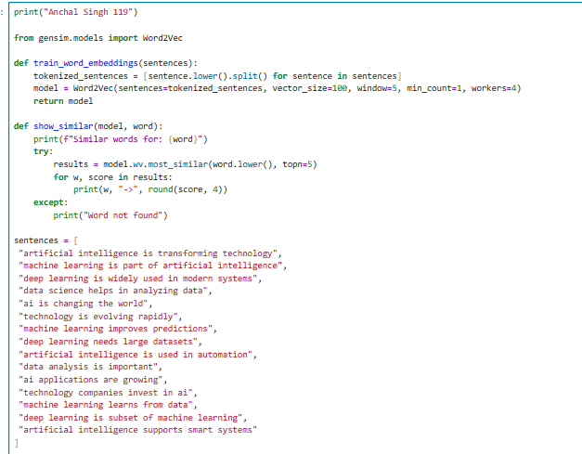
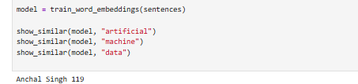
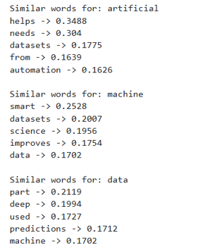

Using GloVe:
print("Anchal Singh 119")
import re
import nltk
import numpy as np
from collections import Counter
from scipy.sparse import coo_matrix
from sklearn.metrics.pairwise import cosine_similarity

nltk.download('punkt')

text_corpus = [
"sachin tendulkar is one of the greatest cricketers in the world",
"sachin tendulkar is known as the master blaster of cricket",
"he played international cricket for india and scored many centuries"
]

def preprocess(text):
text = text.lower()
text = re.sub(r'[^a-z\s]', '', text)
return nltk.word_tokenize(text)

tokenized = [preprocess(sentence) for sentence in text_corpus]

word_counts = Counter(word for sent in tokenized for word in sent)
vocab = list(word_counts.keys())

word_to_id = {w: i for i, w in enumerate(vocab)}
id_to_word = {i: w for w, i in word_to_id.items()}

WINDOW_SIZE = 2
co_occurrence = Counter()

for sentence in tokenized:
for i, word in enumerate(sentence):
for j in range(max(0, i - WINDOW_SIZE), min(len(sentence), i + WINDOW_SIZE + 1)):
if i != j:
co_occurrence[(word_to_id[word], word_to_id[sentence[j]])] += 1

rows, cols, data = zip(*[(i, j, v) for (i, j), v in co_occurrence.items()])
X = coo_matrix((data, (rows, cols)), shape=(len(vocab), len(vocab)))
X_dense = X.toarray()

print("Vocabulary:", vocab)
print("\nCo-occurrence Matrix:\n", X_dense)

EMBEDDING_DIM = 10
EPOCHS = 50
LR = 0.05
X_MAX = 100
ALPHA = 0.75

W = np.random.randn(len(vocab), EMBEDDING_DIM) * 0.01
W_tilde = np.random.randn(len(vocab), EMBEDDING_DIM) * 0.01
b = np.zeros(len(vocab))
b_tilde = np.zeros(len(vocab))

def weight(x):
return (x / X_MAX) ** ALPHA if x < X_MAX else 1

for epoch in range(EPOCHS):
loss = 0
for i in range(len(vocab)):
for j in range(len(vocab)):
X_ij = X_dense[i, j]
if X_ij == 0:
continue

w_ij = weight(X_ij)
log_x = np.log(X_ij)

pred = np.dot(W[i], W_tilde[j]) + b[i] + b_tilde[j]
diff = pred - log_x

loss += w_ij * diff**2

grad = w_ij * diff

W[i] -= LR * grad * W_tilde[j]
W_tilde[j] -= LR * grad * W[i]
b[i] -= LR * grad
b_tilde[j] -= LR * grad

if epoch % 20 == 0:
print(f"Epoch {epoch}, Loss: {loss:.4f}")

word_vectors = W + W_tilde
word_embeddings = {id_to_word[i]: word_vectors[i] for i in range(len(vocab))}

def find_similar(word, top_n=5):
if word not in word_embeddings:
return "Word not found"

vec = word_embeddings[word].reshape(1, -1)
sims = {
w: cosine_similarity(vec, word_embeddings[w].reshape(1, -1))[0][0]
for w in word_embeddings if w != word
}

return sorted(sims.items(), key=lambda x: x[1], reverse=True)[:top_n]

print(find_similar("cricket"))
print(find_similar("sachin"))

Output:
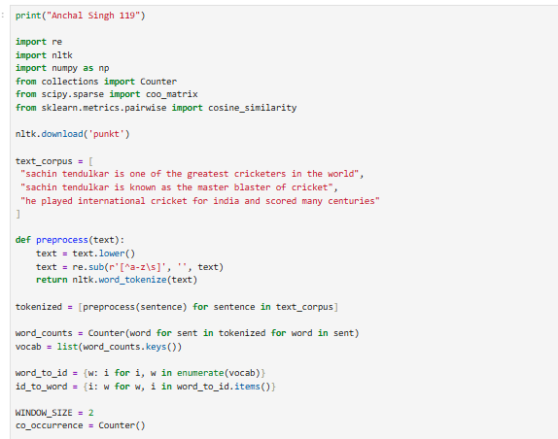

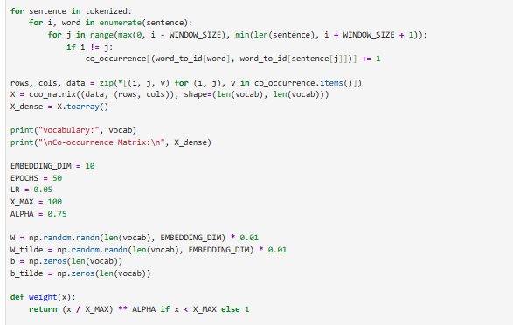

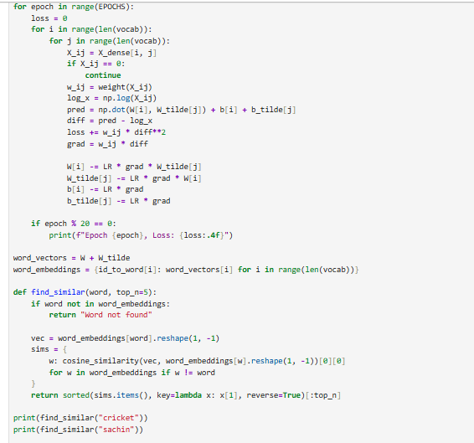

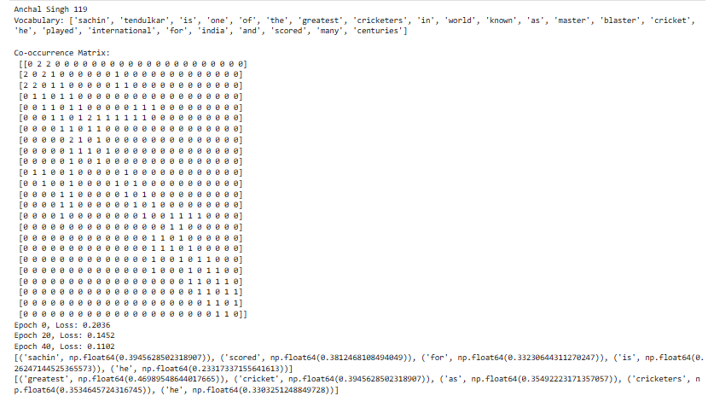

PRACTICAL NO. 13
AIM : WRITE A PROGRAM TO IMPLEMENT A TEXT CLASSIFIER USING NAIVEBAYES WITH SCIKIT-LEARN
Code:
print("Anchal Singh 119")
from sklearn.feature_extraction.text import CountVectorizer
from sklearn.naive_bayes import MultinomialNB
from sklearn.model_selection import train_test_split
from sklearn.metrics import classification_report
def train_text_classifier(X, y):
X_train, X_test, y_train, y_test = train_test_split(
X, y, test_size=0.2, random_state=42
)
vectorizer = CountVectorizer()
X_train_vec = vectorizer.fit_transform(X_train)
X_test_vec = vectorizer.transform(X_test)
model = MultinomialNB()
model.fit(X_train_vec, y_train)
y_pred = model.predict(X_test_vec)
print("Classification Report:")
print(classification_report(y_test, y_pred))
return vectorizer, model
def classify_text(text, vectorizer, model):
vec = vectorizer.transform([text])
return model.predict(vec)[0]
X = [
"this mobile phone has amazing performance and fast processing speed",
"battery drains very quickly and needs frequent charging",
"earphones provide clear sound quality and deep bass experience",
"product quality is very poor and not worth the money",
"laptop works smoothly and is perfect for programming tasks",
"system hangs often and performance is very disappointing"
]
y = [
"positive", "negative", "positive", "negative", "positive", "negative"]

vectorizer, model = train_text_classifier(X, y)
new_text = "the phone performance is fast and very smooth experience"
prediction = classify_text(new_text, vectorizer, model)
print("Prediction:", prediction)

Output:
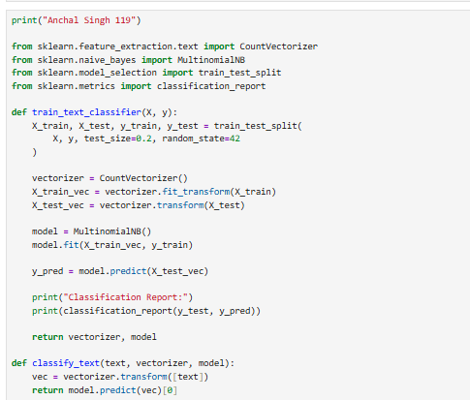

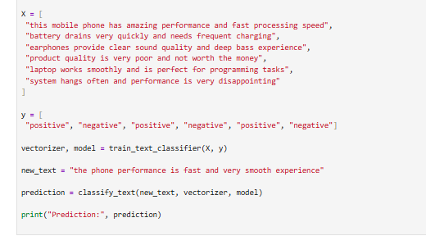
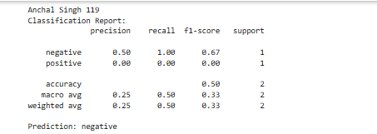

PRACTICAL NO. 14
AIM: WRITE A PROGRAM TO BUILD A SENTIMENT ANALYSIS SYSTEM
Code:
print("Anchal Singh 119")
import nltk
from nltk.sentiment import SentimentIntensityAnalyzer
import pandas as pd
nltk.download('vader_lexicon')
def analyze_sentiment(text):
sia = SentimentIntensityAnalyzer()
scores = sia.polarity_scores(text)
if scores['compound'] >= 0.1:
sentiment = "Positive"
elif scores['compound'] <= -0.1:
sentiment = "Negative"
else:
sentiment = "Neutral"
return sentiment, scores
def analyze_sentiments(texts):
results = []
for text in texts:
sentiment, scores = analyze_sentiment(text)
results.append({
"text": text,
"sentiment": sentiment,
"pos_score": scores['pos'],
"neg_score": scores['neg'],
"neu_score": scores['neu'],
"compound_score": scores['compound']
})
return pd.DataFrame(results)
texts = [
"this mobile phone performance is very fast and impressive",
"service was very slow and disappointing experience",
"product is okay not too good not too bad",
"customer support helped me quickly and politely",
"battery life is terrible and drains very fast",
"quality is excellent and build feels premium",
"application keeps crashing and is very frustrating",
"experience was average nothing special",
"the device works smoothly and efficiently",
"totally waste of money and not useful at all"
]
results_df = analyze_sentiments(texts)
print(results_df)

Output:
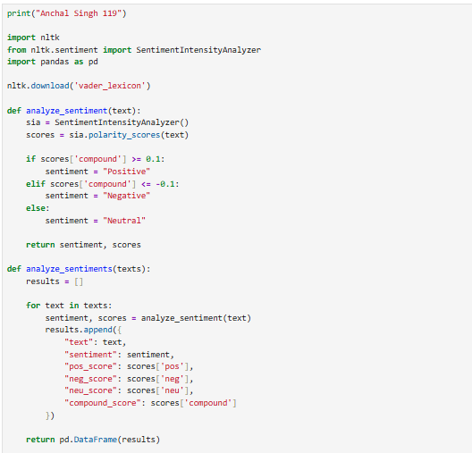
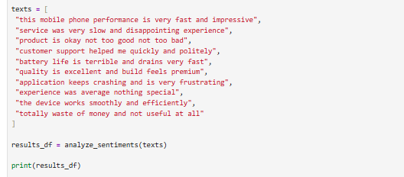
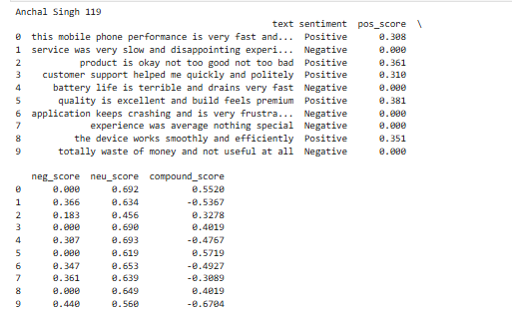

PRACTICAL NO. 15
AIM: WRITE A PROGRAM TO CREATE A TEXT SUMMARIZATION TOOL.
Code:
print("Anchal Singh 119")
from transformers import AutoTokenizer, AutoModelForSeq2SeqLM
import torch
# Load model and tokenizer
model_name = "facebook/bart-large-cnn"
tokenizer = AutoTokenizer.from_pretrained(model_name)
model = AutoModelForSeq2SeqLM.from_pretrained(model_name)
def summarize_text(text):
inputs = tokenizer(text, return_tensors="pt", truncation=True, max_length=512)
# Generate summary
output = model.generate(
inputs["input_ids"],
max_length=120,
min_length=40,
do_sample=False
)
return tokenizer.decode(output[0], skip_special_tokens=True)
# Long text to summarize
long_text = """
Artificial Intelligence is transforming industries by improving automation, decision making, and data analysis.
It is widely used in healthcare, finance, education, and cybersecurity systems.
AI helps in predicting outcomes and improving efficiency in many industries.
With continuous advancements, AI is becoming an essential part of modern technology.
"""
summary = summarize_text(long_text)
print("\nAbstractive Text Summarization")
print("Original text length:", len(long_text))
print("Summary length:", len(summary))
print("Summary:", summary)

Output:

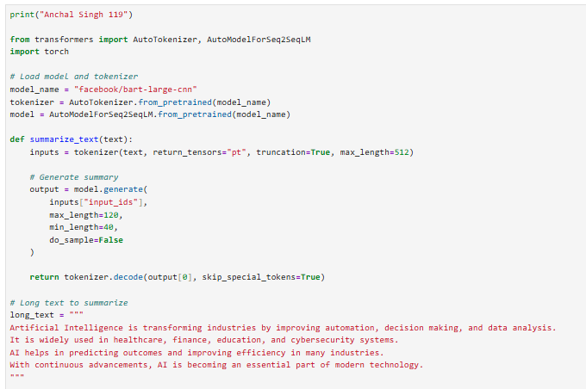
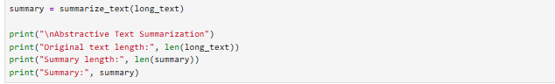

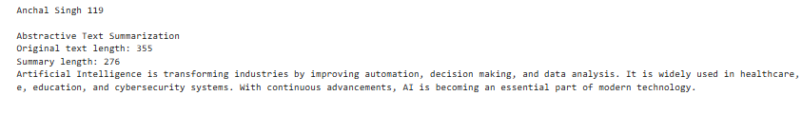

Code:

print("Anchal Singh 119")
from sumy.parsers.plaintext import PlaintextParser
from sumy.nlp.tokenizers import Tokenizer
from sumy.summarizers.lex_rank import LexRankSummarizer
text = """
Artificial intelligence and cyber security are important fields in modern computing.
AI helps in automation, prediction, and decision making across different industries.
Cyber security protects systems and data from attacks like hacking and malware.
Both technologies are widely used in banking, healthcare, education, and government sectors.
With increasing digital transformation, their importance continues to grow rapidly.
"""
parser = PlaintextParser.from_string(text, Tokenizer("english"))
summarizer = LexRankSummarizer()
summary = summarizer(parser.document, 2)
summary_text = " ".join(str(sentence) for sentence in summary)
print("\nExtractive Text Summarization")
print("Original words:", len(text.split()))
print("Summary words:", len(summary_text.split()))
print("\nSummary:\n", summary_text)

Output:

