Experiment No - 1

Q. Introduction to UI life cycle and UI tools.

UI Life Cycle:
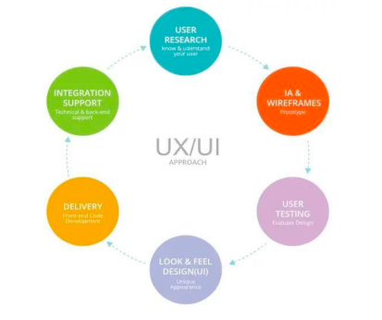
UI Tools:
1. InVision:
InVision is a web-based prototyping tool popular with both UX and UI designers alike. You can upload static design files and quickly turn them into high-fidelity, interactive prototypes.
2. Sketch:
The digital design app that every UI pro needs: Sketch. This is a vector-based tool, so you can easily resize anything that you draw without losing sharpness.
3. Figma:
Discover the very first in-browser interface design tool, Figma. With powerful editing tools and loads of handy features, Figma is a one-stop shop for designing, prototyping and gathering feedback. UI designers especially can take advantage of constraints feature, which adapts your designs when the screen size changes. With the

components feature, it’s also extremely easy to reuse elements across your designs.
4. Flinto:
Flinto is an interactive prototyping app for Mac which offers pretty much everything you need to bring your designs to life. Design micro-interactions and screen transitions, add video layers simply by dragging video or GIF files straight into your designs, incorporate UI sound effects and customizable scrolling—the list goes on.
5. Adobe XD:
Adobe XD is a vector-based tool for designing and prototyping user experiences for web, mobile, and even voice! If you’re already familiar with the Adobe Creative Cloud suite, you’ll feel right at home in Adobe XD—an extremely versatile tool which offers a whole host of features for designing, prototyping, sharing, collaborating, and creating a complete design system. XD natively supports Windows 10 and macOS, and is also available as a mobile app for both Android and iOS. 3. Figma:
Discover the very first in-browser interface design tool, Figma. With powerful editing tools and loads of handy features, Figma is a one-stop shop for designing, prototyping and gathering feedback. UI designers especially can take advantage of constraints feature, which adapts your designs when the screen size changes. With the components feature, it’s also extremely easy to reuse elements across your designs.

Experiment No - 2

Q. Project Proposal and Requirement Gathering (Introduction of Project)
Project Name: E-Revolt (Electric Bike and EV Store Platform)
1. Introduction
E-Revolt is a user interface project for an electric bike discovery and store platform. The system is designed to help users explore electric bikes, understand features, compare options, find nearby stores, and contact the business through a simple digital interface. The project focuses on clean navigation, clear product presentation, and a modern experience suitable for users interested in electric mobility.
2. Problem Statement
Many users interested in electric bikes find it difficult to compare models, locate reliable stores, and understand the benefits and features of electric vehicles from one organized interface. Information is often scattered across different websites, making the buying journey slow and confusing. E-Revolt aims to solve this by presenting bikes, store details, company information, contact options, and key features in one structured user interface.
3. Project Objectives
• To design a user-friendly interface for browsing electric bikes.
• To provide clear pages for Home, Login, Register, Bikes, Stores, About Us, Contact Us, and Features.
• To support easy navigation through wireframes and an interactive prototype.
• To communicate the purpose of electric mobility in a clean and modern UI.
• To evaluate the design through usability review and third-party test scripts.
4. Scope of the Project
• Creating logo, persona, journey map, ER diagram, storyboard, sitemap, wireframe, and prototype screens.
• Designing the main website/app pages required for an electric bike platform.
• Keeping the project focused on UI design, navigation flow, and usability.
• The project does not include backend implementation, payment processing, or real inventory integration.

User Requirement Gathering Questions – E Revolt
(E-Bike Rental & Sharing Application)

Section 1: Demographic Questions
(To understand who the user is)
- What is your age?
- What is your gender? (Male / Female / Other)
- What is your educational background?
- Where do you currently live? (City / Town / Village)
- Do you own a personal vehicle?
- How often do you travel daily?
- Do you usually travel alone or with others?
Section 2: Questions About Profession
(To understand daily routine and travel habits)
- Are you a student, working professional, or self-employed?
- What is your occupation/profession?
- How far do you travel daily for work or study?
- How many hours per day do you spend commuting?
- Which mode of transport do you currently use most often?
- Do you use any ride-sharing or transport apps regularly?
Section 3: Questions About Physical and Social Environment
(To understand the user’s transportation environment)
- Are e-bike stations available near your area?
- Do you face traffic congestion regularly?
- Do you think pollution is a major issue in your city?
- Do you feel public transportation is convenient in your area?
- Would you prefer eco-friendly transportation methods?
- Have you ever used a bicycle or e-bike for commuting?
- What challenges do you face while traveling daily?
Section 4: Questions About Technical Environment
(To understand the user's comfort with technology)
- Do you own a smartphone? If yes, which type? (Android / iPhone)
- How comfortable are you using mobile apps?
(Very Comfortable / Somewhat Comfortable / Not Comfortable)
- Do you use digital payment apps such as Google Pay, PhonePe, or Paytm?
- Have you used any bike rental or ride-booking app before?
- Do you use GPS or map applications regularly?
- Do you have internet access while traveling?
- Would you prefer simple buttons and easy navigation in the app?

Section 5: Questions About Goals and Motivations
(To understand user expectations and goals)
- What is your main reason for using an e-bike rental app?
- Would you use e-bikes to save travel time?
- Would low rental prices motivate you to use the app regularly?
- How important is eco-friendly transportation to you?
- Would you like the app to help you track your ride history and expenses?
- Would rewards, discounts, or loyalty points motivate you to use the app more often?
- Would you recommend an e-bike rental app to friends or family?
Section 6: Questions About Values, Fears, and Challenges
(To understand user pain points and concerns)
- What is your biggest concern while using rental vehicles?
- Are you worried about safety while riding an e-bike? Why?
- Would you be concerned about online payment security in the app?
- What frustrates you most about transportation apps in general?
- Have you ever faced problems with vehicle availability or booking cancellations?
- Would battery issues or charging concerns stop you from using e-bikes?
- What problems would make you stop using the app?
Section 7: Questions About Personal Preferences and Traits
(To understand how the user wants to interact with the app)
- Would you prefer dark mode or light mode in the app?
- Do you prefer quick one-tap booking options?
- Would you like voice navigation or map guidance during rides?
- Do you prefer notifications through sound, vibration, or pop-ups?
- Would you like the app in English, Hindi, or another regional language?
- Would you like the option to reserve bikes in advance?
- Would you like ride statistics and travel summaries in the app?
Section 8: Buyer Behavior Questions
(To understand willingness to adopt and use the app)
- Would you be willing to use a free e-bike rental app?
- Would you pay extra for premium features like reserved parking or priority booking?
- Who would influence your decision to use this app?
(Friends / Family / Social Media / Advertisements)
- Would discounts or referral rewards encourage you to use the app more?
- Would you recommend this app to others if you had a good experience?
- How frequently would you use an e-bike rental service?
- What would make you switch to another e-bike rental app?
Section 9: Questions About Competitors and Preferred Tools
(To understand existing solutions and user comparisons)
- Have you used any other bike rental or ride-sharing apps before?
(Rapido / Bounce / Yulu / Uber / Ola etc.)
- What did you like most about those apps?
- What problems did you face while using those apps?
- Do you prefer e-bikes over fuel-based bikes? Why?
- What feature would make E Revolt better than other rental apps?
- Would live bike tracking improve your experience?
- Which feature is most important to you?
(Low Cost / Easy Booking / Fast Service / Safety / Battery Backup)
Section 10: Questions Specific to E Revolt
(To gather direct feedback about the E Revolt application)
- Which feature of E Revolt would be most useful to you?
(Bike Booking / Live Tracking / Payment System / Ride History / Navigation)
- How would you prefer to unlock the e-bike?
(QR Scan / OTP / App Button)
- Would you like the app to show nearby charging stations?
- Would you use the Ride History feature to track previous trips?
- Would you like emergency support or SOS features in the app?
- How important is the battery status feature before booking a bike?
(1 to 5 Rating)
- Would you like the app to provide estimated travel cost and time before booking?
- Is there any additional feature you would like in E Revolt that has not been mentioned?

Experiment No - 3
Q. Logo Designing
Link: https://www.figma.com/proto/z0X3PsKSGOUaRD48cUHEIl/LOGO_119?node-id=1-2&p=f&t=kXRZBoBlRfKhclxb-0&scaling=scale-down&content-scaling=fixed&page-id=0%3A1
https://www.figma.com/design/z0X3PsKSGOUaRD48cUHEIl/LOGO_119?node-id=0-1&p=f&t=kXRZBoBlRfKhclxb-0
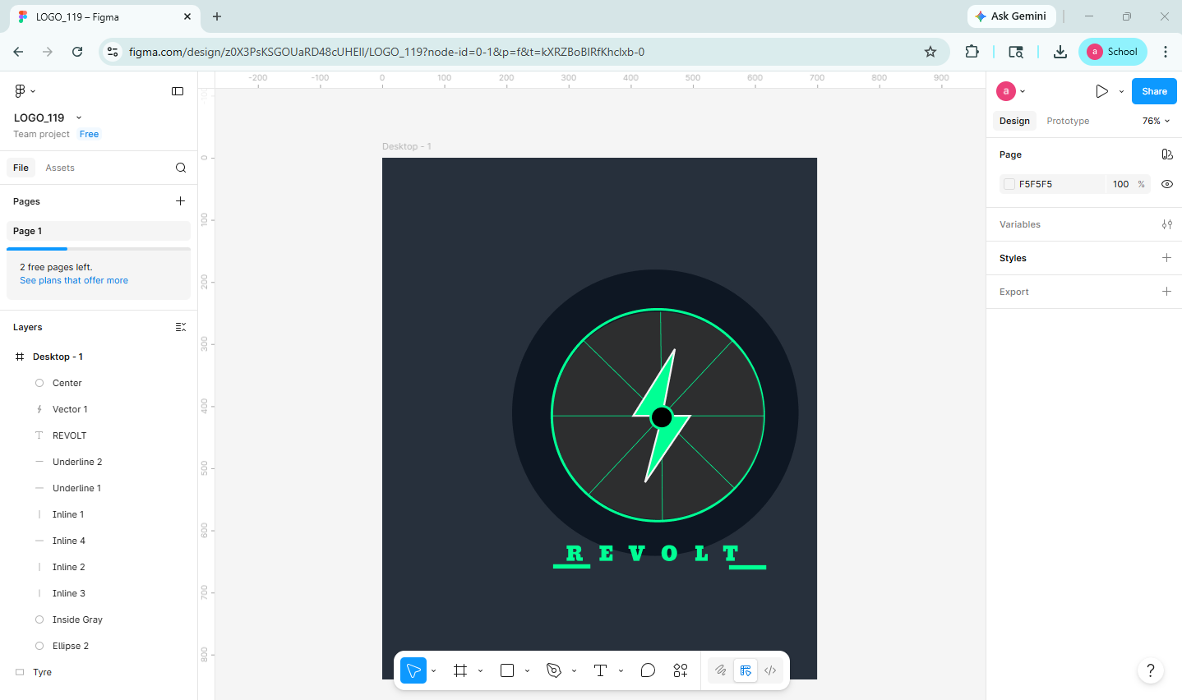
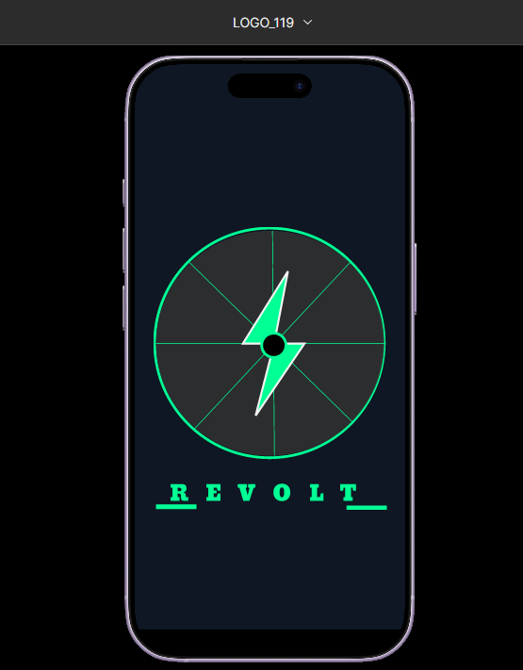

Experiment No - 4

Q. Problem Statement: System Concept Statement
System Name: E-Revolt
Target Users:
• Customers searching for electric bikes.
• New users who want to understand EV features and benefits.
• Visitors looking for stores, contact details, and product information.
Problem Statement:
Users who want to purchase or learn about electric bikes need a simple way to view bike options, store information, and company details. Without a well-organized interface, users may struggle to find the right model, understand features, or complete basic actions such as login, registration, and contacting the store.
System Solution:
E-Revolt provides a structured electric bike interface with clear sections for Home, Login, Register, Bikes, Stores, About Us, Contact Us, and Features. The design uses wireframes, prototype screens, and visual planning artifacts to create an accessible and easy-to-follow user journey.
Key Features:
• Bike listing and product discovery pages.
• Store information for users looking for nearby purchase options.
• Login and registration flow for user access.
• Contact and About Us pages for trust and communication.
• Feature-focused content explaining the electric bike platform.
Final Concept Statement:
E-Revolt is a user interface project for an electric bike platform that helps users explore bikes, understand key features, find stores, and contact the business through a simple and modern design. The system focuses on reducing confusion in the EV discovery journey and creating a clear, usable interface for potential electric bike customers.

Experiment No - 5
Q. Design a user Persona
Link :https://www.figma.com/proto/XOhz1lQqiVYKkw9gQXzmiN/Personas_119?node-id=5-4&t=kXRZBoBlRfKhclxb-0&scaling=scale-down&content-scaling=fixed&page-id=0%3A1
https://www.figma.com/design/XOhz1lQqiVYKkw9gQXzmiN/Personas_119?node-id=5-3&t=kXRZBoBlRfKhclxb-0
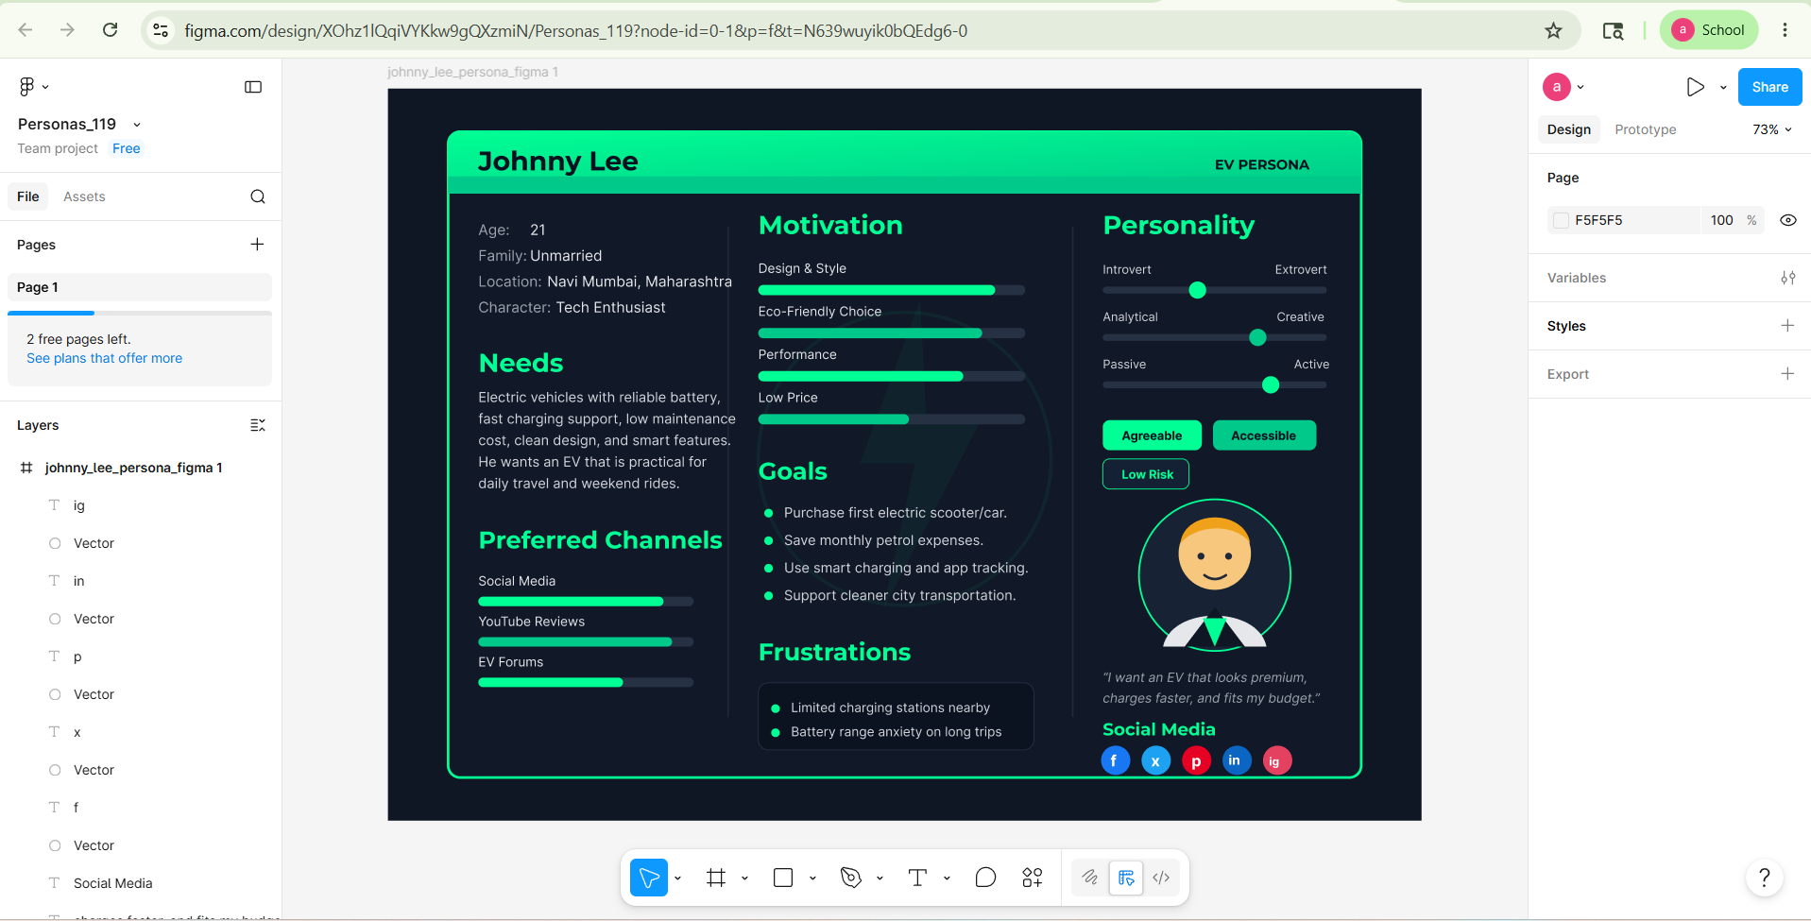
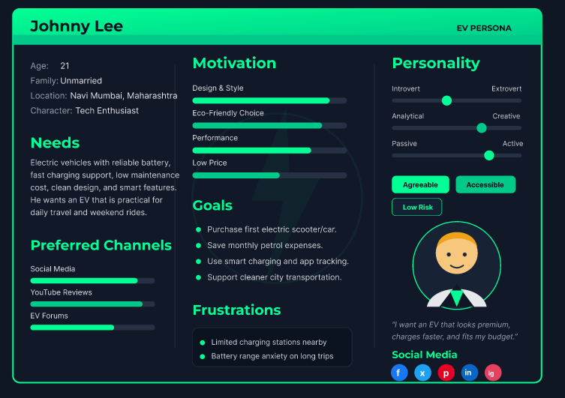

Experiment No - 6
Q. Customer Journey Map
Link: https://www.figma.com/design/L3boFBeuuEpsMRQqnniBWc/Figma-basics?node-id=602-652&t=9WLVVAQbTmCg2zPb-0
https://www.figma.com/proto/L3boFBeuuEpsMRQqnniBWc/Figma-basics?node-id=602-440&t=9WLVVAQbTmCg2zPb-0&scaling=scale-down&content-scaling=fixed&page-id=602%3A9
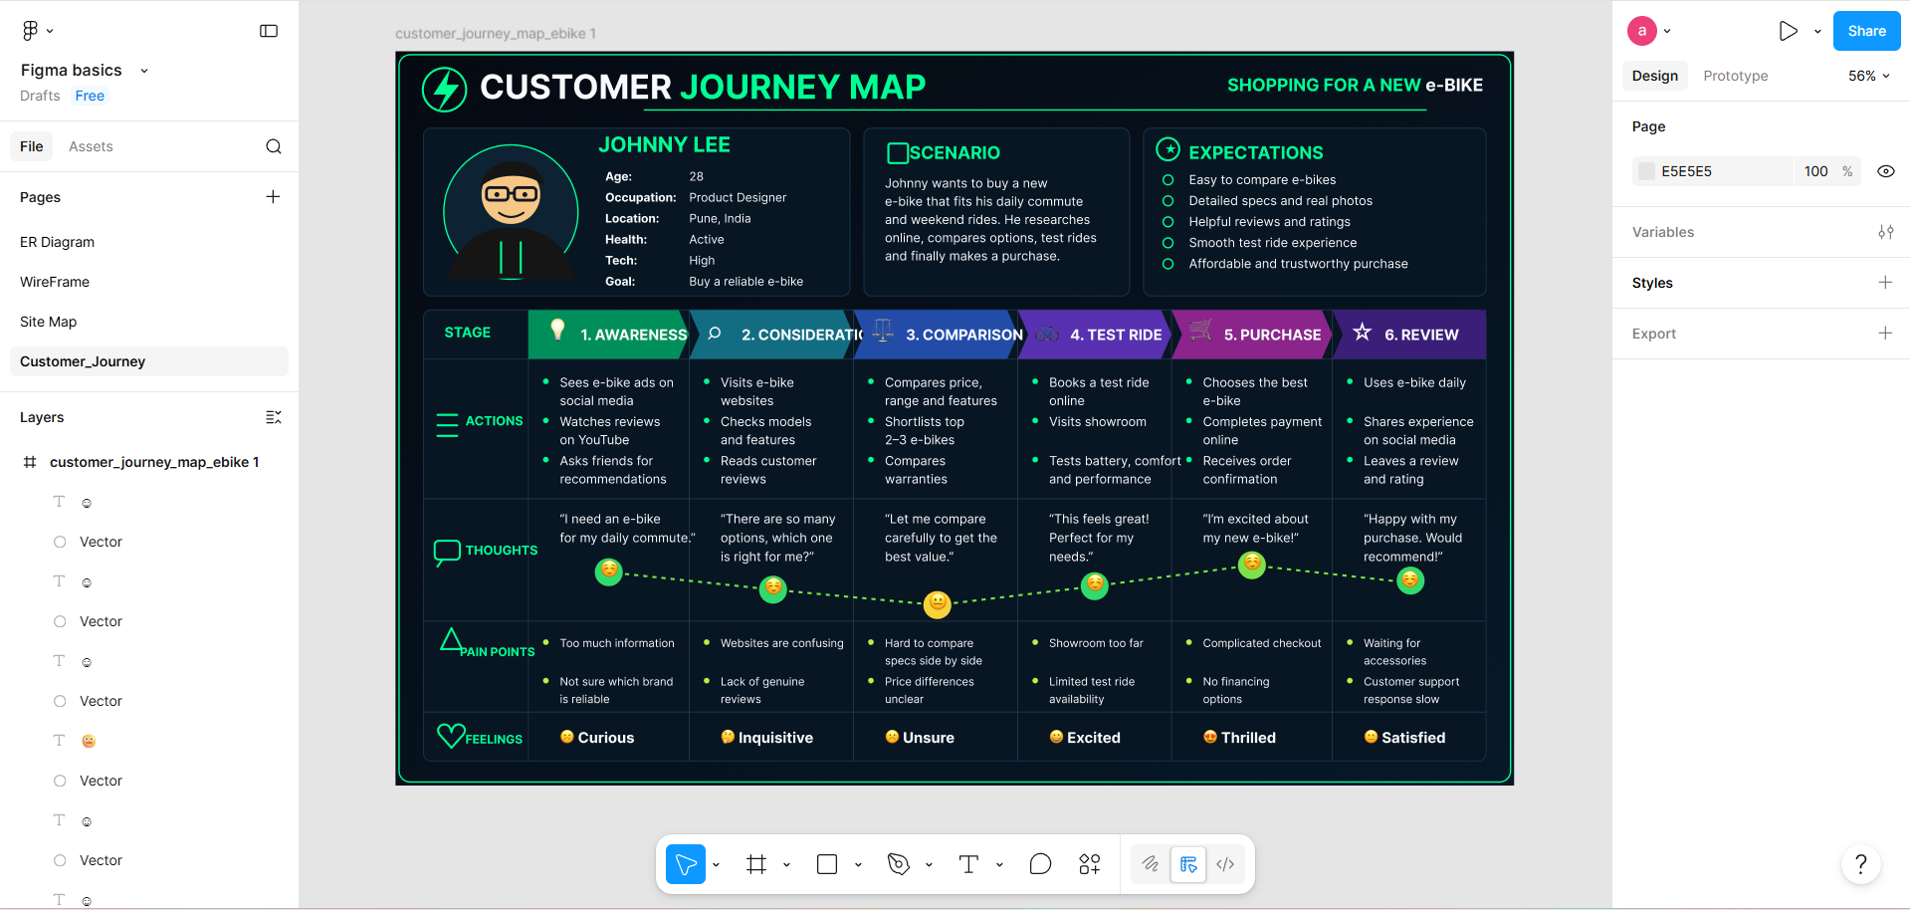
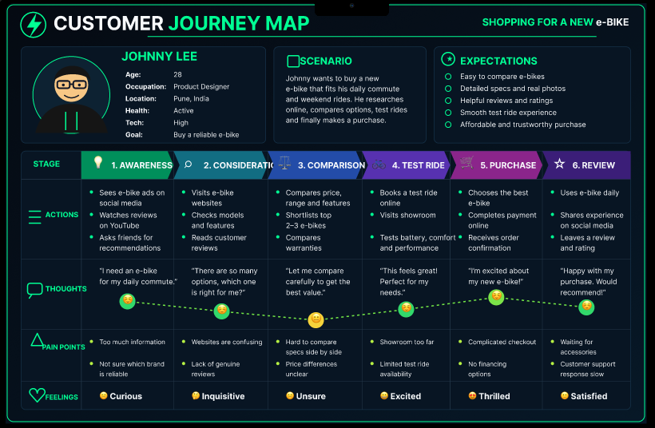

Experiment No - 7
Q. Entity-Relationship diagram.
ER Diagram stands for Entity Relationship Diagram, also known as ERD is a diagram that displays the relationship of entity sets stored in a database. In other words, ER diagrams help to explain the logical structure of databases. ER diagrams are created based on three basic concepts: entities, attributes and relationships.
ER Diagrams contain different symbols that use rectangles to represent entities, ovals to deZine attributes and diamond shapes to represent relationships.
ER Model stands for Entity Relationship Model is a high-level conceptual data model diagram. ER model helps to systematically analyse data requirements to produce a well designed database. The ER Model represents real-world entities and the relationships between them. Creating an ER Model in DBMS is considered as a best practice before implementing your database.
Some E-R model notations are:
1. Entity: entity is a thing or object that can be distinguished.
Ex: a person is an entity as every person is distinguishable.
2. Attribute: each entity has a set of attributes.
Ex: entity person has attributes like name age address gender etc
3. Relationship: relationship is an association among several entities . example and enquiry relationship is there between customer entity and Railway entity.
Some Notations of E-R model are:
1. Rectangle: It represent entity set.

2. Ellipse: It represent attributes.

3. Diamond: It represents relationship among entity set

4. Line: Line lies between the attribute entity and entity to relationship.

Link: https://www.figma.com/design/L3boFBeuuEpsMRQqnniBWc/Figma-basics?node-id=1669-162202&p=f&t=2lupTw42GKtY8PHg-0
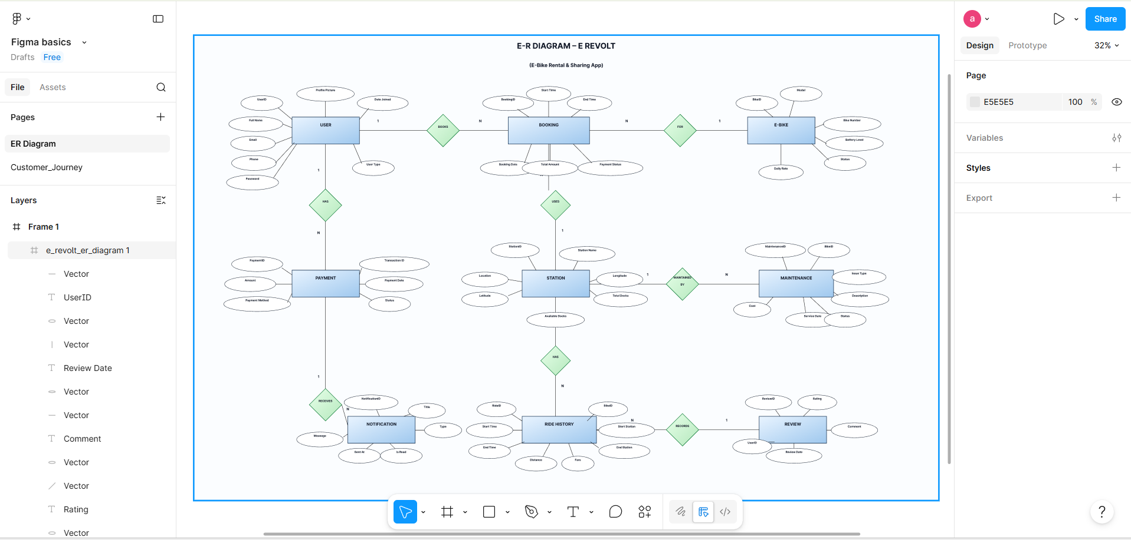

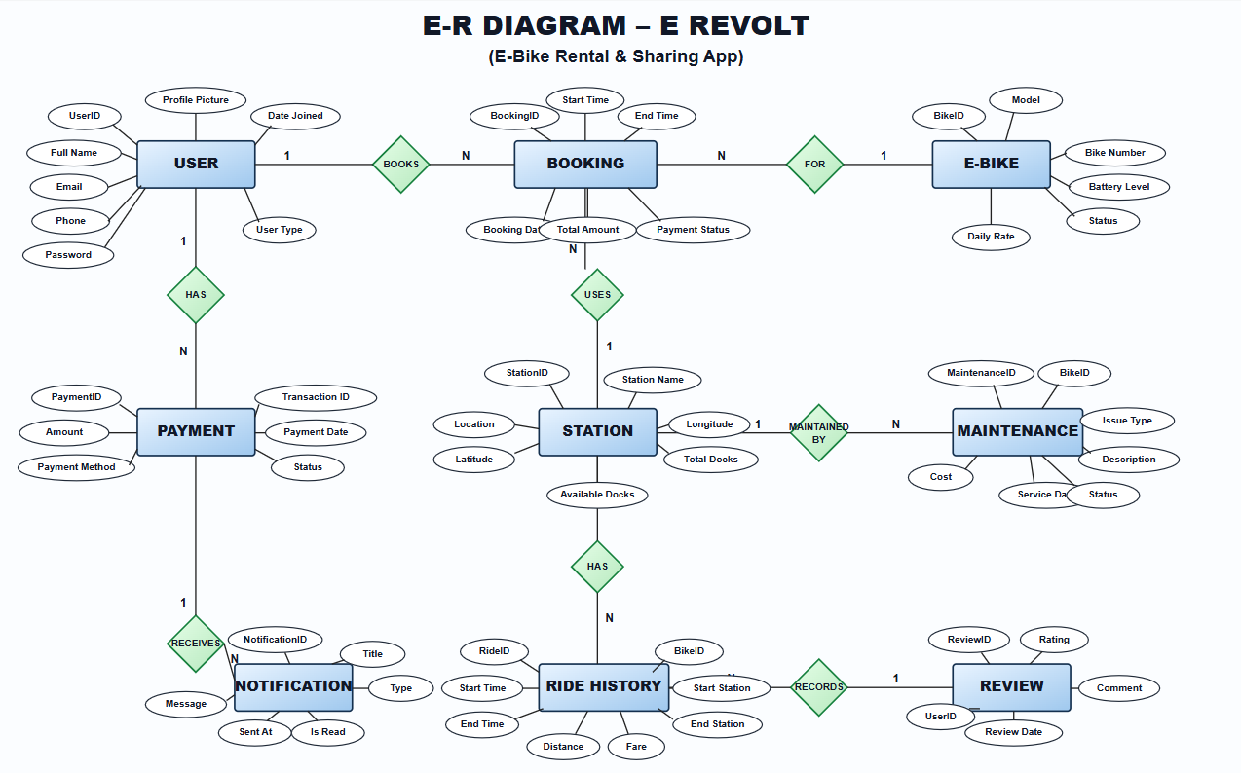

Experiment No - 8

Q. Creation of scenario - Story Board.
Link: https://anchalsingh1708.github.io/e-revolt-storyboard/
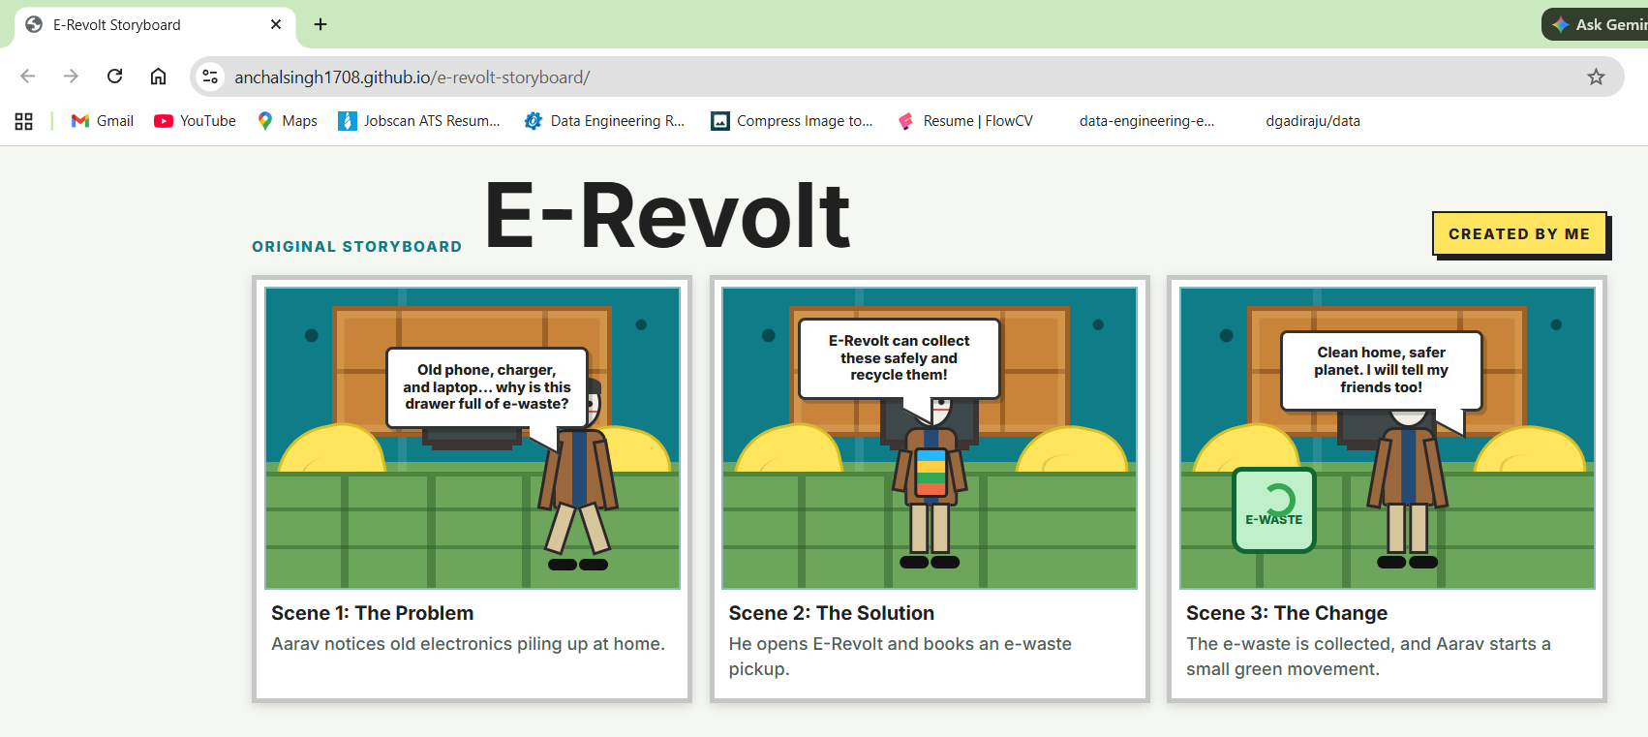
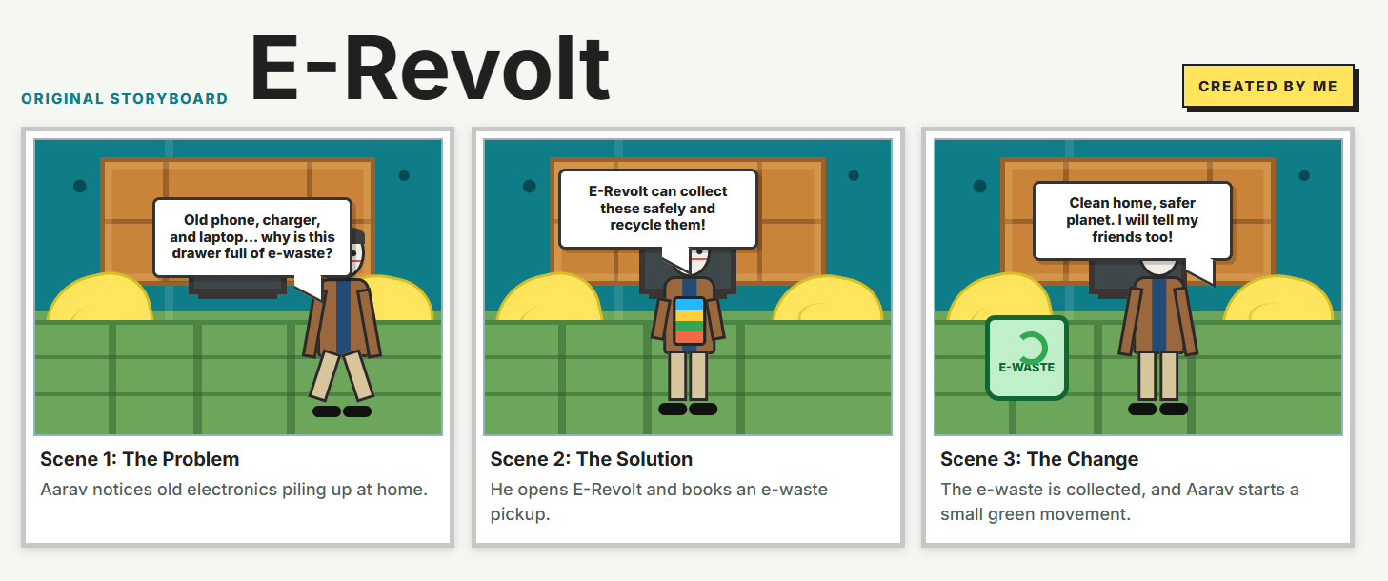

Experiment No - 9

Q. Create Mind Map/ Site map
Link: https://www.figma.com/design/L3boFBeuuEpsMRQqnniBWc/Figma-basics?node-id=627-3&t=ewXXryCJUuc8hqfG-0
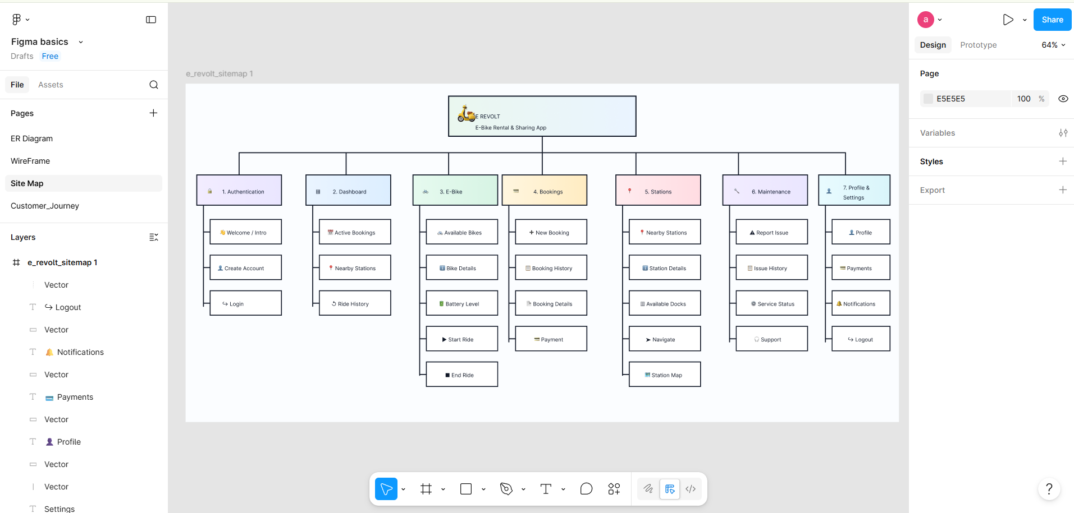
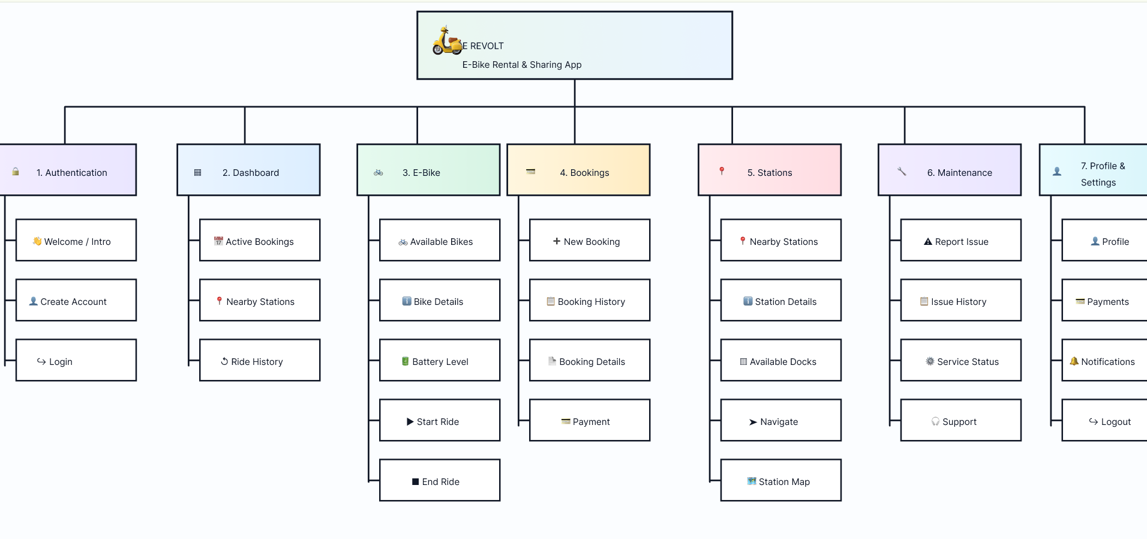

Experiment No - 10
Q. Create Wire framing
Link: https://www.figma.com/design/L3boFBeuuEpsMRQqnniBWc/Figma-basics?node-id=621-497&p=f&t=2lupTw42GKtY8PHg-0
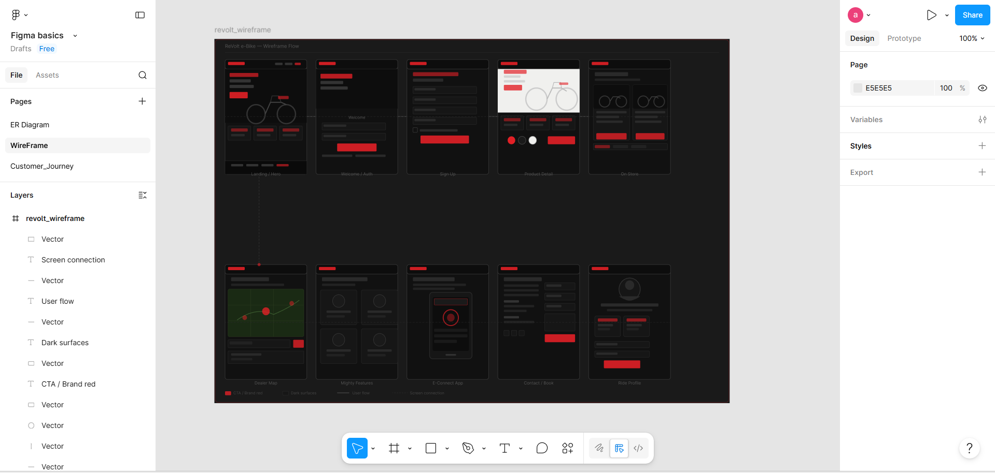
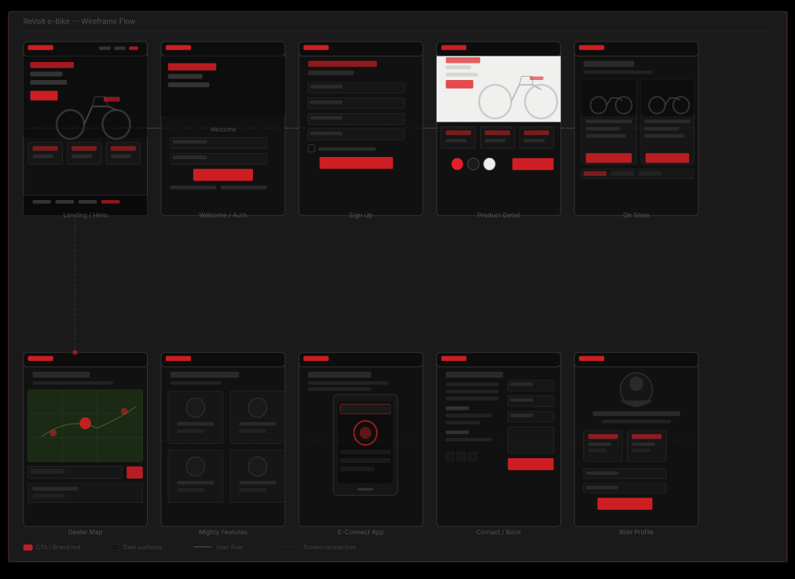

Experiment No - 11
Q. Create Prototype
Link:https://www.figma.com/design/cWwJo17kUoxeFljqyR4p1q/Wireframe_119?node-id=0-1&p=f&t=5rWUWPh05AQxFdmb-0
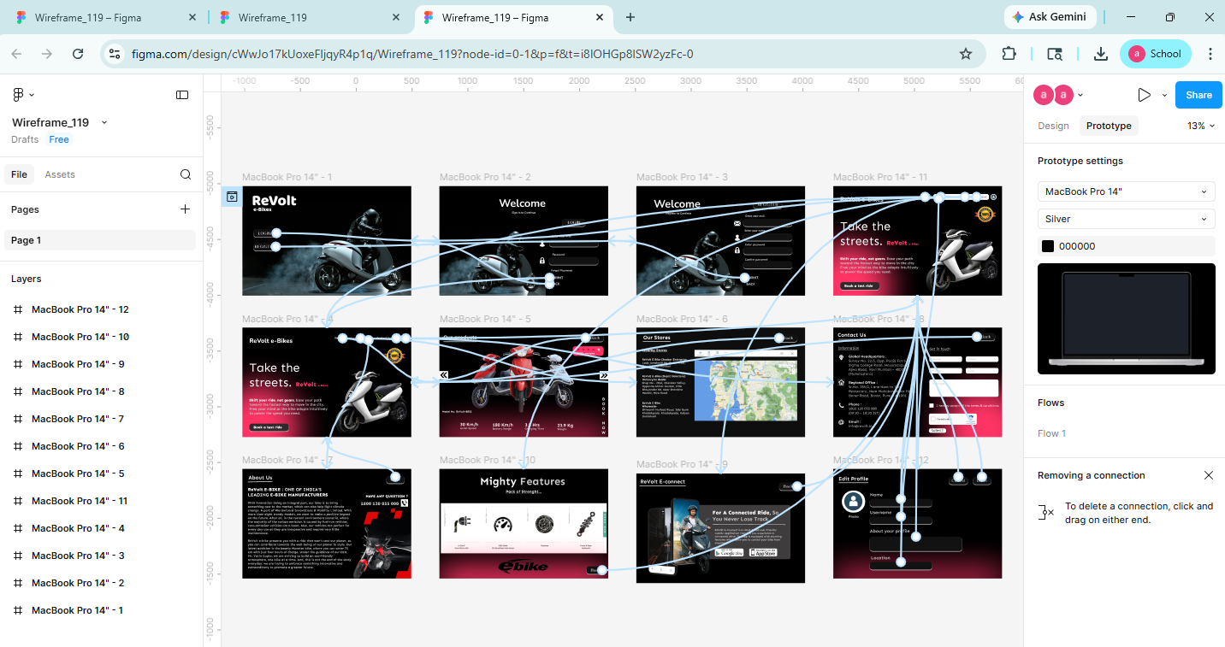
Home Page
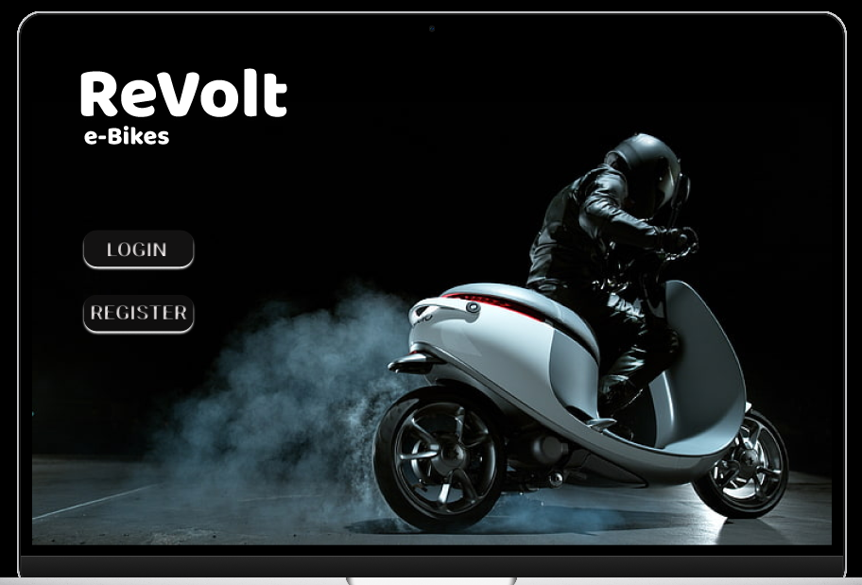
Login
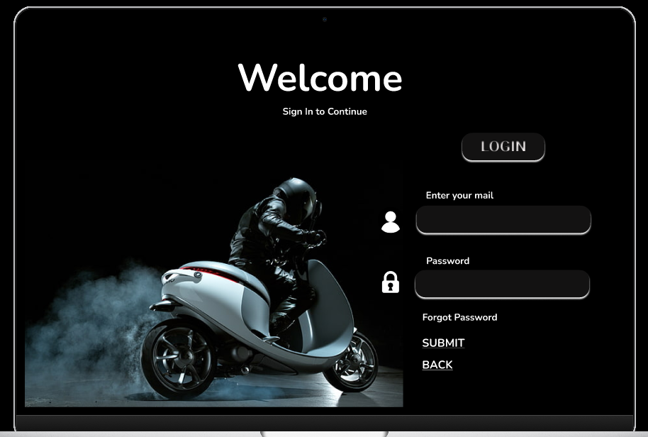
Register:
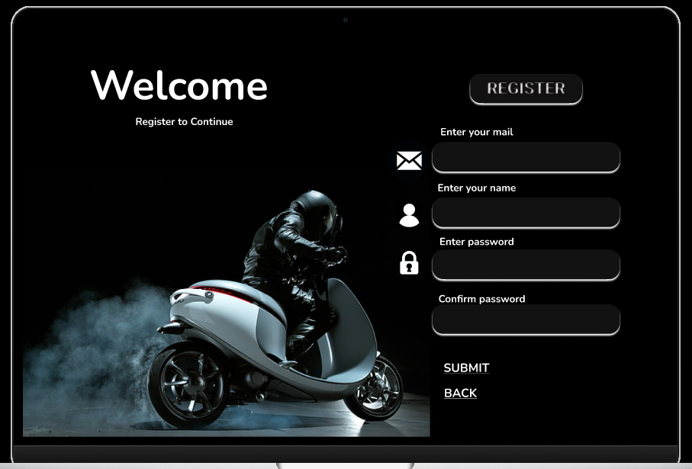
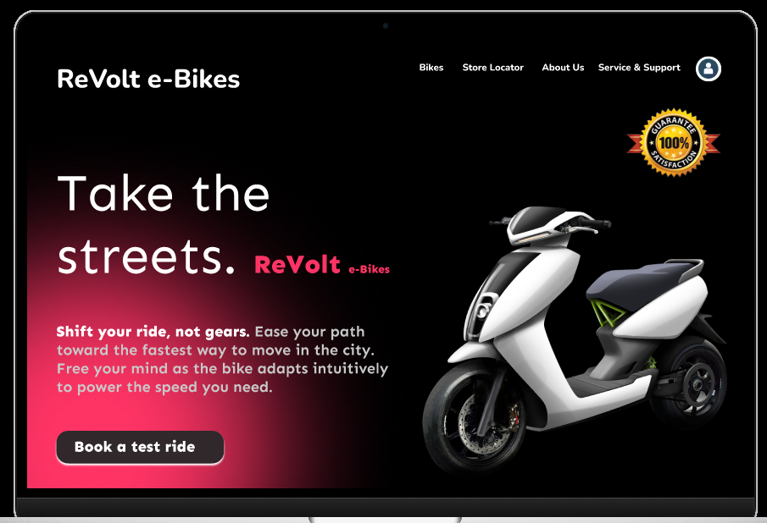
Bikes
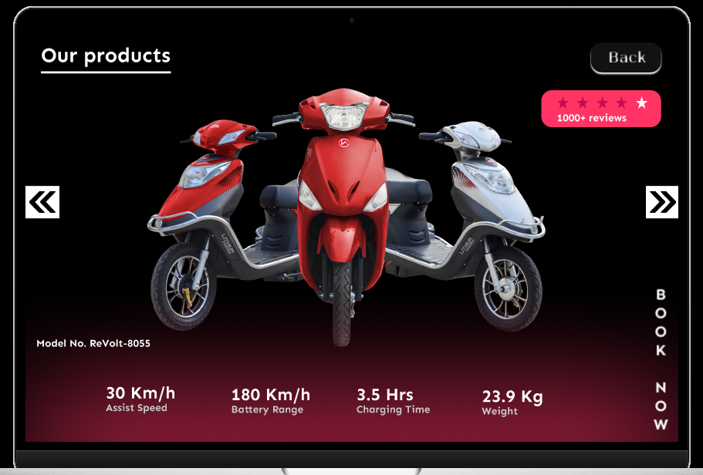

Stores:
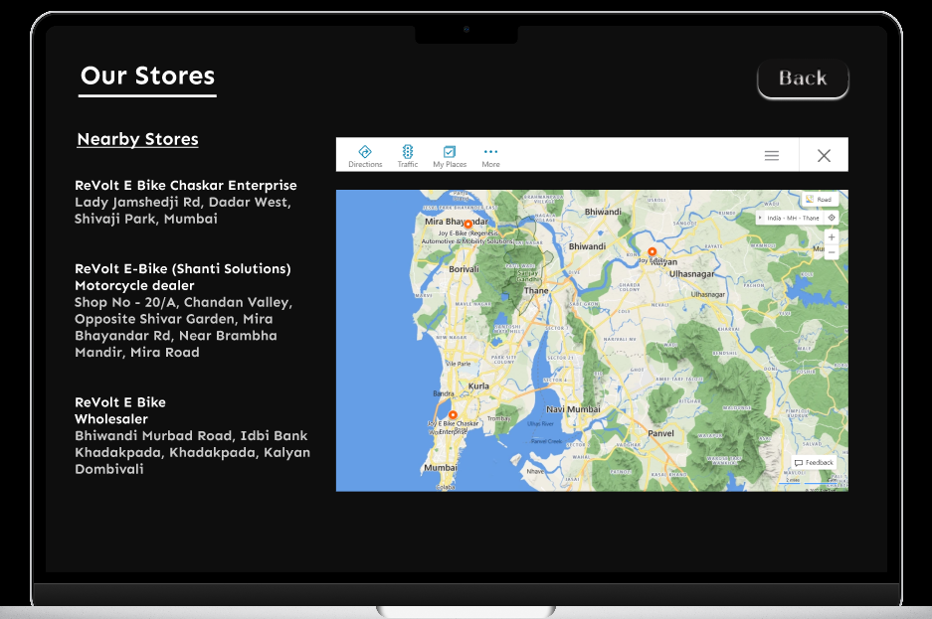
About Us:
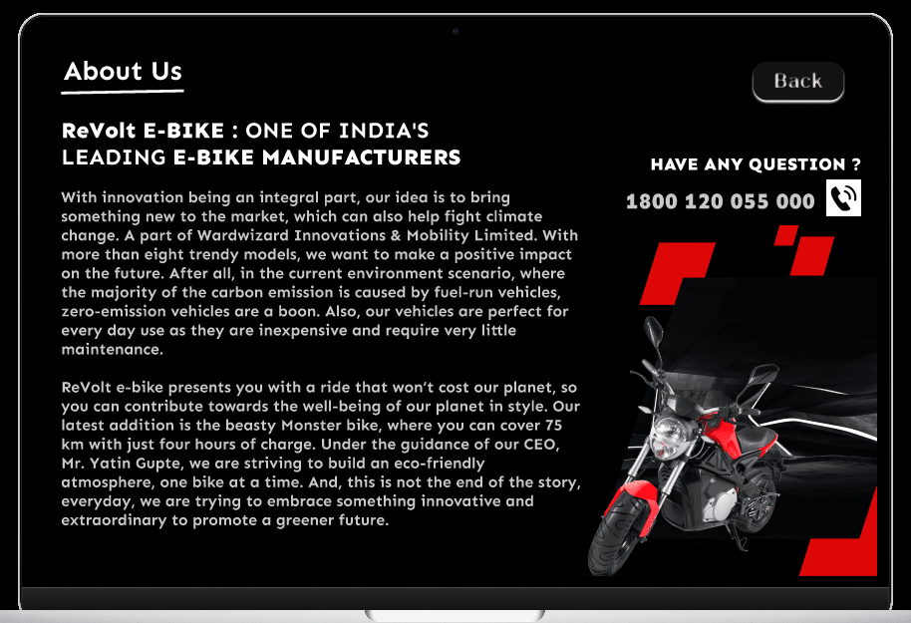
Contact Us:
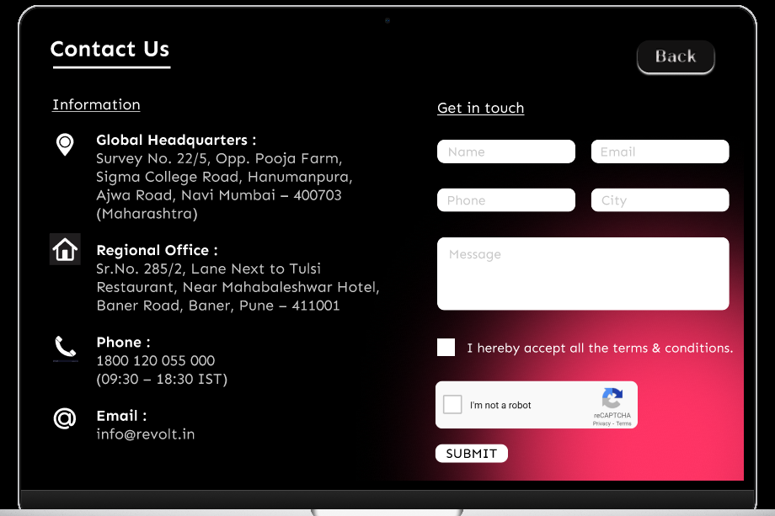
Features
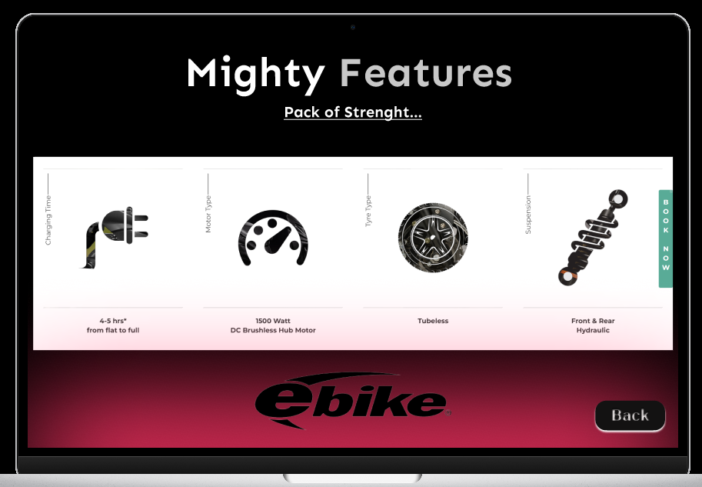

Experiment No - 12

Q. Usability Evaluation of the Design Testing of User Interface from Third Party (Test scripts).
Testing is the process of executing a program to Zind errors. To make our software perform well it should be error-free. If testing is done successfully, it will remove all the errors from the software.
Types of Testing:
1. Unit Testing:
It focuses on the smallest unit of software design. In this, we test an individual unit or group of interrelated units. It is often done by the programmer by using sample input and observing its corresponding outputs.
2. Integration Testing:
The objective is to take unit-tested components and build a program structure that has been dictated by design. Integration testing is testing in which a group of components is combined to produce output.
3. Regression Testing:
Every time a new module is added leads to changes in the program. This type of testing makes sure that the whole component works properly even after adding components to the complete program.
4. Smoke Testing:
This test is done to make sure that the software under testing is ready or stable for further testing. It is called a smoke test as the testing of an initial pass is done to check if it did not catch the Zire or smoke in the initial switch on.
5. Alpha Testing:
This is a type of validation testing. It is a type of acceptance testing which is done before the product is released to customers. It is typically done by QA people.

6. Beta Testing:
The beta test is conducted at one or more customer sites by the end-user of the software. This version is released for a limited number of users for testing in a Realtime environment
7. System Testing:
This software is tested such that it works Zine for the different operating systems. It is covered under the black box testing technique. In this, we just focus on the required input and output without focusing on internal working.
8. Stress Testing:
In this, we give unfavorable conditions to the system and check how they perform in those conditions.
9. Performance Testing:
It is designed to test the run-time performance of software within the context of an integrated system.
10. Acceptance Testing:
Acceptance testing is done by the customers to check whether the delivered products perform the desired tasks or not, as stated in requirements.

Usability evaluation checks whether the interface is easy to understand, navigate, and complete. For the E-Revolt project, the testing focuses on the main user tasks such as opening the Home page, logging in, registering, browsing bike information, viewing stores, checking features, and contacting the business.
Test Script:
Sr No. | Task | Expected Result | Result
1 | Open the prototype/home page | Home page should load clearly with visible navigation | Pass
2 | Go to Login page | Login form should be visible and understandable | Pass
3 | Go to Register page | User should identify fields required for registration | Pass
4 | Open Bikes section | Bike information should be visible and easy to scan | Pass
5 | Open Stores section | Store details should be accessible | Pass
6 | Open About Us and Contact Us | User should understand company purpose and contact path | Pass
7 | Review Features page | Important features should be communicated clearly | Pass

Conclusion:
The E-Revolt interface is suitable for the intended electric bike discovery flow. The screens are organized around common user actions and the prototype provides a clear path between the major sections of the project.

