Practical 1
- To install Node.js on the system and verify its successful installation
Installation & verification
Steps:
1. Open a web browser and go to the official Node.js website:
https://nodejs.org/en/download & on the homepage, download the LTS (Long-Term Support) version of Node.js suitable for your operating system.
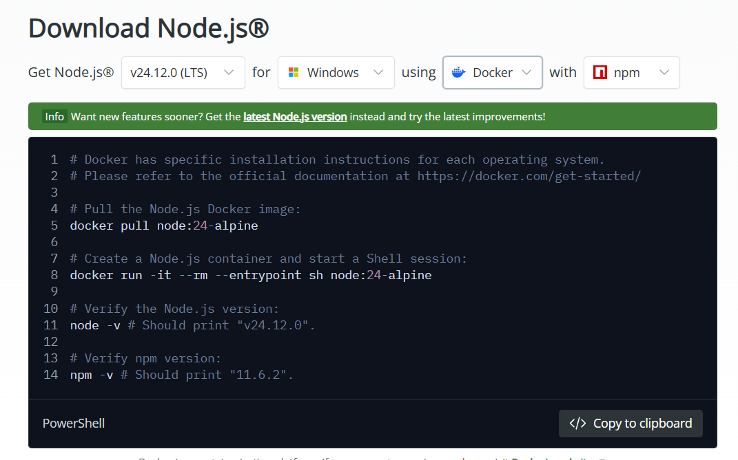
2. Once the installer is downloaded, double-click on it to start the installation & Follow the installation wizard:
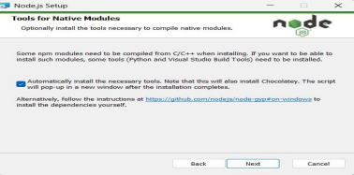
Accept the License Agreement
2. Choose the installation path (default is recommended)
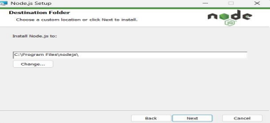3. Select the default components (Custom Setup) and click Next
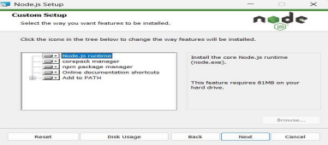
4. Click Install
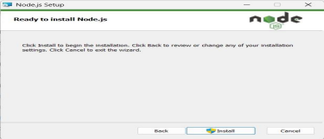

5. Wait until the installation is completed
Prompt / Terminal to verify installation & Type the following commands to check the version:
∙ node -v → Displays Node.js version
∙ npm -v → Displays npm (Node Package Manager) version

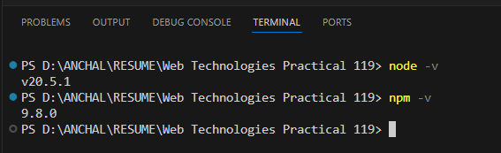

- To execute basic Node.js console programs for arithmetic

a) Addition of two numbers
let a = 5;
let b = 7;
let c = a + b;
console.log(c);
Output:
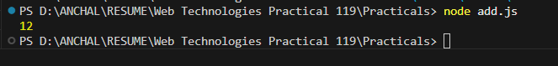

b) Creating a simple calculator
arithmetic.js
function add(a, b) {
return a + b;
}
function subtract(a, b) {
return a - b;
}
function multiply(a, b) {
return a * b;
}
function divide(a, b) {
if (b === 0) {
return "Error: Division by zero";
}
return a / b;
}
module.exports = { add, subtract, multiply, divide };

index.js
const arithmetic = require('./arithmetic');
const num1 = 10;
const num2 = 5;
console.log(`Addition of ${num1} and ${num2}: ${arithmetic.add(num1, num2)}`);
console.log(`Subtraction of ${num1} and ${num2}: ${arithmetic.subtract(num1, num2)}`);
console.log(`Multiplication of ${num1} and ${num2}: ${arithmetic.multiply(num1, num2)}`);
console.log(`Division of ${num1} by ${num2}: ${arithmetic.divide(num1, num2)}`);

Output :
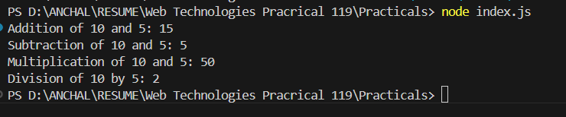

Practical 2
To implement iterative logic using Node.js loops

a) do…while loop
let a = 4;
let i = 1;
do {
console.log(a * i);
i++;
} while (i <= 10);

Output:
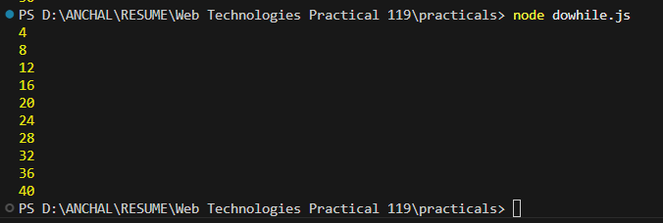

b) for loop
a = 5;
for (i = 1; i <= 10; i++) {
console.log(a * i);

}

Output:
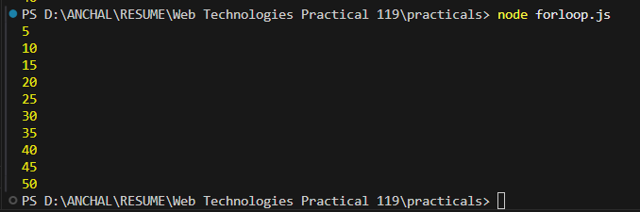

Practical 3
To demonstrate mathematical table generation and conditional logic

a) Table of 2
Code:

// Table of 2
console.log("Table of 2:");
for (let i = 1; i <= 10; i++) {
console.log(`2 x ${i} = ${2 * i}`);
}

Output:
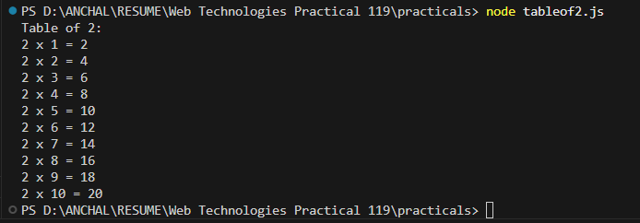

b) Table of 3
Code:
// Table of 3
console.log("\nTable of 3:");
for (let i = 1; i <= 10; i++) {
console.log(`3 x ${i} = ${3 * i}`);
}

Output:
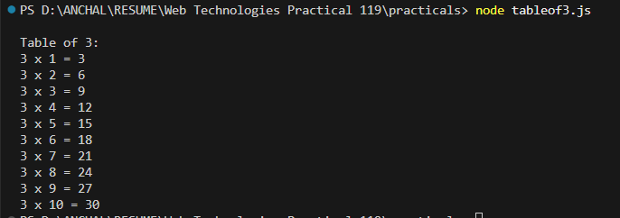

c) Greatest of three numbers
Code:
// Greatest of 3 numbers
let a = 10;
let b = 25;
let c = 15;
let greatest;

if (a >= b && a >= c)
{
greatest = a;
} else if (b >= a && b >= c) {
greatest = b;
} else {
greatest = c;
}

console.log(`\nGreatest number is: ${greatest}`);

Output:
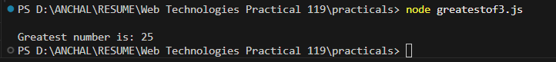

Practical 4
To demonstrate nested loop structures for pattern printing

- Create an Application in NodeJS to print * patterns

// Function to print a square of stars
function squarePattern(size) {
console.log("Square Pattern:");
for (let i = 0; i < size; i++) {
console.log("* ".repeat(size));}
console.log("\n");}
// Function to print a right-angled triangle
function trianglePattern(size)
{
console.log("Triangle Pattern:");
for (let i = 1; i <= size; i++)
{
console.log("* ".repeat(i));
}
console.log("\n");}
// Function to print a pyramid
function pyramidPattern(size)
{
console.log("Pyramid Pattern:");
for (let i = 1; i <= size; i++)
{
let spaces = " ".repeat(size - i);
let stars = "* ".repeat(i);
console.log(spaces + stars);
}
console.log("\n");
}
// Set the size of patterns
const size = 5;
squarePattern(size);
trianglePattern(size);
pyramidPattern(size);

Output:

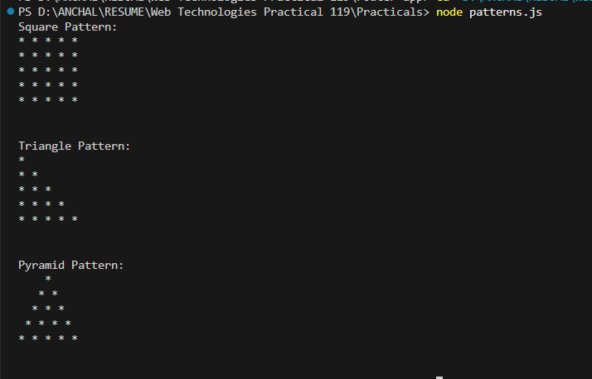

Practical 5
To implement number property checks and ranges

a) Odd or Even
Code:
function checkOddOrEven(num){
if(num % 2 == 0){
console.log(num+" is an Even Number")
}else{
console.log(num+" is an Odd Number")
}
}
const number = 17;
checkOddOrEven(number);

Output:
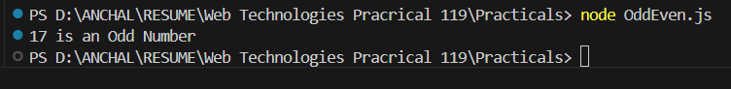

b) Prime numbers (1–50)
Code:
function isPrime(num) {
if (num <= 1) return false;
for (let i = 2; i <= Math.sqrt(num); i++) {
if (num % i === 0) {
return false;
}
}
return true;
}
for (let i = 1; i <= 50; i++) {
if (isPrime(i)) {
console.log(i);
}
}

Output :

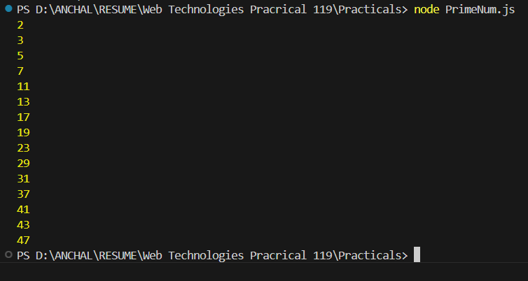

Practical 6
To study digit manipulation and mathematical constants

Reverse number
Code:
function reverseNumber(num){
if(num<1000 || num>9999){
console.log("Please enter valid four digit number");
return;
}
const reverseNum=num.toString().split('').reverse().join('');
return parseInt(reverseNum);
}
const number =1234;
const reversed = reverseNumber(number);
console.log("Orignal :" +number);
console.log("Reversed :" + reversed);

Output :
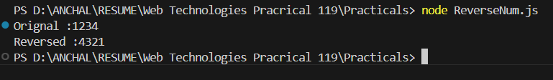

Armstrong number
Code:
function isArmstrong(num) {
const numStr = num.toString();
const numDigits = numStr.length;
let sum = 0;
let temp = num;
while (temp > 0) {
const digit = temp % 10;
sum += Math.pow(digit, numDigits);
temp = Math.floor(temp / 10);
}
if (sum === num) {
console.log(num + " is an Armstrong number!");
} else {
console.log(num + " is not an Armstrong number.");
}
}
isArmstrong(153);
Output:

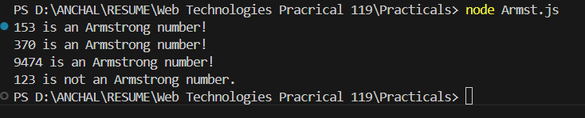

Practical 7
To implement series generation and unit conversion

a) Fibonacci series
Code:
function printFibonacci(n) {
let a = 0, b = 1, next;
console.log("Fibonacci Series up to " + n + " terms:");
for (let i = 1; i <= n; i++) {
console.log(a);
next = a + b;
a = b;
b = next;
}
}
const prompt = require('prompt-sync')();
const numTerms = parseInt(prompt("Enter the number of terms for Fibonacci series: "));
printFibonacci(numTerms);
Output:

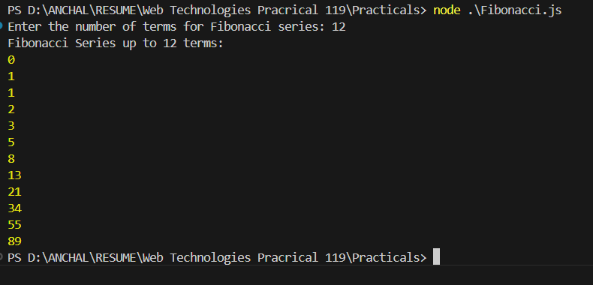

b) Temperature conversion
Code:
const prompt = require('prompt-sync')();
function celsiusToFahrenheit(celsius) {
return (celsius * 9/5) + 32; }
function fahrenheitToCelsius(fahrenheit) {
return (fahrenheit - 32) * 5/9; }
console.log("Choose the conversion type:");
console.log("1. Celsius to Fahrenheit");
console.log("2. Fahrenheit to Celsius");
const choice = prompt("Enter 1 or 2 to choose conversion: ");
if (choice === "1") {
const celsius = parseFloat(prompt("Enter temperature in Celsius: "));
const fahrenheit = celsiusToFahrenheit(celsius);
console.log(`${celsius}°C is equal to ${fahrenheit}°F`);
} else if (choice === "2") {
const fahrenheit = parseFloat(prompt("Enter temperature in Fahrenheit: "));
const celsius = fahrenheitToCelsius(fahrenheit);
console.log(`${fahrenheit}°F is equal to ${celsius}°C`);
} else {
console.log("Invalid choice. Please enter 1 or 2.");
}
Output:
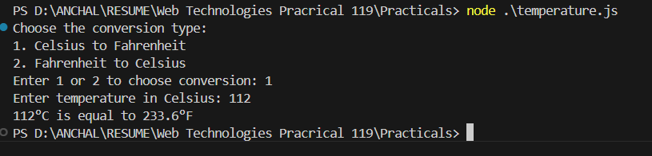

Practical 8
To demonstrate the use of Anonymous Functions in Node.js

a) Factorial
Code:
const prompt = require('prompt-sync')();
const number = parseInt(prompt("Enter a number: "));
if (isNaN(number) || number < 0) {
console.log("Please enter a valid non-negative integer.");
} else {
const factorial = function(num) {
return num === 0 ? 1 : num * factorial(num - 1);
};
console.log(`The factorial of ${number} is: ${factorial(number)}`);
}

Output :

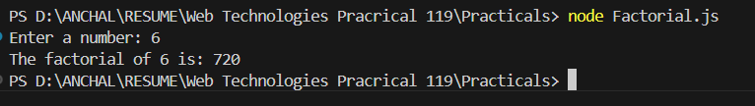

b) Pattern using anonymous function

Code:

const generatePattern = (rows) => {
const patternLine = (i) => Array.from({ length: i }, (_, idx) => idx + 1).join(" ");
for (let i = 1; i <= rows; i++) {
console.log(patternLine(i));
}
}
const rows = 5;
generatePattern(rows);

Ouput:

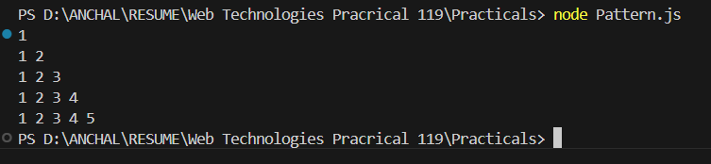

Practical 9
To study asynchronous behavior and callback functions

a) Arithmetic using callbacks

Code:
function add(a, b, callback) {
const result = a + b;
callback(null, result); }
function subtract(a, b, callback) {
const result = a - b;
callback(null, result); }
function multiply(a, b, callback) {
const result = a * b;
callback(null, result); }
function divide(a, b, callback) {
if (b === 0) {
callback("Error: Division by zero is not allowed", null);
} else {
const result = a / b;
callback(null, result); }}
function main() {
const a = 10, b = 5;
console.log("Performing Arithmetic Operations Using Callbacks:");
add(a, b, (err, result) => {
if (err) {
console.error(err);
} else {
console.log(`Addition: ${a} + ${b} = ${result}`); }
});
subtract(a, b, (err, result) => {
if (err) {
console.error(err);
} else {
console.log(`Subtraction: ${a} - ${b} = ${result}`); }
});
multiply(a, b, (err, result) => {
if (err) {
console.error(err);
} else {
console.log(`Multiplication: ${a} * ${b} = ${result}`);}
});
divide(a, b, (err, result) => {
if (err) {
console.error(err);
} else {
console.log(`Division: ${a} / ${b} = ${result}`);}
});}
main();
Output:
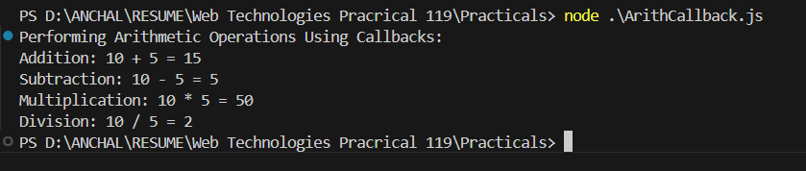

b) Write a program to demonstrate the setTimeout function

const delayedTask = () => {
console.log("This message is displayed after a 3-second delay.");
};
console.log("Program started. Waiting for 3 seconds...");
console.log("You will see this message immediately after the program starts.");

Output:

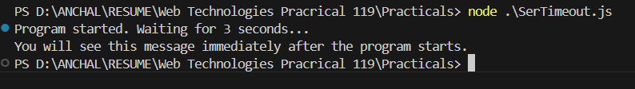

Practical 10
To implement modularity in Node.js using require and exports

a) Arithmetic module
arithmetic.js
function add(a, b) {
return a + b;}

function subtract(a, b) {
return a - b;}

function multiply(a, b) {
return a * b;}

function divide(a, b) {
if (b === 0) {
return "Error: Division by zero"; }
return a / b;}
module.exports = { add, subtract, multiply, divide };

index.js
const arithmetic = require('./arithmetic');
const num1 = 10;
const num2 = 5;
console.log(`Addition of ${num1} and ${num2}: ${arithmetic.add(num1, num2)}`);
console.log(`Subtraction of ${num1} and ${num2}: ${arithmetic.subtract(num1, num2)}`);
console.log(`Multiplication of ${num1} and ${num2}: ${arithmetic.multiply(num1, num2)}`);
console.log(`Division of ${num1} by ${num2}: ${arithmetic.divide(num1, num2)}`);
Output :

b) Using modules, index the Area of a Circle, Rectangle, Square
area.js
function circle(radius) {
if (radius < 0) return "Invalid radius";
return Math.PI * radius * radius; }
function rectangle(length, width) {
if (length < 0 || width < 0) return "Invalid dimensions";
return length * width; }
function square(side) {
if (side < 0) return "Invalid side length";
return side * side; }
module.exports = { circle, rectangle, square };
console.log("Exported object:", module.exports);
Index1.js
const area = require('./area');
console.log("Imported area module:", area);
const radius = 5; const length = 10; const width = 6; const side = 4;
console.log(`Area of Circle with radius ${radius}:`, area.circle(radius));
console.log(`Area of Rectangle with length ${length} and width ${width}:`, area.rectangle(length, width));
console.log(`Area of Square with side ${side}:`, area.square(side));
Output :
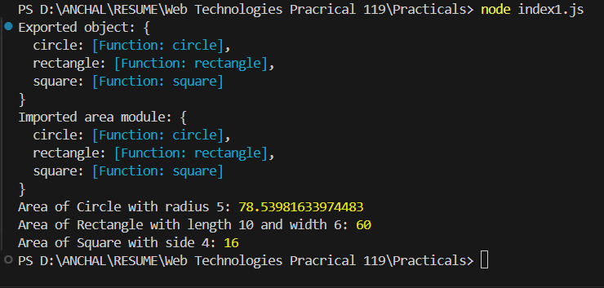

Practical 11
To implement user input processing and grading logic
- Write a program to take the marks of four subjects from user and check if the student has passed the examination or not, calculate percentage and grade

Code:
const prompt = require('prompt-sync')();
const subject1 = parseFloat(prompt("Enter marks for subject 1: "));
const subject2 = parseFloat(prompt("Enter marks for subject 2: "));
const subject3 = parseFloat(prompt("Enter marks for subject 3: "));
const subject4 = parseFloat(prompt("Enter marks for subject 4: "));
let passStatus;
if (subject1 >= 40 && subject2 >= 40 && subject3 >= 40 && subject4 >= 40) {
passStatus = 'Passed';
} else {
passStatus = 'Failed';
}
const totalMarks = subject1 + subject2 + subject3 + subject4;
const percentage = (totalMarks / 400) * 100;
function calculateGrade(percentage) {
if (percentage >= 90) {
return 'A+';
} else if (percentage >= 80) {
return 'A';
} else if (percentage >= 70) {
return 'B+';
} else if (percentage >= 60) {
return 'B';
} else if (percentage >= 50) {
return 'C+';
} else if (percentage >= 40) {
return 'C';
} else {
return 'F';
}
}
const grade = calculateGrade(percentage);
console.log(`Total Marks: ${totalMarks}/400`);
console.log(`Percentage: ${percentage}%`);
console.log(`Status: ${passStatus}`);
console.log(`Grade: ${grade}`);

Output :

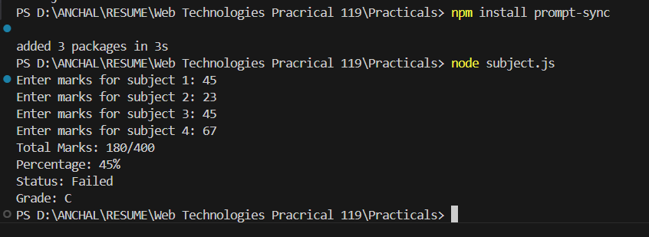

Practical 12
To manage event listeners using EventEmitter
Write an application to demonstrate functions (removeListner, listnerCount).

Code:

const events = require("events");
const eventEmitter = new events.EventEmitter();
function listner1(){
console.log("Event received by Listner 1");
}

function listner2(){
console.log("Event received by Listner 2");
}
eventEmitter.addListener("write", listner1);
eventEmitter.on("write", listner2);
eventEmitter.emit("write");
console.log(eventEmitter.listenerCount("write"));

eventEmitter.removeListener("write", listner1);
console.log("Listner 1 is removed");
eventEmitter.emit("write");

console.log(eventEmitter.listenerCount("write"));
console.log("Program ended...");

Output:

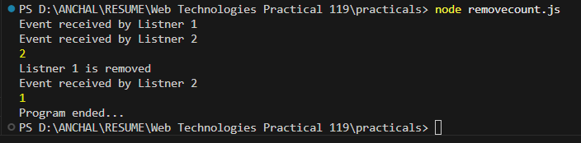

Practical 13
To implement advanced EventEmitter patterns

a) Create an application in node.js to create a Return Event Emitter.
EventEmitter.js

const EventEmitter = require('events').EventEmitter;

function LoopProcessor(num) {
const e = new EventEmitter();

setTimeout(function () {
for (let i = 1; i <= num; i++) {
e.emit("BeforeProcess", i);
console.log("processing number: " + i);
e.emit("AfterProcess", i);
}
}, 2000);

return e;
}

const lp = LoopProcessor(3);

lp.on("BeforeProcess", function (data) {
console.log("About to start the process for " + data);
});

lp.on("AfterProcess", function (data) {
console.log("Complete processing " + data);
});

Output:
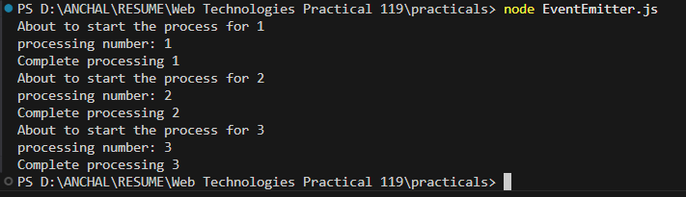

b) Create an application in node.js to create an Extent Event Emitter.

ExtentEventEmit.js

var emitter = require("events").EventEmitter;
var util = require("util");
function LoopProcessor(num) {
var me = this;
setTimeout(function () {
for (var i = 1; i <= num; i++) {
me.emit("BeforeProcess", i);
console.log("processing number: " + i);
me.emit("AfterProcess", i); }
}, 2000);
return this; }
util.inherits(LoopProcessor, emitter);
var lp = new LoopProcessor(3);
lp.on("BeforeProcess", function (data) {
console.log("About to start the process for " + data);
});
lp.on("AfterProcess", function (data) {
console.log("Completed processing " + data);
});
Output:
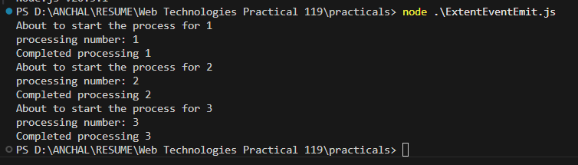

Practical 14
To apply event-driven programming to business workflow
Write a program to place the order for a pizza using the EventsEmitter class

Code:
const EventEmitter = require("node:events");
const emitter = new EventEmitter();

// Listener 1
emitter.on("order-pizza", (size, toppings) => {
console.log(`Order received! Baking a ${size} pizza with ${toppings} toppings.`);
});

// Listener 2
emitter.on("order-ready", () => {
console.log("Order is ready !!!");
});

// Emit events
emitter.emit("order-pizza", "Large", "Onion");
emitter.emit("order-pizza", "Small", "Peppe Paneer");

setTimeout(() => {
emitter.emit("order-ready");
}, 4000);

//Class
const EventEmitter2 = require("events");

class PizzaOrder extends EventEmitter2 {}

const pizzaShop = new PizzaOrder();

// Event 1
pizzaShop.on("orderPlaced", (customerName, pizzaType) => {
console.log(`Order placed by ${customerName} for a ${pizzaType} pizza.`);

setTimeout(() => {
pizzaShop.emit("preparing", customerName, pizzaType);
}, 2000);
});

// Event 2
pizzaShop.on("preparing", (customerName, pizzaType) => {
console.log(`Preparing the ${pizzaType} pizza for ${customerName}.`);

setTimeout(() => {
pizzaShop.emit("delivering", customerName, pizzaType);
}, 3000);
});

// Event 3
pizzaShop.on("delivering", (customerName, pizzaType) => {
console.log(`Delivering the ${pizzaType} pizza to ${customerName}.`);

setTimeout(() => {
pizzaShop.emit("delivered", customerName, pizzaType);
}, 2000);
});

// Event 4
pizzaShop.on("delivered", (customerName, pizzaType) => {
console.log(`The ${pizzaType} pizza has been delivered to ${customerName}. Enjoy your meal!`);
});

console.log("Welcome to Pizza Shop!");

setTimeout(() => {
pizzaShop.emit("orderPlaced", "Anchal Singh", "Cheese & Onion");
}, 1000);

Output:
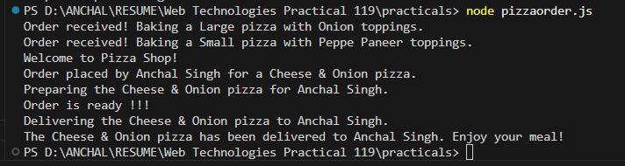

Practical 15
To apply event-driven programming to financial calculations

Write a program to calculate the salary using the EventEmitter class

Code:
const EventEmitter = require('events');
class SalaryCalculator extends EventEmitter {}
const salaryEmitter = new SalaryCalculator();
const TAX_RATE = 0.2;
const BONUS = 5000;
const DEDUCTIONS = 2000;
salaryEmitter.on('calculate', (baseSalary) => {
console.log(`Base Salary: $${baseSalary}`);
const tax = baseSalary * TAX_RATE;
salaryEmitter.emit('applyTax', baseSalary, tax); });
salaryEmitter.on('applyTax', (baseSalary, tax) => {
console.log(`Tax Deducted: $${tax}`);
const afterTaxSalary = baseSalary - tax;
salaryEmitter.emit('applyBonus', afterTaxSalary); });
salaryEmitter.on('applyBonus', (afterTaxSalary) => {
console.log(`Bonus Added: $${BONUS}`);
const afterBonusSalary = afterTaxSalary + BONUS;
salaryEmitter.emit('applyDeductions', afterBonusSalary);
});
salaryEmitter.on('applyDeductions', (afterBonusSalary) => {
console.log(`Other Deductions: $${DEDUCTIONS}`);
const finalSalary = afterBonusSalary - DEDUCTIONS;
salaryEmitter.emit('finalSalary', finalSalary);
});
salaryEmitter.on('finalSalary', (finalSalary) => {
console.log(`Final Salary: $${finalSalary}`);
});
const baseSalary = 380000;
console.log("Starting salary calculation...");
salaryEmitter.emit('calculate', baseSalary);

Output:
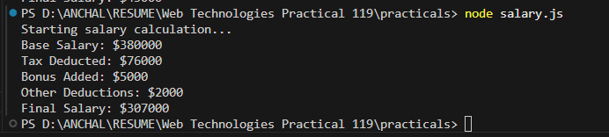

Practical 16
To handle arrays and duplicate event

a) Sum of odd & even
Code:
const EventEmitter = require("events");
const emitter = new EventEmitter();

// Event to calculate sum of odd and even numbers
emitter.on("calculateSum", (arr) => {
let oddSum = 0;
let evenSum = 0;

arr.forEach(num => {
if (num % 2 === 0) {
evenSum += num;
} else {
oddSum += num;
}
});

console.log("Input Array:", arr);
console.log("Sum of Even Numbers:", evenSum);
console.log("Sum of Odd Numbers:", oddSum);
});

// Emit Event
const numbers = [5, 10, 13, 22, 35, 40, 51];
emitter.emit("calculateSum", numbers);

Output:
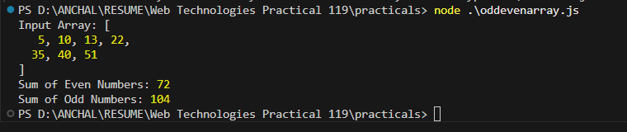

b) Same-name events

Code:
const EventEmitter = require("events");
const pizzaEvent = new EventEmitter();

// Multiple listeners with SAME event name
pizzaEvent.on("order", (name) => {
console.log(`1st Listener: Order placed by ${name}`);
});

pizzaEvent.on("order", (name) => {
console.log(`2nd Listener: Preparing pizza for ${name}`);
});

pizzaEvent.on("order", (name) => {
console.log(`3rd Listener: Pizza ready for ${name}`);
});

// Emit SAME event once → triggers ALL listeners
pizzaEvent.emit("order", "Singh");

// Emit SAME event again
pizzaEvent.emit("order", "Anchal");

Output:

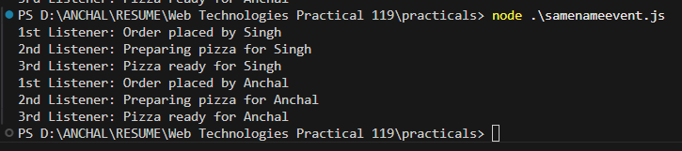

Practical 17
To study and display local system file paths

Path module
Write in application to display details of the current file path.

Code:
const location = require("path");
const localobj = location.parse(__filename);
console.log(localobj);

OUTPUT:
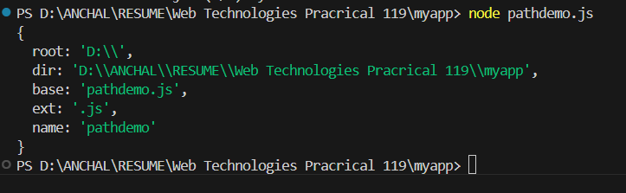

Practical 18
To implement basic file I/O operations using fs module

a) Read file
Write an application to readfile.

CODE:
const fs = require('fs');
fs.readFile("lifecycle.js", 'utf8', function (err, data) {
if (err) {
console.log("Error reading file:", err);
return;
}
console.log("Reading File...");
console.log(data);
});

Output:
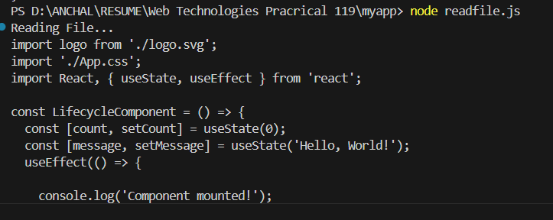

b) Write file
Write an application to write in file.

Code:
const fs = require("fs");
fs.writeFile("input.txt", "Welcome to the live Stream", function (err) {
if (err) {
console.log("Error writing file:", err);
return;
}
console.log("Writing File...");
console.log("File written successfully!");
});

OUTPUT:
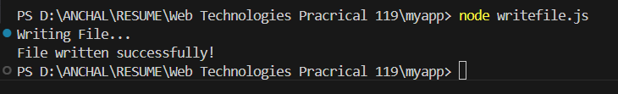
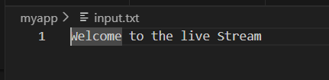

Practical 19
To perform advanced file system operations

a) Append file
Write an application to add data in file.

Code:
const fs = require("fs");
fs.appendFile(
"input.txt",
"\nHello Everyone\nDo like, share & subscribe\n",
function (err) {
if (err) {
console.log("Error while appending:", err);
return;
}
console.log("Append file successful!");
}
);
OUTPUT:
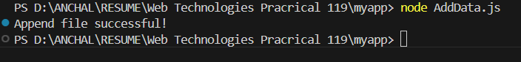
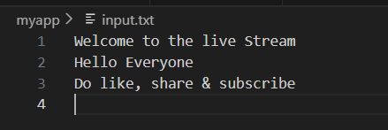

b) Write an application to delete a file.

Code:
const fs = require("fs");
fs.unlink("input.txt", function (err) {
if (err) {
console.log("Error deleting file:", err);
return;
}
console.log("Deleting File...");
console.log("File Deleted Successfully!");
});

OUTPUT:
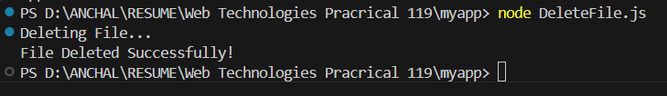

c) Arrow functions
Code:
// Creating an Arrow Function
const pattrn = (num) => {
for (let i = 1; i <= num; i++) {
for (let j = i; j < num; j++) {
process.stdout.write(" ");
}

for (let k = 1; k <= i - 1; k++) {
process.stdout.write("* ");
}
console.log();
}
};
pattrn(5);

Output:
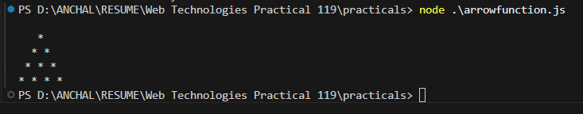

Practical 20
To create a web server and handle data streams

a) Write an application to create Home page, Admin page and Student page using http server.

Code:
var http = require('http');

var server = http.createServer(function (req, res) {

if (req.url == '/') {
res.writeHead(200, { 'content-type': 'text/html' });
res.write('<html><head></head><body>');
res.write('<style>ul li{display: inline-block; float: right; height: 40px;} ul li a{padding: 20px; background:orange; color: white;}</style>');
res.write('<div><h1>My First Website</h1></div><div><ul><li><a href="/admin">Contact Admin</a></li><li><a href="/student">Student</a></li><li><a href="/home">Home</a></li></ul></div></div>');
res.write('<div style="background: white; padding: 20px;"><h2>Start Page</h2><p>This is my first webpage hehe!</p><p>Hi everyone</p></div></body></html>');
res.end();
}

else if (req.url == '/home') {
res.writeHead(200, { 'content-type': 'text/html' });
res.write('<html><head><style>body{padding-left: 43px; padding-right:43px; background-color:lightyellow;} </style></head><body><p><h1>This is home page</h1></p><h1>Anchal Singh</h1><h3>This page is a brief insight to who I am.</h3>');
res.write('<nav style="background-color:black; text-align:center;"><ul><li><a href="/">Start Page</a></li><li><a href="/student">Student</a></li><li><a href="/admin">Admin</a></li></ul></nav></body></html>');
res.end();
}

else if (req.url == '/student') {
res.writeHead(200, { 'content-type': 'text/html' });
res.write('<html><head><style>body{background-color:pink;}</style><title>Form</title></head><body bgcolor="White" ><h1 align="center">Student Page Form</h1>');
res.write('<div style="display: inline-block; float: right; height: 40px; padding: 20px;"><ul><li><a href="/home">Home</a></li><li><a href="/">Start Page</a></li><li><a href="/admin">Contact Admin</a></li></ul></div>');
res.write('<form action="url" method="post"><fieldset><legend>Personal Imformation</legend>');
res.write('<label><strong>Student Name</strong></label><br/><input type="text" placeholder="Enter Your Name" /><br/>');
res.write('<label><strong>Email</strong></label><br/><input type="email" placeholder="Enter Your Email Address" /><br/>');
res.write('<label><strong>Password</strong></label><br/><input type="password" placeholder="Enter Your Password" /><br/>');
res.write('<label><strong>Gender</strong></label><br/><input type="Radio" name="Gender" value="Male" />Male <input type="Radio" name="Gender" value="FeMale" />FeMale<br/>');
res.write('<label><strong>Hobbies</strong></label><br/><input type="checkbox" value="Playing Sports" />Playing Sports<br/>');
res.write('<input type="checkbox" value="Listening Music" />Listening Music<br/>');
res.write('<input type="checkbox" value="Traveling" />Traveling<br/><input type="checkbox" value="Reading Books" />Reading Books<br/>');
res.write('<label><strong>Select Your City</strong></label><select name="City">');
res.write('<option value="Ahemdabad">Ahemdabad</option><option value="Kalol">Kalol</option><option value="Surat">Surat</option><option value="Rajkot">Rajkot</option></select><br/>');
res.write('<input type="submit" onclick="alert(\'Thanks!\')" value="Submit"/></form></body></html>');
res.end();
}

else if (req.url == '/admin') {
res.writeHead(200, { 'content-type': 'text/html' });
res.write('<style>ul li{display: inline-block; float: right; height: 40px;} ul li a{padding: 20px; background:orange; color: white;}</style>');
res.write('<div><ul><li><a href="/admin">Contact Admin</a></li><li><a href="/student">Student</a></li><li><a href="/home">Home</a></li></ul></div></div><br><br>');
res.write('<html><head><style>legend{text-align:center;} body{background-color:#faf89a;border: 5px solid darkred;} form{display: inline-block; padding: 20px;} </style></head>');
res.write('<body><legend><h1><u>Admin Login</u></h1></legend>');
res.write('<form action="#" method="POST" autocomplete="off">');
res.write('<div class="input_field"><h3>Username</h3></div><div class="input_field"><input type="text" name="userid" placeholder="Username" required/></div>');
res.write('<div class="input_field"><h3>Password</h3></div><div class="input_field"><input type="Password" name="pword" placeholder="Password" required/></div>');
res.write('<button onclick="alert(\'SUCCESS\')" style="border:none; border-radius:5px; padding:15px; background-color:lavender;">LOGIN NOW</button></form></body></html>');
res.end();
}

else {
res.end('Invalid request');
}
});

server.listen(9000);
console.log('Node.js web server at port 9000 is running');

OUTPUT:

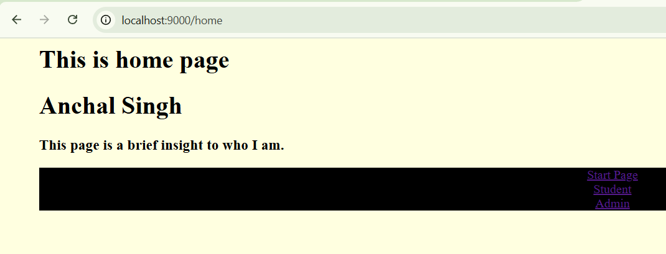

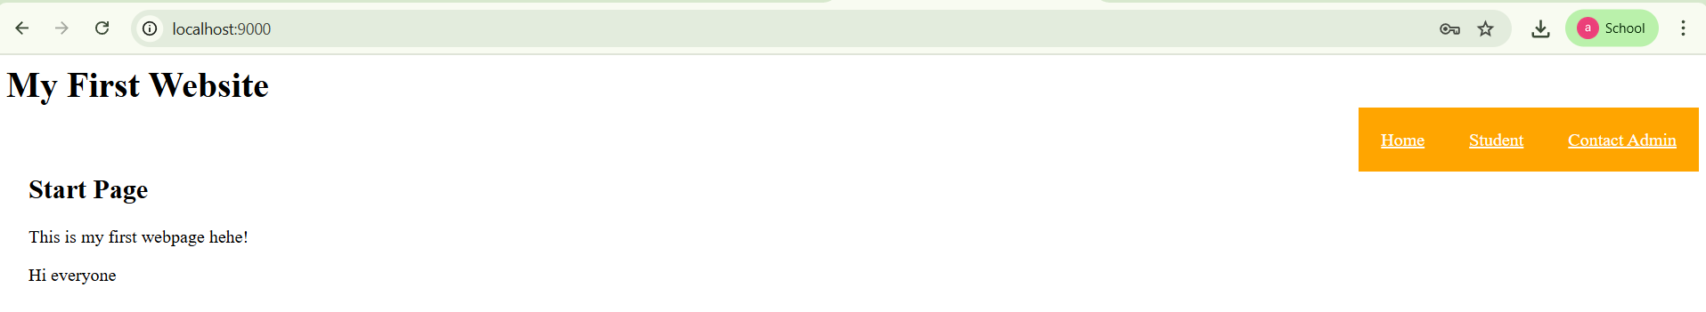

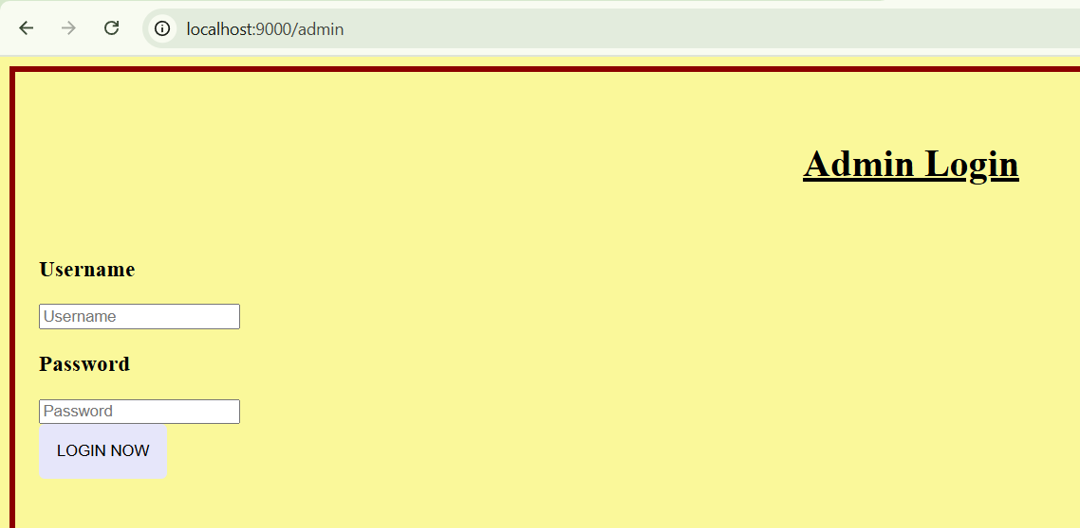

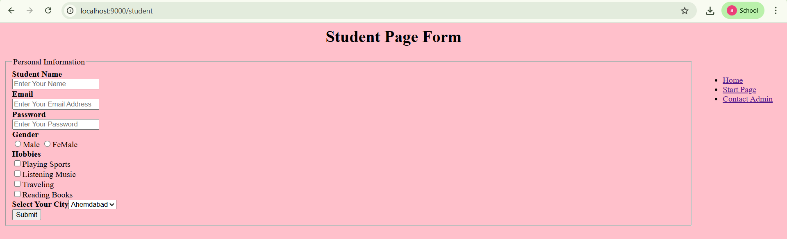

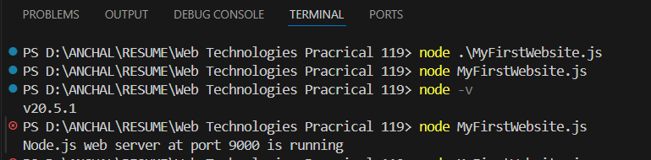

b) Piping program
Program 1
const fs = require('fs');
// Create a readable stream from 'input.txt'
const readableStream = fs.createReadStream('input.txt');
// Create a writable stream to 'output.txt'
const writableStream = fs.createWriteStream('output.txt');
// Pipe the data from the readable stream to the writable stream
readableStream.pipe(writableStream);

Output:

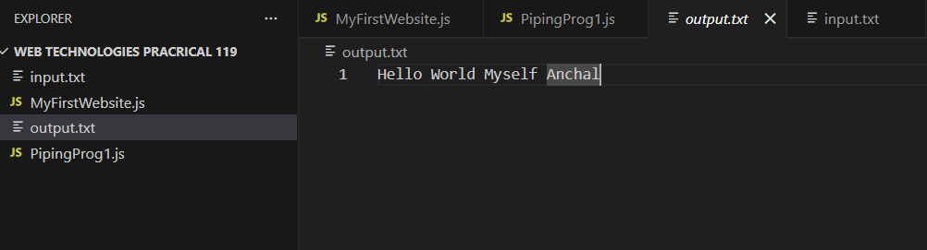

Piping program 2
const fs = require('fs');

// Create a readable stream from a file
const readableStream = fs.createReadStream('input.txt', 'utf8');

// Create a writable stream to a file
const writableStream = fs.createWriteStream('output.txt');

// Pipe the data from readable to writable stream
readableStream.pipe(writableStream);

// Handle completion and errors
writableStream.on('finish', () => {
console.log('File copy completed!');
});

readableStream.on('error', (err) => {
console.error('Error reading file:', err);
});

writableStream.on('error', (err) => {
console.error('Error writing file:', err);
});

Output:

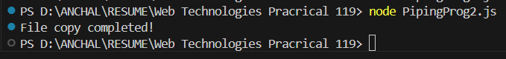

Practical 21
To implement server-side routing and business logic

a) Pages routing
Code:
const express = require("express");
const app = express();
const PORT = 5000;

// Helper function to generate navbar HTML
function navbar() {
return `
<nav style="background-color:#eee; padding:10px;">
<a href="/" style="margin-right:15px;">Home</a>
<a href="/about" style="margin-right:15px;">About</a>
<a href="/contact" style="margin-right:15px;">Contact</a>
</nav>
<hr/>
`;
}
// Home Page
app.get("/", (req, res) => {
res.send(`
${navbar()}
<h1>Welcome to the Home Page</h1>
<p>This is the home page content.</p>
`);
});
// About Page
app.get("/about", (req, res) => {
res.send(`
${navbar()}
<h1>About Us</h1>
<p>We are a team of web developers creating awesome web applications!</p>
`);
});
// Contact Page
app.get("/contact", (req, res) => {
res.send(`
${navbar()}
<h1>Contact Us</h1>
<p>Email: support@example.com</p>
<p>Phone: +91 12345 67890</p>
`);
});

// 404 Page
app.use((req, res) => {
res.status(404).send(`
${navbar()}
<h1>404 - Page Not Found</h1>
<p>Oops! The page you are looking for does not exist.</p>
`);
});
// Start server
app.listen(PORT, () => {
console.log(`Server running at http://localhost:${PORT}`);
});

Output:
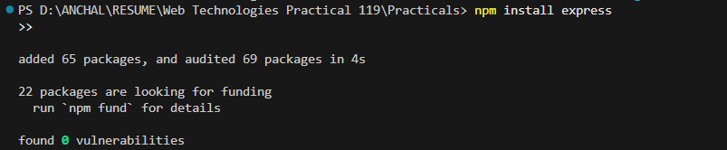

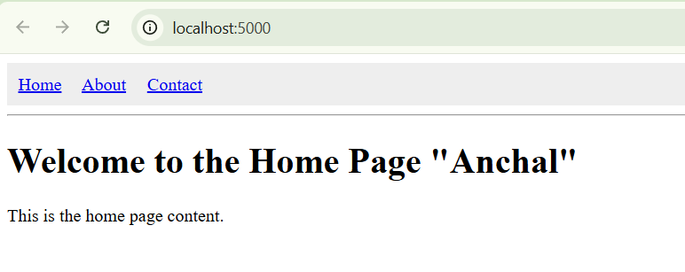

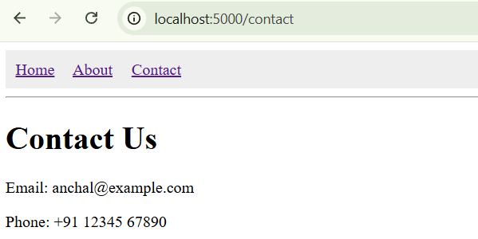

b) ERP program
Code:

const http = require('http');
const qs = require('querystring');
const PORT = 3000;
// HTML Form for Employee
const formHTML = `
<!DOCTYPE html>
<html lang="en">
<head>
<meta charset="UTF-8" />
<meta name="viewport" content="width=device-width, initial-scale=1" />
<title>ERP Employee Form</title>
<style>
body {
font-family: 'Segoe UI', Tahoma, Geneva, Verdana, sans-serif;
background: #f0f4f8;
display: flex;
justify-content: center;
align-items: center;
height: 100vh;
margin: 0;
}
.container {
background: white;
padding: 30px 40px;
border-radius: 10px;
box-shadow: 0 8px 20px rgba(0,0,0,0.1);
width: 400px;
}
h1 {
margin-bottom: 25px;
color: #2c3e50;
text-align: center;
letter-spacing: 1.5px;
}
label {
display: block;
margin-top: 15px;
color: #34495e;
font-weight: 600;
}
input, select {
width: 100%;
padding: 10px;
margin-top: 6px;
border: 1.5px solid #bdc3c7;
border-radius: 6px;
font-size: 1rem;
transition: border-color 0.3s ease;
}
input:focus, select:focus {
outline: none;
border-color: #2980b9;
box-shadow: 0 0 8px #2980b9;
}
button {
margin-top: 25px;
width: 100%;
padding: 12px;
background-color: #2980b9;
border: none;
color: white;
font-size: 1.1rem;
border-radius: 6px;
cursor: pointer;
transition: background-color 0.3s ease;
font-weight: 700;
}
button:hover {
background-color: #1c5980;
}
</style>
</head>
<body>
<div class="container">
<h1>ERP Employee Form</h1>
<form method="POST" action="/">
<label for="empId">Employee ID</label>
<input type="text" id="empId" name="empId" required placeholder="e.g. EMP12345" />

<label for="name">Full Name</label>
<input type="text" id="name" name="name" required placeholder="John Doe" />

<label for="department">Department</label>
<select id="department" name="department" required>
<option value="" disabled selected>Select Department</option>
<option>Finance</option>
<option>Sales</option>
<option>HR</option>
<option>Operations</option>
<option>IT</option>
<option>Marketing</option>
</select>
<label for="role">Role</label>
<input type="text" id="role" name="role" required placeholder="e.g. Manager" />
<label for="salary">Salary ($)</label>
<input type="number" id="salary" name="salary" required min="0" step="0.01" placeholder="50000" />
<label for="joiningDate">Joining Date</label>
<input type="date" id="joiningDate" name="joiningDate" required />
<button type="submit">Submit</button>
</form>
</div>
</body>
</html>
`;
// Create HTTP Server
const server = http.createServer((req, res) => {
if (req.method === 'GET' && req.url === '/') {
// Serve form HTML
res.writeHead(200, { 'Content-Type': 'text/html' });
res.end(formHTML);
}
else if (req.method === 'POST' && req.url === '/') {
let body = '';
req.on('data', chunk => {
body += chunk.toString();
if (body.length > 1e6) req.connection.destroy(); // Prevent huge POST
});
req.on('end', () => {
const formData = qs.parse(body);
const { empId, name, department, role, salary, joiningDate } = formData;

if (!empId || !name || !department || !role || !salary || !joiningDate) {
res.writeHead(400, { 'Content-Type': 'text/plain' });
res.end('All fields are required!');
return;
}
// Confirmation Page
res.writeHead(200, { 'Content-Type': 'text/html' });
res.end(`
<!DOCTYPE html>
<html lang="en">
<head>
<title>Submission Received</title>
<style>
body {
font-family: 'Segoe UI', Tahoma, Geneva, Verdana, sans-serif;
background: #e1f5fe;
display: flex;
justify-content: center;
align-items: center;
height: 100vh;
margin: 0;
}
.message-box {
background: white;
padding: 30px 40px;
border-radius: 10px;
box-shadow: 0 8px 20px rgba(0,0,0,0.1);
max-width: 500px;
text-align: center;
color: #2e7d32;
}
h2 { margin-bottom: 20px; }
p { font-size: 1.1rem; line-height: 1.5; }
button {
margin-top: 25px;
padding: 12px 25px;
background-color: #2e7d32;
border: none;
color: white;
font-size: 1rem;
border-radius: 6px;
cursor: pointer;
transition: background-color 0.3s ease;
font-weight: 700;
}
button:hover { background-color: #1b4d23; }
</style>
</head>
<body>
<div class="message-box">
<h2>Employee Record Submitted!</h2>
<p><strong>Employee ID:</strong> ${empId}</p>
<p><strong>Name:</strong> ${name}</p>
<p><strong>Department:</strong> ${department}</p>
<p><strong>Role:</strong> ${role}</p>
<p><strong>Salary:</strong> $${parseFloat(salary).toFixed(2)}</p>
<p><strong>Joining Date:</strong> ${joiningDate}</p>
<form action="/"><button type="submit">Add Another</button></form>
</div>
</body>
</html>
`);
});
}
else {
// 404 Not Found for other routes
res.writeHead(404, { 'Content-Type': 'text/plain' });
res.end('404 Not Found'); } });
// Start server
server.listen(PORT, () => {
console.log(`Server running on http://localhost:${PORT}`);
});

Output:

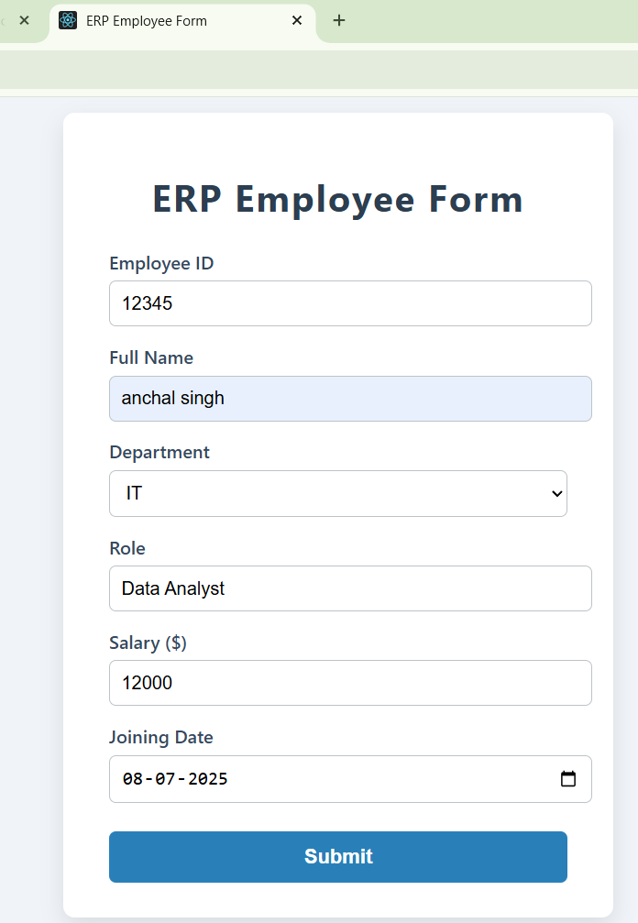 | 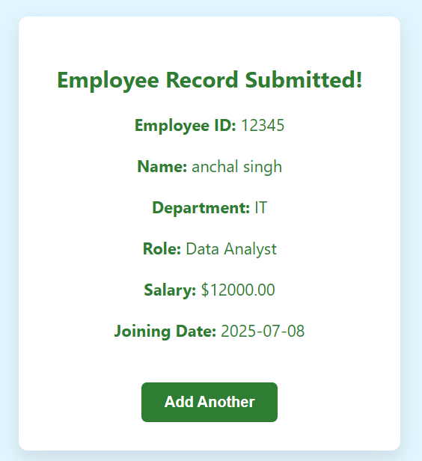

Practical 22
To implement ReactJS fundamentals and routing

a) Hello World
What is React?
React is a front-end JavaScript library.
React was developed by the Facebook Software Engineer Jordan Walke.
React is also known as React.js or ReactJS.
React is a tool for building UI components.
npx create-react-app my-app
cd my-app
npm start

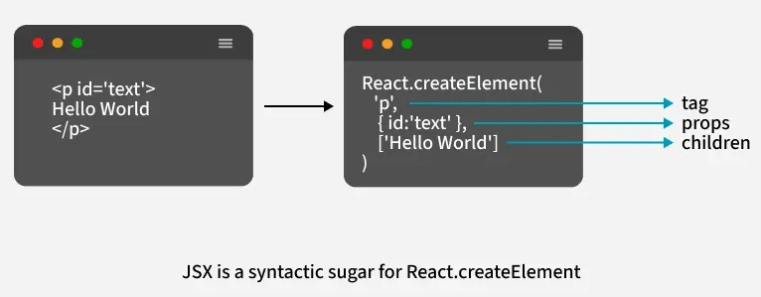
How to Implement JSX in Action
JSX can be implemented in a React project to create dynamic and interactive UI components. Here are the steps to use JSX in a React application:
- Create a React App
- Write JSX in the Component: In the src/App.js file, write JSX to display a message:

Make below files

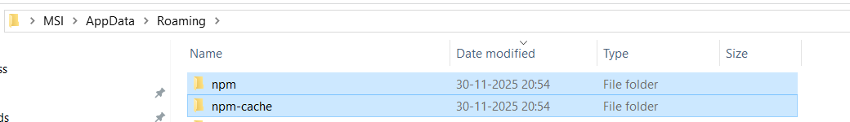

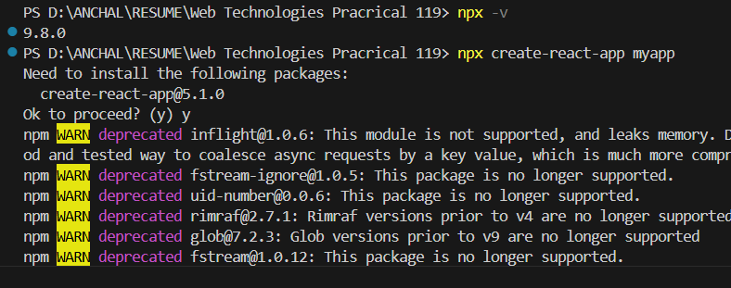

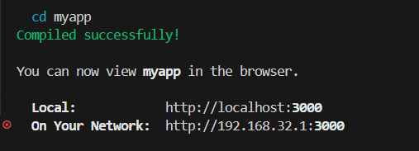

import logo from './logo.svg';
import './App.css';
function App() {
return (
<div className="App">
<header className="App-header">
<img src={logo} className="App-logo" alt="logo" />
<h1>Hello, World!</h1>
</header>
</div>
);
}
export default App;

Output :



b) JSX
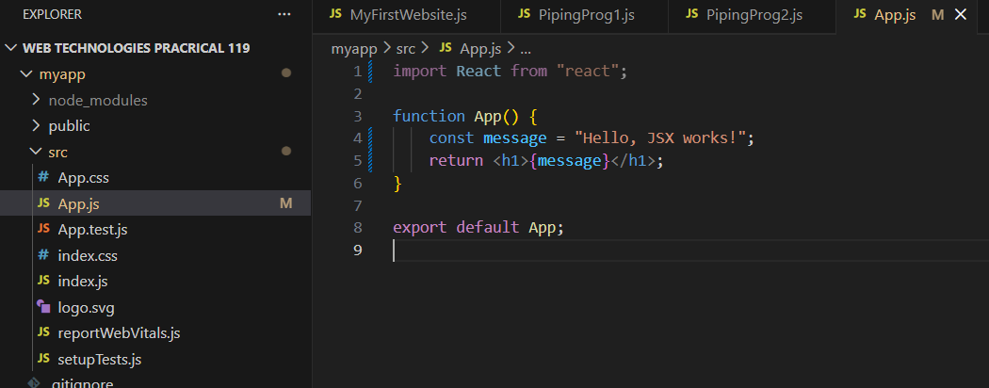

import React from "react";
function App() {
const message = "Hello, JSX works!";
return <h1>{message}</h1>;
}
export default App;

Output:

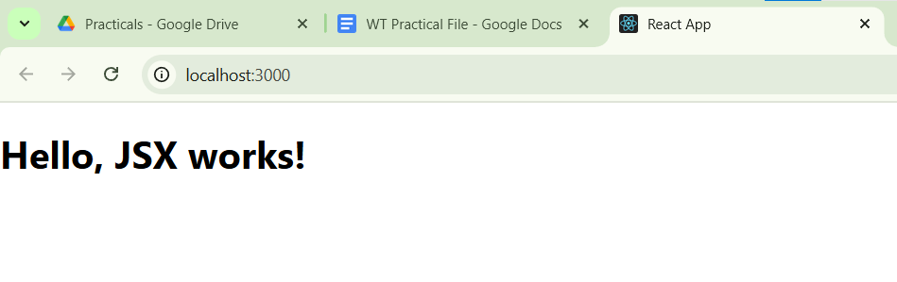

c) Import/Export
App.js
import React from "react";
import FileUploader from "./components/fileUploader";
import FileDownloader from "./components/filedownloader";
function App() {
return (
<div style={{ textAlign: "center", margin: "20px" }}>
<h1>React File Import/Export</h1>
<FileUploader />
<FileDownloader />
<h2 style={{ color: "purple" }}>Anchal Singh 119</h2>
</div>
); }
export default App;

fileuploader.js
import React, { useState } from "react";
const FileUploader = () => {
const [fileContent, setFileContent] = useState("");
const handleFileUpload = (e) => {
const file = e.target.files[0];
const reader = new FileReader();
reader.onload = (event) => {
setFileContent(event.target.result);
};
if (file) reader.readAsText(file);
};
return (
<div>
<h3>Upload a File</h3>
<input type="file" onChange={handleFileUpload} />
{fileContent && (
<div>
<h4>File Content:</h4>
<textarea value={fileContent} readOnly rows="10" cols="50" />
</div>
)}
</div>
);
};
export default FileUploader;

filedownloader.js
import React from "react";
const FileDownloader = () => {
const handleDownload = () => {
const content = "This is some sample text for the file.";
const blob = new Blob([content], { type: "text/plain" });
const url = URL.createObjectURL(blob);
const link = document.createElement("a");
link.href = url;
link.download = "sample.txt";
link.click();
URL.revokeObjectURL(url);
};
return (
<div>
<h3>Download a File</h3>
<button onClick={handleDownload}>Download</button>
</div>
);
};
export default FileDownloader;
Output :
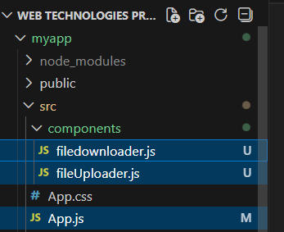
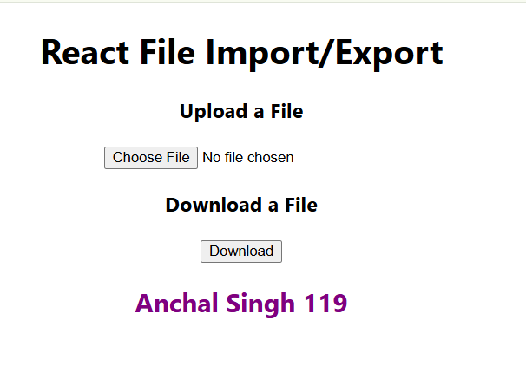

d) Create SPA using React Router (AboutUs, ContactUs and Admin) Links

React Router is a standard library for creating dynamic routes and navigation in React JS Applications. It allows you to create dynamic routes providing a seamless user experience by mapping various URLs to components. It enables navigation in single-page application (SPA) without refreshing the entire page

npx create-react-app router-app
cd router-app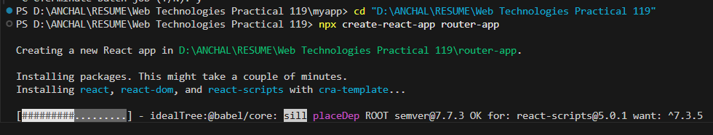npm start
npm install react-router-dom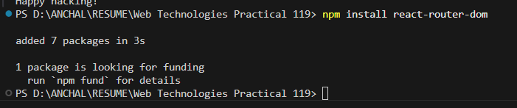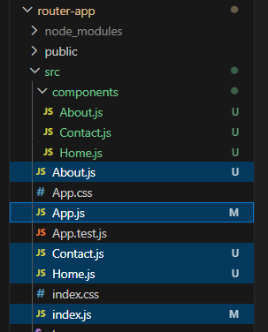

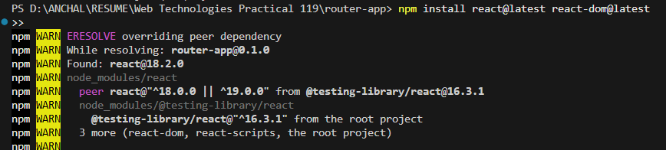
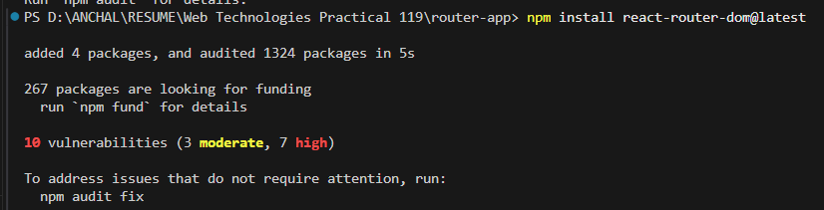

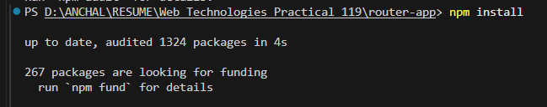

App.js

import React from "react";
import { BrowserRouter as Router, Routes, Route, Link } from "react-router-dom";
import Home from "./Home";
import About from "./About";
import Contact from "./Contact";

const App = () => {
return (
<Router>
<nav>
<ul>
<li><Link to="/">Home</Link></li>
<li><Link to="/about">About</Link></li>
<li><Link to="/contact">Contact</Link></li>
</ul>
</nav>

<Routes>
<Route path="/" element={<Home />} />
<Route path="/about" element={<About />} />
<Route path="/contact" element={<Contact />} />
</Routes>
</Router>
);
};

export default App;

About.js
import React from "react";
const About = () => {
return <h1>About Us</h1>;
};
export default About;

Home.js
import React from "react";
const Home = () => {
return <h1>Welcome to the Home Page...Anchal!!</h1>;
};
export default Home;

Contact.js
import React from "react";

const Contact = () => {
return <h1>Contact Us</h1>;
};

export default Contact;

index.js

import React from "react";
import ReactDOM from "react-dom/client";
import App from "./App";
const root = ReactDOM.createRoot(document.getElementById("root"));
root.render(
<React.StrictMode>
<App />
</React.StrictMode>
);

Output:
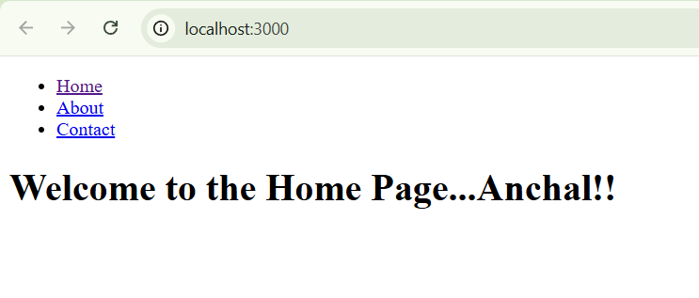
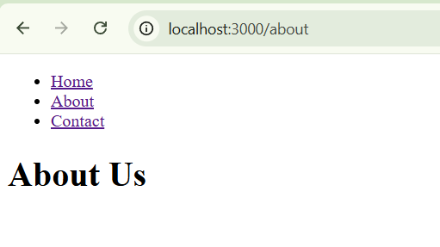
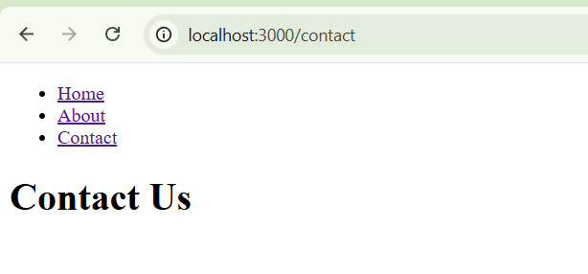

Practical 23
To implement React lifecycle, state management and validation

a) Create an application in ReactJS to implement component life cycle
App.js
import React from "react";
import Heading from "./Heading1";
import List from "./List";
import Picture from "./Picture";
function App() {
return (
<div>
<Heading />
<List />
<Picture />
</div>
);
}
export default App;
Picture.js
import React from "react";
function Picture() {
return (
<div>
<img
src="https://www.touropia.com/gfx/b/2011/02/mount_rushmore.jpg"
alt="Landscape"
style={{ width: "200px", height: "200px" }}
/>
</div>
);
}
export default Picture;

Heading1.js
import React from "react";
function Heading1() {
return (
<h1>Best Places to Visit</h1>
);
}
export default Heading1;
List.js
function List() {
return (
<div>
<ul>
<li>USA</li>
<li>Canada</li>
<li>Singapore</li>
<li>Australia</li>
<li>South Africa</li>
<li>Mexico</li>
</ul>
</div>
);}
export default List;
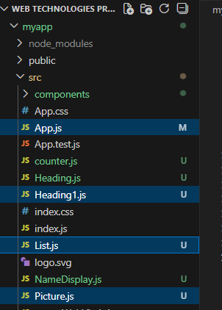
Output:
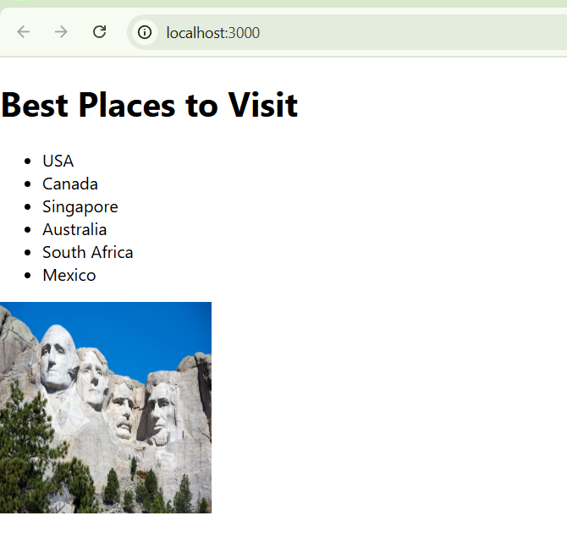

b) Counter
Code:
import logo from './logo.svg';
import './App.css';
import React, { useState, useEffect } from 'react';
const LifecycleComponent = () => {
const [count, setCount] = useState(0);
const [message, setMessage] = useState('Hello, World!');
useEffect(() => {
console.log('Component mounted!');
return () => {
console.log('Component will unmount!');
};
}, []);
useEffect(() => {
console.log(`Count updated to: ${count}`);
}, [count]);
const handleClick = () => {
setCount(count + 1);
};
const handleMessageChange = () => {
setMessage('Message has been changed!');
};
return (
<div>
<h1>React Component Lifecycle Example</h1>
<p>Message: {message}</p>
<p>Count: {count}</p>
<button onClick={handleClick}>Increment Count</button>
<button onClick={handleMessageChange}>Change Message</button>
</div>
);
};
const App = () => {
return (
<div className="App">
<h2>React Component Lifecycle Demo</h2>
<p>Created by: <strong>Anchal Singh 119</strong></p>
<LifecycleComponent />
</div>
);
<p><strong>Anchal Singh 119</strong></p>
};
export default App;
Output :
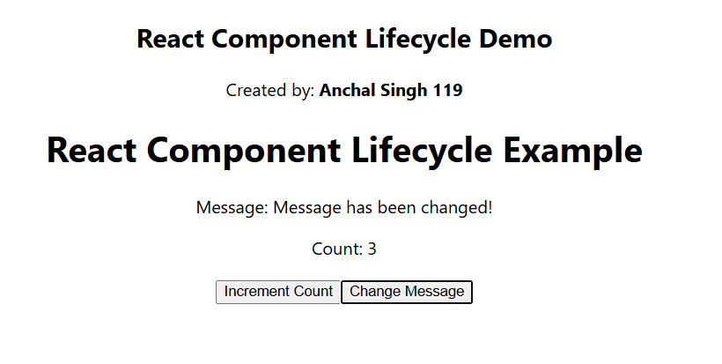
Create an application to implement functional component in ReactJS
Code:
import React from 'react';
const Greeting = ({ name }) => {
return (
<div>
<h1>Hello, {name}!</h1>
<p>Welcome to the React Functional Component Demo.</p>
</div>
); };
const App = () => {
return (
<div style={{ textAlign: 'center', marginTop: '50px' }}>
<Greeting name="User" />
<p>Created by: <strong>Anchal Singh 119</strong></p>
</div> ); };
export default App;
Output:
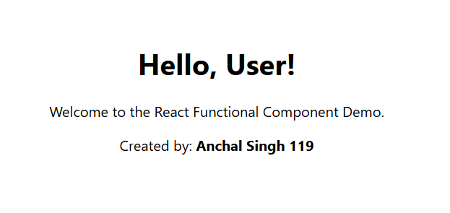

c) Form validation
Create an application in ReactJS to validate the form (username and email address) and submit it

App.js

import React from "react";
import BasicFormValidation from "./BasicFormValidation";

function App() {
return (
<div>
<h2>Basic Form Validation</h2>
<BasicFormValidation />
</div>
);
}
export default App;

BasicFormValidation.js

import React, { useState } from "react";
function BasicFormValidation() {
const [formData, setFormData] = useState({ name: "", email: "" });
const [errors, setErrors] = useState({});
const handleChange = (e) => {
const { name, value } = e.target;
setFormData({ ...formData, [name]: value });
};
const validate = () => {
const newErrors = {};
if (!formData.name) newErrors.name = "Name is required";
if (!formData.email) newErrors.email = "Email is required";
else if (!/\S+@\S+\.\S+/.test(formData.email))
newErrors.email = "Email is invalid";
setErrors(newErrors);
return Object.keys(newErrors).length === 0;
};
const handleSubmit = (e) => {
e.preventDefault();
if (validate()) {
alert("Form submitted successfully!");
}};
return (
<form onSubmit={handleSubmit}>
<div>
<label>Name:</label>
<input
type="text"
name="name"
value={formData.name}
onChange={handleChange}/>
{errors.name && <p style={{ color: "red" }}>{errors.name}</p>}
</div><div>
<label>Email:</label>
<input
type="text"
name="email"
value={formData.email}
onChange={handleChange} />
{errors.email && <p style={{ color: "red" }}>{errors.email}</p>}
</div>
<button type="submit">Submit</button>
</form>);}
export default BasicFormValidation;
Output:
npm start
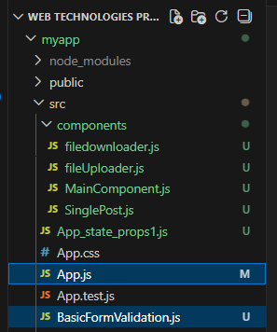
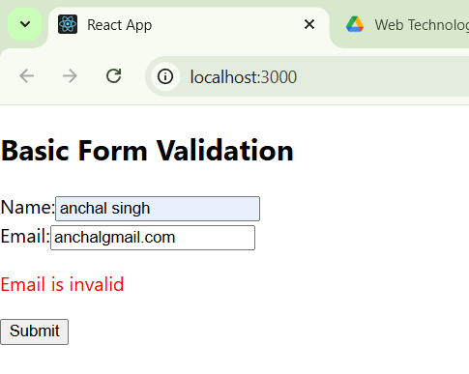

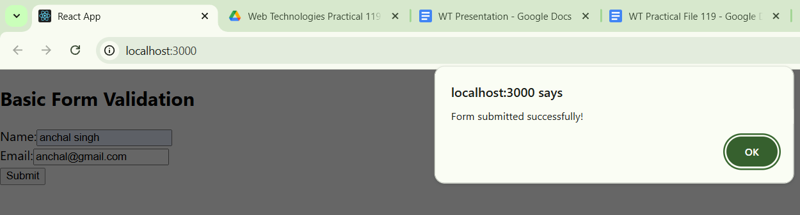

Practical 24
To handle user interaction via DOM events and Props

a) Create an application to display your name using prop.
App.js
import React from "react";
import NameDisplay from "./NameDisplay";
function App() {
return (
<div>
<NameDisplay name="Anchal Singh 119" />
</div>
);}
export default App;
NameDisplay.js
import React from "react";
const NameDisplay = (props) => {
return (
<div style={{ textAlign: "center", marginTop: "50px" }}>
<h1>Hello, {props.name}!</h1>
</div> ); };
export default NameDisplay;
Output :
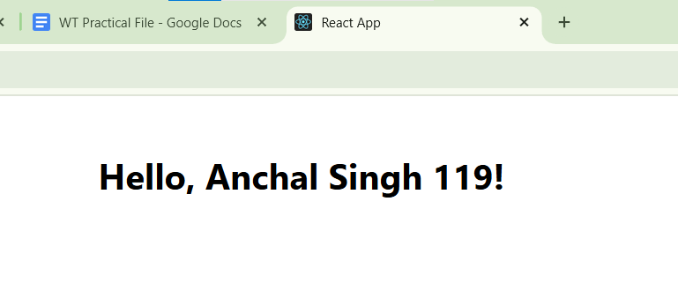

b) onChange
Create an application in ReactJS to use DOM events- onChange.

App.js
import React, { useState } from "react";
function App() {
const [inputValue, setInputValue] = useState("");
const [displayText, setDisplayText] = useState("");
const handleInputChange = (event) => {
setInputValue(event.target.value);
};
const handleDisplay = () => {
setDisplayText(inputValue);
};
return (<div style={{ padding: "20px", textAlign: "center" }}>
<h1>React onChange Event Demo</h1>
<div style={{ marginBottom: "20px" }}>
<input
type="text"
value={inputValue}
onChange={handleInputChange}
placeholder="Type something..."
style={{ padding: "10px", width: "300px" }}
/>
</div>
<button
onClick={handleDisplay}
style={{
padding: "10px 20px",
backgroundColor: "#007BFF",
color: "#FFF",
border: "none",
borderRadius: "5px",
cursor: "pointer",
}}
>
Display Text
</button>
<p style={{ marginTop: "20px", fontSize: "20px" }}>
<strong>{displayText}</strong>
</p>
</div>
);
}
export default App;
Output:
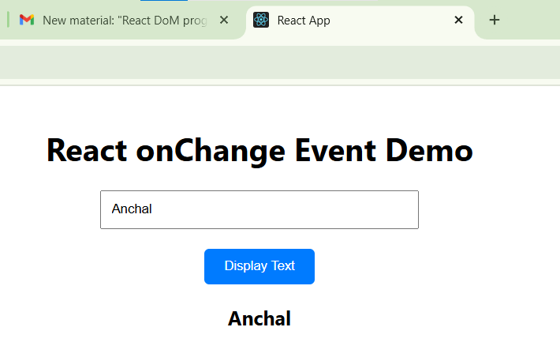

C. Write a program that tracks the changes in an input field and displays the entered text in real-time using onChange DOM event.

App.js
import React, { useState } from "react";
function App() {
const [text, setText] = useState("");
const handleInputChange = (event) => {
setText(event.target.value);
};
return (
<div style={{ padding: "20px", textAlign: "center" }}>
<h1>Real-Time Text Tracker</h1>
<div style={{ marginBottom: "20px" }}>
<input
type="text"
value={text}
onChange={handleInputChange}
placeholder="Type something..."
style={{
padding: "10px",
width: "300px",
border: "1px solid #ccc",
borderRadius: "5px",
fontSize: "16px",
}}
/>
</div>
<p style={{ fontSize: "20px", color: "#333" }}>
<strong>You typed: </strong>
{text}
</p>
</div>
);
}
export default App;

Output:

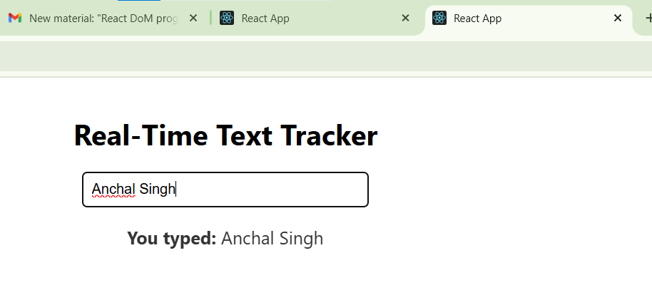

D. Create an application in ReactJS to use DOM events- onKeyUp.
App.js
import React, { useState } from "react";
function App() {
const [keyPressed, setKeyPressed] = useState("");
const handleKeyUp = (event) => {
setKeyPressed(event.key);
};
return (
<div style={{ padding: "20px", textAlign: "center" }}>
<h1>React onKeyUp Event Demo</h1>
<div style={{ marginBottom: "20px" }}>
<input
type="text"
onKeyUp={handleKeyUp} // Attach onKeyUp event handler
placeholder="Type something and release a key"
style={{
padding: "10px",
width: "300px",
border: "1px solid #ccc",
borderRadius: "5px",
fontSize: "16px",
}}
/>
</div>
<p style={{ fontSize: "20px", color: "#333" }}>
<strong>Last key pressed: </strong>
{keyPressed}
</p>
</div>
);
}
export default App;

Output :

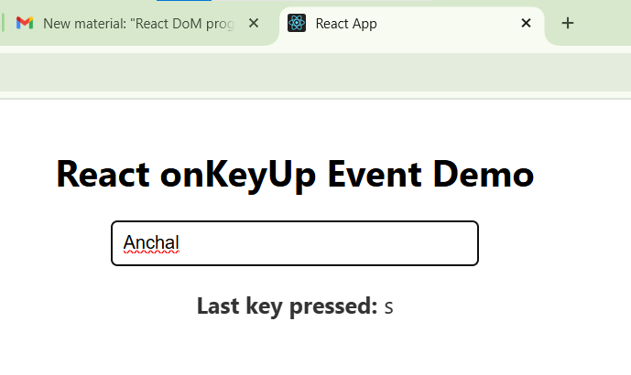

E. Write a Program to Counts words as they are typed using onKeyUp event.

App.js
import React, { useState } from "react";
function WordCount() {
const [wordCount, setWordCount] = useState(0);
const handleKeyUp = (e) => {
const words = e.target.value.trim().split(/\s+/);
setWordCount(words[0] === "" ? 0 : words.length);
};
return (
<div>
<textarea
onKeyUp={handleKeyUp}
placeholder="Type your text here..."
/>
<p>Word Count: {wordCount}</p>
</div>
);
}
export default WordCount;
Output :

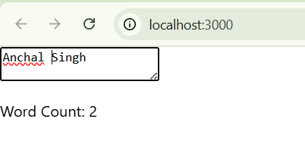

Practical 25
To perform database operations and implement React Hooks

a) Create an application to implement To-Do tasks.
App.js
import React from "react";
import ToDo from "./ToDo";
function App() {
return (
<div> <ToDo /> </div>);}
export default App;
ToDo.js
import React, { useState } from "react";
const ToDo = () => {
const [tasks, setTasks] = useState([]);
const [task, setTask] = useState("");
const addTask = () => {
if (task.trim()) {
setTasks([...tasks, task]);
setTask(""); }};
const removeTask = (index) => {
const updatedTasks = tasks.filter((_, i) => i !== index);
setTasks(updatedTasks); };
return (
<div style={{ textAlign: "center", marginTop: "50px" }}>
<h2 style={{ color: "purple" }}>Anchal Singh 119</h2>
<h1>To-Do List</h1>
<div>
<input
type="text"
value={task}
onChange={(e) => setTask(e.target.value)}
placeholder="Enter a task"
style={{ padding: "8px", width: "200px" }}
/>
<button onClick={addTask} style={{ padding: "8px 16px", marginLeft: "10px" }}>
Add Task
</button>
</div>
<ul style={{ listStyle: "none", padding: "0", marginTop: "20px" }}>
{tasks.map((t, index) => (
<li
key={index}
style={{
margin: "10px 0",
display: "flex",
justifyContent: "center",
alignItems: "center",
}}
>
<span style={{ marginRight: "20px" }}>{t}</span>
<button
onClick={() => removeTask(index)}
style={{
backgroundColor: "red",
color: "white",
border: "none",
padding: "5px 10px",
cursor: "pointer",
}}
>
Remove
</button>
</li>
))}
</ul>
</div>
);
};
export default ToDo;
Output:
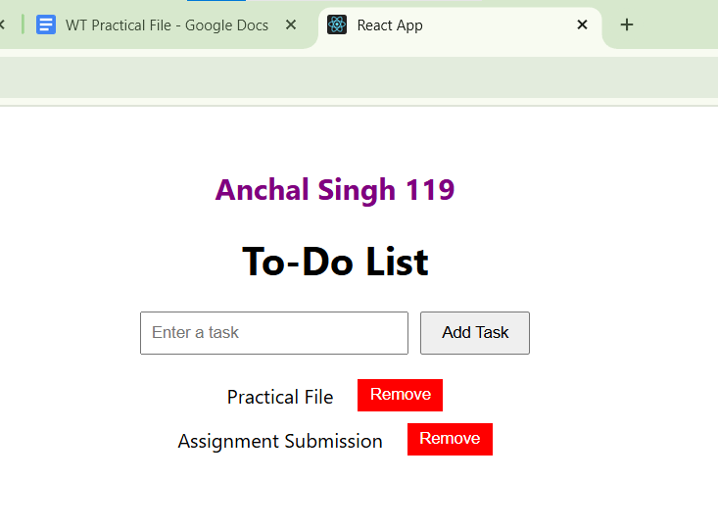

b) Create an Application to create Database and student table columns in NodeJS

CREATE DATABASE WT_Practical_119;

USE WT_Practical_119;

CREATE TABLE Student (
id INT AUTO_INCREMENT PRIMARY KEY,
name VARCHAR(50),
age INT,
grade VARCHAR(5)
);

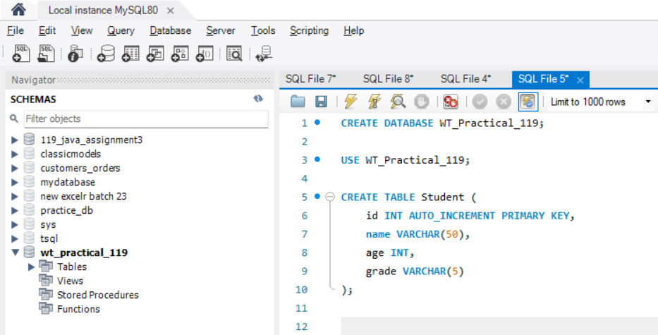

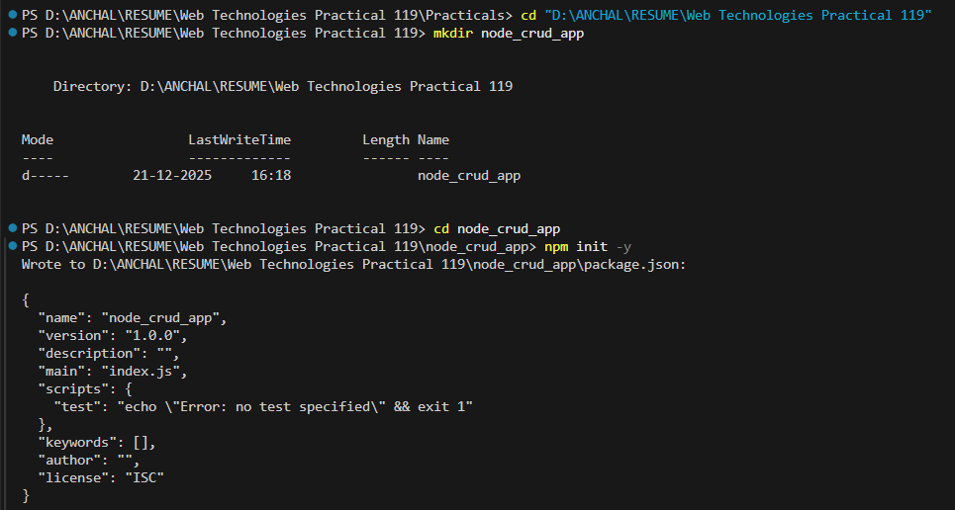

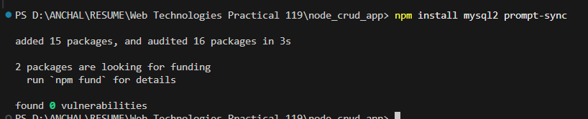

db.js

const mysql = require('mysql2');

const connection = mysql.createConnection({
host: 'localhost',
user: 'root', // Your MySQL username
password: 'Vaibhav@9594', // Your MySQL password
database: 'WT_Practical_119' // Database name
});

connection.connect((err) => {
if (err) throw err;
console.log('Connected to MySQL database!');
});

module.exports = connection;

insertStudent.js
const connection = require('./db');
const prompt = require('prompt-sync')();
const name = prompt("Enter student name: ");
const age = parseInt(prompt("Enter age: "));
const grade = prompt("Enter grade: ");

const sql = "INSERT INTO Student (name, age, grade) VALUES (?, ?, ?)";

connection.query(sql, [name, age, grade], (err, result) => {
if (err) throw err;
console.log("Student inserted successfully, ID:", result.insertId);
connection.end();
});

updateStudent.js

const connection = require('./db');
const prompt = require('prompt-sync')();
const id = parseInt(prompt("Enter student ID to update: "));
const name = prompt("Enter new name: ");
const grade = prompt("Enter new grade: ");
const sql = "UPDATE Student SET name = ?, grade = ? WHERE id = ?";
connection.query(sql, [name, grade, id], (err, result) => {
if (err) throw err;
console.log(result.affectedRows, "row(s) updated.");
connection.end();
});

deleteStudent.js

const connection = require('./db');
const prompt = require('prompt-sync')();
const id = parseInt(prompt("Enter student ID to delete: "));
const sql = "DELETE FROM Student WHERE id = ?";
connection.query(sql, [id], (err, result) => {
if (err) throw err;
console.log(result.affectedRows, "row(s) deleted.");
connection.end();
});

addColumnStudent.js

const connection = require('./db');
const sql = "ALTER TABLE Student ADD COLUMN email VARCHAR(50)";
connection.query(sql, (err, result) => {
if (err) throw err;
console.log("Column added successfully!");
connection.end();
});

  - Create an application to insert row into table in Nodejs

node insertStudent.js

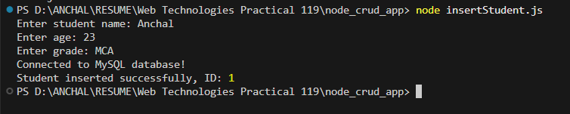

  - Create an application to update row into table in Nodejs

node updateStudent.js
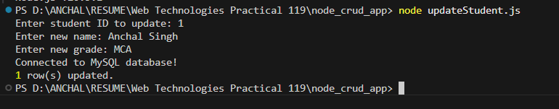
  - Create an application to delete row into table in Nodejs

node deleteStudent.js

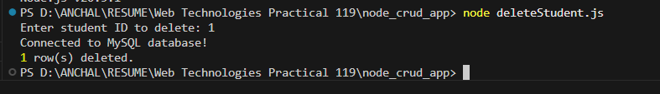
  - Create an application to add a column into table in Nodejs

node addColumnStudent.js

c) React Hooks
Create an application in ReactJS to increase the counter by clicking a button using useState Hook

App.js

import React, { useState } from "react";
function App() {
const [counter, setCounter] = useState(0);
const increaseCounter = () => {
setCounter(counter + 1);
};
return (
<div>

<h1>Anchal Singh 119</h1>
<h1>Counter: {counter}</h1>
<button onClick={increaseCounter}>Increase</button>
</div>
);
}

export default App;

Output:

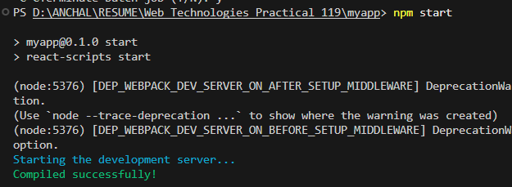
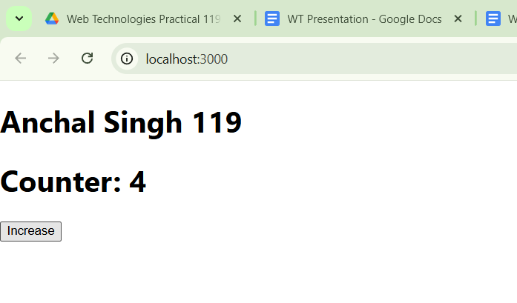
- Create an application in ReactJS to demonstrate useEffect Hook

(i) useEffect without dependency array

App.js

import React, { useState, useEffect } from "react";
function App() {
const [count, setCount] = useState(0);
useEffect(() => {
document.title = `${count} new messages!`;
});
return (
<div>

<h3>Anchal Singh 119</h3>
<h3>{count} new Messages!</h3>
<button onClick={() => setCount(count + 1)}>Increase</button>
</div>
);
}
export default App;

Output:

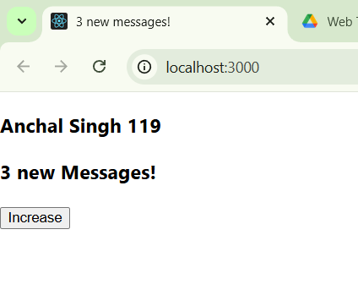

(ii) useEffect with dependency array
➡ Runs only when count changes
import React, { useState, useEffect } from "react";
function App() {
const [count, setCount] = useState(0);
useEffect(() => {
document.title = `${count} new messages!`;
}, [count]);
return (
<div>
<h3>Anchal Singh 119</h3>
<h3>{count} new Messages!</h3>
<button onClick={() => setCount(count + 1)}>Increase</button>
</div>
);
}

export default App;

Output:
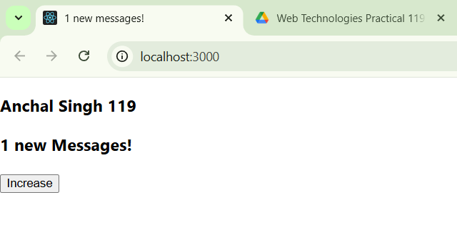

iii) useEffect with cleanup (Timer example)

import React, { useState, useEffect } from "react";
function App() {
const [time, setTime] = useState(0);
useEffect(() => {
const timer = setInterval(() => {
setTime(time + 1);
}, 1000);

return () => clearInterval(timer);
}, [time]);

return (
<div>

<h3>Anchal Singh 119</h3>
<h3>{time} in seconds</h3>
</div>
);
}

export default App;

Output:

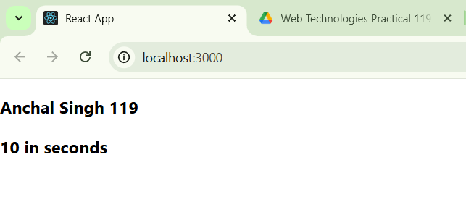

- Create an application in ReactJS to demonstrate useContext Hook

App.js – Creating & Providing Context
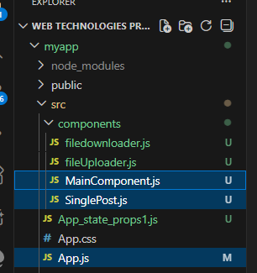
App.js
import React, { createContext } from "react";
import MainComponent from "./components/MainComponent";
export const LoginContext = createContext();
const App = () => {
return (
<LoginContext.Provider value={true}>
<div>
<MainComponent />
</div>
</LoginContext.Provider>
);};
export default App;
MainComponent.js – Just a Middle Component

import React from "react";
import SinglePost from "./SinglePost";
const MainComponent = () => {
return <SinglePost />;
};
export default MainComponent;

SinglePost.js – Consuming Contex
import React, { useContext } from "react";
import { LoginContext } from "../App";
const SinglePost = () => {
const login = useContext(LoginContext);
console.log(login);
return <h3>Single POST</h3>;
};
export default SinglePost;
Output:
