PRACTICAL NO: 1

(A) Aim : Implementation of different Searching Techniques

1) Write a java program to implement Linear Search

Code :-
import java.util.Scanner;
public class Main {
public static void main(String[] args) {
int i,
x,
n;
int flag = 0;
Scanner scanner = new Scanner(System. in );
System.out.println("Anchal Singh 119");

System.out.println("How many numbers you want to enter in the array:");
n = scanner.nextInt();
int[] a = new int[n];
for (i = 0; i < n; i++) {
System.out.println("Enter Element:");
a[i] = scanner.nextInt();
}
System.out.println("Enter number which you want to search:");
x = scanner.nextInt();
for (i = 0; i < n; i++) {
if (a[i] == x) {
flag = 1;
break;
}
}
if (flag == 1) {
System.out.println("Element Found!");
} else {

System.out.println("Element not found!");
}
scanner.close();
}
}

Output:-

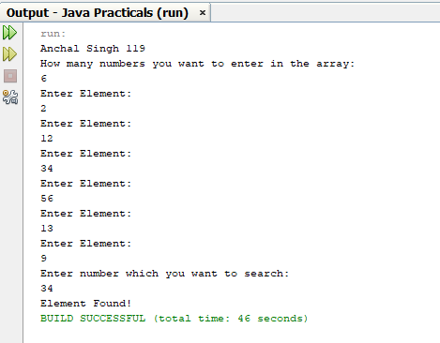

2) Write a program to implement Binary Search

Code:-
import java.util.Scanner;
public class Main {
public static void main(String[] args)
{
System.out.println("Anchal Singh 119");
Scanner scanner = new Scanner(System. in );
System.out.print("how many number you want to insert: ");
int n = scanner.nextInt();
int[] a = new int[n];
System.out.println("Enter the sorted array: ");
for (int i = 0; i < n; i++) {
System.out.print("Enter the number: ");
a[i] = scanner.nextInt();
}
System.out.print("Array: ");
for (int i = 0; i < n; i++) {
System.out.print(a[i] + " ");
}
System.out.print("\nenter the number you want to search: ");
int x = scanner.nextInt();
int low = 0,
high = n - 1;
int flag = 0;
while (low <= high) {
int mid = low + (high - low) / 2;
if (a[mid] == x) {
flag = 1;
break;
}
if (a[mid] > x) {
high = mid - 1;

} else {
low = mid + 1;
}
}
if (flag == 1) {
System.out.println("number found");
} else {
System.out.println("number not found");
}
scanner.close();
}
}

Output:-
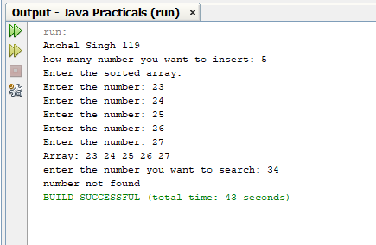

(B) Implementation of different Sorting Techniques.

1) Write a program to implement Bubble Sort.
Code:-
import java.util.Scanner;
public class BubbleSort {
public static void main(String[] args) {
System.out.println("Anchal Singh 119");
Scanner scanner = new Scanner(System. in );
System.out.print("How many elements you want to add: ");
int n = scanner.nextInt();
int[] a = new int[n];
for (int i = 0; i < n; i++) {
System.out.print("Enter the elements: ");
a[i] = scanner.nextInt();
}
System.out.print("Given array is: ");
for (int i = 0; i < n; i++) {
System.out.print(a[i] + " ");
}
for (int i = 0; i < n - 1; i++) {
for (int j = 0; j < n - i - 1; j++) {
if (a[j] > a[j + 1]) {
int temp = a[j];
a[j] = a[j + 1];
a[j + 1] = temp;}}}
System.out.println("\n");
System.out.print("sorted array is: ");
for (int i = 0; i < n; i++) {
System.out.print(a[i] + " ");}
scanner.close();}}

Output:
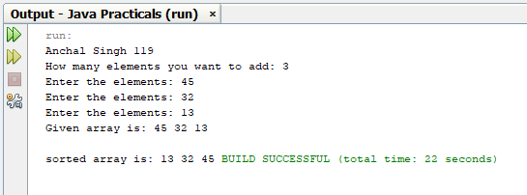

2) Write a program to implement Insertion Sort.
Code:-
import java.util.Scanner;
public class Main {
public static void main(String[] args) {
System.out.println("Anchal Singh 119");
Scanner scanner = new Scanner(System. in );
System.out.print("How many elements you want to add: ");
int n = scanner.nextInt();
int[] a = new int[n];
for (int i = 0; i < n; i++) {
System.out.print("Enter the elements: ");
a[i] = scanner.nextInt();
}
System.out.print("Given array is: ");
for (int i = 0; i < n; i++) {
System.out.print(a[i] + " ");
}
for (int i = 1; i < n; i++) {
int k = a[i];
int j = i - 1;
while (j >= 0 && k < a[j]) {
a[j + 1] = a[j];
j = j - 1;
}
a[j + 1] = k;}
System.out.print("\nsorted array is: ");
for (int i = 0; i < n; i++) {
System.out.print(a[i] + " ");}
scanner.close();}}

Output:-

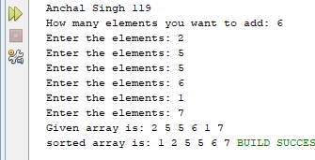

3) Write a program to implement Selection Sort.
Code:-
import java.util.Scanner;
public class Main {
public static void main(String[] args) {
System.out.println("Anchal Singh 119");
int i,n,j,temp,min;
System.out.print("How many elements you want to add: ");
Scanner scanner = new Scanner(System. in );
n = scanner.nextInt();
int[] a = new int[n];
for (i = 0; i < n; i++) {
System.out.print("Enter the elements: ");
a[i] = scanner.nextInt();
}
System.out.print("Given array is: ");
for (i = 0; i < n; i++) {
System.out.print(a[i] + " ");
}
for (i = 0; i < n; i++) {
min = i;
for (j = i + 1; j < n; j++) {
if (a[min] > a[j]) {
min = j;
}}
if (a[min] != a[i]) {
temp = a[i];
a[i] = a[min];
a[min] = temp;
}}
System.out.print("Sorted array is: ");
for (i = 0; i < n; i++) {
System.out.print(a[i] + " ");
}}}
Output:-

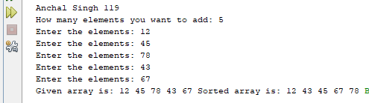

4) Write a program to implement Shell Sort.
Code:-
import java.util.Scanner;
public class Main {
public static void main(String[] args) {
System.out.println("Anchal Singh 119");
Scanner scanner = new Scanner(System. in );
System.out.print("How many elements you want to add: ");
int n = scanner.nextInt();
int[] a = new int[n];
for (int i = 0; i < n; i++) {
System.out.print("Enter the elements: ");
a[i] = scanner.nextInt();
}
System.out.print("Given array is: ");
for (int i = 0; i < n; i++) {
System.out.print(a[i] + " ");
}
System.out.println();
for (int i = n / 2; i > 0; i /= 2) {
int flag = 1;
while (flag == 1) {
flag = 0;
for (int j = 0; j < n - i; j++) {
if (a[j] > a[j + i]) {
int temp = a[j];
a[j] = a[j + i];
a[j + i] = temp;
flag = 1;}}}}
System.out.print("sorted array is: ");
for (int i = 0; i < n; i++) {
System.out.print(a[i] + " ");}}}

Output:-

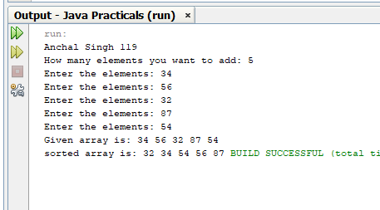

PRACTICAL NO: 3

Aim : Implementation Using Array

1) Write a program to implement Stack Using Array
Code:-
import java.util.Scanner;
class Stack1 {
int top = -1;
int x,
stk[] = new int[5],
i; int MAX = 5;
public void push(int x) {
if (top == MAX - 1) {
System.out.println("Stack Overflow\n");
} else {
System.out.println("Enter the number to push to the stack:");
Scanner sc = new Scanner(System. in );
x = sc.nextInt();
stk[++top] = x;
stk[top] = x;}}
public void pop() {
if (top == -1) {
System.out.println("Stack Underflow\n");
}
System.out.print("Popped value: ");
x = stk[top];
top--;
System.out.println(x);
}
public void display() {
if (top == -1) {
System.out.println("Stack is empty.\n");
} else {
System.out.println("Stack:");
for (i = top; i >= 0; i--) {
System.out.println(stk[i]); }}}}
public class Main {
public static void main(String[] args) {
System.out.println("Anchal Singh 119");
Stack1 s = new Stack1();
int ch,
x = 0;
Scanner sc = new Scanner(System. in );
while (true) {
System.out.println("1.Push\n2.Pop\n3.Display\n4.Exit");
System.out.print("Enter the value for operation:\n");
ch = sc.nextInt();
switch (ch) {
case 1:
s.push(x);
break;
case 2:
s.pop();
break;
case 3:
s.display();
break;
case 4:
return;
default:
System.out.println("\nWrong choice.\n"); }}}}
Output:

1. Adding and displaying element .

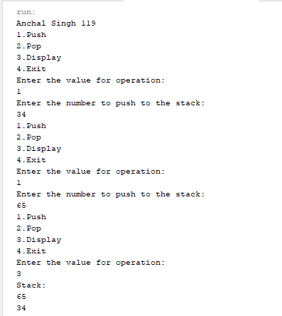

Stack overflow

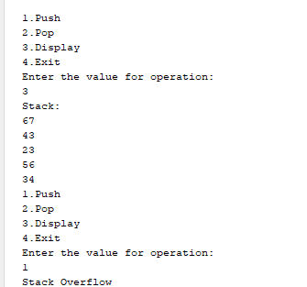
2. Removing element

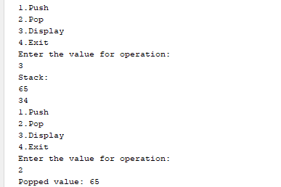

2) Write a program to implement Ordinary Queue Using Array.
Code :-
import java.util.Scanner;
class Queue {
private int front = -1,
rear = -1;
private int[] queue;
private final int MAX = 3;
public Queue() {
queue = new int[MAX];
}
public void enqueue(Scanner scanner) {
if (rear == MAX - 1) {
System.out.println("Queue Overflow\n");
} else {
if (front == -1) {
front = 0;
}
System.out.println("Enter the number to enqueue to the queue:");
int x = scanner.nextInt();
queue[++rear] = x;
}
}
public void dequeue() {
if (front == -1 || front > rear) {
System.out.println("Queue Underflow\n");
return;
}
System.out.println("Dequeued value: " + queue[front] + "\n");
front++;
}
public void display() {
if (front == -1 || front > rear) {
System.out.println("Queue is empty.\n");
} else {
System.out.println("Queue:");
for (int i = front; i <= rear; i++) {
System.out.print(queue[i] + " ");
}
System.out.println();}}}
public class Main {
public static void main(String[] args) {
System.out.println("Anchal Singh 119");
Queue q = new Queue();
Scanner scanner = new Scanner(System. in );
int ch = 0;
while (ch != 4) {
System.out.println(" 1.Enqueue\n 2.Dequeue\n 3.Display\n 4.Exit");
System.out.println("Enter the value for operation:");
ch = scanner.nextInt();
switch (ch) {
case 1:
q.enqueue(scanner);
break;
case 2:
q.dequeue();
break;
case 3:
q.display();
break;
case 4:
break;
default:
System.out.println("\nWrong choice.\n");}}
scanner.close();}}

Output:-
1. Adding and displaying elements in the queue.
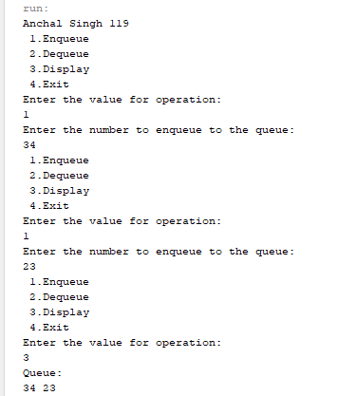
Queue overflow

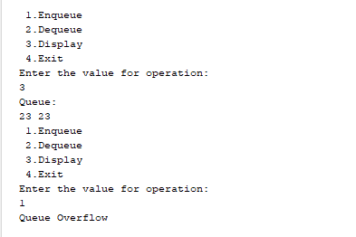

2. Removing and displaying element from queue.

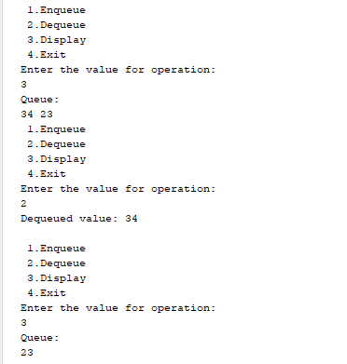

3) Write a program to implement Circular Queue Using Array.
Code:-
package sp;
import java.util.Scanner;
public class Main {
static int[] cqueue = new int[5];
static int front = -1,
rear = -1,
n = 3;
public static void insertCQ(int val) {
if ((front == 0 && rear == n - 1) || (front == rear + 1)) {
System.out.println("Queue Overflow");
return;
}
if (front == -1) {
front = 0;
rear = 0;
} else {
if (rear == n - 1) rear = 0;
else rear = rear + 1;
}
cqueue[rear] = val;
}
public static void deleteCQ() {
if (front == -1) {
System.out.println("Queue Underflow");
return;
}
System.out.println("Element deleted from queue is: " + cqueue[front]);
if (front == rear) {
front = -1;
rear = -1;
} else {
if (front == n - 1) front = 0;
else front = front + 1;}}
public static void displayCQ() {
int f = front,
r = rear;
if (front == -1) {
System.out.println("Queue is empty");
return;
}
System.out.println("Queue elements are:");
if (f <= r) {
while (f <= r) {
System.out.print(cqueue[f] + " ");
f++;
}
} else {
while (f <= n - 1) {
System.out.print(cqueue[f] + " ");
f++;
}
f = 0;
while (f <= r) {
System.out.print(cqueue[f] + " ");
f++;}}
System.out.println();
}
public static void main(String[] args) {
System.out.println("Anchal Singh 119");
Scanner scanner = new Scanner(System. in );
int ch,
val;
do {
System.out.println("1) Insert");
System.out.println("2) Delete");
System.out.println("3) Display");
System.out.println("4) Exit");
System.out.print("Enter choice: ");
ch = scanner.nextInt();
switch (ch) {
case 1:
System.out.print("Input for insertion: ");
val = scanner.nextInt();
insertCQ(val);
break;
case 2:
deleteCQ();
break;
case 3:
displayCQ();
break;
case 4:
System.out.println("Exit");
break;
default:
System.out.println("Incorrect choice!");
}
} while ( ch != 4 );
scanner.close();}}

Output:-
1. Inserting and displaying element

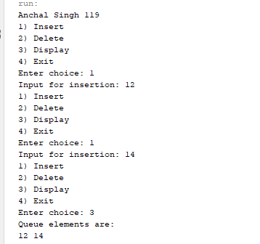
2. Deleting and displaying element

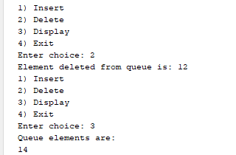

PRACTICAL NO : 5
Aim : Implementation of all types of Linked Lists.

1) Write a program to implement a Singly Linked List.
Code :-
import java.util.Scanner;
class LinkList {
int flag;
int pos,
i,
value,
count1 = 0;
Node start = null;

class Node {
int data;
Node next;
}
public int countNodes() {
int count = 0;
Node p = start;
while (p != null) {
count++;
p = p.next;
}
return count;
}
public void insertAtBeg(int x) {
Node tmp = new Node();
tmp.data = x;
tmp.next = start;
start = tmp;
}
public void insertAtEnd(int x) {
Node tmp = new Node();
tmp.data = x;
tmp.next = null;
if (start == null) {
start = tmp;
} else {
Node p = start;
while (p.next != null) {
p = p.next;
}
p.next = tmp;
}
}
public void insertAtPos(int x) {
Scanner scanner = new Scanner(System. in );
System.out.println("Insert the position:");
pos = scanner.nextInt();
int count = countNodes();
if (pos == 1) {
insertAtBeg(x);
} else if (pos > 1 && pos <= count + 1) {
Node tmp = new Node();
tmp.data = x;
Node p = start;
for (i = 1; i < pos - 1; i++) {
p = p.next;
}
tmp.next = p.next;
p.next = tmp;
} else {
System.out.println("Invalid position.");
}
}
public void searchPos() {
Scanner scanner = new Scanner(System. in );
System.out.println("Insert the value to search:");
value = scanner.nextInt();
count1 = 0;
flag = 0;
if (start == null) {
System.out.println("List is empty");
} else {
Node p = start;
while (p != null) {
count1++;
if (p.data == value) {
flag = 1;
System.out.println("Value found at position " + count1);
break;
}
p = p.next;
}
if (flag == 0) {
System.out.println("Value not found");
}
}
}
public void del() {
Scanner scanner = new Scanner(System. in );
System.out.println("Delete the position:");
pos = scanner.nextInt();
int count = countNodes();
if (start == null) {
System.out.println("List is empty.");
} else if (pos == 1) {
start = start.next;
} else if (pos > 1 && pos <= count) {
Node p = start;
Node ptr = null;
for (i = 1; i < pos; i++) {
ptr = p;
p = p.next;
}
ptr.next = p.next;
} else {
System.out.println("Invalid position.");
}
}
public void sort() {
if (start == null) {
System.out.println("List is empty.");
} else {
Node ptr = start;
while (ptr != null) {
Node p = ptr.next;
while (p != null) {
if (ptr.data > p.data) {
int temp = ptr.data;
ptr.data = p.data;
p.data = temp;
}
p = p.next;
}
ptr = ptr.next;
}
}
}
public void rev() {
if (start == null) {
System.out.println("List is empty.");
} else {
Node prev = null;
Node curr = start;
Node next = null;
while (curr != null) {
next = curr.next;
curr.next = prev;
prev = curr;
curr = next;
}
start = prev;
}
}
public void display() {
if (start == null) {
System.out.println("List is empty.");
} else {
Node p = start;
System.out.println("\nSingly Linked List:");
while (p != null) {
System.out.print(p.data + " -> ");
p = p.next;
}
System.out.println("null");
}
}
public static void main(String[] args) {
LinkList l = new LinkList();
Scanner scanner = new Scanner(System. in );
int ch = -1;
while (ch != 0) {
System.out.println("Anchal Singh 119");
System.out.println("1.Insert at beginning\n2.Insert at end\n3.Insert at position\n4.Delete\n5.Search\n6.Display\n7.Sort\n8.Reverse\n9.Exit");
System.out.println("Enter the choice:");
ch = scanner.nextInt();
switch (ch) {
case 1:
System.out.println("Enter the value");
int x1 = scanner.nextInt();
l.insertAtBeg(x1);
l.display();
break;
case 2:
System.out.println("Enter the value");
int x2 = scanner.nextInt();
l.insertAtEnd(x2);
l.display();
break;
case 3:
System.out.println("Enter the value");
int x3 = scanner.nextInt();
l.insertAtPos(x3);
l.display();
break;
case 4:
l.del();
l.display();
break;
case 5:
l.searchPos();
l.display();
break;
case 6:
l.display();
break;
case 7:
l.sort();
l.display();
break;
case 8:
l.rev();
l.display();
break;
case 9:
System.out.println("Exiting program.");
scanner.close();
System.exit(0);
break;
default:
System.out.println("Wrong choice");
}
}
}
}
Output:-

1) Insert at beginning  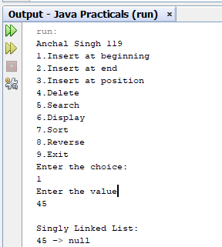 | 2) Inserting at end  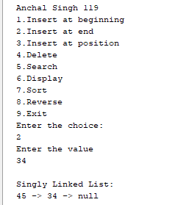
3) Inserting at position  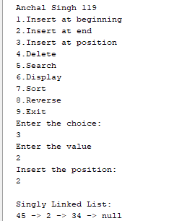 | 4) Searching element found searching element not found  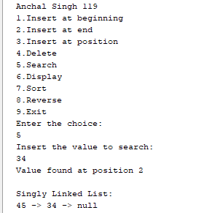
5) displaying list  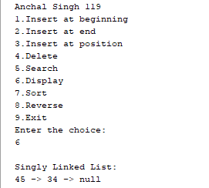 | 7) sorting link list  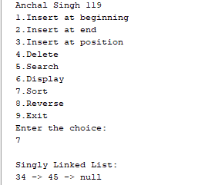
8) Reversing link list  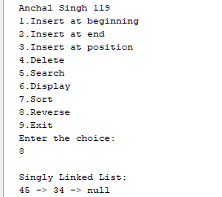 | 9) Deleting element  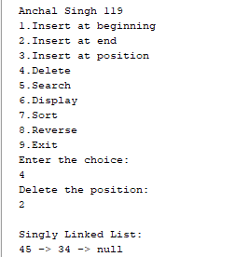

2) Write a program to implement a Circular Linked List.
Code:-
import java.util.Scanner;
class SinglyCircular {
boolean flag = true;
int pos,
i,
value,
count = 0;
Node tmp = null;
Node start = null;
Node last = null;
Node p = null;
Node ptr = null;
class Node {
int data;
Node next;
Node prev;
}
void create(int x) {
tmp = new Node();
tmp.data = x;
if (last == null) {
last = tmp;
tmp.next = last;
} else {
tmp.next = last.next;
last.next = tmp;
last = tmp;
}
}
void addAtBegin(int x) {
if (last == null) {
System.out.println("List is empty.");
}
tmp = new Node();
tmp.data = x;
tmp.next = last.next;
last.next = tmp;
}
void addAfter(int x, int pos) {
if (last == null) {
System.out.println("List is empty.");
}
p = last.next;
for (i = 0; i < pos - 1; i++) {
p = p.next;
if (p == last.next) {
System.out.println("Position does not exist.");
return;
}
}
tmp = new Node();
tmp.next = p.next;
tmp.data = x;
p.next = tmp;
if (p == last) {
last = tmp;
}
}
void del(int x) {
if (last.next == last && last.data == x) { //
tmp = last;
last = null;
return;
}
p = last.next;
if (p.data == x) { // first element deleted
tmp = p;
last.next = p.next;
return;
}
while (p.next != last) {
if (p.next.data == x) {
tmp = p.next;
p.next = tmp.next;
return;
}
p = p.next;
}
if (p.next.data == x) {
tmp = p.next;
p.next = last.next;
last = p;
return;
}
System.out.println("Element not found.");
}

void search1(int x) {
int pos = 1;
p = last.next;
while (p.next != last) {
if (p.data == x) {
System.out.println("Element found at position " + (pos - 1) + ".");
}
p = p.next;
pos++;
}
if (p == null) System.out.println("Item not found.");
}

void sort() {
int x;
if (last == null) {
System.out.println("List is empty.");
return;
}
p = last.next;
while (p != last) {
ptr = p.next;
while (ptr != last.next) {
if (ptr != last.next) {
if (p.data > ptr.data) {
x = p.data;
p.data = ptr.data;
ptr.data = x;
}
}
ptr = ptr.next;
}
p = p.next;
}
}

void count1() {
if (last == null) {
System.out.println("List is empty.");
return;
}
p = last.next;
while (p != last) {
count++;
p = p.next;
}
count++;
System.out.println("Number of elements are " + count);
}
void display() {
if (last == null) {
System.out.println("List is empty.");
return;
}
p = last.next;
System.out.println("\nSingly Circular Linked List:");
while (p != last) {
System.out.print(p.data + " -> ");
p = p.next;
}
System.out.println(last.data + "\n");
}

public static void main(String[] args) {
System.out.println("Anchal Singh 119");
SinglyCircular d = new SinglyCircular();
Scanner sc = new Scanner(System. in );
int x,
ch,
pos;
while (true) {
System.out.println("1. Create a list\n2. Add at begin\n3. Add after\n4. Search");
System.out.println("5. Sort\n6. Count\n7. Display\n8.Delete\n9. Exit");
System.out.print("Enter the choice:\n");
ch = sc.nextInt();
switch (ch) {
case 1:
System.out.print("Enter the value :\n");
x = sc.nextInt();
d.create(x);
d.display();
break;
case 2:
System.out.print("Enter the value :\n");
x = sc.nextInt();
d.addAtBegin(x);
d.display();
break;
case 3:
System.out.print("Enter the position :\n");
pos = sc.nextInt();
System.out.print("Enter the value :\n");
x = sc.nextInt();
d.addAfter(x, pos);
d.display();
break;
case 4:
System.out.print("Enter element to be searched:\n");
x = sc.nextInt();
d.search1(x);
d.display();
break;
case 5:
System.out.print("Before sorting -");
d.display();
d.sort();
System.out.print("After sorting -");
d.display();
break;
case 6:
d.count1();
d.display();
break;
case 7:
d.display();
break;
case 8:
System.out.print("Enter the element to be deleted:\n");
x = sc.nextInt();
d.del(x);
d.display();
break;
case 9:
sc.close();
return;
default:
System.out.println("Wrong choice.");
}
}
}
}
Output:-

1. Creating and adding element at begin  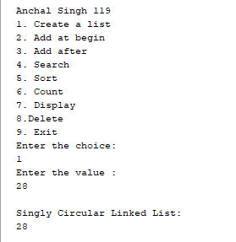 | 2. Adding alement at position  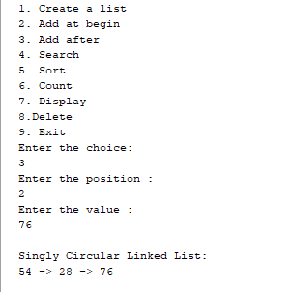
3. Searching an element  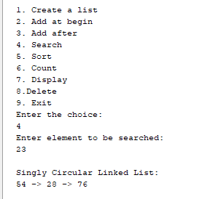 | 4) Sorting circular link list  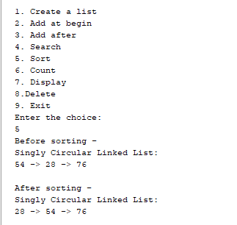
5)counting element in singly circular link list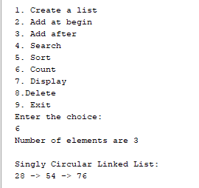 | 6) displying circular link list  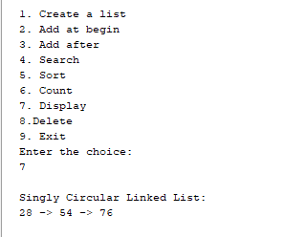
7) deleteing elment  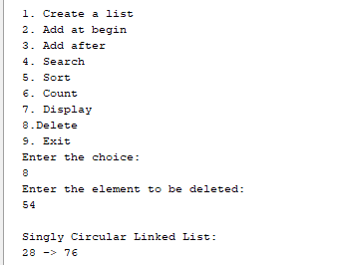 | 8) At at begin  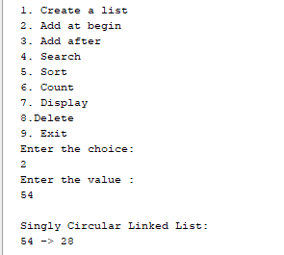

3) Write a program to implement a Doubly Linked List.
Code:-
package DoublyLinkedList;
import java.util.Scanner;
public class DoublyLinkedList {
class Node {
int data;
Node next;
Node prev;
}
private Node tmp = null;
private Node ptr = null;
private Node start = null;
private Node p = null;
private Node p1 = null;
private Node p2 = null;

public void create(int x) {
tmp = new Node();
tmp.data = x;
tmp.next = null;
if (start == null) {
tmp.prev = null;
start = tmp;
} else {
p = start;
while (p.next != null) {
p = p.next;
}
p.next = tmp;
tmp.prev = p;
}
}
public void addAtBegin(int x) {
if (start == null) {
System.out.println("List is empty.\n");
}
tmp = new Node();
tmp.data = x;
tmp.next = start;
start.prev = tmp;
start = tmp;
}

public void addAfter(int x, int pos) {
if (start == null) {
System.out.println("List is empty.\n");
}
p = start;
for (int i = 0; i < pos - 1; i++) {
p = p.next;
if (p == null) {
System.out.println("Position does not exist.\n");
return;
}
}
tmp = new Node();
tmp.data = x;
if (p.next == null) {
p.next = tmp;
tmp.next = null;
tmp.prev = p;
} else {
tmp.next = p.next;
tmp.next.prev = tmp;
p.next = tmp;
tmp.prev = p;
}
}
public void del(int x) {
if (start == null) {
System.out.println("List is empty.\n");
return;
}
if (start.data == x) {
tmp = start;
if (start.next == null) {
start = null;
} else {
start = start.next;
start.prev = null;
}
tmp = null;
return;
}
p = start;
while (p != null) {
if (p.data == x) {
if (p.next != null) {
p.next.prev = p.prev;
}
if (p.prev != null) {
p.prev.next = p.next;
}
tmp = p;
tmp = null;
return;
}
p = p.next;
}
System.out.println("Element not found.");
}
public void reverse() {
p1 = start;
p2 = p1.next;
p1.next = null;
p1.prev = p2;
while (p2 != null) {
p2.prev = p2.next;
p2.next = p1;
p1 = p2;
p2 = p2.prev;
}
start = p1;
System.out.println("List reversed.");
}

public void count() {
p = start;
int cnt = 0;
while (p != null) {
p = p.next;
cnt++;
}
System.out.println("Number of elements are " + cnt +".");
}
public void search() {
int count = 0,
value;
int flag = 0;
Scanner sc = new Scanner(System. in );
System.out.println("Enter the element to be searched:");

value = sc.nextInt();
if (start == null) {
System.out.println("List is empty.\n");
} else {
p = start;
while (p != null) {
count++;
if (p.data == value) {
flag = 1;
System.out.println("Element found at position " + count + ".");
}
p = p.next;}}} public void sort() {
if (start == null) {
System.out.println("List is empty.\n");
}
ptr = start;
while (ptr != null) {
for (p = ptr.next; p != null; p = p.next) {
if (ptr.data > p.data) {
int x = ptr.data;
ptr.data = p.data;
p.data = x;
}
}
ptr = ptr.next;
}
}
public void display() {
if (start == null) {
System.out.println("List is empty.\n");
return;
} else {
p = start;
System.out.println("\nDoubly Linked List :");
while (p != null) {
System.out.print(p.data + " -> ");
p = p.next;
}
System.out.println("\n");}}
public static void main(String[] args) {
System.out.println("Anchal Singh 119");
DoublyLinkedList d = new DoublyLinkedList();
Scanner sc = new Scanner(System. in );
int x,
ch;
int pos;
while (true) {
System.out.println("1.Create a list\n2.Add at begin\n3.Add after\n4.Search\n5.Reverse\n6.Count\n7.Sort\n8.Display\n9.Delete\n10.Exit");

System.out.print("\nEnter the choice:\n");
ch = sc.nextInt();
switch (ch) {
case 1:
System.out.print("Enter the value :\n");
x = sc.nextInt();
d.create(x);
d.display();
break;
case 2:
System.out.print("Enter the value :\n");
x = sc.nextInt();
d.addAtBegin(x);
d.display();
break;
case 3:
System.out.print("Enter the position:\n");
pos = sc.nextInt();
System.out.print("Enter the value :\n");
x = sc.nextInt();
d.addAfter(x, pos);
d.display();
break;
case 4:
d.search();
d.display();
break;
case 5:
d.reverse();
d.display();
break;
case 6:
d.count();
d.display();
break;
case 7:
System.out.print("Before sorting -");
d.display();
d.sort();
System.out.print("After sorting -");
d.display();
break;
case 8:
d.display();
break;
case 9:
System.out.print("Enter the element to be deleted :\n");

x = sc.nextInt();
d.del(x);
d.display();
break;
case 10:
sc.close();
return;
default:
System.out.println("Wrong choice.\n");}}}}

Output:-

1) Creating a list  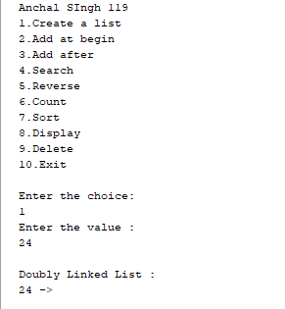 | 2) entering at begin  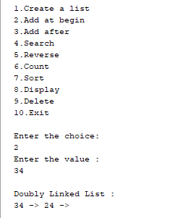
3) Entering element at position Entering at begin  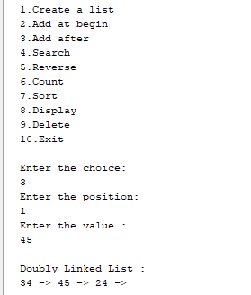 | 4) searching an element  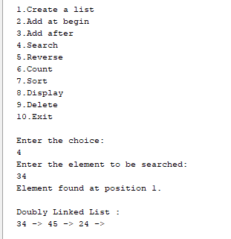
5) reversing a list  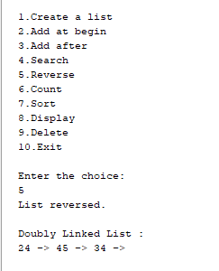 | 6) counting element  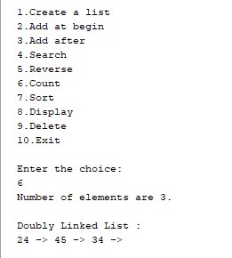
7) sorting a list  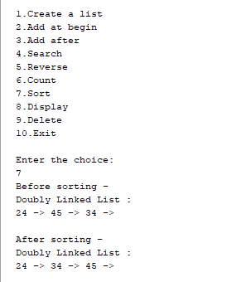 | 8) Displying a list  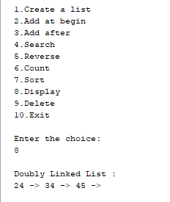
9) deleting element from list
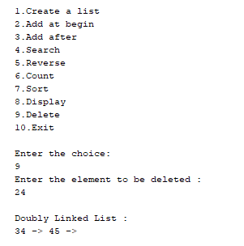

4) Write a program to implement Polynomial Addition.
Code:-
public class PolynomialAddition {
public static int max(int m, int n) {
return (m > n) ? m: n; }
public static int[] add(int[] A, int[] B, int m, int n) {
int size = max(m, n);
int[] sum = new int[size];
for (int i = 0; i < m; i++) {
sum[i] = A[i];}
for (int i = 0; i < n; i++) {
sum[i] += B[i];}
return sum;}
public static void printPoly(int[] poly, int n) {
for (int i = 0; i < n; i++) {
System.out.print(poly[i]);
if (i != 0) {
System.out.print("x^" + i); }
if (i != n - 1) {
System.out.print(" + ");}}
System.out.println();}
public static void main(String[] args) {
System.out.println("Anchal Singh 119");
System.out.println("\nPOLYNOMIAL ADDITION\n");
int[] A = {1,0,2,4};
int[] B = {3, 5,7};
int m = A.length;
int n = B.length;
System.out.println("First polynomial is ");
printPoly(A, m);
System.out.println("Second polynomial is ");
printPoly(B, n);
int[] sum = add(A, B, m, n);
int size = max(m, n);
System.out.println("\nsum polynomial is ");
printPoly(sum, size);}}
Output:
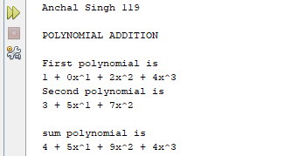

PRACTICAL NO : 6
Aim : Demonstrate application of linked list.

1) Write a program to implement Stack Using Linked List.
Code :-
import java.util.Scanner;
class Node {
int data;
Node next;
Node(int data) {
this.data = data;
this.next = null;}}
class Stack {
private Node top = null;
public void push(int x) {
Node ptr = new Node(x);
if (top != null) {
ptr.next = top; }
top = ptr;}
public void pop() {
if (top == null) {
System.out.println("\nStack is empty.");
} else {
Node temp = top;
top = top.next;
System.out.println("Popped value : " + temp.data);}}
public void display() {
Node ptr1 = top;
if (top == null) {
System.out.println("Stack is empty.\n");
} else {
System.out.println("Stack :");
while (ptr1 != null) {
System.out.println(ptr1.data);
ptr1 = ptr1.next;}}}}
public class StackLinkedList {
public static void main(String[] args) {
System.out.println("Anchal Singh 119");
Stack s = new Stack();
int ch = 0,x;
Scanner scanner = new Scanner(System. in );
while (ch != 4) {
System.out.println("1.Push\n2.Pop\n3.Display\n4.Exit");
System.out.println("Enter the value for operation :");
ch = scanner.nextInt();
switch (ch) {
case 1:
System.out.println("Enter the value :");
x = scanner.nextInt();
s.push(x);
break;
case 2:
s.pop();
break;
case 3:
s.display();
break;
case 4:
break;
default:
System.out.println("\nWrong choice.\n");}}
scanner.close();}}

Output:

1. Adding and displaying element  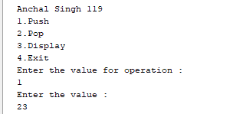 | 2. Removing and displaying element  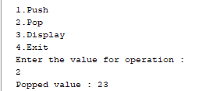
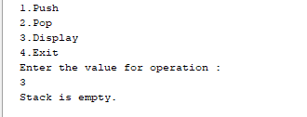

2) Write a program to implement Ordinary Queue Using Linked List.
Code :-
import java.util.Scanner;
class Node {
int data;
Node next;
Node(int data) {
this.data = data;
this.next = null;}}
// Renamed this class from LinkQueue → QueueList
class QueueList {
private Node front = null;
private Node rear = null;

public void enqueue(int x) {
Node tmp = new Node(x);
if (front == null && rear == null) {
front = rear = tmp;
} else {
rear.next = tmp;
rear = tmp;}}
public void dequeue() {
if (front == null) {
System.out.println("Queue is empty\n");
return;
}
System.out.println("Deleted");
if (front == rear) {
front = rear = null;
} else {
front = front.next;}}
public void display() {
if (front == null) {
System.out.println("Queue is empty.\n");
} else {
Node ptr = front;
System.out.println("Queue:");
while (ptr != null) {
System.out.print(ptr.data + "\t");
ptr = ptr.next;
}
System.out.println();}}}
public class LinkQueue { // This is now only your MAIN class
public static void main(String[] args) {

System.out.println("Anchal Singh 119");
QueueList q = new QueueList(); // Use QueueList object
Scanner scanner = new Scanner(System. in );
int ch,x;
do {
System.out.println("1.Enqueue\n2.Dequeue\n3.Display\n4.Exit");
System.out.println("Enter the value for operation :");
ch = scanner.nextInt();
switch (ch) {
case 1:
System.out.println("Enter the value :");
x = scanner.nextInt();
q.enqueue(x);
break;
case 2:
q.dequeue();
break;
case 3:
q.display();
break;
case 4:
break;
default:
System.out.println("\nWrong choice.\n");}}
while ( ch != 4 );
scanner.close();}}

Output:-
1. Adding and displaying elements.
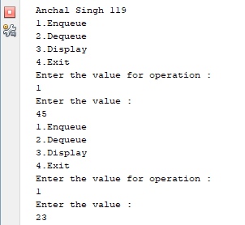

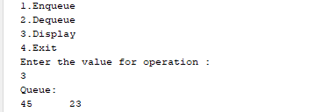

2. Removing and Displaying element.

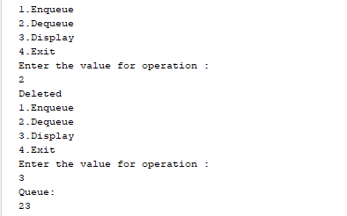

3) Write a program to implement Priority Queue Using Linked List.
Code :-
import java.util.Scanner;
class Node {
int data;
int priority;
Node next;
Node(int data, int priority) {
this.data = data;
this.priority = priority;
this.next = null;}}
class PriorityQueue {
private Node front;
public PriorityQueue() {
front = null;}
public void enqueue(int value, int priority) {
Node newNode = new Node(value, priority);
if (front == null || priority < front.priority) {
newNode.next = front;
front = newNode;
} else {
Node current = front;
while (current.next != null && current.next.priority <= priority) {
current = current.next;}
newNode.next = current.next;
current.next = newNode;
}
System.out.println(value + " enqueued with priority " + priority);}
public int dequeue() {
if (front == null) {
System.out.println("Queue is empty");
return - 1;
}
int value = front.data;
front = front.next;
return value;}
public int peek() {
if (front == null) {
System.out.println("Queue is empty");
return - 1;
}
return front.data;}

public void display() {
if (front == null) {
System.out.println("Queue is empty");
return;}
Node current = front;
System.out.print("Priority Queue (data:priority): ");
while (current != null) {
System.out.print("(" + current.data + ":" + current.priority + ") ");
current = current.next;
}
System.out.println();}}
// Renamed main class (NOT public)
class PQTest {
public static void main(String[] args) {
System.out.println("Anchal Singh 119");
PriorityQueue pq = new PriorityQueue();
Scanner scanner = new Scanner(System. in );
int ch, value,priority;
do {
System.out.println("\nPriority Queue Menu:");
System.out.println("1. Enqueue");
System.out.println("2. Dequeue");
System.out.println("3. Display");
System.out.println("4. Exit");
System.out.print("Enter your choice: ");
ch = scanner.nextInt();
switch (ch) {
case 1:
System.out.print("Enter value: ");
value = scanner.nextInt();
System.out.print("Enter priority (lower = higher): ");
priority = scanner.nextInt();
pq.enqueue(value, priority);
break;
case 2:
value = pq.dequeue();
if (value != -1) System.out.println(value + " dequeued");
break;
case 3:
pq.display();
break;
case 4:
System.out.println("Exiting...");
break;

default:
System.out.println("Invalid choice!");}
} while ( ch != 4 );
scanner.close();}}

Output:-
1) Inserting and displaying element
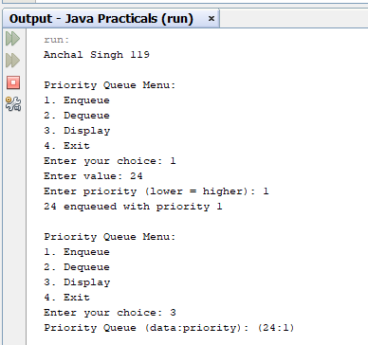
2) Deleting and displaying element

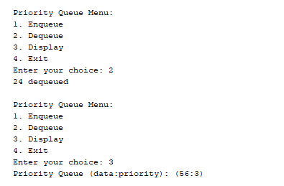

4) Write a program to implement a Double Ended Queue Using Linked List.
Code :
import java.util.Scanner;
class Node {
int data;
Node next;
Node prev;
Node(int value) {
data = value;
next = null;
prev = null;
}
}
class Deque {
private Node front;
private Node rear;
public Deque() {
front = rear = null;
}
public void insertFront(int value) {
Node newNode = new Node(value);
newNode.next = front;
if (front != null) {
front.prev = newNode;
}
front = newNode;
if (rear == null) {
rear = newNode;
}
System.out.println(value + " inserted at front");
}
public void insertRear(int value) {
Node newNode = new Node(value);
newNode.next = null;
newNode.prev = rear;
if (rear != null) {
rear.next = newNode;
}
rear = newNode;
if (front == null) {
front = newNode;
}
System.out.println(value + " inserted at rear");
}
public int deleteFront() {
if (front == null) {
System.out.println("Deque is empty");
return - 1;
}
int value = front.data;
front = front.next;
if (front != null) {
front.prev = null;
} else {
rear = null;}
return value;}
public int deleteRear() {
if (rear == null) {
System.out.println("Deque is empty");
return - 1;}
int value = rear.data;
rear = rear.prev;
if (rear != null) {
rear.next = null;}
else {
front = null; }
return value;}
public int getFront() {
if (front == null) {
System.out.println("Deque is empty");
return - 1;}
return front.data;}
public int getRear() {
if (rear == null) {
System.out.println("Deque is empty");
return - 1;}
return rear.data; }
public void display() {
if (front == null) {
System.out.println("Deque is empty");
return;
}
Node current = front;
System.out.print("Deque contents: ");
while (current != null) {
System.out.print(current.data + " ");
current = current.next;
}
System.out.println();}}
public class DoubleEndedQueue {
public static void main(String[] args) {
System.out.println("Anchal Singh 119");
Deque dq = new Deque();
Scanner scanner = new Scanner(System. in );
int ch,
value;
do {
System.out.println("\nDeque Operations Menu:");
System.out.println("1. Insert Front \n2. Insert Rear\n3. Delete Front");
System.out.println("4. Delete Rear \n5. Display \n6.Exit");
System.out.print("Enter your choice: ");
ch = scanner.nextInt();
switch (ch) {
case 1:
System.out.print("Enter value to insert at front: ");
value = scanner.nextInt();
dq.insertFront(value);
break;
case 2:
System.out.print("Enter value to insert at rear:");
value = scanner.nextInt();
dq.insertRear(value);
break;
case 3:
value = dq.deleteFront();
if (value != -1) {
System.out.println(value + " deleted from front");
}
break;
case 4:
value = dq.deleteRear();
if (value != -1) {
System.out.println(value + " deleted from rear");
}
break;
case 5:
dq.display();
break;
case 6:
System.exit(0);
default:
System.out.println("Invalid choice. Please try again.");
}
} while ( ch != 6 );
scanner.close();}}

Output:-
1) Inserting and displaying element at front
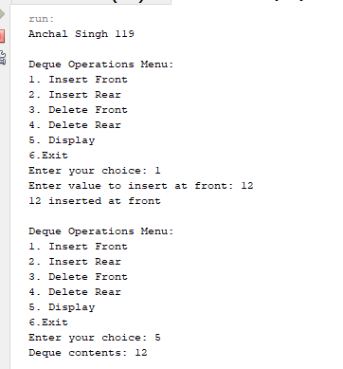
2) Insert at rear
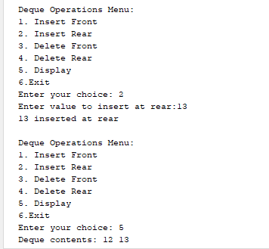
3) Deleting from front

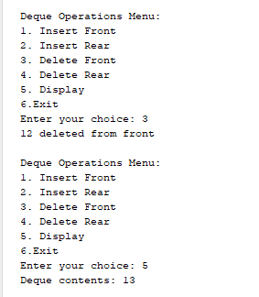
4) Deleting from rear List is empty

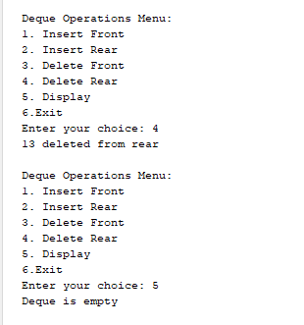

PRACTICAL NO : 7
Aim : Create and perform various operations on BST.

1) Write a program to implement Binary Search Tree (BST).

Code :-
import java.util.Scanner;
public class Main {
// Node structure for the tree
class Node {
int data;
Node left,
right;
public Node(int item) {
data = item;
left = right = null;
}
}
private Node tree;
public Main() {
tree = null;
}
// Method to create a tree (insert node)
public Node createTree(Node node, int item) {
if (node == null) {
node = new Node(item);
} else {
if (node.data > item) {
node.left = createTree(node.left, item);
} else {
node.right = createTree(node.right, item);
}
}
return node;
}
// Preorder traversal
public void preorder(Node node) {
if (node != null) {
System.out.print(" " + node.data);
preorder(node.left);
preorder(node.right);
}
}
// Inorder traversal
public void inorder(Node node) {
if (node != null) {
inorder(node.left);
System.out.print(" " + node.data);
inorder(node.right);
}
}
// Postorder traversal
public void postorder(Node node) {
if (node != null) {
postorder(node.left);
postorder(node.right);
System.out.print(" " + node.data);
}
}
// Count total nodes in the tree
public int totalNodes(Node node) {
if (node == null) {
return 0;
}
return totalNodes(node.left) + totalNodes(node.right) + 1;
}
// Find the smallest node
public void findSmallestNode(Node node) {
if (node == null || node.left == null) {
System.out.println(node.data);
} else {
findSmallestNode(node.left);
}
}
// Find the largest node
public void findLargestNode(Node node) {
if (node == null || node.right == null) {
System.out.println(node.data);
} else {
findLargestNode(node.right);
}
}
// Main method to handle user input
public static void main(String[] args) {
Main obj = new Main();
Scanner scanner = new Scanner(System. in );
int choice,n,item;
System.out.println("Anchal Singh FYMCA B-119");
while (true) {
System.out.println("\nBinary search tree common operation");
System.out.println("1) Create Tree");
System.out.println("2) Traversal");
System.out.println("3) Total Nodes");
System.out.println("4) Insert Nodes");
System.out.println("5) Find Smallest Node");
System.out.println("6) Find Largest Node");
System.out.println("7) Exit");
System.out.print("Enter your choice: ");
choice = scanner.nextInt();
switch (choice) {
case 1:
System.out.print("\nCreating Tree----");
System.out.print("\nHow many nodes do you want to enter: ");
n = scanner.nextInt();
for (int i = 0; i < n; i++) {
System.out.print("Enter value: ");
item = scanner.nextInt();
obj.tree = obj.createTree(obj.tree, item);
}
break;
case 2:
System.out.println("\nInorder Traversal:");
obj.inorder(obj.tree);
System.out.println("\nPreorder Traversal:");
obj.preorder(obj.tree);
System.out.println("\nPostorder Traversal:");
obj.postorder(obj.tree);
break;
case 3:
int total = obj.totalNodes(obj.tree);
System.out.println("Total nodes: " + total);
break;
case 4:
System.out.print("\nInsert node in a tree \nEnter value: ");
item = scanner.nextInt();
obj.tree = obj.createTree(obj.tree, item);
System.out.println("\nItem is inserted.");
break;
case 5:
System.out.println("\nSmallest node is:");
obj.findSmallestNode(obj.tree);
break;
case 6:
System.out.println("\nLargest node is:");
obj.findLargestNode(obj.tree);
break;
case 7:
System.out.println("Exiting program.");
scanner.close();
System.exit(0);
default:
System.out.println("Invalid choice, try again.");}}}}

Output:
1. Create Tree
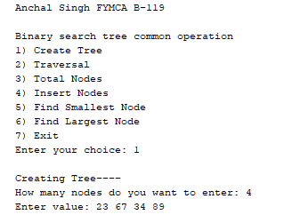
2. Traverse Tree
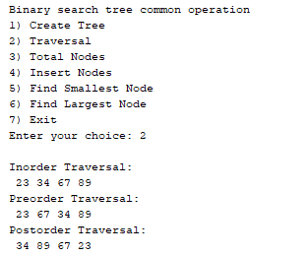
3. Display Total Nodes
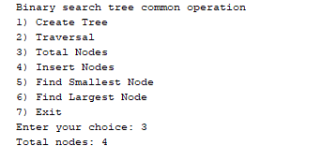
4. Insert Node
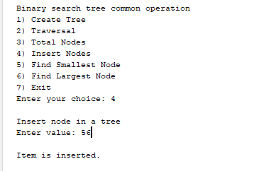

5. Find smallest Node  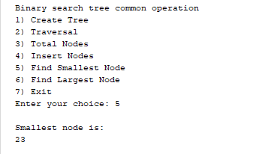 | 6. Find Largest Node  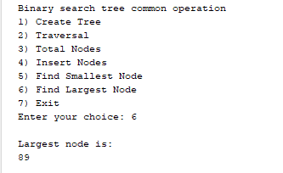

PRACTICAL NO : 10

Aim :Implementation of Graph traversal. (DFS and BFS)

Write a program to implement Depth-First Search (DFS).
Code:
package practicals;

import java.util.ArrayList;
import java.util.Stack;
import java.util.List;

public class DFSWithStack {

// Represents the graph using an adjacency list
private List<List<Integer>> adj;
private int V; // Number of vertices

public DFSWithStack(int V) {
this.V = V;
adj = new ArrayList<>(V);
for (int i = 0; i < V; i++) {
adj.add(new ArrayList<>());
}
}

// Adds an edge to the graph
public void addEdge(int u, int v) {
adj.get(u).add(v);
// For an undirected graph, add the reverse edge as well
// adj.get(v).add(u);
}

// Performs DFS starting from a given source vertex
public void dfs(int startNode) {
boolean[] visited = new boolean[V]; // To keep track of visited nodes
Stack<Integer> stack = new Stack<>();

stack.push(startNode);
visited[startNode] = true; // Mark the starting node as visited

while (!stack.isEmpty()) {
int currentNode = stack.pop();
System.out.print(currentNode + " "); // Process the node (e.g., print it)

// Push all unvisited neighbors onto the stack
for (int neighbor : adj.get(currentNode)) {
if (!visited[neighbor]) {
visited[neighbor] = true;
stack.push(neighbor);
}
}
}
}

public static void main(String[] args) {
DFSWithStack graph = new DFSWithStack(5); // Create a graph with 5 vertices

graph.addEdge(0, 1);
graph.addEdge(0, 2);
graph.addEdge(1, 3);
graph.addEdge(2, 4);
graph.addEdge(3, 4);

System.out.println("Anchal Singh 119");
System.out.println("DFS Traversal starting from vertex 0:");
graph.dfs(0); // Perform DFS starting from vertex 0
}
}

Output:
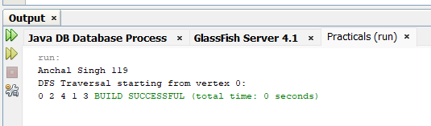

Write a program to implement Breadth-First Search (BFS).

Code:
package practicals;
import java.util.ArrayList;
import java.util.LinkedList;
import java.util.Queue;

public class BFSExample {

// Function to perform BFS traversal
public static void bfs(ArrayList<ArrayList<Integer>> adj, int startNode, int V) {
Queue<Integer> queue = new LinkedList<>();
boolean[] visited = new boolean[V]; // To keep track of visited nodes

// Mark the start node as visited and enqueue it
visited[startNode] = true;
queue.add(startNode);

while (!queue.isEmpty()) {
int currentNode = queue.poll(); // Dequeue a node
System.out.print(currentNode + " "); // Process the node (e.g., print it)

// Get all adjacent vertices of the dequeued vertex currentNode
// If an adjacent vertex has not been visited, mark it visited and enqueue it
for (int neighbor : adj.get(currentNode)) {
if (!visited[neighbor]) {
visited[neighbor] = true;
queue.add(neighbor);
}
}
}
}

public static void main(String[] args) {
int V = 5; // Number of vertices
ArrayList<ArrayList<Integer>> adj = new ArrayList<>(V);

// Initialize adjacency list
for (int i = 0; i < V; i++) {
adj.add(new ArrayList<>());
}

// Add edges to the graph
addEdge(adj, 0, 1);
addEdge(adj, 0, 2);
addEdge(adj, 1, 3);
addEdge(adj,1,4);
addEdge(adj,2,4);

System.out.println("Anchal Singh 119");

System.out.println("BFS Traversal starting from node 0:");
bfs(adj, 0, V);
}

// Helper function to add an edge to the graph
public static void addEdge(ArrayList<ArrayList<Integer>> adj, int u, int v) {
adj.get(u).add(v);
// For an undirected graph, add the reverse edge as well
// adj.get(v).add(u);
}
}

Output:
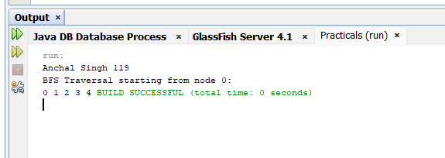

PRACTICAL NO: 2

Aim : Perform various Hashing techniques with Linear Probe as collision.
1)Write a program to implement Hashing using Linear Probing
Code:-
package hashtechniques;
import java.util.Scanner;
public class HashTechniques {
public static int hashSearch(int[] hashTable, int x, int n) {
int index = x % n;
int start = index;
if (hashTable[index] == x) {
return index;
} else if (hashTable[index] == -1) {
return -1;
} else {
do {
index = (index + 1) % n;
if (hashTable[index] == x) {
return index;
} else if (hashTable[index] == -1) {
break; }
} while (index != start);
return -1;
} }
public static void main(String[] args) {
Scanner scanner = new Scanner(System.in);
int[] hashTable = new int[10];

int i, x, index, k;
for (i = 0; i < 10; i++) {
hashTable[i] = -1;
}
System.out.println("Anchal Singh 119");
System.out.println("Hashing using linear probing\n");
System.out.println("Hash table creation\n");
for (i = 1; i <= 7; i++) {
System.out.print("\nEnter a number: ");
x = scanner.nextInt();
index = x % 10;
while (hashTable[index] != -1) {
index = (index + 1) % 10;
}
hashTable[index] = x;
}
System.out.println("\nHASH TABLE");
for (i = 0; i < 10; i++) {
System.out.print(i + " ");
}
System.out.println();
for (i = 0; i < 10; i++) {
System.out.print(hashTable[i] + " ");
}
do {
System.out.print("\nElement to be searched (enter -1 to stop): "); x = scanner.nextInt();
if (x >= 0) {
k = hashSearch(hashTable, x, 10);
if (k >= 0) {
System.out.println(x + " is present at hash[" + k + "]");

} else {
System.out.println(x + " is not present"); } }
} while (x >= 0);
scanner.close(); } }

Output:-
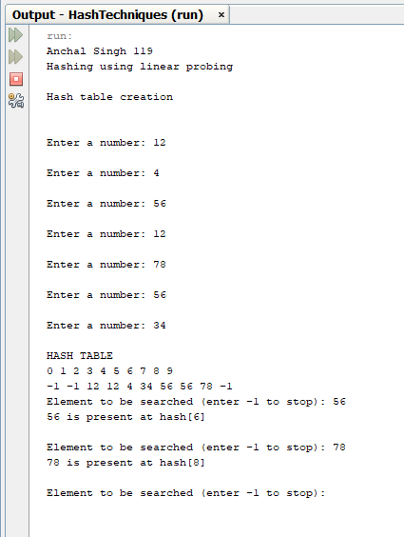

1)Write a program to implement Hashing using Linear Probing
Code:
import java.util.Arrays;
import java.util.Objects;
public class CustomHashTable {
private static final int TABLE_SIZE = 10; // Prime numbers work best for modulo hashing
private Integer[] table; // Using Integer to allow null values

public CustomHashTable() {
table = new Integer[TABLE_SIZE];
Arrays.fill(table, null);
}

/**
* Hashing Function using Modulo Division (h(k) = k mod m)
* @param key The integer key to hash.
* @return The initial hash index.
*/
private int moduloHash(int key) {
// Use Math.abs to handle potential negative hash codes
return Math.abs(key) % TABLE_SIZE;
}

/**
* Hashing Function using Digit Extraction (extracting specific digits)
* For demonstration, extracts the 2nd and 3rd digits of a 4+ digit number
* (e.g., from 12345, extracts '23', which becomes index 23 % TABLE_SIZE)
* @param key The integer key to hash (assumed >= 1000 for this example).
* @return The initial hash index.
*/
private int digitExtractionHash(int key) {
String keyStr = String.valueOf(Math.abs(key));
if (keyStr.length() < 4) {
// Fallback to modulo hash for smaller numbers
return moduloHash(key);
}

// Extract 2nd digit (index 1) and 3rd digit (index 2)
int digit2 = Character.getNumericValue(keyStr.charAt(1));
int digit3 = Character.getNumericValue(keyStr.charAt(2));

// Combine digits (e.g., 2 and 3 become 23)
int extractedVal = digit2 * 10 + digit3;

return Math.abs(extractedVal) % TABLE_SIZE;
}

/**
* Inserts a key into the hash table using Linear Probing for collision resolution.
* @param key The key to insert.
* @param useDigitExtraction True to use digit extraction hash, False for modulo hash.
*/
public void insert(int key, boolean useDigitExtraction) {
int index = useDigitExtraction ? digitExtractionHash(key) : moduloHash(key);
int startIndex = index;

while (table[index] != null) {
if (table[index].equals(key)) {
// Key already exists, just return or handle as an update
return;
}
// Linear probing: move to the next index
index = (index + 1) % TABLE_SIZE;
if (index == startIndex) {
System.out.println("Error: Hash table is full. Cannot insert key " + key);
return;
}
}

table[index] = key;
System.out.println("Inserted Key " + key + " at index " + index);
}

/**
* Displays the contents of the hash table.
*/
public void printTable() {
System.out.println("\nHash Table Contents:");
for (int i = 0; i < TABLE_SIZE; i++) {
System.out.println("Index " + i + ": " + (table[i] == null ? "Empty" : table[i]));
}
}

public static void main(String[] args) {
CustomHashTable ht = new CustomHashTable();
System.out.println("\nAnchal Singh 119");
System.out.println("--- Using Modulo Division Hashing ---");
int[] keys = {50, 70, 76, 85, 93, 100};
for (int key : keys) {
ht.insert(key, false);
}
ht.printTable();

CustomHashTable ht2 = new CustomHashTable();
System.out.println("\n--- Using Digit Extraction Hashing (Keys: 1234, 5678, 9012, 1111) ---");
ht2.insert(1234, true); // Extracts '23' -> index 3
ht2.insert(5678, true); // Extracts '67' -> index 7
ht2.insert(9012, true); // Extracts '01' -> index 1
ht2.insert(1111, true); // Extracts '11' -> index 1 (collision, probes to index 2)
ht2.printTable();
}
}

Output:

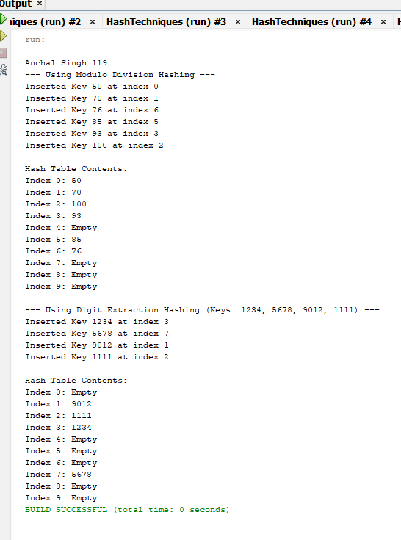

PRACTICAL NO : 4

Aim : Implementation of Stack Applications.

1) Write a program to implement Infix to Postfix.
Code :
import java.util.Scanner;
public class InxToPostxWithoutImport {
static final int MAX = 100;
public static int precedence(char c) {
if (c == '^') return 3;
if (c == '*' || c == '/') return 2;
if (c == '+' || c == '-') return 1;
return -1;
}
public static boolean isOperand(char c) {
return Character.isLetterOrDigit(c);
}
public static String inxToPostx(String inx) {
char[] stack = new char[MAX];
int top = -1;
StringBuilder postx = new StringBuilder();
for (int i = 0; i < inx.length(); i++) {
char currentChar = inx.charAt(i);
if (isOperand(currentChar)) {
postx.append(currentChar);
} else if (currentChar == '(') {
stack[++top] = currentChar;
} else if (currentChar == ')') {
while (top != -1 && stack[top] != '(') { postx.append(stack[top--]);
}
top--;
} else {
while (top != -1 && precedence(stack[top]) >= precedence(currentChar)) {
postx.append(stack[top--]);
}
stack[++top] = currentChar;
}}
while (top != -1) {
postx.append(stack[top--]);
}
return postx.toString();
}
public static void main(String[] args) {
System.out.print("Anchal Singh 119\n");
Scanner scanner = new Scanner(System.in);
System.out.print("Enter the infix expression: ");

String inx = scanner.nextLine();
String postx = inxToPostx(inx);
System.out.println("Postfix Expression: " + postx); scanner.close();
}}
Output:-
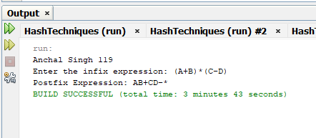

2) Write a program to implement Postfix Evaluation.
Code :-
import java.util.Stack;
public class Postfix {
public static int evaluatePostfix(String expr) {
Stack<Integer> stack = new Stack<>();
for (int i = 0; i < expr.length(); i++) {
char ch = expr.charAt(i);
if (Character.isDigit(ch)) {
stack.push(ch - '0');
} else {
int b = stack.pop();
int a = stack.pop();
switch (ch) {
case '+':
stack.push(a + b);
break;
case '-':
stack.push(a - b);
break;
case '*':
stack.push(a * b);
break;
case '/':
if (b != 0) {
stack.push(a / b);
} else {
System.out.println("Division by zero error");
return -1;
}
break;
default:
System.out.println("Invalid operator: " + ch);
return -1;
} }}
return stack.pop();
}
public static void main(String[] args) {
System.out.println("Anchal Singh 119");
java.util.Scanner scanner = new java.util.Scanner(System.in);
System.out.print("Enter Postfix Expression: ");
String expr = scanner.next();
int result = evaluatePostfix(expr);
if (result != -1) {
System.out.println("Result: " + result);
}
scanner.close();
}
}

Output:-
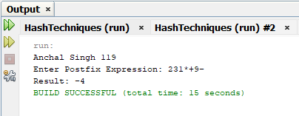

3) Write a program to implement Balancing of Parenthesis.
Code:-
import java.util.Scanner;
class Node {
int data;
Node next;
}
public class BalancingParanthesis {
static Node top = null;
static void push(char x) {
Node tmp = new Node();
tmp.data = x;
tmp.next = null;
if (top == null) {
top = tmp;
} else {
Node tmp1 = top;
top = tmp;
tmp.next = tmp1;
}
}
static char pop() {
if (top == null) {
System.out.println("Stack is empty.");
return '\0';
} else {
Node ptr = top;
top = top.next;
char data = (char) ptr.data;
return data;
} }
public static void main(String[] args) {
System.out.println("Anchal Singh 119");
Scanner scanner = new Scanner(System.in);
int len;
char c, d, e;
char[] a = new char[30];
System.out.println("Enter expression :");
String input = scanner.nextLine();
len = input.length();
a = input.toCharArray();
for (int i = 0; i < len; i++) {
if (a[i] == '{' || a[i] == '[' || a[i] == '(') { push(a[i]);

} else {
switch (a[i]) {
case ')':
c = pop();
if (c == '{' || c == '[') {
System.out.println("Invalid"); return;
}
break;
case ']':
d = pop();
if (d == '{' || d == '(') {
System.out.println("Invalid"); return;
}
break;
case '}':
e = pop();
if (e == '(' || e == '[') {
System.out.println("Invalid"); return;
}
break;
default:
System.out.println("Enter the correct choice");
return; } } }
if (top == null)
System.out.println("Balanced");
else
System.out.println("Unbalanced");
scanner.close();
}}

Output:-
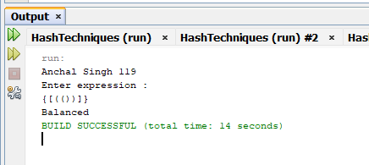
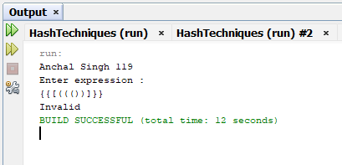

PRACTICAL NO : 8

Aim : Implementing Heap with different operations.

1) Write a program to implement Max Heap.
Code :-
import java.util.Scanner;
public class MaxHeap {
public static void maxHeapify(int[] a, int i, int n) {
int j, temp;
temp = a[i];
j = 2 * i;
while (j <= n) {
if (j < n && a[j + 1] > a[j]) {
j = j + 1;}
if (temp > a[j]) {
break;}
else if (temp <= a[j]) {
a[j / 2] = a[j];
j = 2 * j; } }
a[j / 2] = temp;}
public static void buildMaxHeap(int[] a, int n) {
for (int i = n / 2; i >= 1; i--) {
maxHeapify(a, i, n);} }
public static void main(String[] args) {
Scanner scanner = new Scanner(System.in);
System.out.println("Anchal Singh 119");
System.out.println("Enter number of elements in the array:");
int n = scanner.nextInt();
int[] a = new int[21];
for (int i = 1; i <= n; i++) {
System.out.println("Enter element " + i + ":");
a[i] = scanner.nextInt();}
buildMaxHeap(a, n);
System.out.println("Max Heap:");
for (int i = 1; i <= n; i++) {
System.out.println(a[i]);}
scanner.close();}}
Output:-

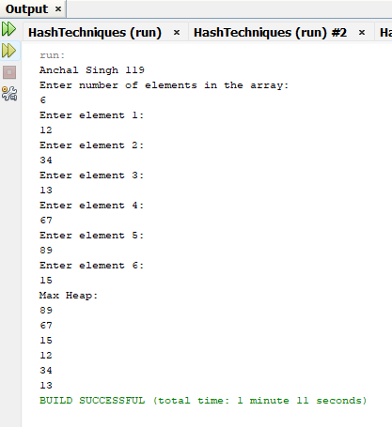

2) Write a program to implement Min Heap.

Code :-
import java.util.Scanner;
public class MinHeap {
public static void minHeapify(int[] a, int i, int n) {
int j, temp;
temp = a[i];
j = 2 * i;
while (j <= n) {
if (j < n && a[j + 1] < a[j]) {
j = j + 1;
}
if (temp < a[j]) {
break;
} else if (temp >= a[j]) {
a[j / 2] = a[j];
j = 2 * j;
}
}
a[j / 2] = temp;
}
public static void buildMinHeap(int[] a, int n) {
for (int i = n / 2; i >= 1; i--) {
minHeapify(a, i, n);
}
}
public static void main(String[] args) {
Scanner scanner = new Scanner(System.in);
System.out.println("Anchal Singh 119");
System.out.println("Enter number of elements in the array:");
int n = scanner.nextInt();
int[] a = new int[21];
for (int i = 1; i <= n; i++) {
System.out.println("Enter element " + i + ":");
a[i] = scanner.nextInt();
}
buildMinHeap(a, n);
System.out.println("Min Heap:");
for (int i = 1; i <= n; i++) {
System.out.println(a[i]);}
scanner.close(); }}

Output:-

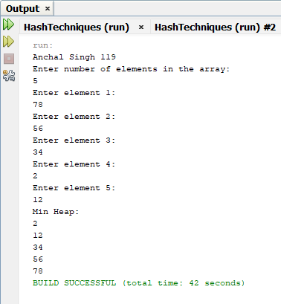

3) Write a program to implement the select kth element from the heap.
Code :-
import java.util.Scanner;
public class HeapOperations {
static int[] array1 = new int[100];
static int n = 0;
public static void display() {
if (n == 0) {
System.out.println("Heap is empty");
return;}
for (int i = 0; i < n; i++) {
System.out.print(array1[i] + "\t"); }
System.out.println();}
public static void insert1(int num, int location) {
int parentnode;
while (location > 0) {
parentnode = (location - 1) / 2;
if (num <= array1[parentnode]) {
array1[location] = num;
return;
}
array1[location] = array1[parentnode];
location = parentnode; }
array1[0] = num;}
public static void delete1(int num) {
int left, right, i, temp, parentnode;
for (i = 0; i < n; i++) {
if (num == array1[i]) {
break;}
}
if (num != array1[i]) {
System.out.println(num + " not found in heap list");
return;
}
array1[i] = array1[n - 1];
n = n - 1;
parentnode = (i - 1) / 2;
if (array1[i] > array1[parentnode]) {
insert1(array1[i], i);
return;
}
left = 2 * i + 1;
right = 2 * i + 2;
while (right < n) {
if (array1[i] >= array1[left] && array1[i] >= array1[right]) {
return;
}
if (array1[right] <= array1[left]) {
temp = array1[i];
array1[i] = array1[left];
array1[left] = temp;
i = left;
} else {
temp = array1[i];
array1[i] = array1[right];
array1[right] = temp;
i = right;
}
left = 2 * i + 1;
right = 2 * i + 2;
}
if (left == n - 1 && array1[i] < array1[left]) {
temp = array1[i];
array1[i] = array1[left];
array1[left] = temp; }}
public static void main(String[] args) {
System.out.println("Anchal Singh 119");
Scanner scanner = new Scanner(System.in);
int choice, num;
while (true) {
System.out.println("1. Insert the element");
System.out.println("2. Delete the element");
System.out.println("3. Display all elements");
System.out.println("4. Quit");
System.out.print("Enter your choice: ");
choice = scanner.nextInt();
switch (choice) {
case 1:
System.out.print("Enter the element to be inserted to the list: ");
num = scanner.nextInt();
insert1(num, n);
n = n + 1;
break;
case 2:
System.out.print("Enter the element to be deleted from the list: ");
num = scanner.nextInt();
delete1(num);
break;
case 3:
display();
break;
case 4:
System.exit(0);
break;
default:
System.out.println("Invalid choice"); }
Output:

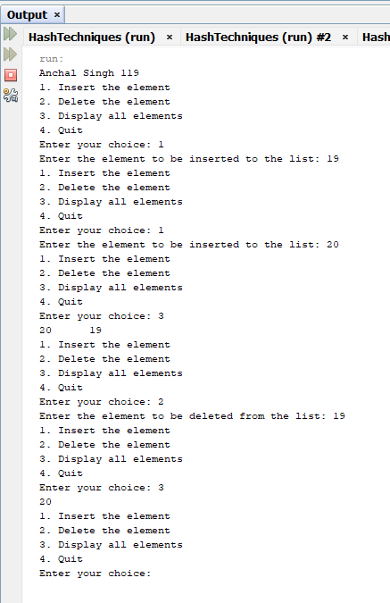

PRACTICAL NO : 9

Aim : Implementation of Adjacency Matrix.

1) Write a program to implement Adjacency Matrix.
Code :-
import java.util.Scanner;
class AdjencyMatrix {
private int[][] adj;
private boolean[] visited;
private int n;
public AdjencyMatrix(int n) {
this.n = n;
visited = new boolean[n];
adj = new int[n][n];
for (int i = 0; i < n; i++) {
for (int j = 0; j < n; j++) {
adj[i][j] = 0;}}}
public void addEdge(int origin, int dest) {
if (origin >= n || dest >= n || origin < 0 || dest < 0) {
System.out.println("Wrong nodes");
} else {
adj[origin][dest] = 1;}}
public void display() {
for (int i = 0; i < n; i++) {
for (int j = 0; j < n; j++) {
System.out.print(adj[i][j] + "\t");}
System.out.println();}}
public static void main(String[] args) {
Scanner scanner = new Scanner(System.in);
int nodes, maxEdges, origin, dest;
System.out.println("Anchal Singh 119");
System.out.print("Enter Maximum number of nodes: ");
nodes = scanner.nextInt();
AdjencyMatrix am = new AdjencyMatrix(nodes);
maxEdges = nodes * (nodes - 1);
System.out.println("Enter -1 -1 to exit");
for (int i = 0; i < maxEdges; i++) {
System.out.print("\nEnter edges: ");
origin = scanner.nextInt();
dest = scanner.nextInt();
if (origin == -1 && dest == -1) {
break;
} else {
am.addEdge(origin, dest);}}
am.display();
scanner.close();}}
Output:

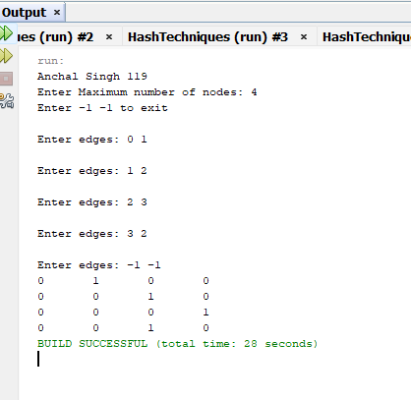

PRACTICAL NO : 11

Aim : Create a Minimum Spanning Tree using any method Kruskal’s or Prim’s Algorithm.

1) Write a program to implement Minimum Spanning Tree using Kruskal’s Algorithm.
Code:-
import java.util.*;
public class KruskarlsMST {
static int[] father;
static Edge[] tree;
static int wt_tree = 0;
static int cnt = 0;
static int n;
static class Edge {
int u, v, weight;
}
// Find with path compression
public static int find(int i) {
if (father[i] < 0)
return i;
father[i] = find(father[i]);
return father[i];
}
// Union by size
public static void union(int root1, int root2) {
if (father[root1] < father[root2]) {
father[root1] += father[root2];
father[root2] = root1;
} else {
father[root2] += father[root1];
father[root1] = root2;}}
public static void insert_pque(int i, int j, int wt, PriorityQueue<Edge> pq) {
Edge temp = new Edge();
temp.u = i;
temp.v = j;
temp.weight = wt;
pq.add(temp);
}
public static void make_tree(PriorityQueue<Edge> pq) {
Edge temp;
int root1, root2;

while (cnt < n - 1 && !pq.isEmpty()) {
temp = pq.poll();

root1 = find(temp.u);
root2 = find(temp.v);

if (root1 != root2) {
insert_tree(temp.u, temp.v, temp.weight);
wt_tree += temp.weight;
union(root1, root2);
}
}
}

public static void insert_tree(int i, int j, int wt) {
cnt++;
tree[cnt] = new Edge();
tree[cnt].u = i;
tree[cnt].v = j;
tree[cnt].weight = wt;
}
public static void create_graph(Scanner sc, PriorityQueue<Edge> pq) {
System.out.print("Enter number of nodes: ");
n = sc.nextInt();
father = new int[n + 1];
Arrays.fill(father, -1);
tree = new Edge[n + 1];
System.out.println("Enter edges (0 0 to stop):");
while (true) {
System.out.print("Enter origin and destination: ");
int origin = sc.nextInt();
int destin = sc.nextInt();
if (origin == 0 && destin == 0)
break;
System.out.print("Enter weight: ");
int wt = sc.nextInt();
if (origin <= 0 || destin <= 0 || origin > n || destin > n) {
System.out.println("Invalid edge!");
continue;
}
insert_pque(origin, destin, wt, pq);
}
if (pq.size() < n - 1) {
System.out.println("Spanning tree not possible.");
System.exit(0);
}
}
public static void display_mst() {
System.out.println("\nEdges in Minimum Spanning Tree:");
for (int i = 1; i <= cnt; i++) {
System.out.println(tree[i].u + " - " + tree[i].v +
" (Weight: " + tree[i].weight + ")");
}
System.out.println("Total weight of MST: " + wt_tree);
}
public static void main(String[] args) {
Scanner sc = new Scanner(System.in);
PriorityQueue<Edge> pq =
new PriorityQueue<>(Comparator.comparingInt(e -> e.weight));
System.out.println("Anchal Singh 119");
create_graph(sc, pq);
make_tree(pq);
display_mst();
sc.close();
}
}

Output:
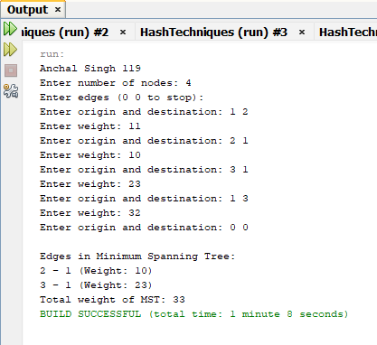

NCRD Sterling Institute of Management Studies

Hospital Patient Queue Management System

Aim: Hospital Patient Queue System – Emergency patients handled first using Queue and Priority Queue

- Name: Anchal Singh
- Roll No: 119
- Subject Teacher : Deepali Shah

Introduction
In a hospital environment, patients arrive with different medical conditions and levels of urgency. Emergency patients must be treated immediately, while normal patients can wait. Managing such situations manually can lead to confusion and delays.
This project, Hospital Patient Queue Management System, is developed using Queue and Priority Queue data structures. The system automatically assigns priority to patients based on their medical condition. Emergency patients are treated first, and patients with the same priority are handled on a First Come First Serve (FCFS) basis.
This project demonstrates the real-world application of Priority Queue in healthcare management systems using Java.

Algorithm: Advanced Hospital Patient Queue System

Step 1: Start the program

Step 2: Initialize
- Priority Queue PQ
- Patient ID counter (1001)
- Order counter (0)
- Statistics counters: emergencyCount, seriousCount, normalCount, treatedCount

Step 3: Display Main Menu
- Register Patient
- Treat Patient
- Display Waiting Patients
- Search Patient by ID
- View Statistics
- Exit

Step 4: Read user choice

Step 5: If choice = 1 (Register Patient)
- Read patient name and age
- Display problem list with codes
- Read problem choice

- Assign priority based on problem:
  - Emergency → 1
  - Serious → 2
  - Normal → 3
- Generate unique patient ID
- Insert patient into priority queue
- Increment corresponding statistics counter
- Show patient ID and queue position

Step 6: If choice = 2 (Treat Patient)
- Check if queue is empty
  - If yes → Display “No patients waiting”
  - Else → Remove patient with highest priority
- Display patient details
- Increment treatedCount

Step 7: If choice = 3 (Display Waiting Patients)
- If queue is empty → Display “No patients in queue”
- Else → Display all patients with ID, name, age, problem, priority

Step 8: If choice = 4 (Search Patient by ID)
- Read patient ID
- Search in the priority queue
- If found → Display patient details
- Else → Display “Patient not found in waiting list”

Step 9: If choice = 5 (View Statistics)
- Display total waiting patients
- Display total treated patients
- Display Emergency / Serious / Normal patient counts

Step 10: If choice = 6
- Exit the program

Step 11: Repeat steps 3–10 until user chooses Exit

Step 12: End program

Code:
import java.util.PriorityQueue;
import java.util.Scanner;

class Patient {
int id;
String name;
int age;
String problem;
int priority;
int order;

Patient(int id, String name, int age, String problem, int priority, int order) {
this.id = id;
this.name = name;
this.age = age;
this.problem = problem;
this.priority = priority;
this.order = order;
}
}

public class HospitalQueueSystem {

private static int orderCounter = 0;
private static int patientIdCounter = 1001;

private int emergencyCount = 0;
private int seriousCount = 0;
private int normalCount = 0;
private int treatedCount = 0;

private PriorityQueue<Patient> queue = new PriorityQueue<>(
(p1, p2) -> {
if (p1.priority != p2.priority)
return p1.priority - p2.priority;
return p1.order - p2.order;
}
);

private int assignPriority(int choice) {
if (choice >= 1 && choice <= 3) return 1;
if (choice >= 4 && choice <= 6) return 2;
return 3;
}

private String getProblemName(int choice) {
switch (choice) {
case 1: return "Accident / Trauma";
case 2: return "Heart Attack";
case 3: return "Stroke";
case 4: return "High Fever";
case 5: return "Fracture / Injury";
case 6: return "Breathing Problem";
case 7: return "Stomach Pain";
case 8: return "Cold / Cough";
case 9: return "Headache";
default: return "General Checkup";
}
}

public void addPatient(String name, int age, int problemChoice) {
int priority = assignPriority(problemChoice);
String problem = getProblemName(problemChoice);

Patient p = new Patient(
patientIdCounter++, name, age, problem, priority, orderCounter++
);
queue.add(p);
if (priority == 1) emergencyCount++;
else if (priority == 2) seriousCount++;
else normalCount++;
System.out.println("Patient Registered Successfully.");
System.out.println("Patient ID: " + p.id + " | Priority: " + priority);
System.out.println("Patients ahead in queue: " + (queue.size() - 1));
}
public void treatPatient() {
if (queue.isEmpty()) {
System.out.println("No patients waiting.");
return;
}
Patient p = queue.poll();
treatedCount++;
System.out.println("\nTreating Patient:");
System.out.println("ID: " + p.id);
System.out.println("Name: " + p.name);
System.out.println("Age: " + p.age);
System.out.println("Problem: " + p.problem);
System.out.println("Priority: " + p.priority);
}
public void displayPatients() {
if (queue.isEmpty()) {
System.out.println("No patients in queue.");
return;
}
System.out.println("\nWaiting Patients:");
for (Patient p : queue) {
System.out.println(
"ID: " + p.id +
", Name: " + p.name +
", Age: " + p.age +
", Problem: " + p.problem +
", Priority: " + p.priority
);
}
}
public void searchPatient(int id) {
boolean found = false;
for (Patient p : queue) {
if (p.id == id) {
System.out.println("Patient Found:");
System.out.println("Name: " + p.name);
System.out.println("Problem: " + p.problem);
System.out.println("Priority: " + p.priority);
found = true;
break;
}
}
if (!found)
System.out.println("Patient not found in waiting list.");
}
public void showStatistics() {
System.out.println("\n--- Hospital Statistics ---");
System.out.println("Total Waiting Patients: " + queue.size());
System.out.println("Total Treated Patients: " + treatedCount);
System.out.println("Emergency Patients: " + emergencyCount);
System.out.println("Serious Patients: " + seriousCount);
System.out.println("Normal Patients: " + normalCount);
}
public static void main(String[] args) {
Scanner sc = new Scanner(System.in);
HospitalQueueSystem hospital = new HospitalQueueSystem();
int choice;
do {
System.out.println("\n--- Hospital Patient Queue System ---");
System.out.println("1. Register Patient");
System.out.println("2. Treat Patient");
System.out.println("3. Display Patients");
System.out.println("4. Search Patient by ID");
System.out.println("5. View Statistics");
System.out.println("6. Exit");
System.out.print("Enter choice: ");
choice = sc.nextInt();
switch (choice) {
case 1:
sc.nextLine();
System.out.print("Enter name: ");
String name = sc.nextLine();
System.out.print("Enter age: ");
int age = sc.nextInt();

System.out.println("\nSelect Problem:");
System.out.println("1. Accident / Trauma");
System.out.println("2. Heart Attack");
System.out.println("3. Stroke");
System.out.println("4. High Fever");
System.out.println("5. Fracture / Injury");
System.out.println("6. Breathing Problem");
System.out.println("7. Stomach Pain");
System.out.println("8. Cold / Cough");
System.out.println("9. Headache");
System.out.println("10. General Checkup");
System.out.print("Enter choice: ");
int problemChoice = sc.nextInt();
hospital.addPatient(name, age, problemChoice);
break;
case 2:
hospital.treatPatient();
break;
case 3:
hospital.displayPatients();
break;
case 4:
System.out.print("Enter Patient ID to search: ");
int id = sc.nextInt();
hospital.searchPatient(id);
break;
case 5:
hospital.showStatistics();
break;
case 6:
System.out.println("System Closed.");
break;
default:
System.out.println("Invalid choice!");
}
} while (choice != 6);

sc.close();
}
}
Output:

- Register Patient
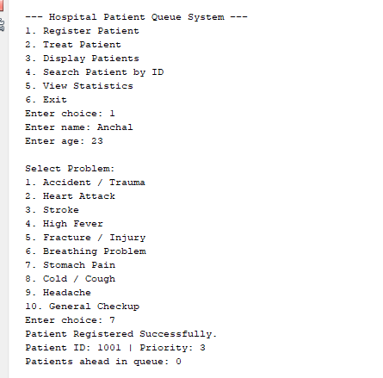
- View Statistics
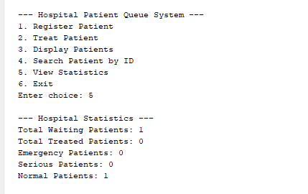

- Search by ID
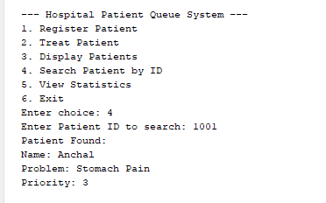
We use a Priority Queue because in a hospital system, patients are not treated on a first-come-first-serve basis. Emergency patients must be treated before normal patients. A priority queue allows us to automatically arrange patients based on the severity of their condition, ensuring that critical patients are handled first.
A priority queue internally uses a heap data structure, which allows insertion and deletion in O(log n) time. This makes the system efficient even when the number of patients increases.

Emergency first
Real-life hospital system
Efficiency

Conclusion
The Hospital Patient Queue Management System efficiently manages patients based on medical priority using Priority Queue. Emergency patients receive immediate attention, while fairness is maintained for patients with the same priority using the First Come First Serve approach. This project demonstrates the practical use of Queue and Priority Queue data structures in real-life healthcare systems.

