What Is a Cost Advantage Moat
A cost advantage moat exists when a company can produce or deliver a product for meaningfully less than its competitors, and use that gap either to undercut rivals on price or to earn a fatter margin at the same price. It is one of the more common types of competitive advantage, and one of the easier ones to measure, because it shows up directly in unit economics.

How a Cost Advantage Forms
Scale is the most familiar driver. A retailer with thousands of stores can negotiate better terms from suppliers than a regional chain can. A chipmaker running its factories at higher utilization spreads fixed costs over more units. Proprietary process or technology is another route: a company that has spent years refining a manufacturing process may simply produce more efficiently than a competitor trying to catch up from scratch.
Access to cheaper inputs matters too. A company with a long-term contract locking in lower raw material costs, or with a logistics network built years ago at lower cost than a new entrant could replicate today, carries a structural cost edge that has nothing to do with current operational skill.
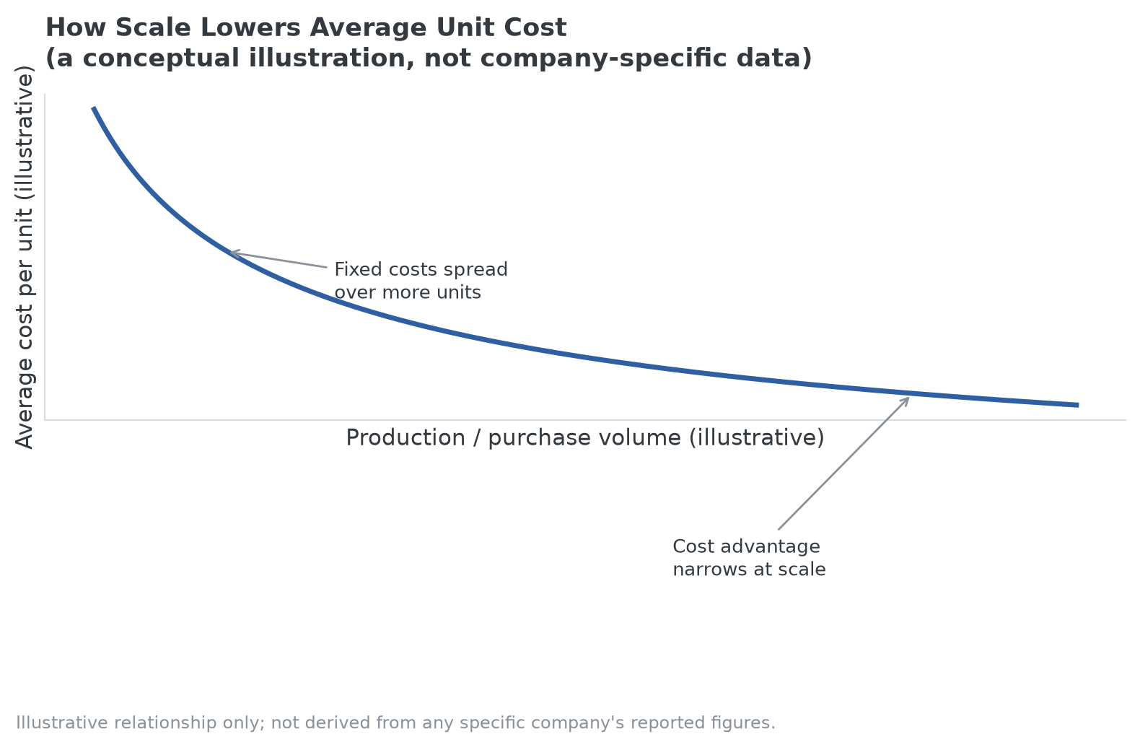
A conceptual illustration of how fixed costs spread over more units as volume grows; not derived from any specific company's figures.

Cost Advantage Moat in Practice
Walmart is the standard reference case for purchasing-scale cost advantage: its size lets it negotiate supplier terms that a regional chain cannot match, and that gap shows up directly in everyday shelf prices. Costco takes a related but distinct approach, using a membership-fee model to run merchandise at thin, sometimes near-breakeven margins while the fee itself carries the profit, which lets it undercut competitors that need to price for margin on every item sold.
Southwest Airlines is the clearer example on the operating side. Since its founding, it has flown a single aircraft family, the Boeing 737, rather than a mixed fleet. That choice simplifies pilot and mechanic training, lets crews and aircraft be swapped between routes without aircraft-specific requalification, and speeds up how quickly a plane can be turned around at the gate. The airline has said the practice saves hundreds of millions of dollars a year compared with operating a mixed fleet, the kind of structural cost gap that is hard for a competitor to close without rebuilding its own fleet strategy from scratch.

Why This Moat Type Is Often Fragile
Cost advantages can erode faster than advantages built on brand or switching costs. A competitor that scales up eventually captures similar purchasing power. A new manufacturing technology can wipe out years of process refinement overnight. And a pure cost advantage, without something else layered on top of it such as a distribution network or brand recognition, invites a price war that can compress margins for everyone in the industry, including the low-cost leader.
That is why investors and analysts typically look past whether a cost advantage exists at all and ask how it was built, and whether a well-capitalized competitor could replicate it within a few years. Cost efficiency by itself is common; cost efficiency that is genuinely hard to copy is rarer, and it's that second, durability-focused question that overlaps with how funds built around identifying durable competitive advantages, including MPLY, frame their own screening process.

Sources
- Southwest Airlines single-fleet strategy and its reported cost savings: Simple Flying, "Why One Of The World's Biggest Airlines Bet Its Future On A Single Aircraft Family" (simpleflying.com)
#CostAdvantageMoat #EconomicMoat #CompetitiveAdvantage #Investing #ValueInvesting #Fundamentals

