What Is a Regulatory Moat
A regulatory moat is a competitive advantage that exists because a government, not the market, has limited how many companies are allowed to compete. Where most moats are earned through better products, brands, or cost structures, a regulatory moat is granted, or at least permitted, by law, which makes it one of the more durable protections a business can have, and one of the least connected to how well the business is actually run.

How Regulatory Moats Form
The mechanism is usually one of three things: a required license that's difficult or capped in number, a compliance burden expensive enough that only large, well-capitalized players can absorb it, or a designation that becomes a de facto requirement for doing business even though it was never legally mandatory. Banking charters, utility franchises, and broadcast licenses are examples of the first. Pharmaceutical manufacturing and financial services compliance are examples of the second. The third is subtler and easy to overlook.

A Case Study in the Third Kind: Credit Rating Agencies
In 1975, the SEC created the "nationally recognized statistical rating organization," or NRSRO, designation for a narrow, technical purpose: determining capital charges on bonds held by broker-dealers. The SEC staff at the time judged that Standard & Poor's, Moody's, and Fitch were the ratings agencies in national use, and designated them accordingly. That narrow designation has since become embedded across financial regulation, legislation, and private contracts as a de facto stamp of credibility. As of March 2024, there were 10 NRSROs in total, but S&P, Moody's, and Fitch, the three the SEC happened to designate first, still generated 91% of NRSRO revenue between them.
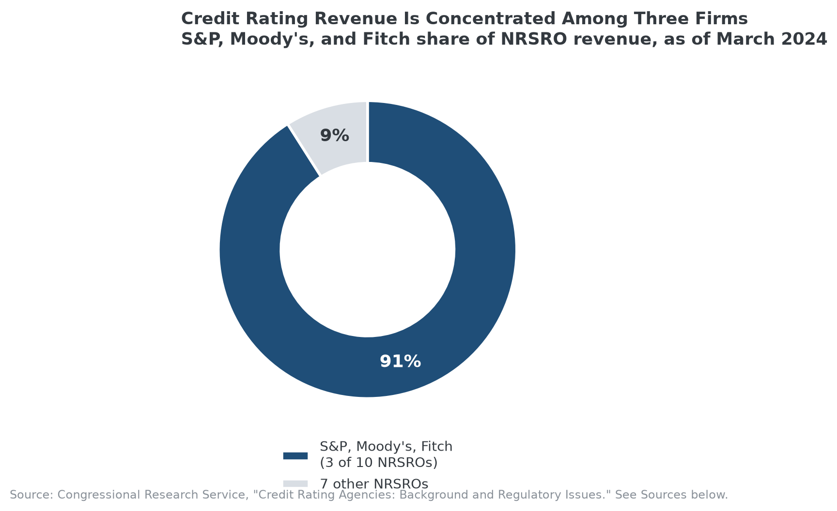
Nearly a century-old regulatory designation still concentrates credit rating revenue among three firms.

Why This Kind of Moat Is Different
A product-based moat, brand, network effects, cost advantage, can in principle be challenged by a competitor with enough skill, capital, or patience. A regulatory moat generally can't be, not through competition anyway. A new credit rating agency can be more accurate, cheaper, or faster than the incumbents and still struggle to gain traction, because the incumbents' designation, not their accuracy, is what the market and regulators have built their processes around. That also makes regulatory moats a specific kind of fragile: they can be legislated away as easily as they were created. Congress passed the Credit Rating Agency Reform Act in 2006 specifically to try to foster more competition in this market, an explicit acknowledgment that the regulatory structure itself, not any company's product quality, was the barrier.

How MPLY's Screen Treats Regulatory Exclusivity
Regulatory exclusivity is named directly in the Strategy Shares Monopoly ETF's (MPLY) stated screening criteria, and the credit rating agency example above is close to a textbook illustration of what that criterion is looking for: durable market position that persists independent of ongoing product superiority. The fund's process also has to weigh the fragility this article describes, a regulatory moat can be a company's strongest protection right up until the regulation itself changes, which is a different risk profile than a brand or a technology barrier eroding gradually.
Readers can check MPLY's current holdings and how the fund weighs this characteristic on its official page.

Sources
- Congress.gov, Congressional Research Service, "Credit Rating Agencies: Background and Regulatory Issues" (NRSRO history, 1975 designation, 2024 revenue concentration)
- Strategy Shares Monopoly ETF official fund page (screening criteria)
#RegulatoryMoat #EconomicMoat #CompetitiveAdvantage #BarriersToEntry #MPLY #Investing

