What Is a Learning Curve Advantage
A learning curve advantage exists when a company's costs fall not because it's producing more units this year than last year, but because it has produced more units cumulatively over its entire history. The distinction is subtle but important: it's a function of accumulated experience, not current output, which means a company that got an early start can hold a cost advantage over a competitor with identical current-year volume.

The Problem: Not All Cost Advantages Come From Current Scale
Standard economies-of-scale thinking asks how big a company is right now. Learning curve thinking asks how much practice a company has accumulated over time, refining a manufacturing process, training a workforce, and discovering efficiencies that only reveal themselves after building the product many times. Two companies can have identical factories and identical current output and still have very different costs, because one has been doing this for twenty years and the other for two.

The Mechanism: Wright's Law
The pattern was first documented by Theodore Wright, an aeronautical engineer, who studied aircraft manufacturing costs in the 1920s and 1930s. He found that every time cumulative aircraft production doubled, the labor time required to build the next plane fell by about 20%, a relationship now called Wright's Law or the experience curve. The same pattern has since shown up across other industries at varying rates: for more than four decades, solar panel prices fell by roughly 20% with each doubling of cumulative global production.
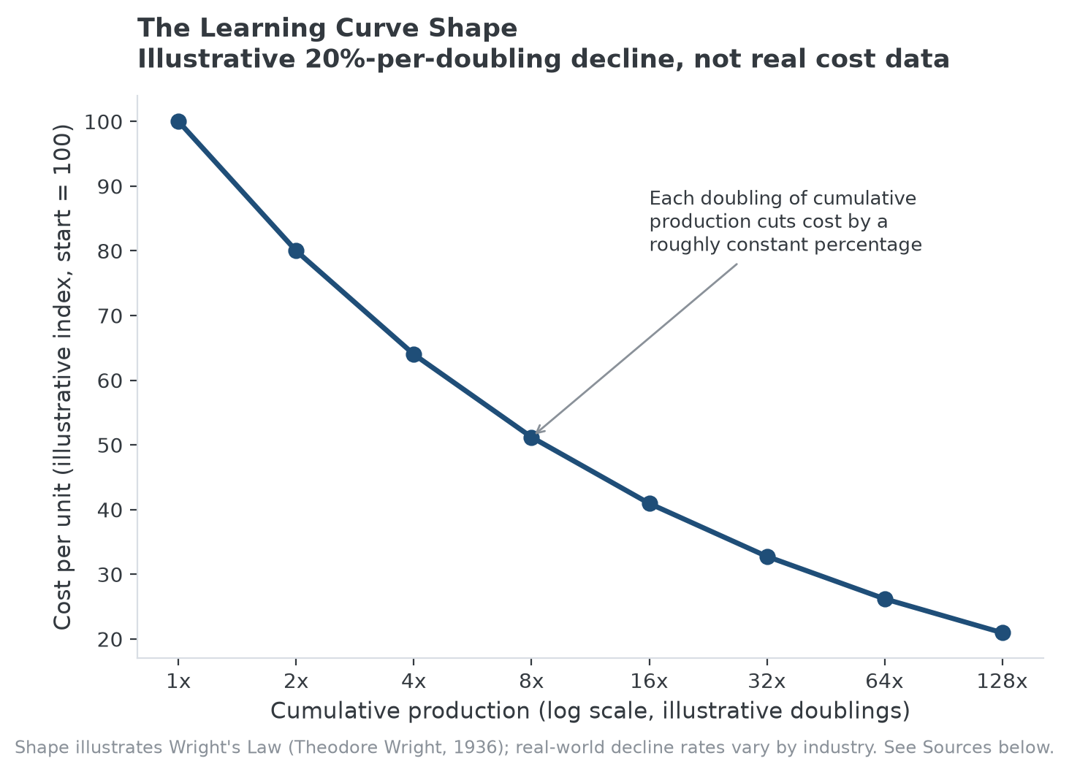
The general shape of a learning curve: cost declines with cumulative experience, not with calendar time.

Why This Creates a Moat, Not Just a Cost Saving
A pure economies-of-scale advantage can, in principle, be matched by any competitor willing to build an equally large operation today. A learning curve advantage is harder to close quickly, because it isn't just about size, it's about accumulated repetition, which takes time to build regardless of how much capital a new entrant is willing to spend. A well-funded competitor entering an industry with strong learning-curve dynamics still has to go through its own early, less-efficient production runs to catch up, and the incumbent keeps accumulating more experience, and a lower cost position, in the meantime.

Where the Advantage Weakens
Learning curve effects flatten over time; the 20% cost reduction from doubling production the first time is easier to achieve than the same percentage reduction after a hundred doublings, since most of the obvious efficiencies have already been captured. A genuinely disruptive new technology can also reset the curve entirely, making an incumbent's decades of accumulated process knowledge on an old method far less valuable once the industry shifts to a fundamentally different approach.

How This Connects to MPLY's Screening Approach
Learning effects aren't named directly in the Strategy Shares Monopoly ETF's (MPLY) stated criteria, but they're one of the mechanisms behind a durable cost advantage that can support pricing power and industry concentration over time, particularly in capital- and process-intensive industries where accumulated experience is genuinely hard for a new entrant to buy or copy quickly. MPLY's official page describes the fund's full investment approach for readers who want the underlying detail.

Sources
- Our World in Data, "Learning curves: What does it mean for a technology to follow Wright's Law?" (Theodore Wright's 1936 aircraft study, solar panel price decline)
- Wikipedia, "Experience curve effect"
#LearningCurve #ExperienceCurve #CompetitiveAdvantage #EconomicMoat #Investing #Fundamentals

