What Is an Ecosystem Moat
An ecosystem moat is a competitive advantage built from multiple connected products and services that work better together than any one of them works alone. The advantage doesn't come from any single product being unbeatable; it comes from the accumulated cost of leaving the whole system once a customer is using several of its pieces at once.

How an Ecosystem Moat Is Built
Apple's product lineup is the example most often used to explain the mechanism. A customer who owns an iPhone, uses iMessage to stay in touch with other Apple users, syncs photos and files through iCloud, and pairs an Apple Watch and AirPods to the same account isn't locked in by any single device. They're locked in by the accumulated convenience of everything working together, and by the friction of unwinding all of it at once to switch to a different platform. Losing iMessage's blue-bubble group threads, iCloud photo history, or cross-device handoff isn't a single deciding factor, but stacked together, they add up to a meaningfully higher switching cost than any one Apple product would create on its own.
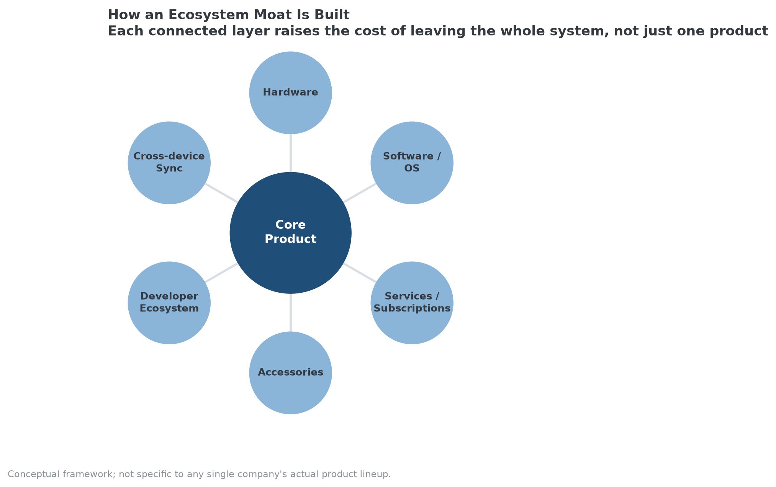
Each additional connected layer around a core product raises the cost of leaving the whole system.

Why This Is a Different Mechanism Than a Single Switching Cost
A single-product switching cost, enterprise software lock-in, for instance, is about one specific migration being expensive. An ecosystem moat compounds several smaller switching costs simultaneously: leaving isn't one hard decision, it's several moderately inconvenient decisions that all have to happen at once. That compounding effect is why ecosystem moats can hold even when a single competing product is objectively better than its Apple equivalent; the cost isn't losing to a better product, it's losing all the connected convenience built around the ecosystem as a whole.

Where Ecosystem Moats Are Vulnerable
The mechanism depends on customers actually adopting multiple connected pieces; a customer who owns only one device in the ecosystem gets none of the compounding benefit and faces the same switching decision as if the ecosystem didn't exist. Regulation is also a live risk specific to this moat type: interoperability requirements, like rules forcing cross-platform messaging compatibility, are explicitly designed to reduce the friction that makes ecosystem lock-in work, similar to how number portability weakened a switching cost tied to phone carriers.

How MPLY's Criteria Capture Ecosystem Effects
An ecosystem moat maps onto several of the Strategy Shares Monopoly ETF's (MPLY) stated screening criteria at once, network effects, since the ecosystem gets more valuable as a customer adopts more of it, vertical integration, since the pieces are typically built and controlled by the same company, and industry concentration, since a well-executed ecosystem tends to concentrate customer spending around one provider rather than splitting it across specialists. The fund's process treats this kind of compounding advantage as a stronger signal than any single switching cost in isolation, which is consistent with why ecosystem-style businesses often show up prominently in funds built around durable competitive positioning.
MPLY's current holdings and investment approach are published on its official page.

FAQ
Is an ecosystem moat the same thing as a network effect?
Related, but not identical. A network effect specifically means the product gets more valuable as more separate users join it. An ecosystem moat is about one customer's own accumulated switching costs across multiple connected products, which can exist even for a customer who never interacts with any other user of the ecosystem.
Can a company with only one or two products have an ecosystem moat?
Generally no, in the full sense described here. The mechanism depends on stacking several moderate switching costs across genuinely connected products; one or two products create ordinary switching costs, not the compounding effect that makes an ecosystem moat distinct.
Does buying into an ecosystem guarantee a company has a durable advantage?
No. The ecosystem still has to deliver enough genuine value that customers keep adopting more of it. A company can build a wide product lineup without the pieces actually reinforcing each other, in which case it has many separate products, not a compounding ecosystem moat.

Sources
- Strategy Shares Monopoly ETF official fund page (screening criteria)
#EcosystemMoat #EconomicMoat #CompetitiveAdvantage #SwitchingCosts #MPLY #Investing #Fundamentals

