What Is a Market Share Moat
The common belief is that dominant market share is itself a moat, the biggest player in a market should be the hardest to displace. The reality is that market share is an outcome, not a cause. It tells you a company has been winning, not why, and not whether that winning position is protected against the kind of shift that can erase a commanding lead within a few years.

The Myth: Leading Share Is Inherently Defensible
It's intuitive to assume the largest company in a market has the most resources, the best distribution, and the strongest customer relationships, and therefore the least to fear from a smaller challenger. Under that view, market share itself does the protecting.

The Reality: Nokia
In 2007, Nokia held 51% of the global mobile phone market, a commanding lead built over roughly a decade of manufacturing scale, brand recognition, and carrier relationships. By 2013, its smartphone market share had fallen below 3%. The company that had shipped 463 million phones in 2007 shipped 4.4 million in 2013. Nokia's dominant share in 2007 didn't protect it, because the market shifted underneath it: touchscreen smartphones and app ecosystems redefined what customers wanted, and Nokia's leadership in the old category, physical keypads, carrier-specific hardware deals, didn't transfer to the new one. Nokia sold its handset business to Microsoft in 2013.
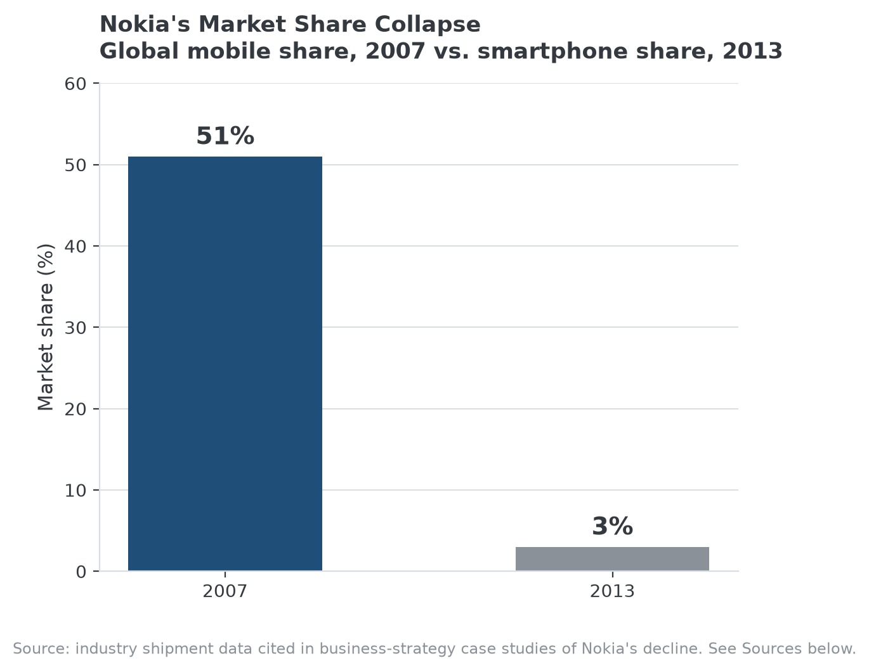
A dominant market position in one product category didn't transfer when the category itself changed.

What Actually Determines Whether Share Is Defensible
The share itself isn't the moat; whatever is causing customers to keep choosing the market leader is. If that reason is a durable structural advantage, network effects, switching costs, a cost structure competitors can't match, high share reflects and reinforces a real moat. If the leading share exists mainly because the leader was first, or because the underlying product category hasn't yet been disrupted, the share can evaporate as fast as Nokia's did once a better alternative exists and customers have a reason to move.

How to Tell the Difference in Practice
The useful question isn't how large a company's market share is, it's whether that share has been tested by a genuinely capable challenger and held, the same kind of evidence that separates Visa and Mastercard's decades-long dominance in payments, repeatedly tested by well-funded fintech challengers and still standing, from Nokia's share, which looked equally commanding right up until it wasn't.

Where MPLY's Screen Applies This Lesson
The Strategy Shares Monopoly ETF's (MPLY) stated criteria explicitly favor durable competitive advantages and market dominance over a snapshot of current position, which is consistent with the Nokia lesson above: the fund's process has to ask whether a company's current market leadership is protected by something structural, or whether it's a lead in a category that could shift the way mobile phones did.
MPLY's official page shows how current holdings are evaluated against that distinction.

Sources
- Wikipedia, "The Decline and Fall of Nokia" (2007 market share, 2013 smartphone share, Microsoft sale)
- Strategy Shares Monopoly ETF official fund page (screening criteria)
#MarketShare #EconomicMoat #CompetitiveAdvantage #MPLY #Investing #Fundamentals

