What Is a Competitive Moat in Investing
A competitive moat is a business advantage durable enough to keep competitors from eroding its profits over time. The term borrows its imagery directly from castle architecture: a moat around a castle is a real obstacle to attackers, not a decoration, and the businesses investors describe as having a moat have something equally real standing between them and a rival who wants to take their customers or their margins.

Where the Term Comes From
Warren Buffett popularized "moat" as investing vocabulary, using it in Berkshire Hathaway's shareholder letters more than twenty times since 1986. His version of the metaphor adds a ruler: a valuable castle needs an honest, capable steward in charge of it, and a moat wide enough that competitors cannot simply wade across. The metaphor stuck because it captures something a balance sheet alone does not: a moat is about what protects future profits, not just what a company earns today.

The Common Sources of a Moat
Equity analysts generally group durable advantages into a handful of recurring categories. A cost advantage lets a company underprice rivals and still turn a profit. Switching costs make it expensive or disruptive for a customer to leave, even if a competitor's product is technically better. Network effects make a product more valuable as more people use it, which raises the bar for any new entrant trying to build a comparable user base from zero. Brand and other intangible assets, including patents, let a company charge more or exclude imitators outright. Efficient scale describes a market only big enough to profitably support the incumbents already in it. Regulatory and intellectual-property barriers, from licensing requirements to patented technology, can block competition by law rather than by market forces.
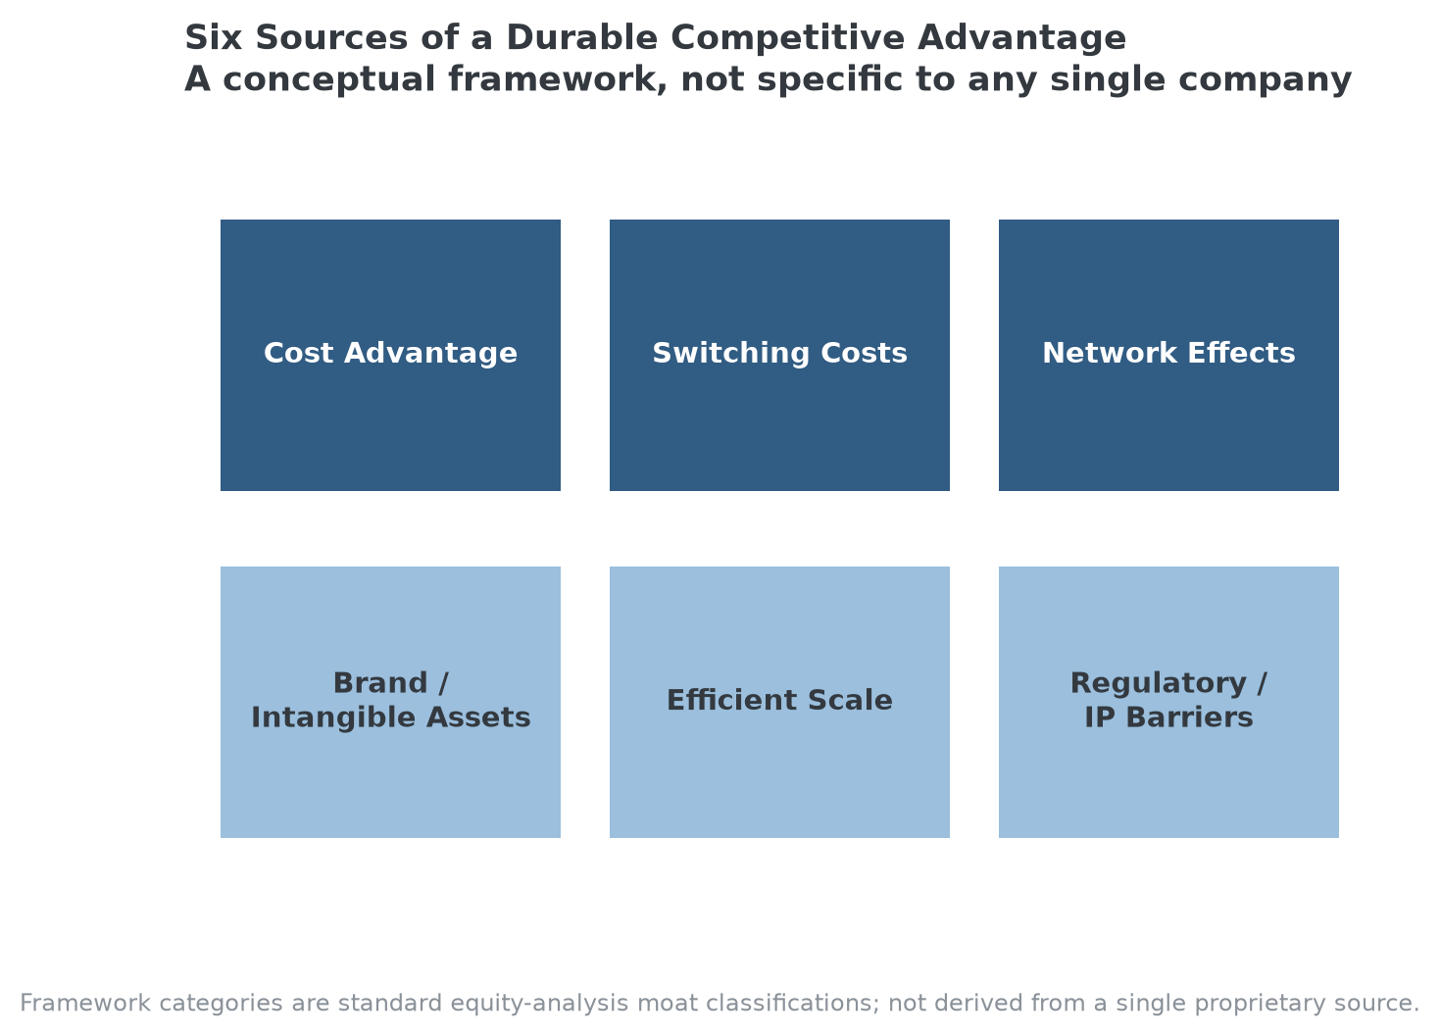
The six categories most equity-research frameworks use to classify a durable competitive advantage.

Why It Matters to Investors
A moat matters because competition is the default state of business, not the exception. Without one, high returns attract competitors who bid down prices and margins until returns fall back toward the market's average. A durable moat is what lets a company keep earning above-average returns on capital for years, sometimes decades, instead of one good product cycle. That is also why a moat is not, by itself, a reason to buy a stock: paying too much for a wonderful business is still a bad investment. The moat protects the business's economics; it does not protect an investor from overpaying for them.

The Limits of the Concept
Moats erode, and they can erode from directions a company never fully accounted for. Kodak filed for bankruptcy in 2012, 137 years after its founding, despite pursuing digital photography seriously and selling a genuinely popular line of digital cameras. Its actual mistake was narrower than "missing the digital shift": its digital strategy focused on printing photographs, protecting the film-development business it still made most of its money on, while the market moved toward sharing photos digitally instead of printing them. Blockbuster, which filed for bankruptcy in 2010, eventually did move to eliminate late fees and build a streaming and online rental strategy, just not quickly enough to outrun Netflix. In both cases, a real, historically durable advantage stopped being durable once the market's underlying structure changed, which is the central risk in treating any moat as permanent rather than as a current, testable condition.

Where MPLY's Screening Approach Fits This Framework
The Strategy Shares Monopoly ETF (MPLY) is built around a version of moat investing, though its lens is narrower and more specific than the general six-category framework above. Rather than asking whether a company has any durable advantage, MPLY's stated criteria look for businesses with brand dominance, regulatory exclusivity, industry concentration, a history of antitrust scrutiny, monopolistic or oligopolistic economic rents, high barriers to market entry, pricing power, vertical integration and control of the supply chain, network effects, or protected intellectual property. Most of these map directly onto the moat sources described above, brand dominance to brand/intangible assets, high barriers to entry and IP protection to regulatory/IP barriers, network effects to network effects, but MPLY's framing pushes further toward market dominance specifically: not just "this business has an edge," but "this business faces limited real competition."
That distinction matters for how a reader should use the rest of this cluster of articles. The individual moat sources covered elsewhere, switching costs, network effects, barriers to entry, brand loyalty, recurring revenue, are each one lens on the same underlying question MPLY's screening process asks about every candidate: is this a business that could keep earning what it earns today with meaningfully less competitive pressure than a typical company in its industry? A single moat source rarely answers that on its own, which is also why MPLY's process, like general moat analysis, treats these characteristics as inputs to a judgment call rather than a checklist that automatically qualifies a company.
Readers who want to see how MPLY's managers currently apply this framework can review the fund's investment approach and current holdings on its official page.

FAQ
How many types of moats are there?
There's no single official count. Most equity-research frameworks group durable advantages into roughly five or six recurring categories, cost advantage, switching costs, network effects, brand/intangible assets, efficient scale, and regulatory or IP barriers, but a real company's advantage is often a combination of more than one, not a pure single type.
Does having a moat guarantee good investment returns?
No. A moat protects a business's underlying economics, not the price an investor pays for the stock. A genuinely durable moat bought at too high a valuation can still be a poor investment, and a company with a narrower or fading moat can still be a reasonable investment at the right price.
Can a moat disappear?
Yes. Kodak and Blockbuster both had real, long-standing competitive advantages that stopped protecting their profits once the underlying market structure shifted, digital photography in Kodak's case and streaming in Blockbuster's. A moat is a current condition to keep testing, not a permanent feature of a business.
Is a "wide moat" the same thing as a monopoly?
Related, but not the same. A wide moat means a durable competitive advantage of any kind, including advantages built on brand, switching costs, or scale. A monopoly specifically means facing little or no real competition. A company can have a genuine moat without approaching monopoly status, which is part of why MPLY's screening criteria go further than general moat language, specifically looking for market dominance and limited competition, not just an edge over rivals.

Sources
- Wikipedia, "Economic moat" (Buffett's use of the term in Berkshire Hathaway shareholder letters)
- Inc., "How Blockbuster, Kodak and Xerox Really Failed (It's Not What You Think)"
- Strategy Shares Monopoly ETF official fund page (screening criteria)
#CompetitiveMoat #EconomicMoat #CompetitiveAdvantage #MPLY #ValueInvesting #Investing #Fundamentals

