Network Effects Explained: A Competitive Advantage
A network effect exists when a product or service becomes more valuable to each user as more people use it. It's one of the few competitive advantages that gets stronger, not weaker, with scale, which is part of why it has become one of the most closely watched moat types in technology and platform investing over the past two decades.

The Idea's Origin
The underlying concept predates the internet by decades, most associated with Robert Metcalfe's observation about telephone and computer networks: a network's value grows disproportionately as connections are added, because each new participant can potentially connect with every existing one. A telephone is worthless if you're the only person who owns one; it becomes more useful with every other person who gets one too. The same logic, applied to platforms rather than physical networks, is what modern investors mean when they talk about a network-effect moat.
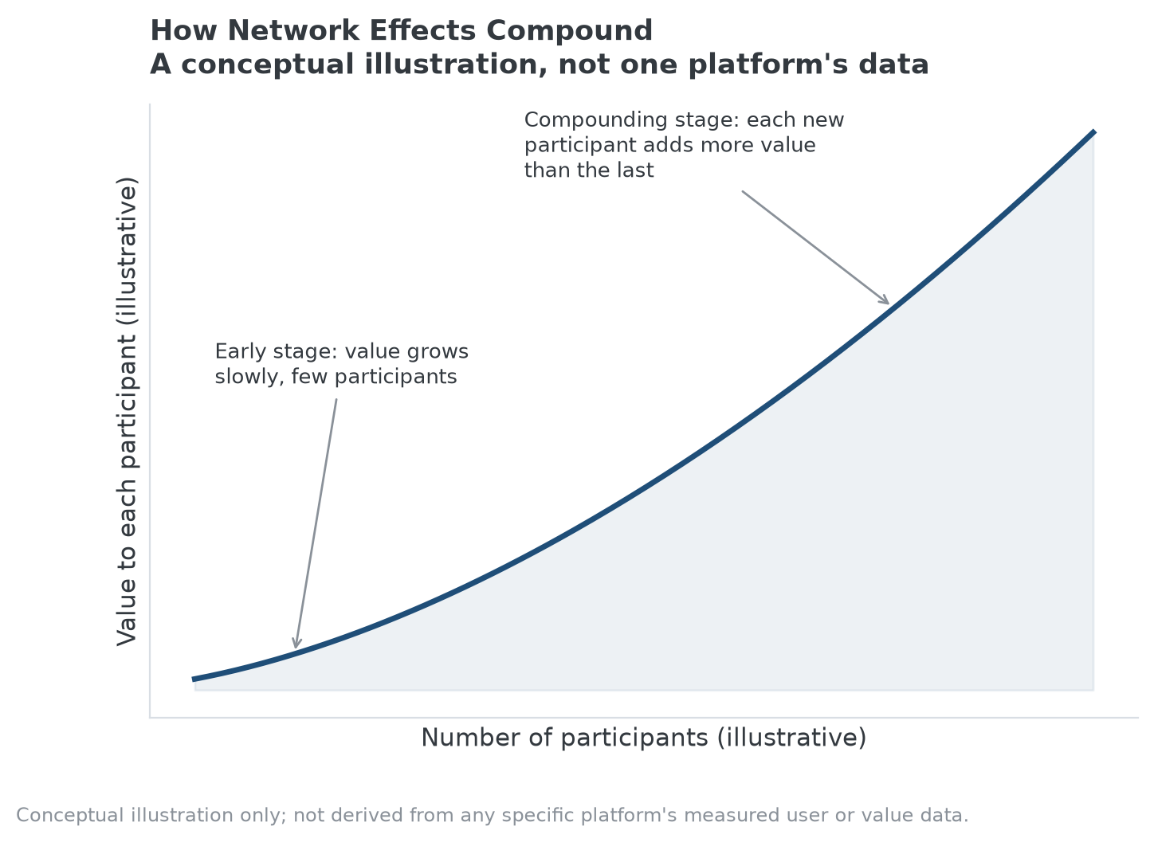
The core mechanism: value to each participant compounds as more participants join, rather than growing at a flat rate.

How Platforms Turned the Concept Into a Business Model
Two-sided marketplaces made the mechanism explicit. A ride-hailing platform is more useful to riders when more drivers are available, and more useful to drivers when more riders are requesting trips; each side's growth makes the platform more valuable to the other side. Messaging and social platforms work through a more direct version: a messaging app is more useful the more of your own contacts already use it, which is why migrating an entire social graph to a new app is a much bigger ask than switching a single-player product for a better one.

The Turning Point Most Discussions Skip: Network Effects Can Fail Too
A network effect is often described as though it guarantees durability once it takes hold, but the historical record doesn't support that. Early social platforms had real network effects and still lost their position when execution problems drove users elsewhere faster than the network effect could hold them. The mechanism protects a company only as long as the product experience stays good enough that leaving feels costly; once it doesn't, users can migrate in large numbers, taking the network effect with them to wherever they land next.

Current State: Where Network Effects Show Up Today
Payment networks, professional social platforms, app marketplaces, and cloud developer ecosystems are the clearest present-day examples, each one harder to displace the larger and more entrenched its two-sided or multi-sided user base becomes. The common feature across all of them is that the network effect compounds a separate, underlying product advantage rather than replacing the need for one; a mediocre product with a large network can still lose share to a much better product once the gap becomes large enough.

Lessons for Evaluating a Network-Effect Moat
The practical takeaway is to treat network effects as a multiplier, not a guarantee. A business with a genuine two-sided or multi-sided dynamic and strong execution can turn scale into a durable advantage that gets harder to attack every year. The same dynamic without disciplined execution is closer to a large, fragile lead than a moat.

How MPLY's Screen Treats Network Effects
Network effects are named directly in the Strategy Shares Monopoly ETF's (MPLY) stated screening criteria, alongside brand dominance, industry concentration, and high barriers to market entry. The fund's process treats a network effect the way this article's turning point suggests it should be treated: as a reinforcing characteristic that strengthens a company's broader competitive position, not as a standalone qualifying trait.
A company with a real network effect but weak execution, or one operating in a market too small to sustain lasting concentration, doesn't automatically fit the fund's broader monopolistic-or-oligopolistic thesis just because a network effect is technically present. Readers researching how the fund weighs network effects against its other criteria can review MPLY's current holdings and investment approach on its official page.

FAQ
Is any large user base a network effect?
No. A network effect specifically means each additional user makes the product more valuable to other users, not just that a company has many customers. A retailer with millions of customers who never interact with each other doesn't have a network effect in this sense, even though it has scale.
Can a network effect be reversed?
Yes. If enough users leave a platform, the remaining users experience less value, which can accelerate further departures, the same compounding mechanism running in the opposite direction. This is part of why platforms with fading engagement can lose share faster than their raw user counts initially suggest.
Are network effects only relevant to technology companies?
They show up most visibly in tech and platform businesses, but the underlying logic isn't tech-specific. Payment networks, stock exchanges, and even some professional standards or certifications carry a version of the same dynamic: they become more useful as more participants adopt them.

Sources
- Wikipedia, "Network effect" (Metcalfe's Law and platform economics background)
- Strategy Shares Monopoly ETF official fund page (screening criteria)
#NetworkEffects #EconomicMoat #CompetitiveAdvantage #PlatformEconomics #MPLY #Investing

