What Is a Network Effect Moat
A network effect moat is a competitive advantage that comes specifically from a network effect being durable enough to survive real competitive pressure, not just present. That distinction matters more than it sounds, because plenty of businesses have had genuine network effects and still lost their market position, which makes network effects one of the more misunderstood moat types: powerful in theory, conditional in practice.

Friendster: A Real Network Effect That Didn't Hold
Friendster launched in March 2002 as one of the first large-scale social networks and grew to tens of millions of users by around 2008, a genuine network effect by any definition: the platform got more useful as more of a person's real-world contacts joined it. That network effect did not save the company. Starting in mid-2009, following a site redesign and persistent technical problems, including load times that reportedly stretched to 40 seconds on a slow connection, users began migrating away in large numbers, first to Myspace and then to Facebook. Friendster shut down in June 2015. The network effect was real; it simply wasn't strong enough to outweigh a bad user experience once a better-executed alternative existed.
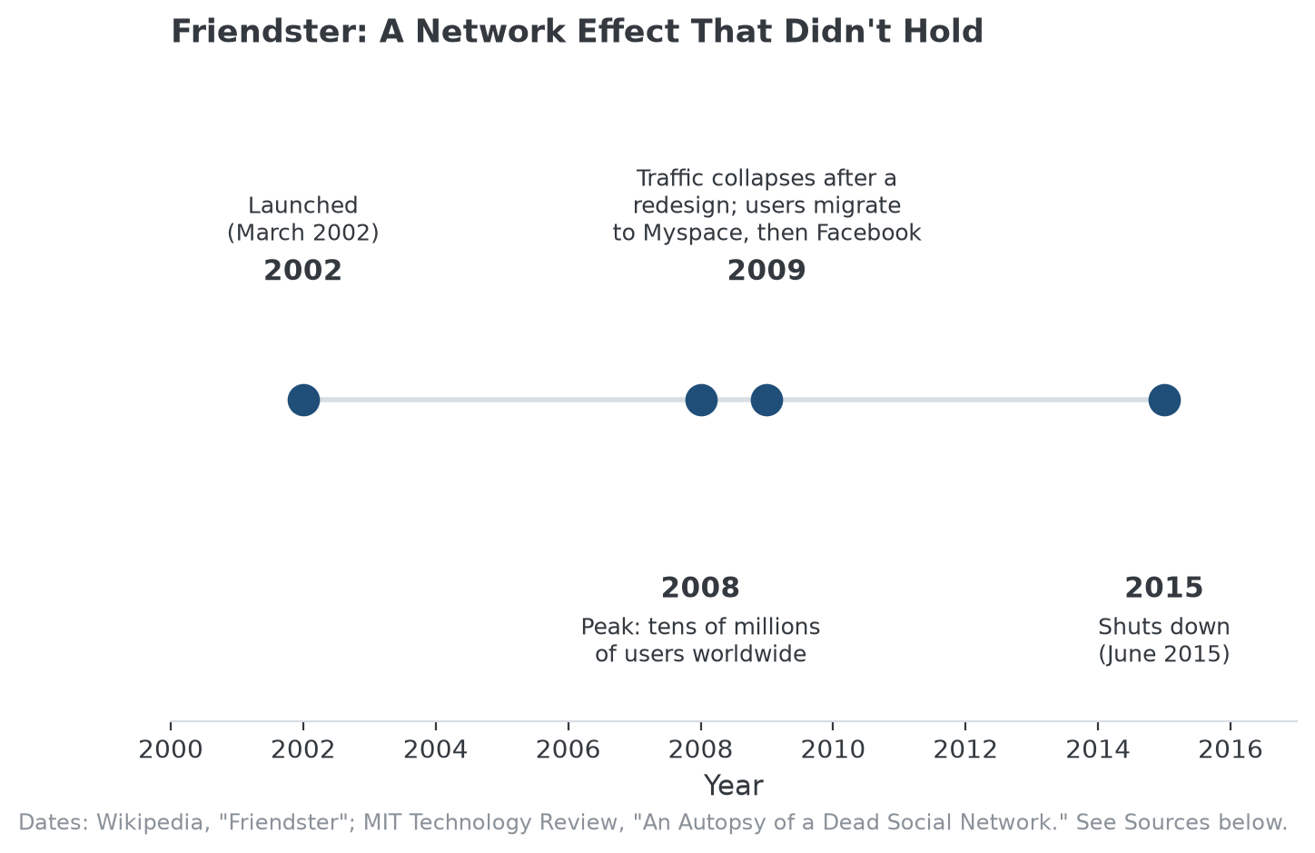
Friendster's full lifecycle, from launch to peak to migration to shutdown.

What Made the Difference: Execution, Not the Existence of a Network
Friendster's failure illustrates the core limitation of treating a network effect as self-sustaining. The mechanism only protects a business as long as staying feels better than leaving, on balance, including the switching cost of moving a social graph elsewhere. Poor execution, slow load times, unreliable service, frustrating changes, can erode that balance faster than the network effect can replace it, especially once a genuinely better-run competitor gives users somewhere else to go that still has their friends on it, or soon will.

Contrast: Network Effects That Have Held for Decades
Payment networks are a useful counterexample. Visa and Mastercard's two-sided network effect, more merchants accepting the card makes it more useful to cardholders, more cardholders carrying it makes it more valuable to merchants, has held for decades rather than years, reinforced by trust, regulatory relationships, and consistent execution rather than a single product redesign away from unraveling. The difference isn't that payment networks have a fundamentally stronger type of network effect than social platforms did; it's that execution and reinforcing structural advantages kept the mechanism intact instead of letting a wave of user frustration overwhelm it.

How to Evaluate Whether a Network Effect Moat Will Hold
The useful question isn't whether a network effect exists, it's whether anything is actively protecting it from an execution failure or a well-run competitor. Regulatory relationships, switching costs layered on top of the network itself, and a track record of reliable execution through past competitive threats are all evidence the network effect is reinforced rather than standing alone. A network effect with none of that backing it is closer to a large, currently-happy user base than a moat.

Where MPLY's Screen Applies This Lesson
Network effects are named directly in the Strategy Shares Monopoly ETF's (MPLY) stated screening criteria, but Friendster's history is a useful check on how that criterion should actually be applied: the fund's broader thesis is built around durable market dominance, not the presence of a network effect in isolation.
A company whose network effect is unreinforced by industry concentration, real barriers to entry, or a track record through competitive pressure is a weaker fit for that thesis than one where the network effect is layered on top of other structural advantages, the same distinction Friendster and Visa illustrate above. MPLY's official page lists its current holdings for readers who want to see how that distinction is applied today.

Sources
- Wikipedia, "Friendster" (launch date, peak users, shutdown)
- MIT Technology Review, "An Autopsy of a Dead Social Network" (2009 decline, technical problems)
- Strategy Shares Monopoly ETF official fund page (screening criteria)
#NetworkEffects #EconomicMoat #CompetitiveAdvantage #PlatformEconomics #MPLY #Investing

