Article 1:
Recurring Revenue Moat: Why Predictable Sales Can Create a Competitive Advantage
In modern corporate valuation, the durability of revenue is frequently far more critical than the sheer volume of top line sales. Institutional investors routinely observe that two corporations generating identical annual revenues of five billion dollars can trade at wildly divergent market capitalizations. The enterprise that must re-sell its value proposition to prospective buyers every ninety days carries substantial forecasting uncertainty, severe customer acquisition overhead, and acute vulnerability to macroeconomic contractions. In stark contrast, a business anchored by a fortified recurring revenue moat begins every fiscal year with eighty or ninety percent of its anticipated revenue already contracted and structurally guaranteed.
A true recurring revenue moat is not simply an accounting convention or the adoption of a software subscription billing schedule. True predictability arises when a firm embeds its operational products so deeply into client workflows that disconnecting the service would trigger catastrophic operational failure or prohibitive financial damage. This structural captivity transforms discretionary spending into non-negotiable operational utility, shielding corporate operating margins from competitive intrusion.
When cash flows become programmatic, leadership teams can deploy capital into research, technological infrastructure, and disciplined acquisitions with surgical precision rather than stockpiling defensive liquidity reserves. This fundamental predictability forms the bedrock of long term capital compounding, serving as a primary quantitative filter for concentrated investment vehicles such as the Strategy Shares Monopoly ETF (MPLY).
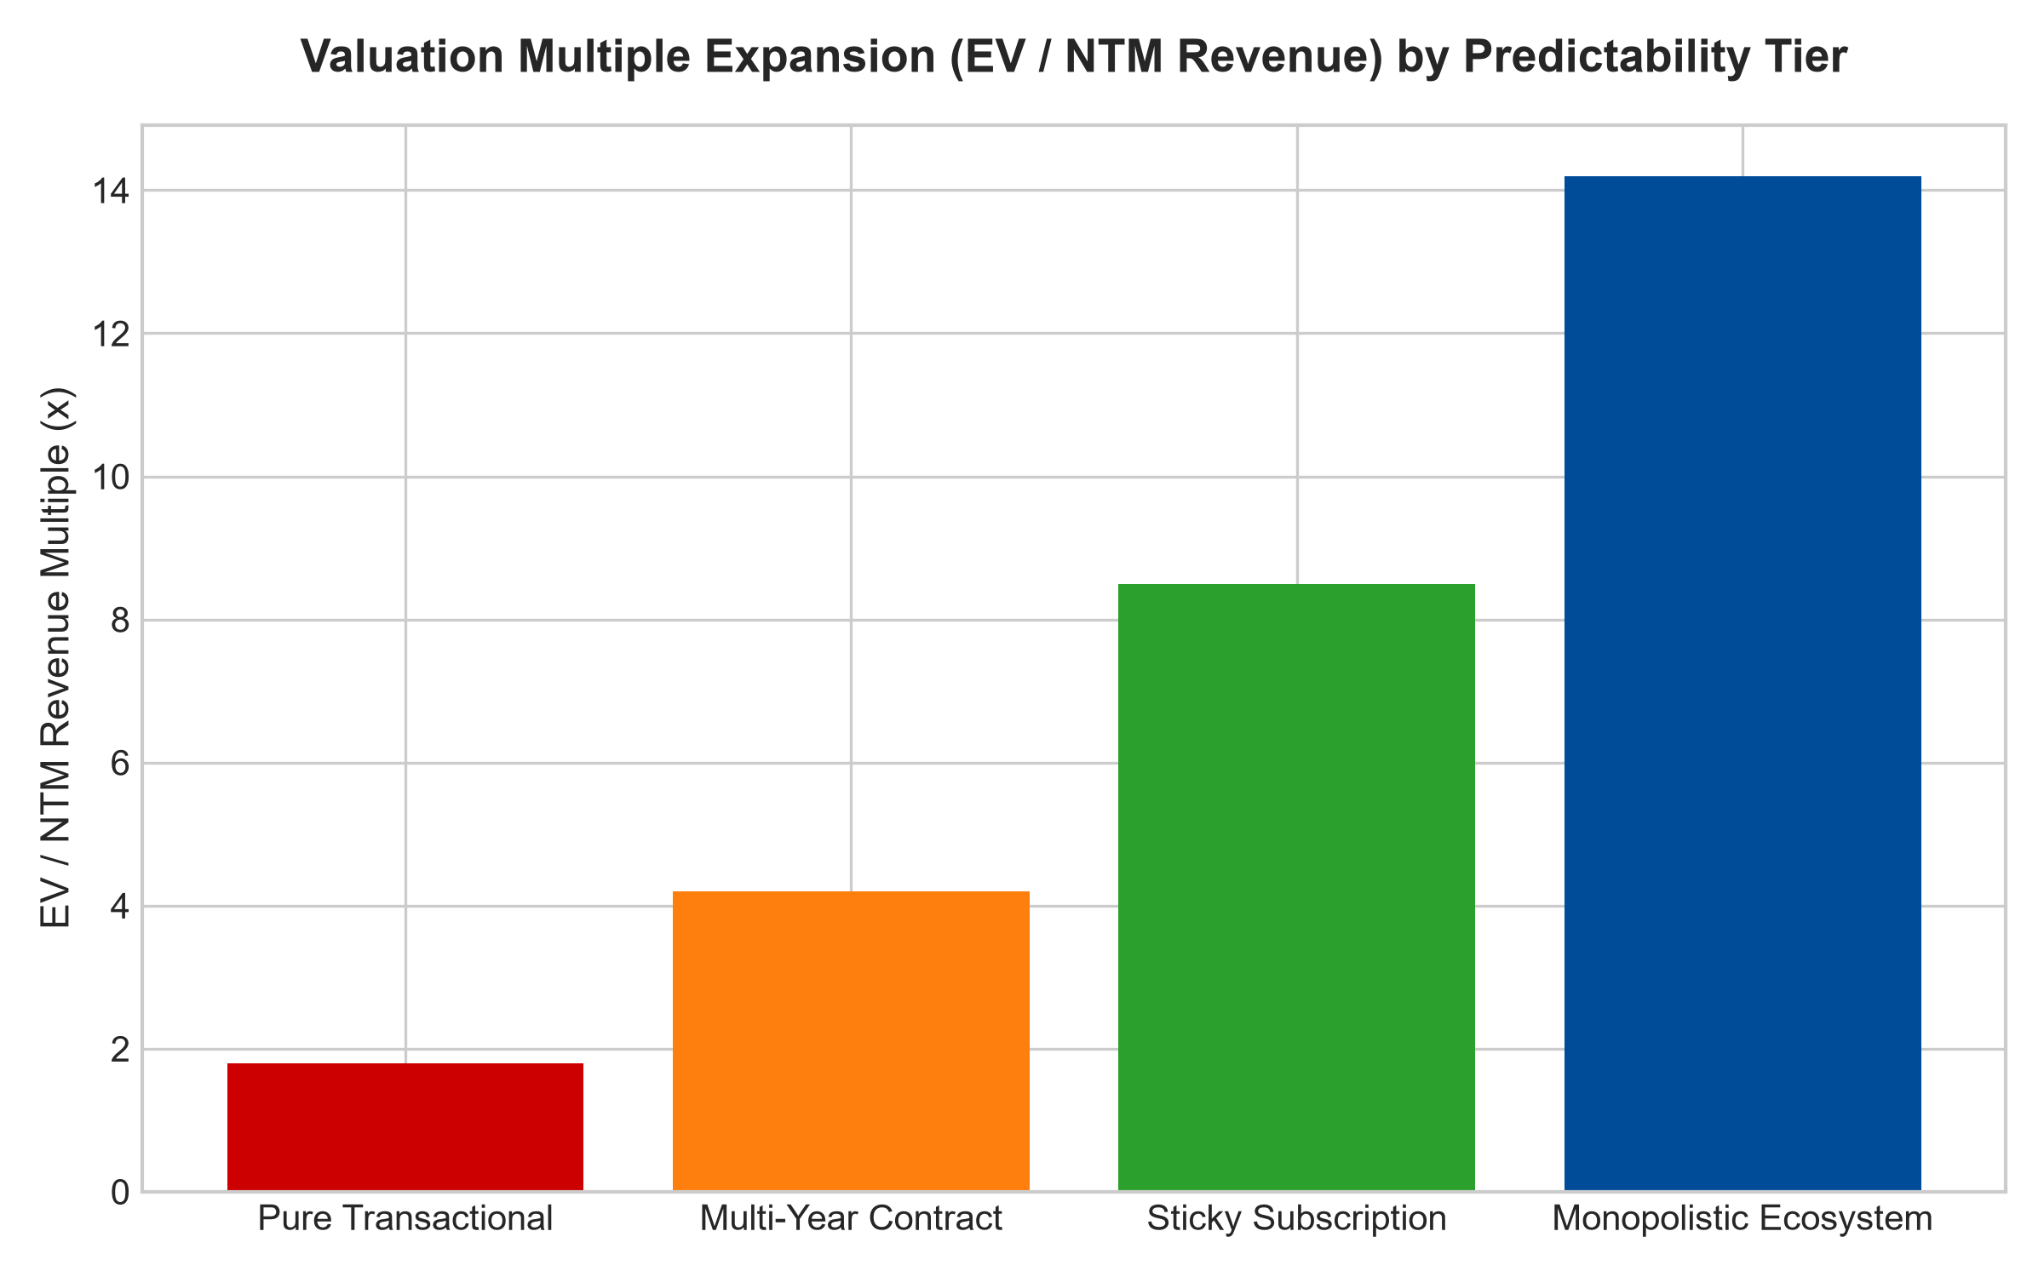
1. The Mathematical Alchemy of Contractual Predictability
The core advantage of recurring revenue centers on the permanent reduction of the Customer Acquisition Cost (CAC) burden relative to Customer Lifetime Value (LTV). In transactional manufacturing or project-based engineering, capital must be continuously reallocated to sales forces, promotional initiatives, and pricing concessions to replenish an empty sales pipeline. Because customer acquisition costs recur continuously, return on invested capital remains permanently suppressed.
In businesses supported by an unyielding recurring revenue moat, customer acquisition cost is treated as an initial capital expenditure amortized across a multi-decade relationship. As retention rates exceed ninety-five percent, the marginal cost of serving each retained customer approaches zero while the revenue streams compound through annual price escalators and usage expansion. Operating leverage expands dramatically, driving superior free cash flow conversion rates that cyclical competitors cannot replicate.
2. High Switching Friction as the Ultimate Anchor
Recurring billing structures without switching barriers represent an illusion of safety rather than an economic moat. Consumer media streaming platforms, for example, feature recurring monthly billing, yet subscribers can terminate their contracts with a single digital click when household budgets tighten. Because switching friction is non-existent, these businesses suffer high customer churn and must continuously engage in predatory price wars.
Conversely, institutional monopolies construct insurmountable switching costs that transform simple subscriptions into unbreachable operational moats. Whether examining specialized core banking software, specialized industrial diagnostic equipment, or global enterprise databases, the risk of technical failure during replacement far outweighs any marginal price savings offered by a competing vendor. Customers remain captive not out of emotional loyalty, but out of absolute operational necessity, allowing dominant operators to systematically exercise pricing power throughout all economic cycles.
3. Quantitative Valuation Implications: The Multiple Premium
From a discounted cash flow valuation perspective, businesses possessing high revenue visibility command structurally lower weighted average costs of capital (WACC). Because cash flows are locked under multi-year contracts or programmatic subscriptions, debt holders accept lower credit spreads, and equity allocators apply a substantially lower equity risk premium. This mathematical reality directly expands the enterprise value to free cash flow multiple.
Furthermore, recurring revenue dampens operating volatility during turbulent economic environments. While transactional peers scramble to discount inventory and slash capital expenditures during contractions, the recurring moat business continues collecting contractual payments. This predictable liquidity enables the leadership team to aggressively acquire distressed competitors or reinvest counter-cyclically in proprietary research and development, permanently widening the competitive divide.
4. Portfolio Construction and the MPLY Quality Framework
Traditional passive indices such as the S&P 500 or broad market benchmarks inevitably dilute an investor's exposure by holding hundreds of highly cyclical, capital intensive companies whose revenues evaporate during recessions. In contrast, actively managed quality strategies concentrate strictly on businesses possessing durable structural dominance and exceptionally high cash flow predictability.
The management philosophy behind the Strategy Shares Monopoly ETF (MPLY) specifically identifies enterprises that possess monopolistic pricing power backed by entrenched recurring customer arrangements. Rather than attempting to time macroeconomic inflections or predict consumer fashion trends, MPLY targets high-conviction market leaders whose underlying revenue streams function as economic toll booths across critical global commerce networks.
Investors seeking to analyze how institutional managers isolate companies with high barriers to entry and resilient cash flow structures can review the full strategy behind the Strategy Shares Monopoly ETF (MPLY) at https://strategysharesetfs.com/mply/.
5. Frequently Asked Questions
Q1: How do institutional analysts differentiate between durable recurring revenue and fragile subscription models?
Analysts examine net revenue retention (NRR) rates and gross churn metrics specifically during economic recessions. A durable recurring revenue moat typically demonstrates gross retention above ninety-five percent and net retention exceeding one hundred and ten percent, proving that existing clients not only stay during contractions but expand their annual expenditures. If gross churn accelerates when industry conditions deteriorate, the business possesses a cosmetic subscription rather than an institutional moat.
Q2: Why do businesses with recurring revenue moats consistently trade at premium valuation multiples?
Because their future cash flows exhibit substantially lower volatility and downside risk, institutional allocators apply a significantly lower discount rate to projected enterprise earnings. This reduced risk premium elevates enterprise value to EBITDA multiples and price to free cash flow ratios, allowing these elite businesses to command premium valuations across every phase of the market cycle.
6. Sources
Morningstar, Equity Research & Moat Analysis: https://www.morningstar.com/articles/moat-research
Harvard Business Review, Competitive Advantage Strategy: https://hbr.org/1979/03/how-competitive-forces-shape-strategy
#recurringrevenuemoat #EconomicMoats #QualityInvesting #PricingPower #MPLY

