Article 2:
How Customer Retention Can Strengthen a Business Moat
In the calculus of corporate competitive advantage, few quantitative metrics reveal the true structural integrity of an enterprise more ruthlessly than customer retention. While aggressive revenue growth can temporarily mask strategic vulnerability through expensive promotional marketing and predatory discounting, a persistent customer retention moat serves as empirical proof that a corporation provides indispensable value. An enterprise capable of retaining ninety-five percent or more of its customer base year over year creates an accelerating compounding mechanism that completely decouples its operational performance from standard business cycle fluctuations.
Customer retention operates as both a defensive shield and an offensive financial engine. Defensively, it insulates the corporate revenue foundation from competitors who must expend enormous capital attempting to lure away deeply embedded clients. Offensively, low customer churn enables the business to reinvest nearly every dollar of operating cash flow into research, strategic expansion, and shareholder distributions rather than continuously paying the exorbitant toll of customer replacement.
For institutional portfolio allocators, evaluating whether retention stems from genuine product supremacy or high switching friction is vital. This analytical discipline informs the stock selection methodology utilized by the Strategy Shares Monopoly ETF (MPLY), which actively avoids commoditized, high-churn businesses in favor of unassailable corporate fortresses.
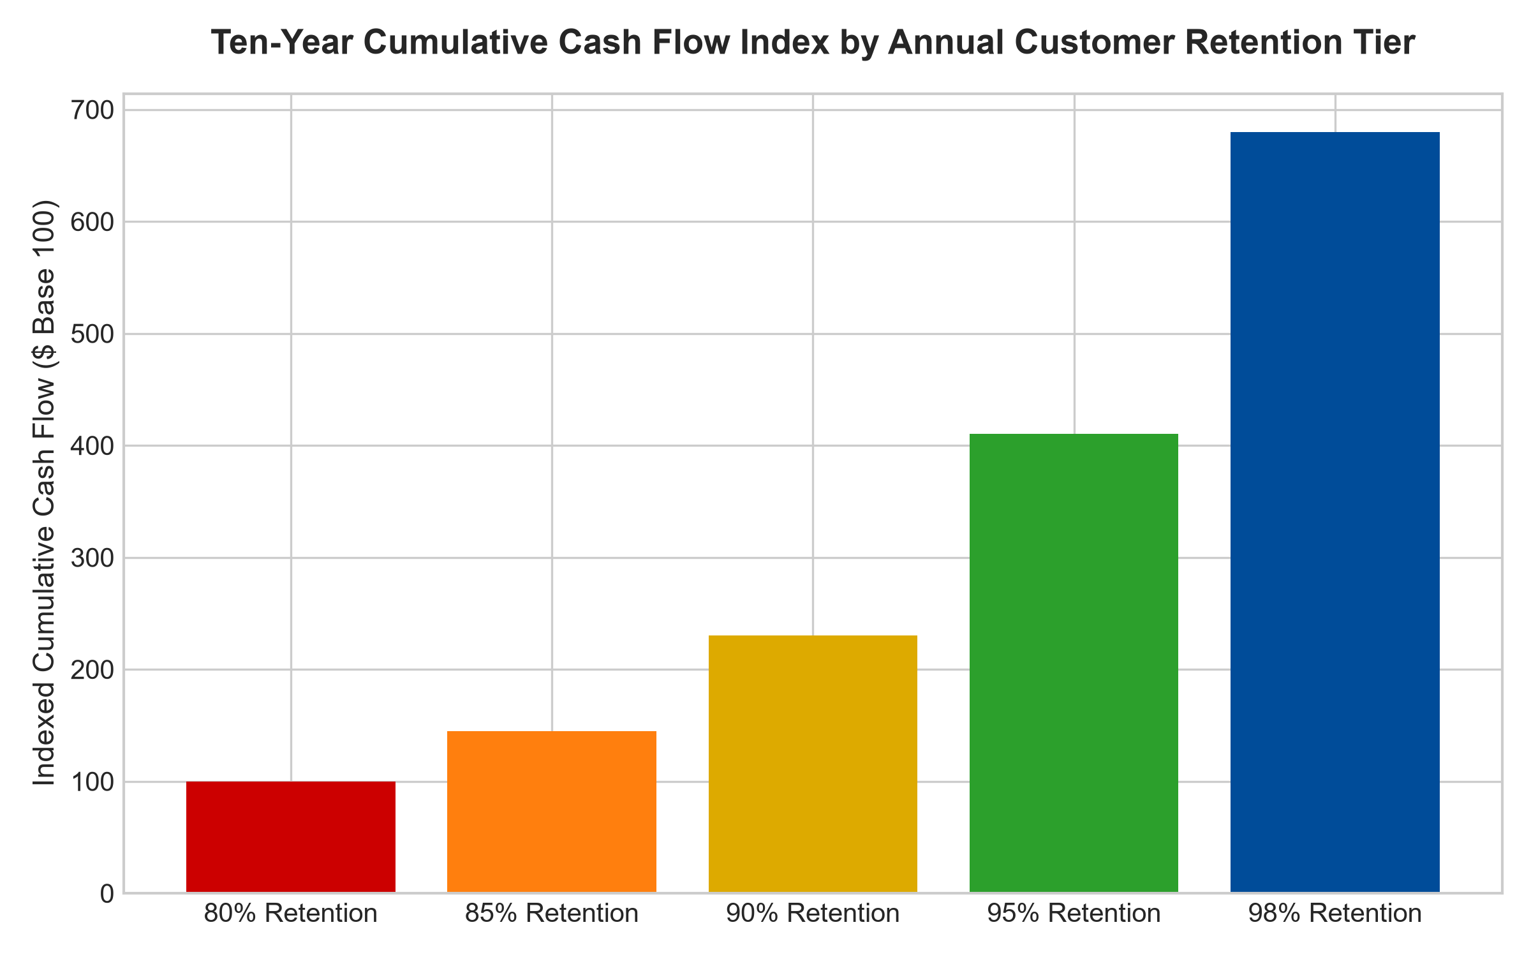
1. The Devastating Mathematics of Customer Churn
To comprehend the power of a customer retention moat, investors must examine the mathematical penalty imposed by high churn. A company experiencing an annual customer churn rate of fifteen percent loses half of its entire customer directory every five years. To maintain simple revenue stagnation, that corporation must expend vast marketing resources merely replacing departing clients. Growth under such conditions requires heroic capital deployment, which permanently depresses return on invested capital and dilutes operating margins.
Conversely, when an enterprise compresses customer churn to two or three percent annually, customer lifetime value approaches perpetuity. Each new client added represents pure incremental margin expansion. Furthermore, because satisfied, embedded clients naturally purchase additional modules, premium services, and contractual upgrades over time, net revenue retention frequently exceeds one hundred and fifteen percent, driving organic top line expansion with minimal incremental overhead.
2. Structural Retention vs Cosmetic Loyalty
A critical error made by retail market participants is conflating brand affinity with a structural customer retention moat. Brand affinity is fickle and subject to shifting consumer sentiment, technological disruption, and competitive pricing promotions. A consumer who purchases a specific luxury apparel brand or beverage can seamlessly alter their buying behavior overnight without incurring any operational friction.
Structural retention, by contrast, is anchored by embedded operational integration. When specialized healthcare software manages a hospital network's entire patient record system, or when specialized industrial machinery dictates a manufacturing assembly line, the client cannot realistically change vendors. The personnel retraining costs, potential regulatory liabilities, and risk of severe operational disruption create an impenetrable wall of retention. The customer remains captive because departure represents unacceptable business risk.
3. The Compound Advantage of Negative Churn and Land-and-Expand
The pinnacle of an institutional customer retention moat is the achievement of structural negative churn, commonly measured through Net Expansion Rate. In this operating paradigm, revenue expansion derived from the existing customer cohort through contractual price escalators, additional software modules, and seat expansion comfortably exceeds the total revenue lost from occasional customer defections.
When negative churn is sustained, an enterprise generates organic revenue growth even if its commercial sales department adds zero new clients in a given fiscal year. This eliminates the marketing treadmill that exhausts transactional companies, allowing operating margins to compound into the high thirties. For portfolio managers, businesses demonstrating negative churn represent the ultimate defensive compounders, making them cornerstone holdings within high-conviction portfolios.
4. MPLY and the Search for Unbreachable Customer Moats
Passive market index funds routinely allocate substantial capital toward high-churn consumer discretionary and commoditized industrial firms simply because their market capitalizations are large. When economic turbulence arrives and customer budgets contract, these fragile businesses experience devastating revenue contraction, dragging down overall portfolio performance.
The Strategy Shares Monopoly ETF (MPLY) bypasses this structural flaw through active conviction management. The portfolio managers continuously audit holding fundamentals, demanding verified proof of high customer retention, structural captivity, and consistent pricing power. By assembling an elite roster of market dominators that possess near-zero customer attrition, MPLY seeks to deliver resilient capital preservation and consistent dividend generation across all market environments.
Investors interested in discovering how institutional analysts identify corporations with elite customer retention and durable monopoly moats can review the investment framework of the Strategy Shares Monopoly ETF (MPLY) at https://strategysharesetfs.com/mply/.
5. Frequently Asked Questions
Q1: What quantitative metrics best measure the strength of a customer retention moat?
Institutional investors prioritize Gross Revenue Retention (GRR), Net Revenue Retention (NRR), and Customer Acquisition Cost Payback Period. A top-tier retention moat will showcase GRR above ninety-five percent, indicating that practically no revenue is lost to competitive switching or customer cancellation, alongside an NRR above one hundred and ten percent.
Q2: How does a customer retention moat protect an enterprise during an inflationary surge?
When a corporation possesses captive customers with near-zero attrition, it can pass through input cost increases via contractual price adjustments without triggering customer defections. Competitors with weak retention must absorb cost increases, compressing their gross margins while the dominant incumbent preserves its pricing power and cash flow.
6. Sources
Morningstar, Equity Research & Moat Analysis: https://www.morningstar.com/articles/moat-research
Harvard Business Review, Competitive Advantage Strategy: https://hbr.org/1979/03/how-competitive-forces-shape-strategy
#customerretentionmoat #EconomicMoats #QualityInvesting #InstitutionalInvesting #MPLY

