Article 3:
Switching Costs vs Network Effects: How Two Moats Work Differently
Within the taxonomy of structural competitive advantages, switching costs and network effects represent two of the most potent economic moats an enterprise can construct. While fundamental equity analysts often discuss them in tandem under the broad umbrella of wide-moat investing, their operational mechanics, compounding trajectories, and systemic vulnerabilities could not be more distinct. Understanding the divergence between switching costs vs network effects is essential for institutional capital allocators who demand sustained capital preservation alongside high return on invested capital.
Switching costs operate primarily as an immovable defensive fortification. They anchor customers through painful friction, intricate workflow integration, capital replacement costs, and operational disruption risks. A company fortified by high switching costs does not necessarily require rapid market adoption to maintain exceptional profitability; its dominance is sustained by the sheer captivity and inertia of its existing corporate client base.
In sharp contrast, network effects function as an explosive offensive flywheel. The intrinsic utility of a network effects platform expands exponentially with each incremental participant added to the ecosystem, creating natural winner-take-most industry concentration. When an elite business successfully fuses both structural moats together, it achieves the status of an unbreachable corporate monopoly, making it an ideal candidate for high-conviction portfolios like the Strategy Shares Monopoly ETF (MPLY).
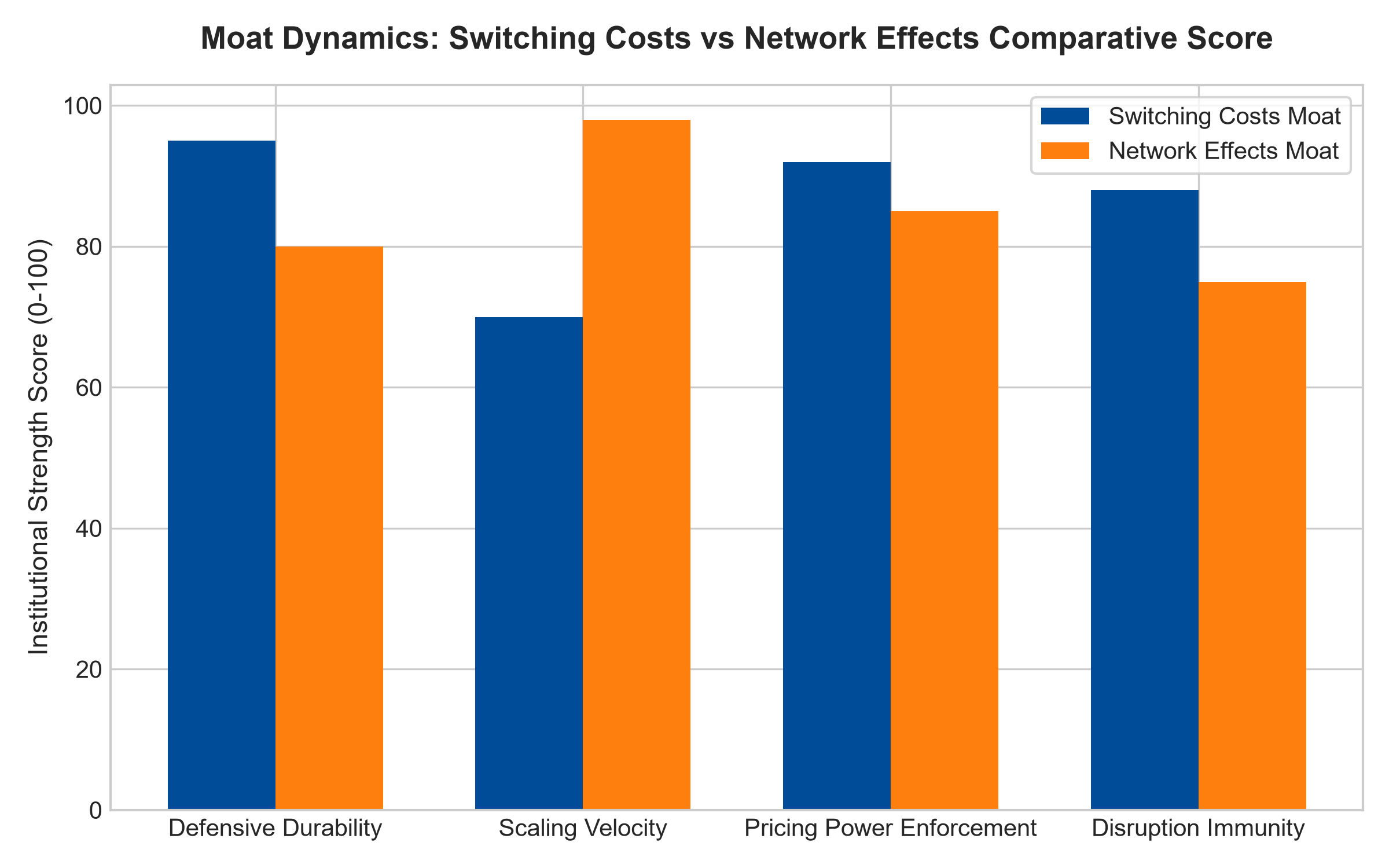
1. Dissecting the Architecture of High Switching Friction
A switching costs moat thrives on friction rather than virality. When a global bank installs a specialized core accounting architecture, that system becomes the central nervous system of every transaction, compliance report, and customer account across the institution. Attempting to rip out and replace that architecture requires hundreds of millions of dollars in capital expenditure, thousands of engineering hours, and introduces the catastrophic threat of customer database corruption.
Consequently, the chief technology officer will tolerate substantial annual price increases from the incumbent software vendor rather than risk their career on an uncertain migration. This dynamic grants the incumbent extraordinary pricing power that is mathematically insulated from economic recessions. Even if an upstart competitor develops a functionally superior software interface at half the price, the switching inertia prevents meaningful customer defection.
2. The Exponential Scaling Power of Network Flywheels
While switching costs defend an established perimeter, network effects aggressively conquer entire market categories through nonlinear scale dynamics. Governing this phenomenon is Metcalfe's Law, which states that the value of a telecommunications or digital commerce network is proportional to the square of the number of connected users. In platforms such as global credit card payment networks or centralized financial exchange clearinghouses, every additional merchant attracts more cardholders, and every incremental cardholder compels more merchants to accept the rails.
Once a network effects platform crosses critical liquidity mass, competition becomes mathematically unviable. A rival cannot simply build a competing clearinghouse or payment terminal; they must simultaneously replicate the entire multi-sided user ecosystem on day one. However, network effects carry a unique vulnerability: if user sentiment shifts or a radical technological protocol bypasses the network entirely, the flywheel can occasionally run in reverse with alarming speed.
3. Capital Allocation and the Longevity of Dual-Moat Platforms
When institutional investors evaluate long-term equity compounding, the duration of excess returns is vastly more consequential than short-term quarterly beats. A company that possesses high switching costs alongside an entrenched network effects flywheel creates an insurmountable barrier that defies standard competitive mean reversion. Traditional economic theory dictates that high returns on invested capital will inevitably attract rival capital until margins normalize.
However, dual-moat monopolies break this economic law. The combined friction of high migration costs and exponential network liquidity prevents rival capital from ever achieving traction. Because customers face severe operational risk if they defect and miss out on the platform's multi-sided liquidity, the incumbent can systematically compound intrinsic value per share for decades without competitive erosion.
4. MPLY and the Synergy of Dual-Moat Monopolies
Institutional investors frequently debate which moat is superior, but elite portfolio managers recognize that the absolute zenith of quality investing occurs when a company combines high switching costs with entrenched network effects. When an industrial transaction network becomes the undisputed industry standard while simultaneously embedding deep administrative software into client operations, competition is permanently extinguished.
The Strategy Shares Monopoly ETF (MPLY) is constructed specifically to capitalize on these institutional power dynamics. Rather than gambling on speculative early-stage growth companies hoping to achieve network scale, MPLY targets mature, cash-generative titans that already control both high switching inertia and dominant network scale across mission-critical economic sectors.
Investors looking to explore how actively managed strategies evaluate switching costs, network effects, and unassailable economic moats can examine the Strategy Shares Monopoly ETF (MPLY) at https://strategysharesetfs.com/mply/.
5. Frequently Asked Questions
Q1: Which moat provides superior downside protection during an economic recession?
Switching costs generally provide superior defensive stability during acute economic downturns. While network effects platforms often experience transaction volume compression when economic activity slows, mission-critical enterprise systems with embedded switching costs continue collecting contractual software licensing and maintenance fees without interruption.
Q2: Can a business with strong network effects be displaced without superior technology?
Direct displacement is exceptionally rare without a fundamental shift in technological architecture or regulatory intervention. Because network value compounds quadratically, a challenger offering a marginally better product cannot overcome the sheer ecosystem liquidity of the dominant incumbent.
6. Sources
Morningstar, Equity Research & Moat Analysis: https://www.morningstar.com/articles/moat-research
Harvard Business Review, Competitive Advantage Strategy: https://hbr.org/1979/03/how-competitive-forces-shape-strategy
#switchingcostsvsnetworkeffects #EconomicMoats #QualityInvesting #MonopolyETF #MPLY

