Article 4:
How Installed Bases Can Become Competitive Moats
In the domain of industrial manufacturing, aerospace engineering, and specialized medical technology, corporate profitability is rarely defined by the headline sale of heavy equipment. Experienced fundamental investors recognize that the initial placement of machinery is merely the admission ticket to a multi-decade annuity stream. An established installed base competitive advantage transforms capital intensive machinery manufacturers into high-margin, defensive compounders that generate immense free cash flow regardless of broader economic fluctuations.
When a manufacturing giant installs thousands of jet engines, commercial elevators, semiconductor lithography machines, or robotic surgical systems, it creates an enormous proprietary footprint within global commerce. These machines operate under intense continuous stress, requiring certified replacement components, regulatory compliance inspections, software telemetry updates, and highly specialized field maintenance over lifespans that span thirty to fifty years.
Because third-party components or unauthorized servicing risk catastrophic mechanical failure, warranty invalidation, and severe regulatory penalties, the original equipment manufacturer (OEM) holds an absolute local monopoly over its installed base. This structural lock-in forms a core pillar of the selective investment strategy executed by the Strategy Shares Monopoly ETF (MPLY).
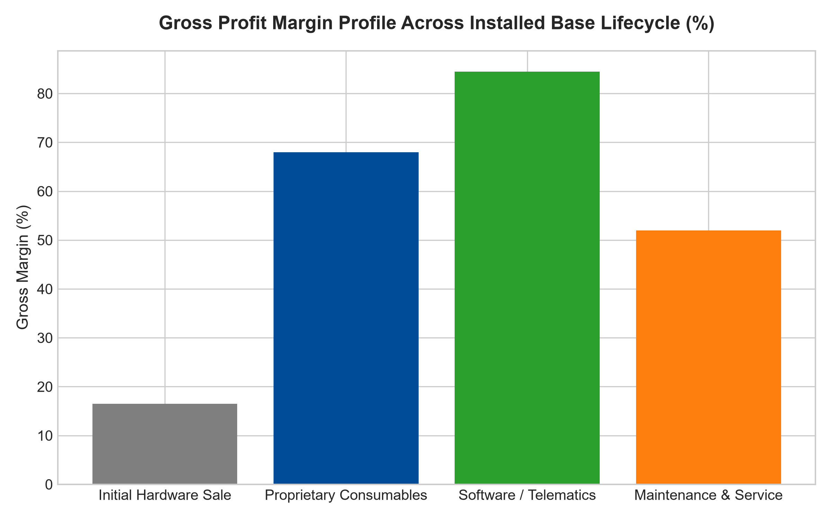
1. The Razor-and-Blade Model at Industrial Scale
The mechanics of an installed base competitive advantage represent the classic razor-and-blade model elevated to an institutional scale. The original equipment is frequently sold at modest gross profit margins of fifteen to twenty percent, or occasionally at near cost during competitive bidding rounds. However, the cumulative lifecycle value of the consumables, software licenses, and replacement parts typically exceeds three to five times the original equipment purchase price.
Crucially, while original equipment sales fluctuate wildly according to corporate capital expenditure cycles and economic recessions, installed base servicing is entirely non-discretionary. An airline cannot pause jet engine inspections during a downturn, nor can a hospital delay maintenance on diagnostic imaging machines. The cash flows generated by the installed base remain exceptionally stable, providing pristine cash flow visibility that cyclical competitors lack.
2. High Regulatory and Technical Replacement Barriers
A common inquiry among equity analysts is why independent aftermarket suppliers cannot replicate these high-margin components and undercut the OEM's pricing power. The answer lies in the formidable web of patent protections, proprietary software interfaces, and governmental regulatory standards governing critical equipment.
In aviation and medical equipment, regulatory agencies mandate strict traceability and certification for every component installed in certified machines. Installing an unverified aftermarket part can expose the operator to catastrophic liability lawsuits and grounding orders. Furthermore, modern equipment incorporates encrypted digital telemetry that only communicates with authorized OEM software systems. By weaving intellectual property, regulatory compliance, and digital security into the physical asset, the incumbent firmly establishes an unassailable commercial monopoly over its installed base.
3. Strategic Moat Depth: The Telemetry and Data Lock-In
In modern industrial ecosystems, installed base moats have evolved far beyond simple physical hardware placement. Dominant manufacturers now equip their machinery with proprietary IoT telemetry, real-time diagnostic sensors, and cloud-connected performance analytics. This diagnostic data is encrypted and fed exclusively into the original equipment manufacturer's proprietary maintenance algorithms.
This digital integration introduces an insurmountable operational barrier for third-party servicing organizations. An independent repair mechanic cannot accurately interpret proprietary fault codes or access automated firmware patches required for optimal performance. The customer is bound to the OEM not merely by warranty agreements, but by the physical and computational reality of modern connected machinery, guaranteeing high-margin lifecycle revenue streams.
4. MPLY and the Hunt for Capital-Light Aftermarket Monopolies
Broad market index funds hold countless industrial enterprises that suffer from brutal cyclicality because they possess large manufacturing footprints without significant aftermarket capture. When equipment demand cools, their fixed overhead costs remain high, leading to rapid margin collapse and dividend cuts.
The Strategy Shares Monopoly ETF (MPLY) differentiates itself by seeking out businesses where the installed base has reached critical mass, allowing the recurring high-margin aftermarket division to completely overshadow the cyclical original equipment division. By concentrating on businesses that command captive industrial ecosystems, MPLY captures defensive cash flows backed by real, mission-critical global infrastructure.
Investors interested in understanding how active managers isolate industrial monopolies with captive installed base cash flows can review the Strategy Shares Monopoly ETF (MPLY) at https://strategysharesetfs.com/mply/.
Furthermore, institutional analysts evaluate the installed base refresh cycle. When machinery reaches the end of its multi-decade operating life, the customer faces a reinvestment decision. Because the client's engineering personnel, software workflows, and operational protocols are already fully standardized around the incumbent's architecture, the incumbent captures over eighty percent of replacement orders. The installed base not only generates continuous recurring service margins, but practically guarantees the next generation of capital sales, locking out prospective competitors permanently.
5. Frequently Asked Questions
Q1: How can an investor quantify the strength of an installed base competitive advantage?
Key metrics include the ratio of aftermarket revenue to total enterprise revenue, aftermarket gross profit margins relative to equipment gross margins, and the average operational lifespan of the installed fleet. Enterprises where aftermarket services generate more than fifty percent of total revenue and carry gross margins above fifty percent typically possess formidable installed base moats.
Q2: How does an installed base moat protect investors during a stagflationary environment?
Because installed base maintenance and replacement parts are legally or operationally mandated, customers exhibit near-zero price sensitivity. The OEM can raise parts and servicing prices well above prevailing inflation rates without suffering unit volume declines, insulating shareholder returns from cost pressures.
6. Sources
Morningstar, Equity Research & Moat Analysis: https://www.morningstar.com/articles/moat-research
Harvard Business Review, Competitive Advantage Strategy: https://hbr.org/1979/03/how-competitive-forces-shape-strategy
#installedbasecompetitiveadvantage #EconomicMoats #IndustrialMonopolies #QualityInvesting #MPLY

