Article 5:
Aftermarket Revenue as a Competitive Advantage
When assessing the strength of corporate competitive advantages, many traditional valuation models overemphasize top line product shipment volume. In capital goods, infrastructure support, and industrial automation, headline sales numbers often mask underlying cyclicality that exposes shareholders to painful drawdown periods. Savvy institutional investors look deeper into the revenue architecture, focusing on the proportion of operating profits anchored by an aftermarket revenue competitive advantage.
Aftermarket revenue consists of the recurring, highly profitable sales of proprietary replacement components, technical diagnostic support, preventative maintenance contracts, and digital upgrades required to maintain operational assets. Unlike initial equipment purchases, which can be deferred indefinitely by corporate finance committees during an economic downturn, aftermarket servicing is functionally unavoidable. The machinery must run to maintain commercial viability.
This dynamic creates a profound structural divergence in corporate earnings stability. Enterprises that command monopolistic control over their aftermarket ecosystem generate consistent, counter-cyclical cash flows that support sustained dividend expansion and capital compounding. Isolating these high-conviction market leaders is central to the portfolio curation philosophy behind the Strategy Shares Monopoly ETF (MPLY).
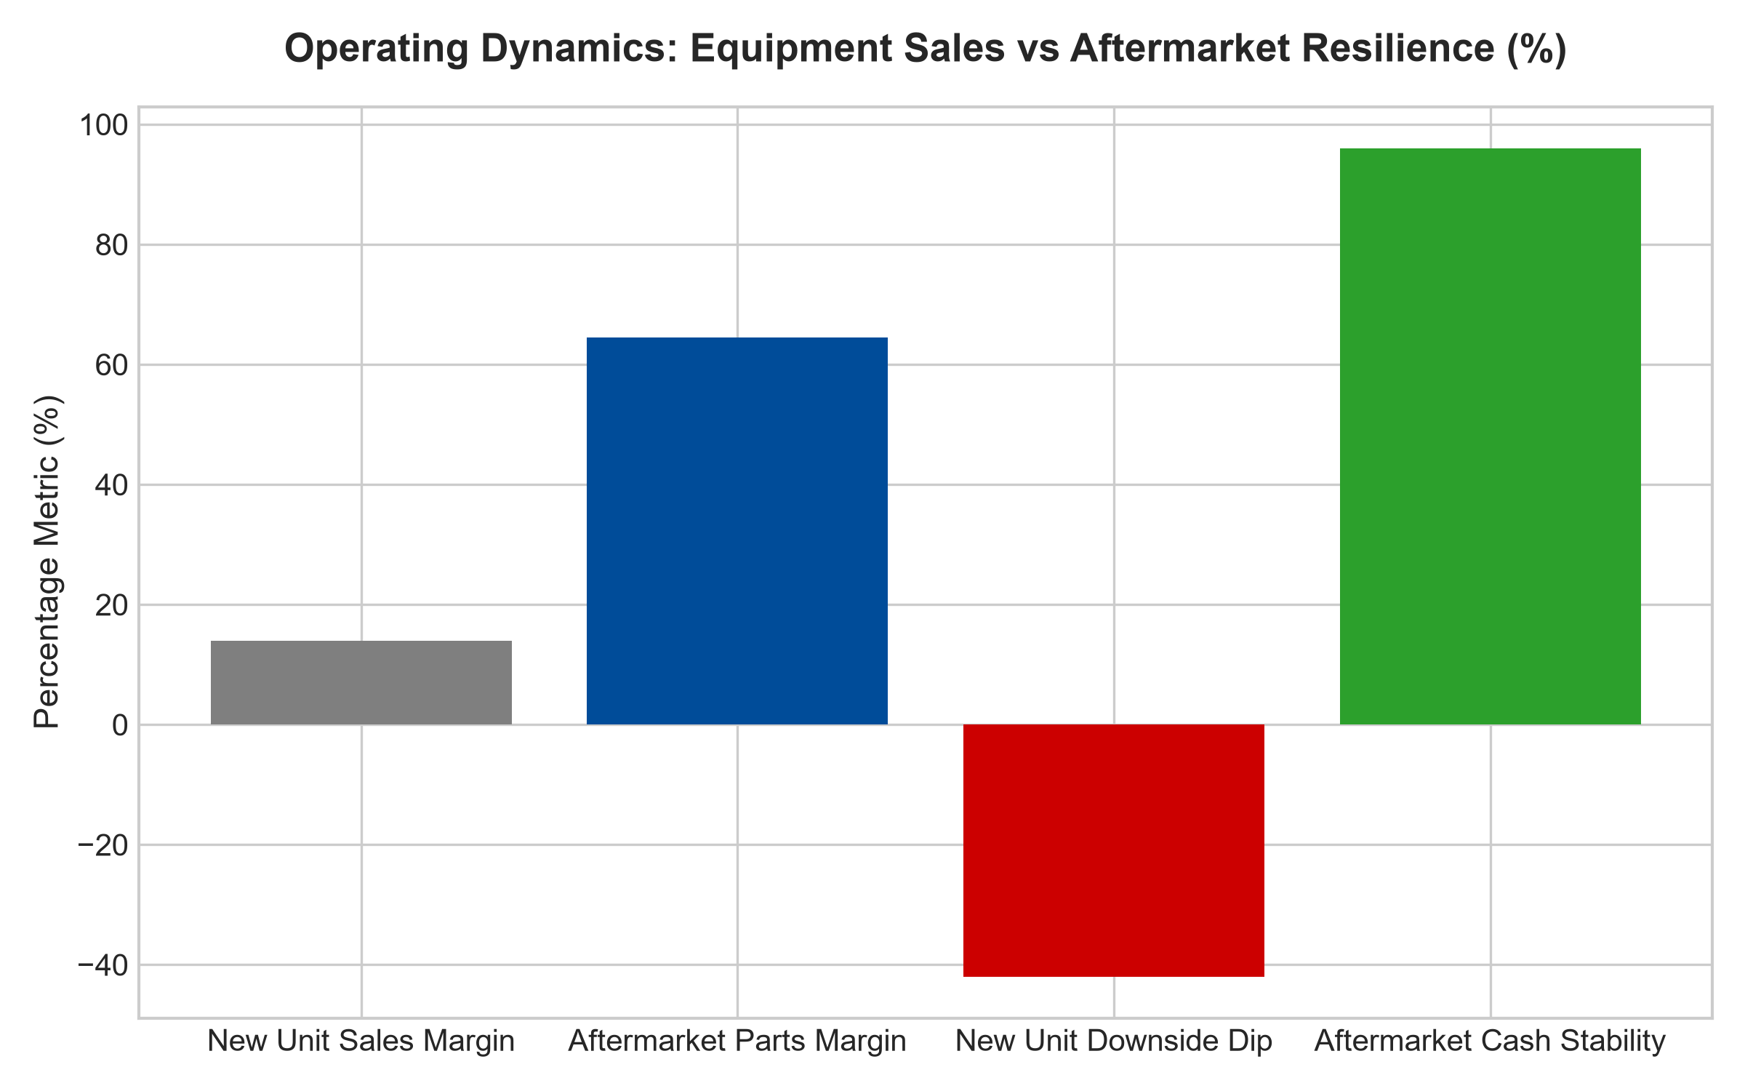
1. The Counter-Cyclical Resilience of Aftermarket Services
During economic contractions, industrial corporations and commercial fleets routinely freeze capital expenditure programs, postponing the purchase of new vehicles, manufacturing turbines, or processing lines. However, postponing new equipment acquisition paradoxically increases the operating age and utilization stress on existing machinery. Older equipment requires more frequent maintenance, accelerated parts replacement, and specialized calibration, creating an immediate tailwind for aftermarket divisions.
Consequently, a business with a powerful aftermarket revenue competitive advantage experiences minimal earnings volatility during recessions. While transactional competitors suffer severe margin contraction as factory utilization plummets, the aftermarket-dominant incumbent reaps continuous high-margin servicing cash flow, providing defensive resilience when equity markets are most turbulent.
2. High Gross Margins and Intellectual Property Protection
Aftermarket components routinely command gross profit margins ranging from fifty to seventy percent, compared to initial machinery margins that frequently hover in the low teens. This gross margin premium is defended by an intricate matrix of legal, operational, and technological protections.
Patented design specifications, proprietary metallurgy, and specialized manufacturing tolerances make unauthorized component replication prohibitively expensive and legally hazardous. Furthermore, modern equipment relies on integrated electronic control units that require proprietary software keys to reset diagnostic codes following a service event. Operators who utilize uncertified third-party mechanics risk voiding critical warranties and assuming immense operational liabilities, effectively ensuring that the original manufacturer retains a captive commercial monopoly.
3. Balance Sheet Fortress Dynamics in Aftermarket Dominance
A profound benefit of commanding an aftermarket revenue competitive advantage is the resulting balance sheet flexibility. Pure equipment manufacturers must maintain massive working capital lines, substantial raw material stockpiles, and heavy finished-goods inventories to weather volatile demand cycles. When a recession strikes, excess inventory must be written down, triggering severe balance sheet distress.
In stark contrast, aftermarket service divisions operate with exceptional inventory velocity and rapid cash conversion cycles. Because maintenance parts are purchased continuously and services are billed on prompt terms, aftermarket leaders maintain pristine net-cash balance sheets. This financial fortress enables them to self-fund strategic growth, repurchase undervalued shares during market panics, and consistently raise dividend distributions regardless of broader economic stagnation.
4. MPLY and the Architecture of Monopolistic Free Cash Flow
Passive index funds are structurally forced to allocate capital mechanically according to market capitalization weightings, meaning they hold vast quantities of low-margin, cyclical manufacturers that possess zero aftermarket protection. When macroeconomic cycles roll over, these holdings experience severe earnings compression.
The Strategy Shares Monopoly ETF (MPLY) bypasses this indexation flaw through active fundamental scrutiny. By identifying enterprises that possess extensive installed bases and legally protected aftermarket revenue streams, MPLY constructs a concentrated, all-weather investment vehicle. These companies generate high return on equity and superior free cash flow conversion, offering institutional investors a dependable foundation for long term capital compounding.
Investors seeking to understand the quantitative criteria used to identify durable monopolies and captive aftermarket cash flows can review the Strategy Shares Monopoly ETF (MPLY) at https://strategysharesetfs.com/mply/.
From an enterprise valuation standpoint, aftermarket-heavy corporations trade at premium free cash flow multiples because their earnings stream closely mirrors that of a regulated utility or high-retention software business. Private equity allocators and sovereign wealth funds aggressively bid for these businesses because their downside risk is severely truncated. Even during protracted industrial recessions, the cash flow generated by mandatory maintenance contracts provides ample liquidity to service debt and compound intrinsic equity value per share.
5. Frequently Asked Questions
Q1: What percentage of total revenue should aftermarket sales represent to constitute an economic moat?
While capital structures vary by sub-industry, institutional analysts look for aftermarket sales to represent at least forty to fifty percent of total corporate revenue, contributing over sixty percent of total operating operating profit. At these levels, the business has successfully transitioned from an equipment manufacturer to an elite infrastructure service annuity.
Q2: How do aftermarket monopolies sustain pricing power over long horizons?
Because the cost of an individual replacement component or maintenance visit is typically a minor fraction of the client's overall operating budget, yet critical to preventing multi-million dollar operational halts, price elasticity of demand is exceptionally low. The manufacturer can institute annual mid-single-digit price hikes without provoking customer attrition.
6. Sources
Morningstar, Equity Research & Moat Analysis: https://www.morningstar.com/articles/moat-research
Harvard Business Review, Competitive Advantage Strategy: https://hbr.org/1979/03/how-competitive-forces-shape-strategy
#aftermarketrevenuecompetitiveadvantage #EconomicMoats #QualityInvesting #PricingPower #MPLY

