Article 6:
How Distribution Reach Can Create an Economic Moat
In the evaluation of corporate durability, market commentators often celebrate digital intellectual property and patented engineering while overlooking the raw physical infrastructure that dictates commerce. Yet across consumer staples, specialized pharmaceuticals, industrial supplies, and global freight, a dense, entrenched distribution moat remains one of the most impenetrable competitive barriers in capitalism. Building a brilliant product is functionally irrelevant if an enterprise cannot transport that product to end consumers at a unit cost that competitors cannot match.
A distribution moat is anchored in route density, physical warehousing scale, and entrenched customer touchpoints accumulated across decades. When an incumbent operates tens of thousands of refrigerated delivery trucks or dedicated warehouse hubs within fifteen minutes of ninety percent of the population, the marginal cost of delivering an extra carton or parcel approaches zero. A prospective challenger faces a devastating paradox: to match the incumbent's delivery prices, they must possess comparable scale, but to achieve that scale, they must absorb billions of dollars in route-running losses.
This mathematical barrier turns physical delivery networks into insurmountable local monopolies that extract steady, toll-like cash flows. Identifying corporations that dominate essential physical distribution routes forms a vital component of the concentrated quality framework employed by the Strategy Shares Monopoly ETF (MPLY).
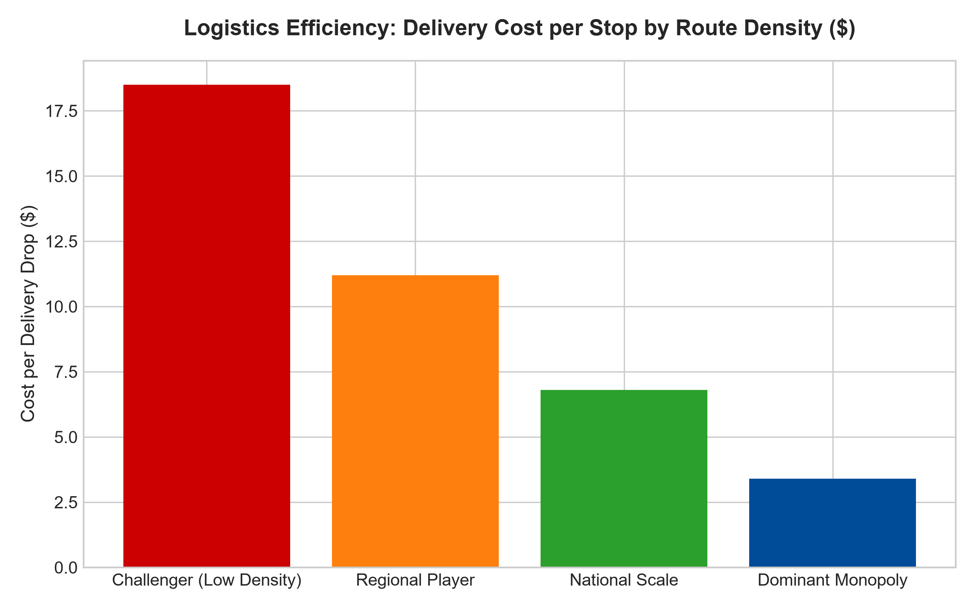
1. The Devastating Economics of Route Density
The mathematical core of a distribution moat is route density. If an incumbent distributor services twenty commercial clients on a single city street, the fuel cost, vehicle depreciation, and driver compensation are divided across twenty revenue-generating delivery stops. The cost per delivery drop collapses to a fraction of total merchandise value.
If a venture-backed competitor attempts to enter that same metropolitan market with only one or two customers per neighborhood, their delivery vehicle must traverse miles between drops. Even if the challenger sources identical products at equal manufacturing wholesale costs, their fulfillment and logistics overhead guarantees catastrophic operating losses. The incumbent's existing route density acts as an invisible gravitational field, suffocating challengers before they can ever reach operational breakeven.
2. Shelf-Space Primacy and Wholesale Captivity
A physical distribution network extends its moat beyond transport logistics directly into wholesale customer captivity. Retail outlets, commercial kitchens, automotive repair shops, and hospitals operate with limited physical storage space and lean inventory schedules. They rely on trusted distribution titans capable of guaranteeing next-morning delivery across thousands of distinct stock-keeping units.
Because managing dozens of separate boutique suppliers creates administrative chaos and billing complexity, commercial buyers naturally consolidate their purchasing through the dominant distributor. This grants the distributor immense bargaining leverage over upstream manufacturers, who must concede significant wholesale discounts simply to secure placement on the distributor's trucks. The distributor captures profits on both ends of the supply chain, expanding gross margins while insulating its balance sheet from inflation.
3. Scale Economies and Capital Expenditure Defensibility
The physical defensibility of a distribution moat is directly tied to the concept of scale economies shared. When an incumbent distributor achieves massive route density, its operating cost per delivery unit plummets. Rather than extracting maximum short-term profits, elite operators reinvest a portion of these logistics efficiencies into lower wholesale prices and enhanced service guarantees for their customers.
This strategic pricing dynamic permanently closes the door on prospective challengers. A new entrant cannot merely match the incumbent's customer prices; they must undercut a titan that is already operating at an optimized cost curve. Because funding an unprofitable distribution network across multiple states requires billions of dollars in unrecoverable capital, venture and private equity sponsors avoid challenging entrenched logistics monopolies, leaving the incumbent's pricing power fully intact.
4. MPLY and the Curation of Essential Infrastructure Moats
Passive index funds frequently allocate substantial capital to asset-light consumer brands that possess zero control over their physical fulfillment. When transportation rates spike or distribution partners renegotiate contract terms, these brands suffer immediate profit compression.
The Strategy Shares Monopoly ETF (MPLY) adopts an active, high-conviction approach by deliberately prioritizing businesses that own and control the physical arteries of commerce. By investing in dominant distribution networks that operate as essential commercial toll roads, MPLY captures durable cash flows and robust pricing power that cannot be disrupted by simple technological duplication.
Investors looking to evaluate how institutional strategies identify wide-moat distribution leaders and monopolistic market operators can examine the Strategy Shares Monopoly ETF (MPLY) at https://strategysharesetfs.com/mply/.
5. Frequently Asked Questions
Q1: Can digital direct-to-consumer (DTC) models dismantle traditional distribution moats?
Direct-to-consumer models initially promised to bypass physical distribution, but escalating digital customer acquisition costs and exorbitant last-mile parcel shipping fees have crushed the unit economics of most DTC operators. Established distribution giants possessing integrated warehousing and proprietary local delivery fleets have proven far more resilient and cost-effective over long market cycles.
Q2: What metrics confirm that a company possesses a genuine distribution moat?
Institutional analysts scrutinize inventory turnover rates, operating margins relative to regional peers, and return on invested capital across distribution centers. Dominant operators consistently demonstrate lower freight costs as a percentage of revenue and industry-leading fulfillment reliability scores.
6. Sources
Morningstar, Equity Research & Moat Analysis: https://www.morningstar.com/articles/moat-research
Harvard Business Review, Competitive Advantage Strategy: https://hbr.org/1979/03/how-competitive-forces-shape-strategy
#distributionmoat #EconomicMoats #SupplyChainMonopolies #QualityInvesting #MPLY

