Article 7:
Can Data Become an Economic Moat? A Framework for Investors
In the modern digital economy, corporate executive teams frequently proclaim that their proprietary data assets constitute an unassailable competitive advantage. However, experienced fundamental analysts recognize that vast quantities of digital information do not automatically translate into a wide economic moat. In truth, the majority of corporate datasets are ephemeral, easily commoditized by web crawlers, or rapidly rendered obsolete by technological evolution. For institutional investors, determining whether an enterprise commands an authentic data economic moat requires a rigorous analytical framework.
A genuine data moat exists only when an enterprise possesses exclusive, legally protected, non-replicable datasets that directly inform mission-critical workflows, automated decision engines, or predictive risk models. Merely accumulating user logs or public search metrics provides negligible defensive protection. True defensibility emerges when the data generation process is tied to a captive, proprietary feedback loop that competitors cannot access regardless of how much capital they deploy.
When a corporation establishes sovereign control over specialized operational telemetry, proprietary credit histories, or clinical diagnostic records, it establishes an insurmountable barrier to entry. This forensic distinction between superficial data accumulation and structural data dominance guides the stock selection process within the Strategy Shares Monopoly ETF (MPLY).
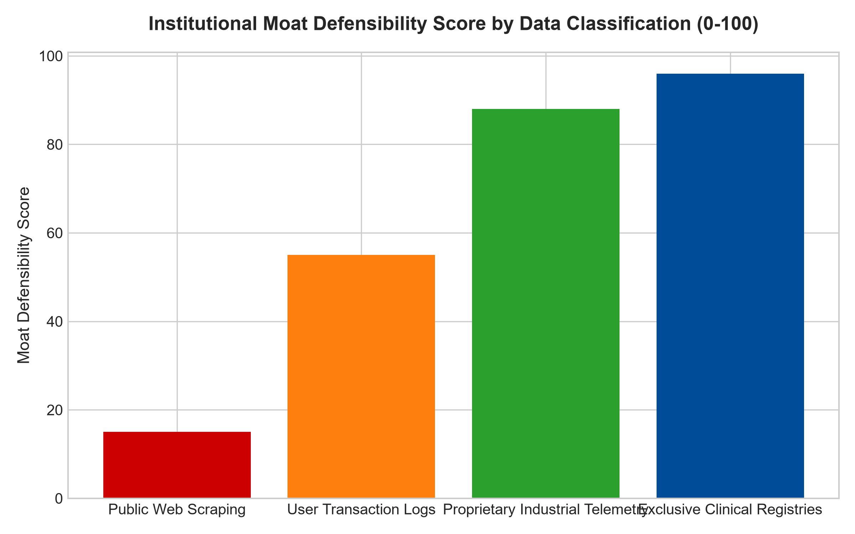
1. The Three Pillars of a Genuine Data Moat
To establish a durable competitive advantage, an enterprise's data asset must satisfy three rigorous quantitative criteria: exclusivity, integration, and continuous self-reinforcement. First, the data must be proprietary. If an upstart can purchase comparable datasets from third-party data brokers or scrape identical parameters from public online repositories, the asset possesses zero moat defensibility.
Second, the dataset must be embedded into client operational workflows. In capital markets, algorithmic credit scoring agencies and specialized financial terminal networks possess decades of proprietary historical transaction records that are hardcoded into institutional compliance guidelines. Third, the data must fuel an automated flywheel where increased customer utilization naturally produces more exclusive telemetry, perpetually widening the analytical gap between the incumbent and prospective challengers.
2. The Commoditization Trap of Generative Technologies
The rapid proliferation of advanced generative artificial intelligence and large foundation models has exposed the fragility of superficial data claims. Foundation models trained on public internet text have commoditized generic summarization, generic copywriting, and basic consumer search. Businesses whose perceived value proposition relied on aggregating public information have seen their margins evaporate virtually overnight.
Conversely, enterprises that possess unique, real-world physical telemetry, such as specialized jet engine sensor diagnostics, robotic surgery outcome registries, or proprietary title insurance land records, have seen their moats widen significantly. Foundation models cannot hallucinate or synthesize physical sensor data that exists solely inside private enterprise servers. The incumbent company's proprietary data asset becomes the indispensable training substrate that outside models must license at high royalties, reinforcing the incumbent's monopoly positioning.
3. Workflow Friction and Regulatory Integration of Enterprise Data
The ultimate test of a data economic moat is whether an enterprise's datasets are legally and operationally mandated within client workflows. In sectors such as financial compliance, pharmacological safety, and aerospace testing, regulatory authorities establish strict evidentiary protocols that require the utilization of recognized benchmark datasets. An institutional client cannot substitute an alternative dataset without risking regulatory non-compliance or civil liability.
When proprietary data achieves the status of an industry standard, the enterprise transcends simple software provision and becomes an indispensable regulatory utility. The company can consistently institute annual price increases of six to eight percent without risking customer defection, because switching to an uncertified data provider is legally and commercially unthinkable.
4. MPLY and the Hunt for Sovereign Data Fortresses
Passive market indices contain numerous high-flying tech firms that market themselves as AI leaders while possessing fragile, easily scraped data architectures. When market sentiment deflates, these speculative entities suffer catastrophic price corrections.
The Strategy Shares Monopoly ETF (MPLY) bypasses these speculative traps through active fundamental vetting. By targeting companies that hold legally fortified, non-replicable data assets across healthcare, finance, and industrial automation, MPLY invests in businesses with genuine pricing power. These sovereign data fortresses generate predictable cash flows and deliver sustainable competitive advantages across all macroeconomic environments.
Investors interested in discovering how institutional analysts distinguish authentic data moats from speculative technological hype can review the Strategy Shares Monopoly ETF (MPLY) at https://strategysharesetfs.com/mply/.
In practical equity valuation, institutional investors scrutinize the legal defensibility and terms of service governing proprietary data. The strongest data moats are backed by rigorous contractual covenants that forbid enterprise clients from exporting raw telemetry to external machine learning vendors. By maintaining exclusive legal ownership over operational data exhausts, dominant platforms ensure that any industry-wide AI innovations must be built on their terms, transforming prospective technological disruption into an incremental licensing revenue engine.
5. Frequently Asked Questions
Q1: Does having more data always create a stronger economic moat?
No. In many applications, data exhibits sharply diminishing marginal returns. Once an algorithmic model achieves ninety-nine percent accuracy, collecting ten times more data yields negligible performance improvements. A true data moat requires that incremental data unlocks entirely new operational capabilities or cements high switching costs for the end client.
Q2: How do intellectual property laws protect corporate data moats?
While raw factual data cannot be copyrighted, proprietary database structures, trade secret protections, and strict terms of service legally prohibit third-party crawling and extraction. Leading data monopolies vigorously litigate against unauthorized automated scraping, securing their perimeter through both legal and cryptographic fortifications.
6. Sources
Morningstar, Equity Research & Moat Analysis: https://www.morningstar.com/articles/moat-research
Harvard Business Review, Competitive Advantage Strategy: https://hbr.org/1979/03/how-competitive-forces-shape-strategy
#dataeconomicmoat #EconomicMoats #ProprietaryData #QualityInvesting #MPLY

