Article 8:
Regulatory Complexity as a Barrier to Entry
In traditional economic theory, government regulations and sprawling bureaucratic compliance standards are frequently portrayed as inefficient deadweight costs that stifle corporate productivity. However, through the lens of institutional equity analysis and corporate moat valuation, regulatory complexity functions as one of the most effective and durable competitive shields an incumbent can enjoy. When navigating legal oversight requires hundreds of millions of dollars in annual compliance overhead, a regulatory barrier to entry legally outlaws casual competition.
A regulatory moat is not simply an operating license; it is an intricate maze of safety certifications, statutory audits, environmental permits, and institutional reporting mandates. For an established titan generating billions in free cash flow, absorbing compliance costs is a minor line item on a vast corporate income statement. For an ambitious startup or mid-sized challenger, that identical regulatory burden represents a lethal financial barrier that consumes venture funding before a single product reaches commercial distribution.
Consequently, highly regulated industries routinely consolidate into durable oligopolies and legally entrenched monopolies that generate superior return on invested capital. The structural resilience created by heavy regulation forms a central quantitative pillar for the Strategy Shares Monopoly ETF (MPLY), which actively targets businesses operating behind unbreachable statutory barricades.
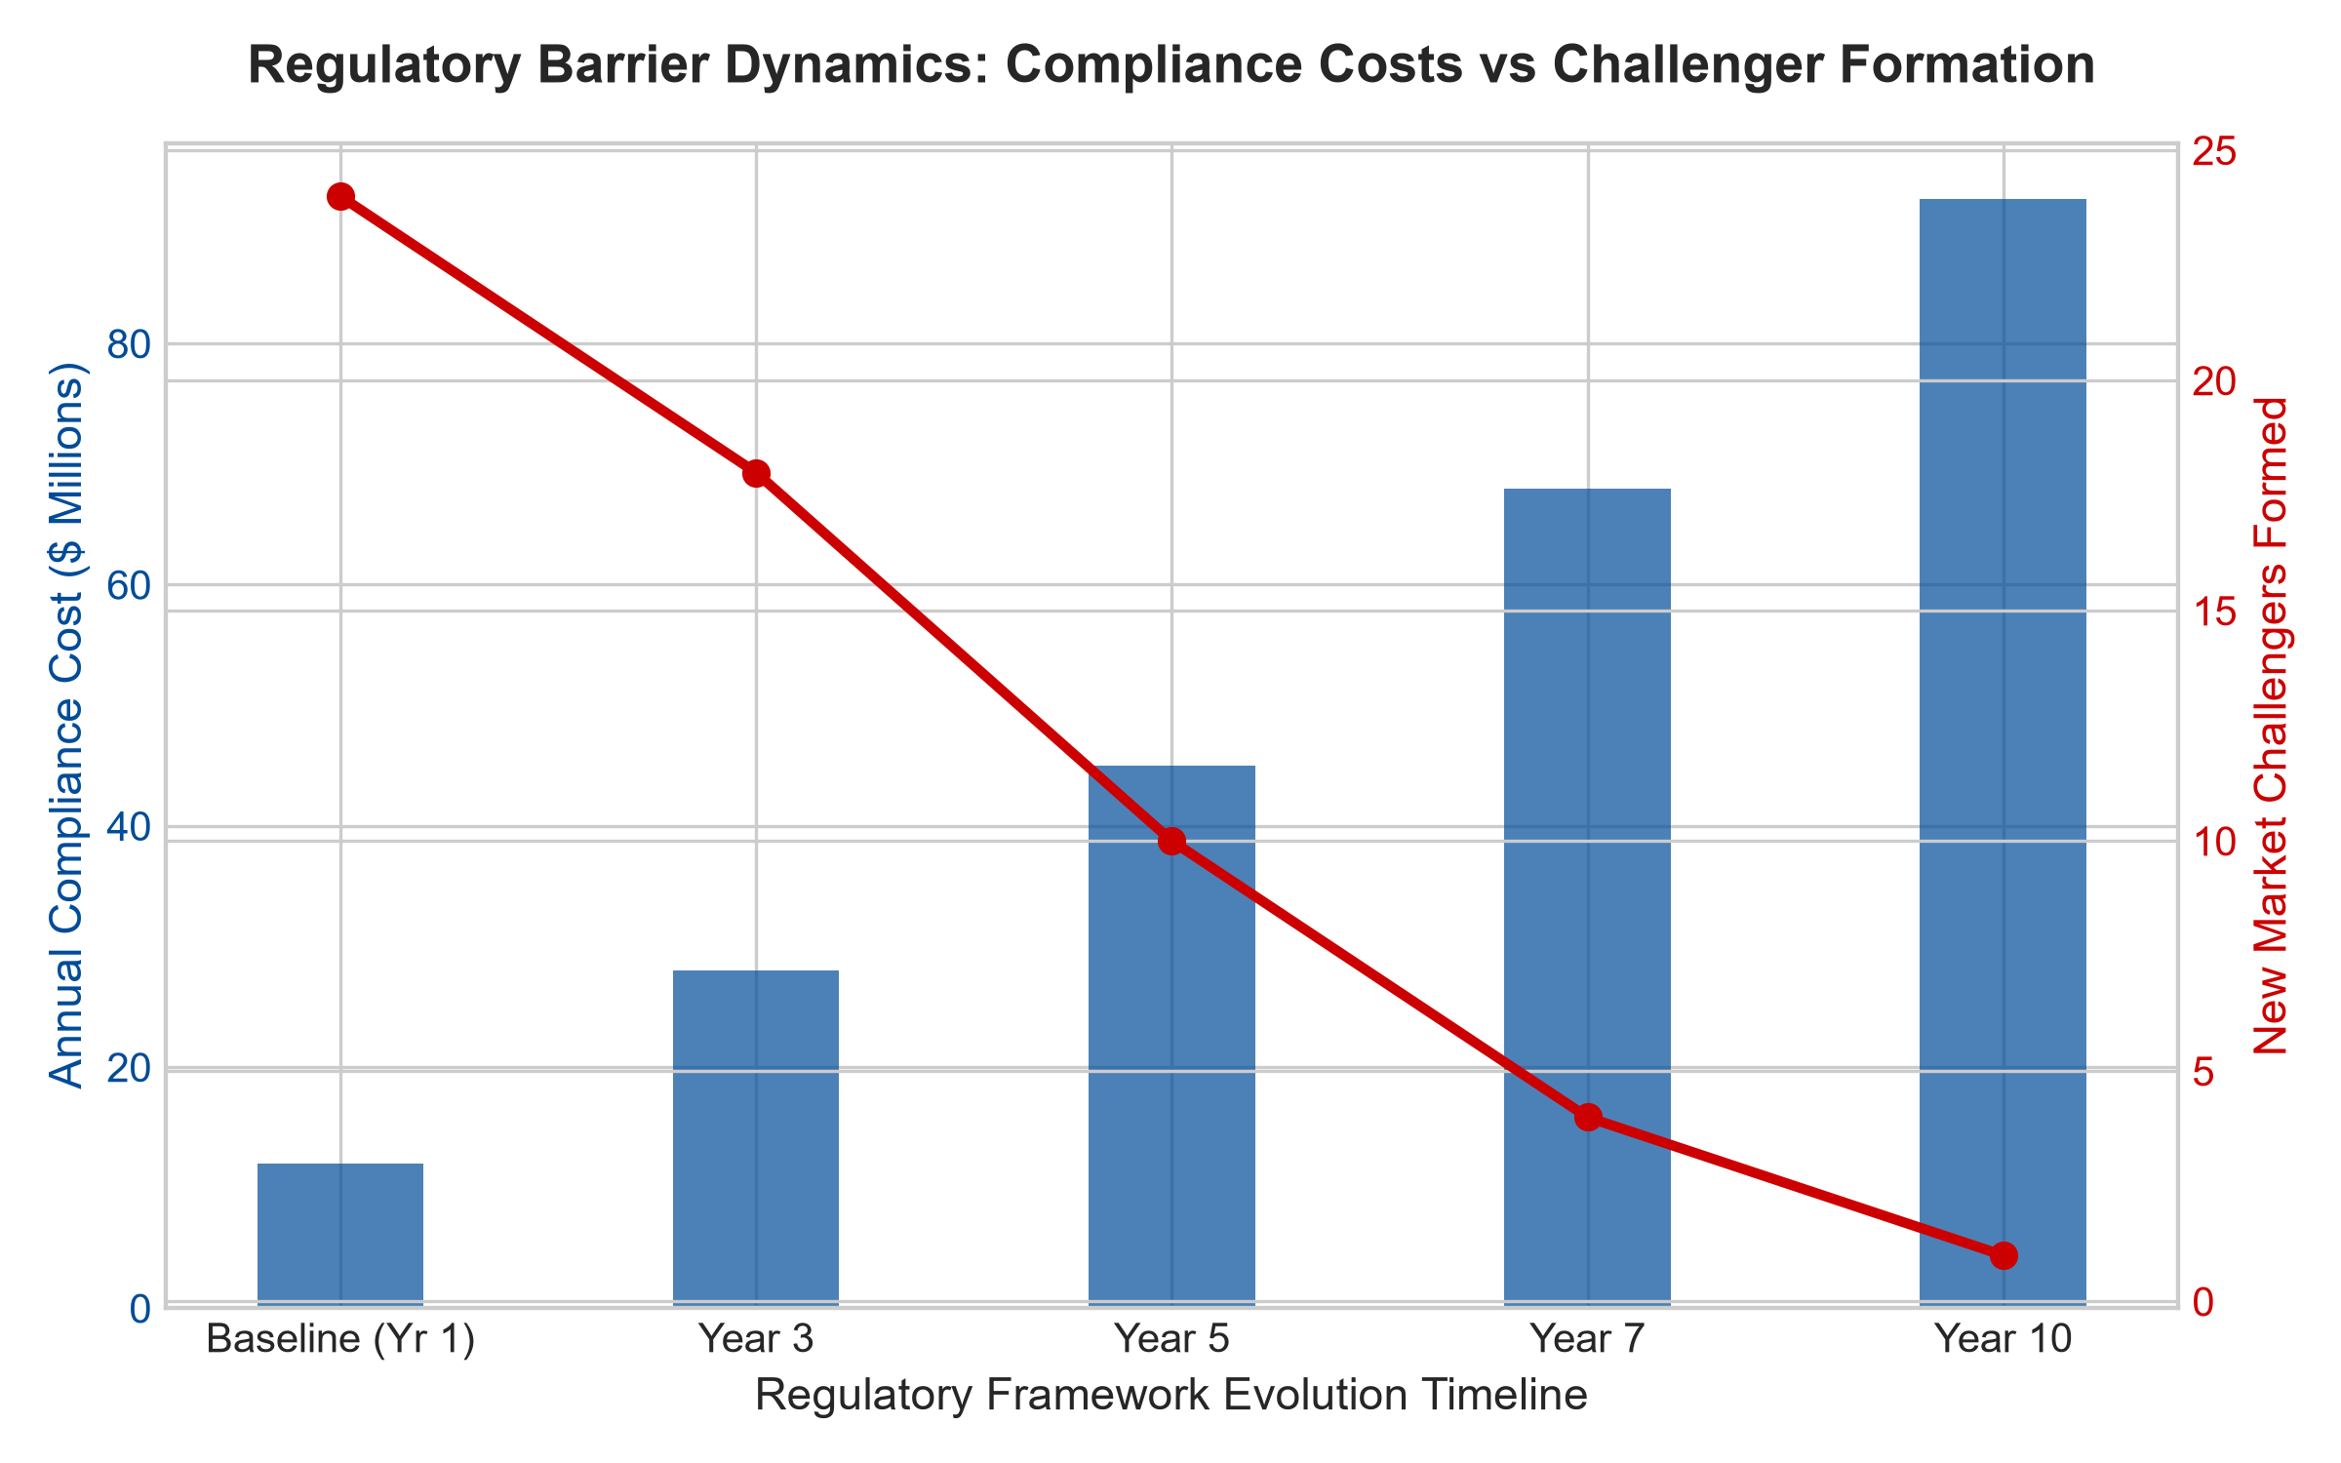
1. The Economics of Asymmetric Compliance Burden
The fundamental power of a regulatory barrier to entry stems from the concept of regulatory asymmetry. Large-scale incumbents maintain dedicated legal departments, specialized political lobbyists, and extensive compliance teams whose costs are distributed across vast revenue bases. If a newly passed regulation mandates an additional twenty-five million dollars in annual statutory reporting and clinical verification, an incumbent with five billion in revenue barely registers a basis-point adjustment to its operating margin.
To a prospective market challenger with fifty million dollars in capital, that identical twenty-five million dollar regulatory obligation represents immediate insolvency. The cost of compliance acts as a regressive tax on competitive innovation, ensuring that only the existing corporate giants possess the financial endurance to remain in the marketplace. Over time, smaller participants are forced to sell themselves to the incumbent or exit entirely, deepening industry concentration.
2. Capture and the Institutional Approval Bottleneck
Beyond ongoing compliance expenses, regulatory moats are reinforced by length and opacity of the administrative approval pipeline. In sectors such as biopharmaceuticals, medical diagnostics, nuclear utility operations, and specialized defense contracting, obtaining governmental authorization requires a multi-year gauntlet of testing, public comment periods, and bureaucratic reviews.
Furthermore, regulatory agencies naturally collaborate with established industry incumbents to formulate technical safety benchmarks. These technical standards often codify the incumbent's existing operational methodologies into statutory law, making it nearly impossible for disruptive non-traditional technologies to qualify for approval. The incumbent's historical operating procedures become the legal definition of market safety, establishing a state-sanctioned monopoly that shields shareholder capital.
3. Legal Architecture and Statutory Entrenchment of Corporate Fortresses
The durability of a regulatory barrier to entry is greatly enhanced by the concept of institutional path dependency. Once a regulatory framework has been established around an incumbent's technical standards, the administrative cost for the governing body to revise those standards is prohibitively high. Regulators, naturally risk-averse, prefer overseeing an established, well-capitalized entity whose operating protocols are thoroughly documented.
This creates an institutional alignment between the regulatory authority and the dominant corporation. The incumbent functions as a de facto administrative partner, assisting the agency in drafting future compliance protocols and safety guidelines. Prospective challengers find themselves fighting not only a commercial giant, but an entrenched statutory apparatus that views new entrants as potential sources of systemic instability.
4. MPLY and the Strategic Selection of Regulated Fortresses
Uninformed retail investors frequently steer clear of heavily regulated industries, fearing political scrutiny or statutory intervention. This reluctance creates significant valuation dislocations that institutional quality managers exploit. While bureaucratic changes can create headline noise, the underlying businesses operate as protected economic toll booths.
The Strategy Shares Monopoly ETF (MPLY) specifically identifies companies that have mastered regulatory navigation and leverage statutory complexity to prevent competitive market entry. By investing in dominant operators that are practically immune to new challenger formation, MPLY captures steady, recession-resilient cash flows backed by legally enforceable market barriers.
Investors seeking to analyze how institutional portfolio managers utilize regulatory complexity and statutory barriers to identify durable monopolies can review the Strategy Shares Monopoly ETF (MPLY) at https://strategysharesetfs.com/mply/.
5. Frequently Asked Questions
Q1: Does heavy government regulation guarantee that an incumbent will remain profitable?
Regulation protects against new competitors, but profitability depends on pricing power. The best regulatory moats exist in sectors where the government mandates high safety and operational standards but does not impose strict rate-of-return utility price caps, allowing the incumbent to raise prices freely while enjoying complete statutory protection from new entrants.
Q2: How can an investor identify if an industry's regulatory barrier is strengthening?
Analysts monitor the volume of new regulatory statutes enacted, average statutory review timeframes for new market applicants, and historical trends in new business license issuances. A steady decline in newly approved market participants alongside rising compliance expenditures confirms a widening regulatory moat.
6. Sources
Morningstar, Equity Research & Moat Analysis: https://www.morningstar.com/articles/moat-research
Harvard Business Review, Competitive Advantage Strategy: https://hbr.org/1979/03/how-competitive-forces-shape-strategy
#regulatorybarriers #EconomicMoats #RegulatedMonopolies #QualityInvesting #MPLY

