Article 9:
How Capital Intensity Can Limit New Competition
Modern venture capital culture has celebrated asset-light software business models, claiming that heavy physical assets represent an undesirable drag on corporate agility and return on invested capital. However, seasoned institutional investors recognize a profound paradox in competitive strategy: asset-light businesses are inherently asset-light for competitors to challenge and disrupt. Conversely, when an enterprise commands vital physical infrastructure that requires tens of billions of dollars to construct, a capital intensity barrier to entry permanently eliminates the possibility of new competitive intrusion.
A capital intensity moat is not defined merely by owning expensive machinery. True defensibility arises when the total capital expenditure required to replicate an existing corporate footprint is so astronomically high that no rational financier would ever underwrite the project. When replicating a national freight railroad, an interstate energy pipeline, or a leading-edge semiconductor fabrication foundry requires decades of construction and tens of billions in unrecoverable upfront capital, the incumbent holds a natural economic monopoly.
These immense physical fortresses operate as commercial toll roads across the global economy. By insulating existing assets from competitive duplication, heavy capital intensity ensures high cash flow visibility and robust pricing power over multi-decade horizons, providing a critical investment thesis for the Strategy Shares Monopoly ETF (MPLY).
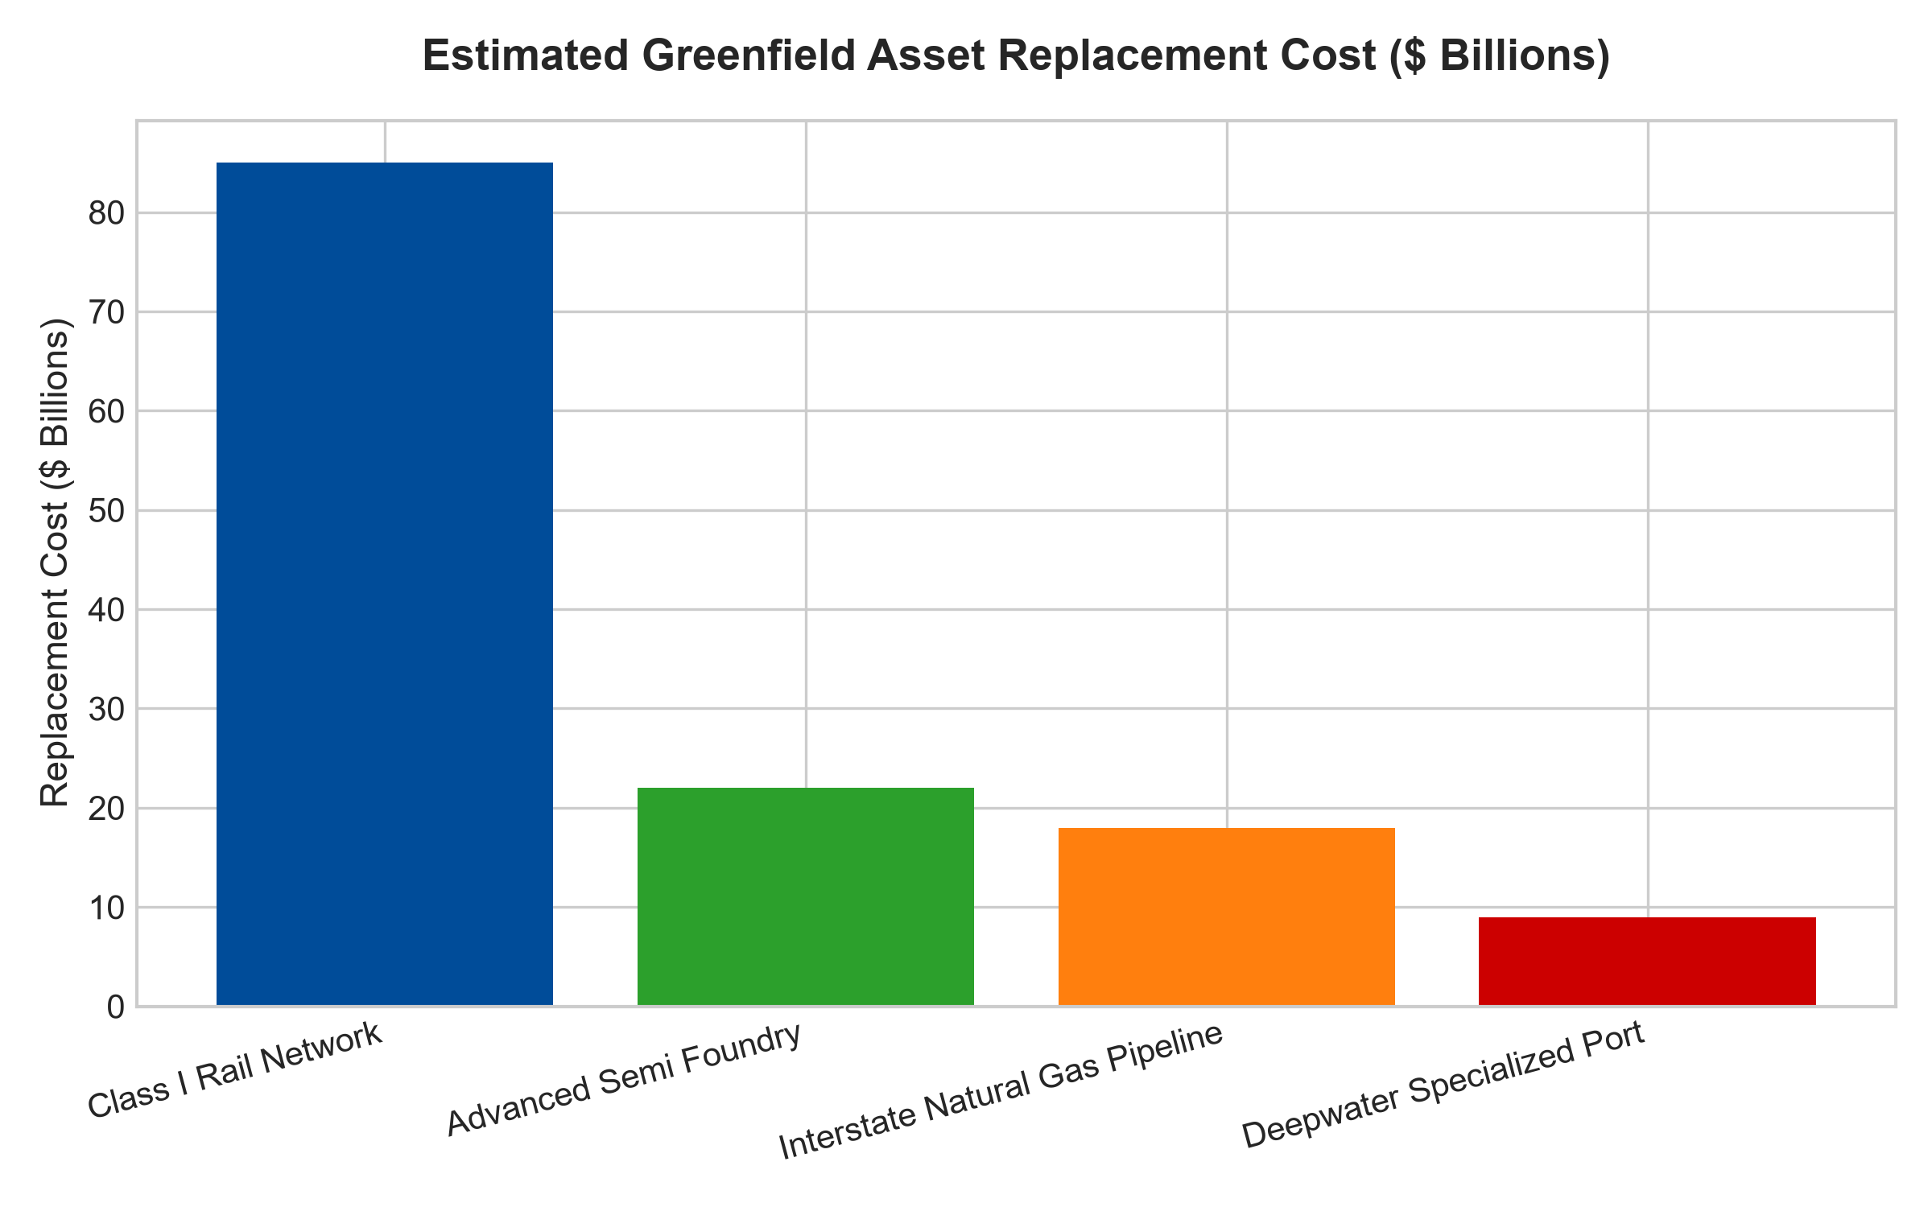
1. The Mathematics of Greenfield Replacement Cost
The primary mechanism defending capital intensive monopolies is the concept of Greenfield Replacement Cost. Consider a transcontinental Class I railroad that acquired its rights-of-way, carved through mountain ranges, and laid thousands of miles of continuous welded steel track over the course of the late nineteenth and early twentieth centuries. The historical book value recorded on the company's balance sheet reflects only a tiny fraction of its true economic replacement cost.
Attempting to assemble identical continuous rights-of-way today through eminent domain, environmental litigation, and modern urban density is legally and physically impossible. Even if permission were miraculously granted, the raw capital outlay required would exceed one hundred billion dollars. Because a new entrant cannot earn an acceptable return on that astronomical capital base, no competitor will ever build a parallel rail line. The incumbent's capital intensity has permanently extinguished all physical competition.
2. Sunk Cost Asymmetry and Pricing Deterrence
A second defensive pillar of capital intensity is the threat of sunk-cost pricing retaliation. In capital intensive infrastructure, once the initial capital expenditure is spent and the physical asset is completed, the marginal cost of running one additional freight car, pumping one additional barrel of fluid, or executing one additional batch of processing is virtually zero.
If an outside competitor were to attempt building a parallel facility, the incumbent possesses the economic capacity to drop prices to near marginal cost for years. Because the incumbent's debt has long been amortized and its asset base is fully operational, it can comfortably outlast any leveraged challenger. The mere knowledge of this sunk-cost pricing power serves as an absolute deterrent, discouraging prospective competitors from ever allocating capital toward the industry.
3. Inflation Protection and Sunk Capital Asymmetry
In periods of prolonged macroeconomic inflation, capital-intensive monopolies with historical asset bases demonstrate extraordinary financial resilience. While prospective competitors face inflated raw material costs, exorbitant contractor rates, and punishing interest rates on construction debt, the incumbent operates with fully amortized, pre-inflation assets.
Because the incumbent's depreciation expenses remain fixed to historical costs while its revenue tariffs increase alongside inflationary indices, operating margins experience structural expansion. The return on invested capital calculated on the historical asset base expands rapidly, generating immense free cash flow that can be returned to shareholders through aggressive share buybacks and growing dividend distributions.
4. MPLY and the Strategic Allocation to Hard Asset Monopolies
Many broad market indices are heavily weighted toward easily replicable consumer and software firms that trade at exorbitant multiples despite possessing low barriers to entry. When competitive dynamics intensify, their profit margins collapse rapidly.
The Strategy Shares Monopoly ETF (MPLY) adopts an active, high-conviction mandate that selectively identifies companies possessing critical, irreplaceable physical infrastructure. By concentrating capital in essential asset-heavy monopolies that control the irreplaceable arteries of modern industry, MPLY delivers institutional-grade capital protection and predictable, inflation-resistant cash flows.
Investors interested in discovering how actively managed strategies evaluate greenfield replacement costs and capital intensive moats can review the Strategy Shares Monopoly ETF (MPLY) at https://strategysharesetfs.com/mply/.
5. Frequently Asked Questions
Q1: Doesn't high capital intensity depress return on invested capital (ROIC)?
It depends on pricing power. If high capital expenditure exists in a fragmented, commoditized industry (like commercial airlines), ROIC is permanently impaired. However, when massive capital requirements lead to natural monopoly or duopoly industry consolidation (like freight railroads or specialized pipeline corridors), the incumbents exercise immense pricing power, generating superior return on invested capital and massive free cash flow.
Q2: How do capital intensive monopolies perform during high inflation environments?
They perform exceptionally well because their physical assets were constructed with historical, pre-inflation dollars. While a prospective competitor faces inflated materials and financing costs that make new construction impossible, the incumbent simply raises its user tariffs in lockstep with CPI, generating accelerating free cash flow.
6. Sources
Morningstar, Equity Research & Moat Analysis: https://www.morningstar.com/articles/moat-research
Harvard Business Review, Competitive Advantage Strategy: https://hbr.org/1979/03/how-competitive-forces-shape-strategy
#capitalintensity #EconomicMoats #InfrastructureMonopolies #QualityInvesting #MPLY

