Article 10:
What Makes a Business Difficult to Replicate?
The bedrock question of fundamental equity analysis was famously articulated by institutional capital allocators: if a well-funded syndicate were granted ten billion dollars, could they replicate and displace the incumbent business? For ninety-nine percent of publicly traded corporations, the honest answer is an emphatic yes. In consumer electronics, apparel, commercial banking, and commoditized digital software, capital and skilled engineering are plentiful. However, an elite handful of corporate enterprises operate within a realm of mathematical irreversibility: they are structurally, legally, and operationally a hard to replicate business.
What prevents an enterprise from being replicated is rarely a single isolated factor. True non-replicability is a dense, interlocking matrix of structural advantages: sovereign regulatory licenses, decades of specialized institutional reputation, physical rights-of-way, proprietary telemetry, and deep integration into global enterprise plumbing. When a competitor cannot buy, hire, or code their way into an industry, the incumbent possesses an enduring economic monopoly.
Identifying these rare, non-replicable commercial fortresses is the exact mission statement of concentrated, actively managed quality vehicles. This analytical scrutiny governs the portfolio architecture of the Strategy Shares Monopoly ETF (MPLY), which systematically rejects easily disrupted market participants in favor of unassailable monopolies.
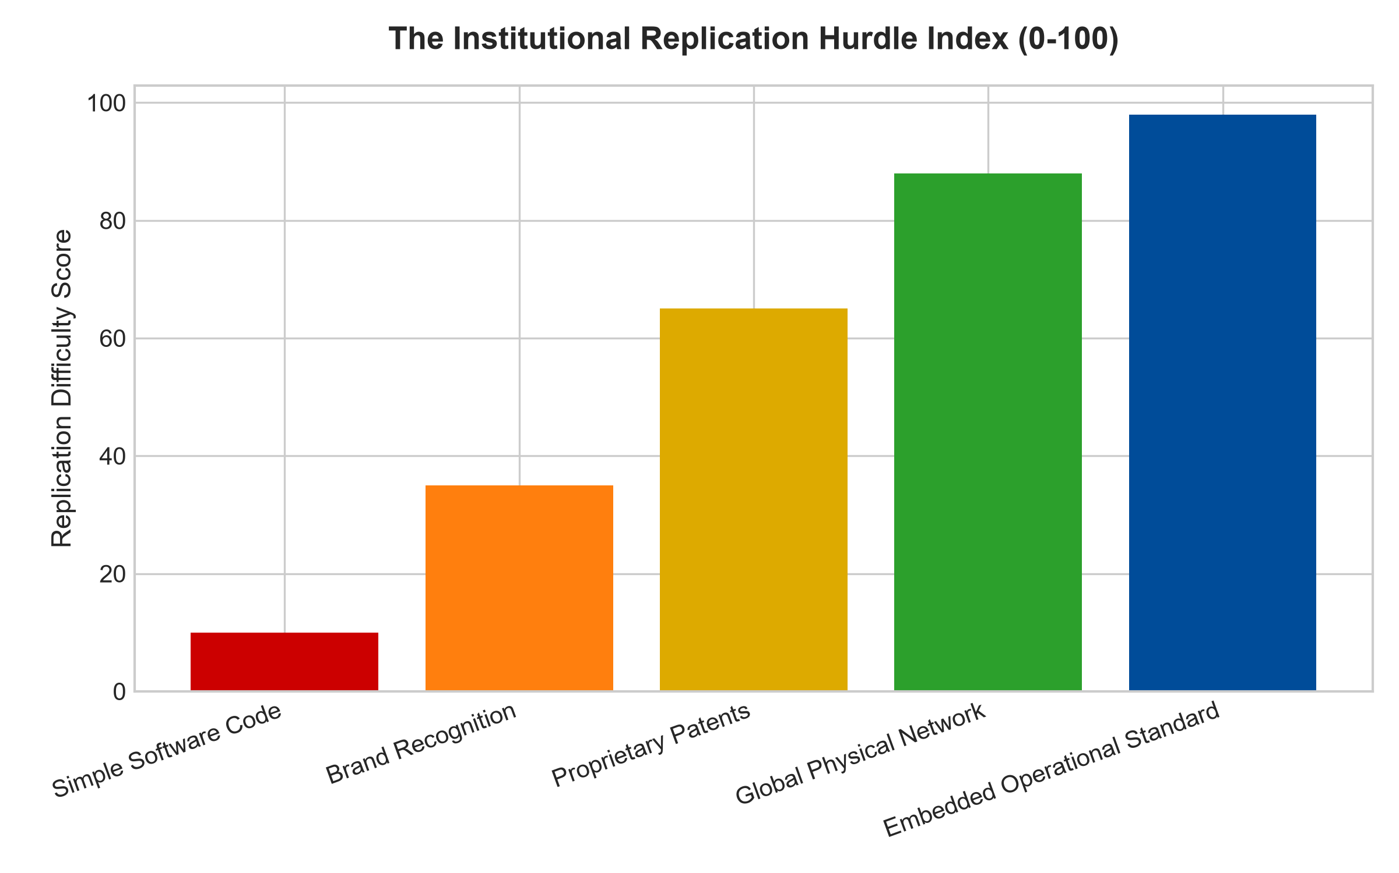
1. The Illusion of Easily Copied Software and Brands
A common trap for retail investors is assuming that a well-known brand name or modern software codebase creates a durable barrier to replication. In truth, consumer brands are subject to constant cultural shifts, and software code can be duplicated by competent engineers in months. When capital is abundant, venture syndicates routinely launch copycat startups that match product features and ignite destructive price wars.
A business becomes truly difficult to replicate only when its value proposition is anchored in physical or operational irreversibility. When an enterprise operates an international payment rail clearing trillions in transactions, a semiconductor fabrication facility with atomic-level tolerances, or an integrated global exchange managing sovereign bond liquidity, replication is impossible. The sheer complexity, systemic trust, and regulatory certifications accumulated over half a century cannot be compressed into a venture capital development sprint.
2. Institutional Trust and Systemic Criticality
Beyond physical infrastructure, the most unbreachable barrier to replication is systemic trust. In mission-critical environments, such as clinical laboratory diagnostic testing, credit rating agencies, aircraft engine manufacturing, and nuclear safety equipment, the cost of component failure is catastrophic loss of human life or multi-billion dollar bankruptcies.
Institutional procurement committees and regulatory compliance officers operate under intense risk aversion. They will never award a contract to an unproven startup offering a ten percent price discount if a failure could shutter their entire enterprise. The incumbent's decades-long track record of flawless operational execution operates as an invisible, unbuyable moat. Trust cannot be purchased with venture capital; it must be earned across decades of flawless operational history.
3. Structural Irreversibility and the Mathematical Durability of Moats
The concept of mathematical irreversibility explains why certain enterprises remain impossible to duplicate. When an enterprise combines physical rights-of-way, multi-decade regulatory approvals, and deep integration into global clearing protocols, the probability of competitive displacement collapses to near zero. A competitor with unlimited capital cannot compress fifty years of regulatory precedent, physical land assembly, and operational track record into a five-year deployment horizon.
For institutional capital allocators, businesses possessing mathematical irreversibility represent the highest tier of investment safety. They are completely decoupled from technological fashion cycles and consumer discretionary trends. By anchoring capital in enterprises that literally cannot be challenged by rival capital, investors achieve enduring capital preservation and superior risk-adjusted returns across entire market generations.
4. MPLY and the Construction of a Non-Replicable Portfolio
Passive market indices are indiscriminately packed with hundreds of easily replicable companies that suffer relentless margin decay as new challengers enter their fields. Over long horizons, this constant competitive friction dilutes shareholder returns.
The Strategy Shares Monopoly ETF (MPLY) bypasses commoditized businesses by applying an uncompromising conviction filter. By isolating market dominators whose operational ecosystems, regulatory moats, and physical assets are practically impossible to replicate, MPLY offers institutional investors a high-conviction vehicle focused on compounding generational wealth through authentic, unassailable economic monopolies.
Investors looking to understand the forensic criteria used to identify truly non-replicable businesses and durable monopoly moats can review the Strategy Shares Monopoly ETF (MPLY) at https://strategysharesetfs.com/mply/.
Ultimately, the degree of business replication difficulty determines whether an investor is purchasing a fragile trading vehicle or a generational compounding asset. In a global economy characterized by rapid capital mobility and technological copycats, businesses that lack structural friction will eventually see their excess returns competed away. Concentrated quality investing succeeds precisely because it rejects easily replicated operations, focusing solely on the rare corporate fortresses that hold irreversible market power.
5. Frequently Asked Questions
Q1: Can artificial intelligence make non-replicable businesses vulnerable to disruption?
Artificial intelligence primarily accelerates software development and digital content generation, which actually makes digital businesses easier to copy. However, AI cannot replicate physical rights-of-way, heavy industrial infrastructure, regulatory agency certifications, or institutional trust. As digital code becomes commoditized, hard physical and regulatory moats become even more valuable and non-replicable.
Q2: How does investing in non-replicable businesses protect capital during market drawdowns?
Because non-replicable businesses face no viable competitive threats, their pricing power and customer retention remain intact during recessions. Their earnings streams are insulated from price-cutting wars, providing exceptional margin stability and superior dividend safety when broader markets decline.
6. Sources
Morningstar, Equity Research & Moat Analysis: https://www.morningstar.com/articles/moat-research
Harvard Business Review, Competitive Advantage Strategy: https://hbr.org/1979/03/how-competitive-forces-shape-strategy
#hardtoreplicatebusiness #EconomicMoats #QualityInvesting #MonopolyETF #MPLY

