Article 11:
How Geographic Density Can Improve Unit Economics
In strategic corporate finance and supply chain operations, expansion is frequently mistaken for progress. Management teams routinely succumb to the temptation of broad territorial expansion, opening operations across nationwide footprints to capture headline revenue growth. However, seasoned institutional capital allocators understand that premature geographic dispersion often destroys shareholder capital. Real economic profitability and durable moat construction are governed by the ruthless mathematics of geographic density unit economics.
Geographic density occurs when an enterprise concentrates its physical distribution facilities, service technicians, retail branches, or route delivery stops within a tightly defined local perimeter before expanding into adjacent territories. By clustering assets in close proximity, the fixed overhead costs of warehousing, supervisor compensation, local media advertising, and vehicular transport are amortized across a massive volume of localized transactions.
This dynamic creates an insurmountable unit-cost advantage over national competitors who operate with thin regional footprints. The local density leader generates superior return on invested capital while charging competitive prices, forming a localized commercial monopoly. Isolating these regionally entrenched infrastructure leaders is a central operational principle of the Strategy Shares Monopoly ETF (MPLY).
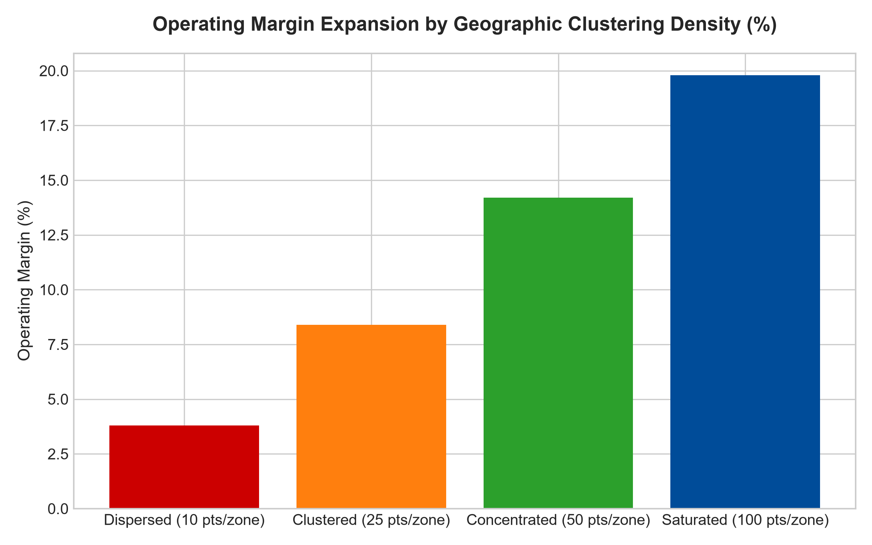
1. The Logistical Physics of Route Compression
To comprehend the power of geographic density, investors must examine the physical cost components of route fulfillment. In waste management, commercial uniform laundering, food distribution, and parcel delivery, the driver's hourly compensation and vehicular fuel are consumed primarily during transit between customer locations. Transit time produces zero revenue; revenue is generated strictly when the vehicle is stopped and actively servicing a client.
When an operator achieves extreme geographic density, transit time between customer stops collapses from thirty minutes to ninety seconds. The enterprise can service three times as many customers per work shift with a single capital asset and one employee. A national challenger attempting to enter that market with scattered accounts must traverse significant mileage between deliveries, incurring unsustainable operating losses. Density transforms physical geography into an unbreachable economic barrier.
2. Local Advertising Dominance and Brand Saturation
The economic benefits of geographic density extend far beyond logistics directly into sales and marketing efficiency. In consumer services, healthcare clinic networks, and specialized banking, advertising costs are determined by the pricing of metropolitan media markets. An enterprise with only three branches in a major metropolitan area pays the exact same regional television, radio, or billboard advertising rates as a dominant competitor with seventy-five locations.
Consequently, the dense operator amortizes its localized customer acquisition costs across an immense revenue base, driving marketing expense per customer down to negligible levels. Prospective customers experience omnipresent brand impressions, creating an intuitive perception of industry leadership and reliability. The fragmented competitor cannot match this advertising presence without destroying its operating margin, reinforcing the incumbent's local market captivity.
3. Capital Expenditure Efficiency and Warehouse Clustering
From a capital allocation perspective, geographic density unlocks massive fixed-asset leverage. A centralized fulfillment hub or specialized cold-storage facility requires tens of millions of dollars in upfront construction capital. If that facility supports fifty tightly clustered commercial client locations, the capital expenditure per revenue dollar is exceptionally low, and inventory turnover accelerates dramatically.
Furthermore, clustered footprints enable dynamic resource sharing. If one retail branch or delivery route experiences an unexpected surge in demand or equipment failure, neighboring units can reallocate inventory and personnel within minutes without incurring exorbitant freight premiums. This operational agility builds exceptional customer fulfillment reliability that geographically dispersed challengers cannot achieve.
4. Portfolio Construction and the MPLY Quality Mandate
Passive broad market indices frequently over-allocate toward sprawling, low-density retail and industrial corporations that carry immense fixed overhead costs across underperforming regional markets. When macroeconomic turbulence strikes, these un-clustered operations suffer immediate margin compression, forcing management into dilutive debt issuance or severe store closures.
The Strategy Shares Monopoly ETF (MPLY) bypasses these structural vulnerabilities through active fundamental curation. By identifying enterprises that prioritize impenetrable geographic clustering, dominant route density, and superior local unit economics, MPLY concentrates capital in highly cash-generative corporate fortresses. These businesses maintain resilient pricing power and robust operating margins across all phases of the macroeconomic cycle.
Investors interested in discovering how active portfolio management identifies regional monopolies with superior geographic unit economics can review the Strategy Shares Monopoly ETF (MPLY) at https://strategysharesetfs.com/mply/.
5. Frequently Asked Questions
Q1: How can an investor identify if a company possesses true geographic density?
Institutional analysts examine market share within specific metropolitan statistical areas (MSAs), store or route count per square mile, and regional operating profit margins compared to corporate-wide margins. High-density operators will consistently report operating margins four hundred to eight hundred basis points higher in their core clustered markets than in newly entered fringe territories.
Q2: Can technological platforms overcome an incumbent's geographic density advantage?
Technology can optimize routing algorithms, but it cannot alter the physical laws of transit time, real estate costs, and localized asset placement. In physical commerce, software must still interact with physical delivery trucks and warehouses, meaning the operator with the highest physical route density will continuously enjoy the lowest marginal delivery cost.
6. Sources
Morningstar, Supply Chain Efficiency & Economic Moats: https://www.morningstar.com/articles/moat-research
Harvard Business Review, The Hidden Power of Local Market Density: https://hbr.org/1979/03/how-competitive-forces-shape-strategy
#geographicdensity #EconomicMoats #SupplyChainMonopolies #QualityInvesting #MPLY

