Article 12:
What Is a Learning Curve Advantage in Business?
In complex technological manufacturing, aerospace engineering, biopharmaceutical formulation, and advanced semiconductor fabrication, corporate competitive advantage is rarely governed by balance sheet size alone. While capital can purchase identical assembly machinery and raw materials, it cannot purchase the accumulated institutional knowledge of ten million production iterations. This structural cost advantage, codified in industrial economics as Wright's Law, is known to fundamental equity analysts as the learning curve advantage.
A learning curve advantage dictates that for every doubling of cumulative historical production volume, the labor hours, raw material scrap rates, and engineering errors required to produce each incremental unit decline by a predictable mathematical percentage. This is distinctly different from simple static economies of scale; while scale advantages depend on the size of a business in a single fiscal year, learning curve advantages depend on the total cumulative experience accumulated since the inception of the product line.
Consequently, a first-mover that maintains aggressive production volume establishes a cumulative manufacturing gap that followers cannot close simply by spending capital. The incumbent's cost curve descends perpetually ahead of the industry, granting it superior pricing power, extraordinary gross margins, and an insurmountable economic moat. Isolating corporations that command deep learning curve advantages forms a foundational pillar of the Strategy Shares Monopoly ETF (MPLY).
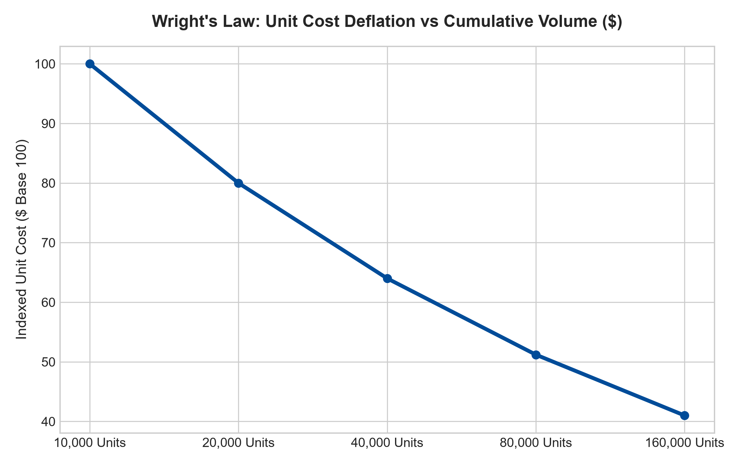
1. The Mathematical Physics of Wright's Law
First formulated by aeronautical engineer Theodore Wright in 1936, Wright's Law demonstrated that the labor cost required to assemble an airframe fell by twenty percent each time cumulative production doubled. This empirical law has since been proven across microchips, lithium-ion battery cells, surgical robotics, and commercial jet engines.
The learning curve is propelled by three compounding operational factors: workforce proficiency specialization, specialized proprietary tooling modifications, and incremental product redesign for automated manufacturability. As technicians execute repetitive assemblies hundreds of thousands of times, subtle engineering bottlenecks are systematically eliminated. A challenger entering the market with zero cumulative production must endure every historical error that the incumbent mastered a decade prior, enduring ruinous scrap rates while attempting to match the incumbent's mature market price.
2. Tacit Knowledge as an Unbuyable Intangible Asset
A critical misconception among amateur market participants is that production knowledge can be completely codified into manuals or software programs and stolen by competitors. In advanced manufacturing, the most vital components of the learning curve consist of tacit knowledge, intuitive insights, specialized metallurgical calibrations, and proprietary equipment tuning that reside solely within the collective culture of the incumbent's engineering workforce.
Even if a rival purchases identical hardware from European machine-tool suppliers, they lack the proprietary software calibration scripts and empirical yield optimization techniques developed across millions of production runs. In advanced semiconductor foundries, for example, wafer yield rates dictate commercial viability. An incumbent achieving a ninety-five percent yield operates with immense profitability, while a well-funded challenger achieving a sixty percent yield faces devastating cash burn.
3. Dynamic Pricing and the Strategic Preservation of the Moat
Elite corporate management teams leverage their learning curve advantage dynamically to permanently deter competitive capital. Rather than hoarding all cost savings as short-term operating profit, the dominant incumbent strategically reduces market prices in lockstep with its declining unit cost curve.
This dynamic pricing strategy ensures that prospective challengers are perpetually forced into a negative gross margin environment. Venture capital syndicates and private equity sponsors run discounted cash flow models and conclude that challenging the incumbent will require billions of dollars in unrecoverable learning losses before ever achieving operational breakeven. The market consolidates into a durable monopoly where the incumbent's learning curve functions as an impenetrable fortress.
4. MPLY and the Selection of Cumulative Knowledge Fortresses
Passive index funds blindly hold hundreds of undifferentiated manufacturing and assembly companies that possess zero cumulative knowledge advantage. These commoditized businesses are easily undercut by low-cost foreign manufacturers, leading to sudden profit collapses and permanent capital impairment.
The Strategy Shares Monopoly ETF (MPLY) differentiates itself by applying an active, institutional conviction mandate. MPLY selectively targets businesses that occupy the extreme frontier of Wright's Law, dominating industries where cumulative manufacturing knowledge, extreme technical yield advantages, and multi-decade engineering expertise extinguish competitive threats. This high-conviction approach delivers resilient capital protection and superior long-term compounding.
Investors looking to analyze how institutional portfolio managers identify companies possessing deep learning curve advantages and wide economic moats can review the Strategy Shares Monopoly ETF (MPLY) at https://strategysharesetfs.com/mply/.
5. Frequently Asked Questions
Q1: What is the primary difference between economies of scale and a learning curve advantage?
Economies of scale are static and depend on production volume in a single time period (e.g., spreading factory overhead over one million units this year). A learning curve advantage is dynamic and cumulative, depending on total volume produced across the entire operating history of the enterprise. Scale can be lost if demand contracts; learning advantages are permanently preserved in institutional processes.
Q2: Can a disruptive technological shift erase a learning curve advantage?
Yes, a radical paradigm shift in fundamental technology (such as transitioning from internal combustion engines to electric powertrains) can reset the cumulative learning curve back to zero. However, in mature, mission-critical engineering fields with high safety certifications, fundamental architectural resets are exceptionally rare, allowing dominant incumbents to compound their knowledge moats for decades.
6. Sources
Morningstar, Advanced Manufacturing & Economic Moat Research: https://www.morningstar.com/articles/moat-research
Harvard Business Review, Managing with the Learning Curve: https://hbr.org/1979/03/how-competitive-forces-shape-strategy
#learningcurveadvantage #EconomicMoats #WrightsLaw #QualityInvesting #MPLY

