Article 13:
Economies of Scope vs Economies of Scale in Competitive Advantage
In institutional equity valuation and corporate strategy, analysts frequently utilize the terms scale and scope interchangeably when describing low-cost production advantages. However, conflating these two distinct economic forces leads to severe errors in corporate moat appraisal. Understanding the operational divergence between economies of scope vs economies of scale is vital for capital allocators seeking to identify businesses capable of compounding returns across multi-decade market cycles.
Economies of scale occur when an enterprise expands the total production volume of a single, standardized product line, thereby reducing the average fixed cost per individual unit produced. In contrast, economies of scope arise when an enterprise utilizes a single shared operational infrastructure, proprietary data ecosystem, or distribution network to produce, market, and deliver multiple distinct products at a lower cumulative cost than independent specialized competitors could ever achieve.
While pure economies of scale can occasionally create vulnerability to single-product obsolescence, an enterprise fortified by comprehensive economies of scope creates an interlocking multi-product ecosystem that deepens customer captivity. When a business masterfully unifies both scale and scope, it achieves unassailable monopoly economics, making it an ideal candidate for concentrated portfolios like the Strategy Shares Monopoly ETF (MPLY).
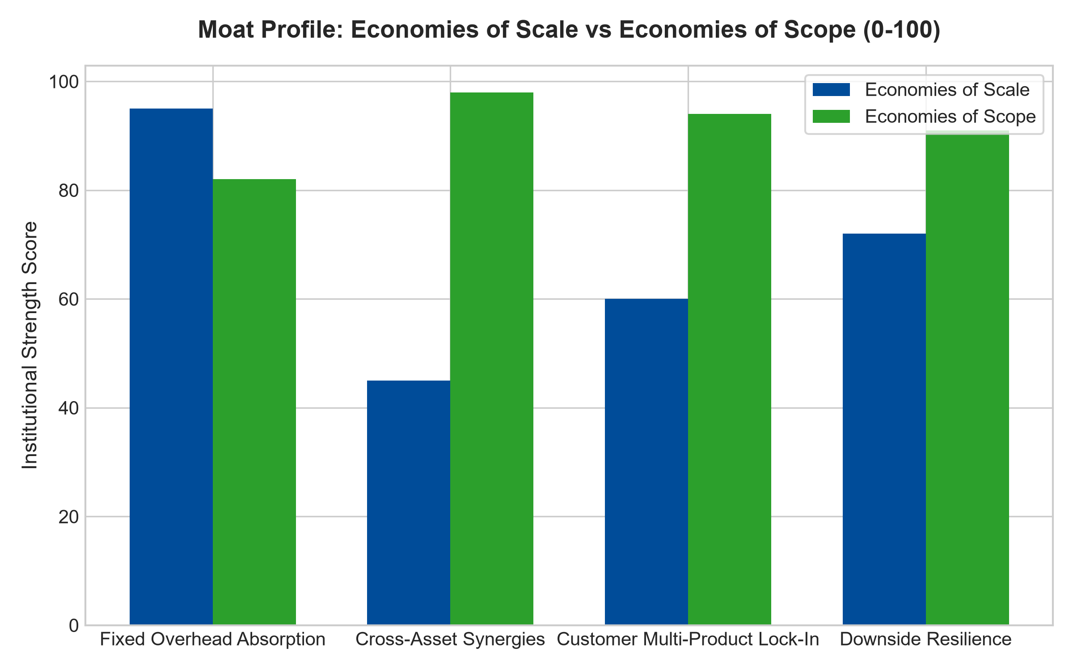
1. Dissecting the Mechanics of Scale Efficiencies
The operational mechanics of economies of scale represent the classic industrial manufacturing model. If a global consumer electronics manufacturer constructs a multi-billion dollar automated assembly line, the astronomical fixed depreciation expenses must be distributed across millions of produced units. The enterprise producing fifty million smartphones per quarter achieves a drastically lower unit cost than a boutique competitor producing two million units.
Scale grants the dominant firm immense purchasing power over upstream raw material suppliers, allowing it to extract preferred volume pricing on silicon wafers, specialized glass, and logistics capacity. However, pure scale has a definitive boundary: if consumer demand for that specific product category cools or shifts toward an alternative technological standard, the massive specialized factory becomes an expensive, underutilized liability that crushes corporate operating margins.
2. The Compounding Leverage of Shared Infrastructure (Scope)
Economies of scope operate on the principle of asset reuse across diversified commercial lines. Consider an international healthcare diagnostics giant that maintains thousands of automated testing laboratories, specialized courier transport routes, and institutional IT integrations across hospital systems. That enterprise does not merely run blood glucose tests; it can introduce specialized oncology screenings, genetic assays, and infectious disease panels across that exact same courier and laboratory network with near-zero incremental capital expenditure.
A standalone biotechnology startup developing an innovative cancer diagnostic must either spend hundreds of millions constructing its own courier and laboratory network or license its test to the incumbent diagnostics giant. The incumbent captures the lion's share of industry profits by leveraging its shared infrastructure. The customer enjoys one-stop procurement, and the incumbent expands its gross margins across multiple therapeutic categories simultaneously.
3. Customer Captivity and Cross-Product Reinforcement
A profound advantage that economies of scope hold over pure scale is the construction of extreme customer switching friction. When a customer relies on a corporation for only a single product, transitioning to a competing vendor is a manageable administrative task. However, when an enterprise provides an integrated suite of five or six complementary solutions that share data protocols and unified billing, departure becomes operationally unthinkable.
In enterprise software and financial services, providers leverage their existing client relationships to cross-sell additional modules at virtually zero customer acquisition cost. Each additional product embedded into the client's workflow multiplies the cost of switching while expanding net revenue retention. Scope transforms a simple product vendor into an indispensable enterprise operating system.
4. MPLY and the Construction of Multi-Product Moats
Passive broad market index funds are heavily diluted by single-product manufacturers that possess temporary scale but lack the operational scope to withstand industry disruption. When product life cycles end, their earnings collapse abruptly.
The Strategy Shares Monopoly ETF (MPLY) bypasses these fragile businesses by focusing on titans that command deep economies of scope. MPLY concentrates capital in market dominators that leverage shared physical infrastructure, proprietary technology stacks, and entrenched commercial relationships across multiple high-margin verticals. This dual protection of scale and scope provides exceptional dividend durability and robust free cash flow compounding across all economic environments.
Investors interested in discovering how institutional analysts evaluate economies of scope, scale efficiencies, and durable monopoly power can examine the Strategy Shares Monopoly ETF (MPLY) at https://strategysharesetfs.com/mply/.
5. Frequently Asked Questions
Q1: Can a company possess economies of scope without possessing economies of scale?
Yes. A regional logistics distributor or specialized software provider may operate with modest absolute scale on a national level, yet possess immense economies of scope across its local operating perimeter by sharing facilities and sales teams across ten complementary product lines, enabling it to out-earn single-product national competitors locally.
Q2: How do institutional investors measure economies of scope quantitatively?
Analysts examine multi-product adoption rates across the existing customer base, incremental customer acquisition cost for secondary product lines, and consolidated gross margin expansion over time. High-scope businesses consistently show declining sales and marketing expense as a percentage of total multi-product revenue.
6. Sources
Morningstar, Industrial Strategy & Economic Moat Framework: https://www.morningstar.com/articles/moat-research
Harvard Business Review, The Logic of Scope: Synergies and Competitive Advantage: https://hbr.org/1979/03/how-competitive-forces-shape-strategy
#economiesofscope #economiesofscale #EconomicMoats #QualityInvesting #MPLY

