Article 14:
Can Customer Service Be an Economic Moat?
In traditional corporate marketing brochures, executive management teams routinely claim that their commitment to exceptional customer service represents their primary competitive advantage. However, through the forensic lens of institutional equity valuation and economic moat analysis, pure customer service is almost universally dismissed as an authentic barrier to entry. Friendly customer support agents, prompt phone response times, and generous return policies can be easily duplicated by any competitor willing to hire additional personnel.
Yet, in specialized institutional markets, high-stakes industrial operations, and complex enterprise technology, customer service can occasionally transcend simple courtesy and transform into an impenetrable structural barrier. A genuine customer service economic moat exists only when the service delivery is deeply integrated into client operations, supported by proprietary diagnostic systems, and executed by highly specialized personnel that competitors cannot hire or replicate at scale.
When service becomes an irreplaceable operational dependency that guarantees mission-critical uptime for the end customer, it creates extraordinary customer captivity and durable pricing power. Identifying corporations that have converted operational support into unassailable economic toll gates is a core analytical competency of the Strategy Shares Monopoly ETF (MPLY).
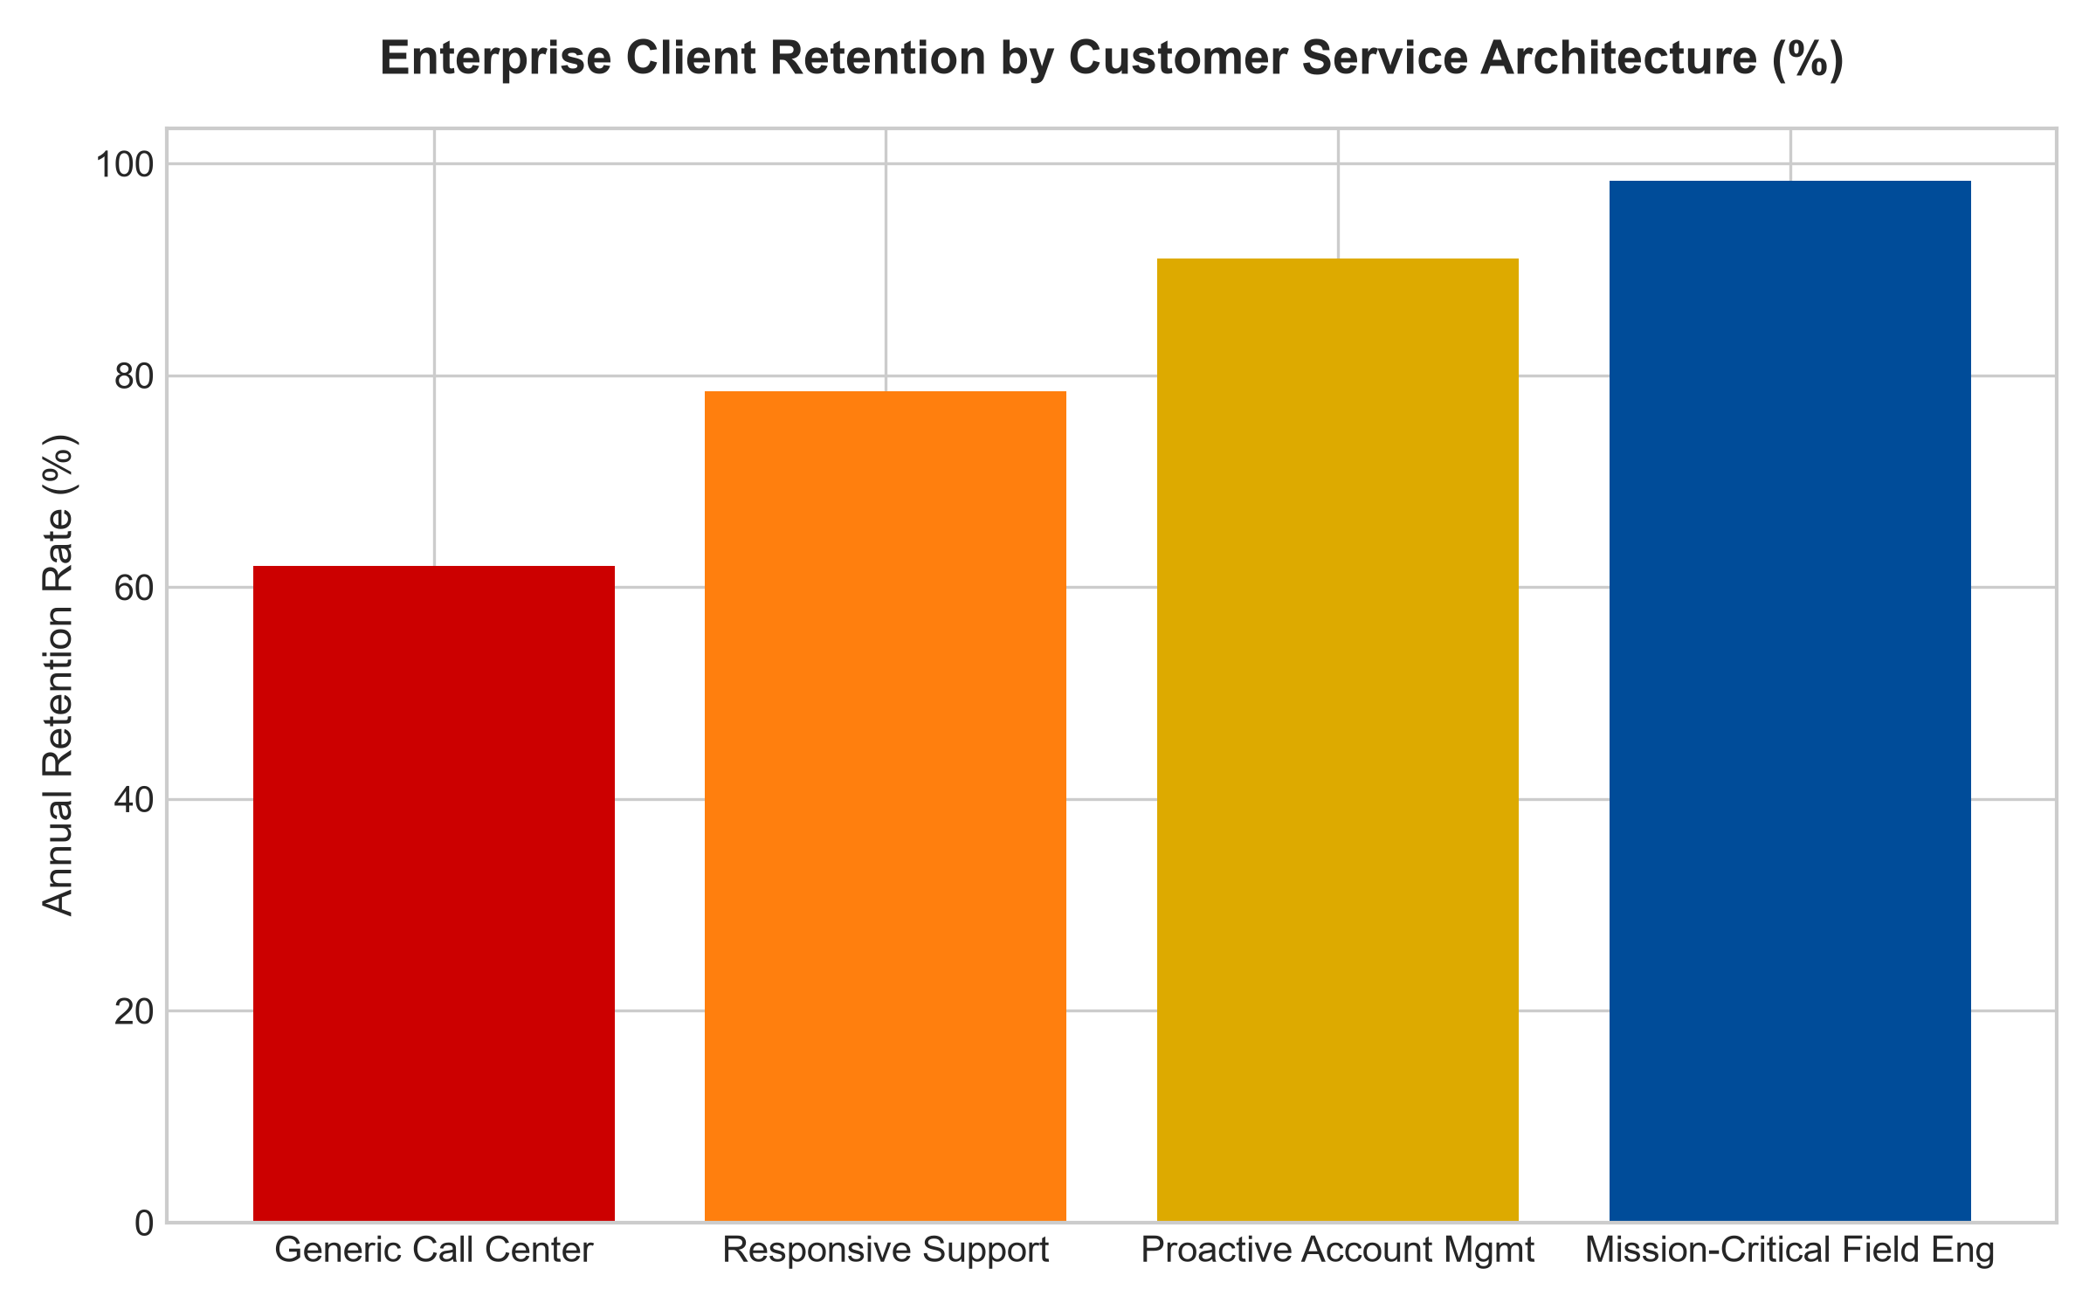
1. The Fragility of Commodity Customer Support
To understand when service becomes a moat, investors must first recognize why standard customer service fails to protect capital. In consumer retail, hospitality, and basic consumer electronics, service quality is highly perishable and subject to human inconsistency. A boutique hotel or direct-to-consumer brand may develop a stellar reputation for customer service, yet that advantage produces zero structural switching friction.
A customer who enjoys excellent service from an airline or retail outlet can seamlessly defect to a competitor the following week if that rival offers a twenty percent price discount. Because the customer incurs zero operational downtime or financial risk by leaving, the service provided acts as a temporary brand preference rather than a fortified economic moat. The business must constantly re-earn its customer base, permanently depressing long-term return on invested capital.
2. Operational Integration and Mission-Critical Field Support
Conversely, a customer service moat emerges when the service architecture operates as a mission-critical utility. Consider a specialized semiconductor manufacturing plant where an unexpected machinery breakdown halts millions of dollars in production every hour. The equipment manufacturer maintains dedicated, highly cleared field engineers stationed on-site twenty-four hours a day, armed with proprietary diagnostic algorithms and bespoke replacement components.
In this operating environment, customer service is not a customer support hotline; it is an irreplaceable insurance policy against catastrophic operational failure. A competing hardware provider cannot displace the incumbent merely by offering a cheaper machine. The client's chief operating officer will not risk multi-million dollar factory shutdowns on an unproven support infrastructure. The incumbent's specialized service network creates an unyielding lock on client operations, enabling it to command premium service contract margins year after year.
3. High Human Capital Barriers and Institutional Trust
The defensibility of an institutional customer service moat is heavily anchored in human capital specialization and regulatory clearance. In sectors such as aerospace avionics, nuclear power facility maintenance, and specialized clinical laboratory operations, field service technicians require multi-year apprenticeships, specialized security clearances, and statutory certifications.
A venture-backed challenger cannot simply allocate capital and recruit these specialized personnel overnight. Furthermore, institutional procurement committees operate under intense professional risk aversion. Entrusting mission-critical infrastructure to an incumbent with a twenty-year track record of flawless emergency response is the only defensible corporate decision. This accumulated institutional trust transforms operational service into a durable monopoly asset.
4. MPLY and the Search for Operationally Embedded Dominance
Passive market index funds are filled with consumer-facing companies whose perceived service advantages evaporate the moment low-cost foreign competitors enter their markets. Over long horizons, these fragile businesses suffer severe margin compression and dividend cuts.
The Strategy Shares Monopoly ETF (MPLY) adopts an active, high-conviction approach that seeks out businesses whose service capabilities are structurally, mathematically enforceable. By targeting enterprises where specialized field service, proprietary diagnostics, and mission-critical support create deep customer captivity, MPLY captures resilient, inflation-protected cash flows that compound reliably across all economic environments.
Investors interested in discovering how actively managed quality strategies identify companies with deep operational integration and durable monopoly moats can review the Strategy Shares Monopoly ETF (MPLY) at https://strategysharesetfs.com/mply/.
5. Frequently Asked Questions
Q1: Can customer service ever create an economic moat in consumer-facing industries?
It is exceptionally rare. A consumer-facing company can achieve an economic moat through service only if that service is systematically tied to a proprietary membership model or technological ecosystem that introduces meaningful financial or operational switching costs (such as enterprise membership clubs or integrated digital hardware-software ecosystems).
Q2: What quantitative metrics confirm the presence of a customer service moat?
Institutional analysts look for annual service contract renewal rates exceeding ninety-five percent, multi-year maintenance agreement backlogs, and service gross profit margins exceeding fifty percent. When an enterprise can raise service contract prices ahead of inflation while maintaining near-zero client attrition, a true service moat is present.
6. Sources
Morningstar, Capital Goods & Service Moat Analysis: https://www.morningstar.com/articles/moat-research
Harvard Business Review, The Truth About Customer Experience and Moats: https://hbr.org/1979/03/how-competitive-forces-shape-strategy
#customerservicemoat #EconomicMoats #QualityInvesting #MissionCriticalSupport #MPLY

