Article 15:
How Ecosystems Create Competitive Advantage
In the modern economic landscape, the competitive unit of analysis has fundamentally shifted. For decades, traditional corporate strategy evaluated market competition through the narrow lens of discrete product-versus-product battles: one automaker versus another, or one software application versus a competing software tool. Today, institutional investors recognize that individual products are inherently vulnerable to technological disruption. True commercial defensibility and generational wealth compounding are achieved by commanding a business ecosystem competitive advantage.
A business ecosystem is an interconnected network of physical devices, software applications, cloud services, third-party developers, and proprietary marketplaces that function cohesively to deliver compound utility to the end user. In an authentic ecosystem, each incremental product or service adopted amplifies the value of every existing product already owned. This dynamic creates an exponential expansion in user utility while raising switching barriers to insurmountable levels.
A customer trapped within a multi-product ecosystem cannot simply defect to a competitor offering a superior standalone product; to leave, they must dismantle their entire personal or enterprise digital infrastructure. This structural captivity produces predictable, toll-like recurring cash flows that form the cornerstone of the high-conviction portfolio within the Strategy Shares Monopoly ETF (MPLY).
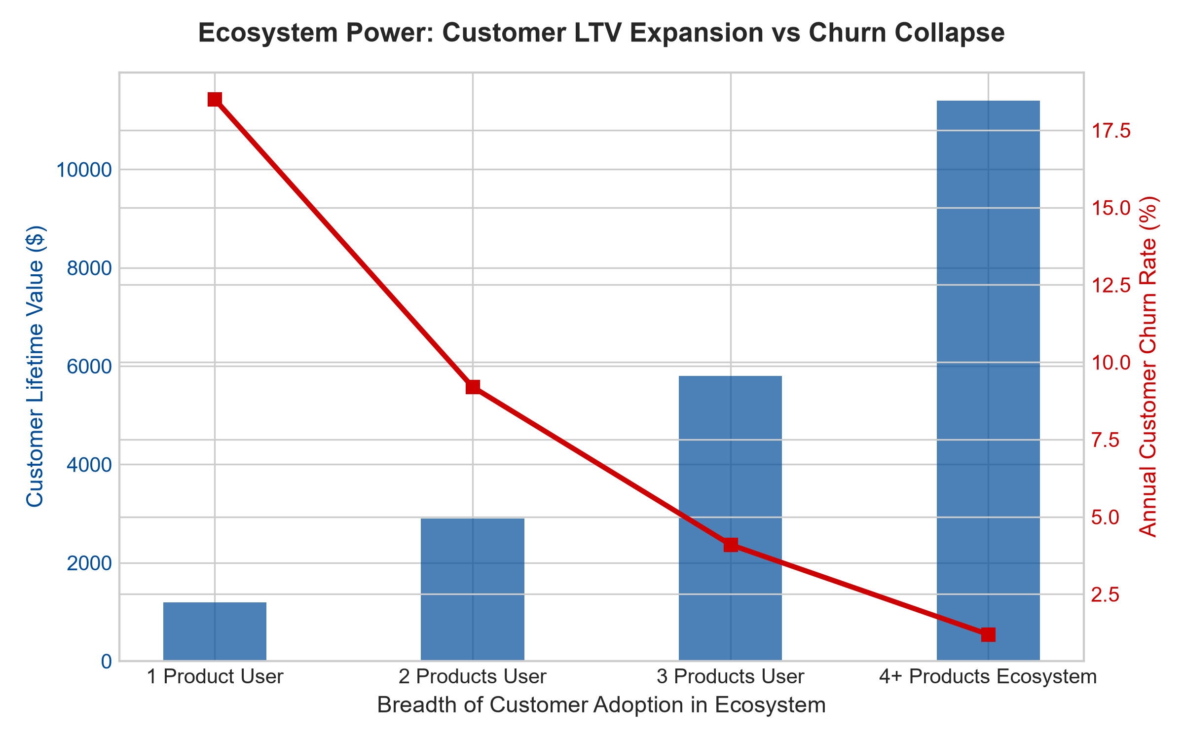
1. The Self-Reinforcing Flywheel of Multi-Product Integration
The operational core of an ecosystem advantage is the self-reinforcing integration flywheel. Consider a dominant global technology platform that provides hardware devices, proprietary operating systems, cloud synchronization, and centralized application stores. When a customer purchases their first hardware device, they represent modest enterprise value and carry standard churn risk.
However, as that customer stores their personal data in the proprietary cloud, purchases specialized applications, and links complementary wearable hardware and media subscriptions, the friction of departure increases exponentially. Defecting to a rival operating system means abandoning purchased software licenses, enduring painful data migration hurdles, and severing hardware compatibility across peripheral devices. The user remains captive because the aggregate ecosystem value vastly exceeds the marginal benefit of any individual rival gadget.
2. Third-Party Developer Gravity and Capital-Light Expansion
A profound superpower of an established business ecosystem is its ability to enlist third-party capital to enrich the platform. Once an ecosystem achieves dominant market reach, independent software developers, accessory manufacturers, and service providers are economically compelled to build exclusively for that platform.
These third-party participants invest billions of dollars of their own risk capital developing innovative applications, peripheral accessories, and complementary services that enhance the platform's overall customer utility. The ecosystem orchestrator takes zero developmental risk, yet collects a toll-like commission on every transaction processed across its digital rails. This capital-light expansion accelerates return on invested capital to astronomical levels, reinforcing an unbreachable commercial monopoly.
3. Asymmetric Customer Acquisition and Monetization Velocity
From a unit economics perspective, an ecosystem titan possesses an unbeatable structural advantage over single-product startups in customer acquisition cost (CAC). While a specialized startup must spend vast marketing budgets acquiring each individual user via paid digital advertising, the ecosystem incumbent markets new products directly to its captive, embedded user base for free.
Furthermore, the incumbent can afford to subsidize an emerging service line or bundle it into an existing membership package, instantly matching or exceeding the feature set of specialized startups. The standalone competitor finds itself competing against a free or heavily discounted feature within an all-encompassing ecosystem, suffocating its cash flow before it can ever achieve operational scale. The ecosystem incumbent captures the industry profit pool virtually unopposed.
4. MPLY and the Curation of Undisputed Ecosystem Monopolies
Passive broad market index funds are indiscriminate, holding hundreds of vulnerable single-feature software and commodity manufacturing companies that are routinely crushed when dominant ecosystem titans expand into their product categories. Over multi-year horizons, this structural vulnerability drags down passive index returns.
The Strategy Shares Monopoly ETF (MPLY) bypasses these fragile businesses by adopting an active, high-conviction mandate. MPLY selectively allocates capital toward the undisputed orchestrators of global corporate and consumer ecosystems. These entrenched platforms command vast multi-product captivity, pricing power, and toll-like cash flows, delivering exceptional capital preservation and dependable long-term growth across all economic environments.
Investors interested in discovering how actively managed strategies evaluate business ecosystems, multi-product captivity, and monopolistic economic moats can review the Strategy Shares Monopoly ETF (MPLY) at https://strategysharesetfs.com/mply/.
From a valuation and capital allocation perspective, business ecosystem dominators enjoy structurally lower costs of capital and elevated free cash flow conversion multiples. Because their revenues are diversified across dozens of software and hardware monetization touchpoints, unexpected weakness in any single consumer vertical is comfortably offset by expansion across enterprise cloud and developer licensing divisions. Institutional portfolio managers view these platforms as premier wealth compounders that can self-fund innovation without diluting shareholders.
5. Frequently Asked Questions
Q1: How do institutional investors measure the depth of a business ecosystem?
Key metrics include multi-product adoption velocity, average products held per active account, and churn rate sensitivity relative to product count. In dominant ecosystems, clients utilizing four or more integrated products consistently exhibit annual churn rates below two percent and lifetime values five to ten times greater than single-product users.
Q2: Are business ecosystems vulnerable to regulatory antitrust intervention?
Antitrust scrutiny is an inherent reality for dominant ecosystems. However, because ecosystems generate immense consumer convenience and lower aggregate transaction costs, regulatory interventions historically result in minor behavioral fines or targeted interface adjustments rather than the structural dismantlement of the underlying commercial platform, leaving the core economic moat fully intact.
6. Sources
Morningstar, Technology Platforms & Ecosystem Moat Valuation: https://www.morningstar.com/articles/moat-research
Harvard Business Review, Pipelines, Platforms, and the New Rules of Strategy: https://hbr.org/1979/03/how-competitive-forces-shape-strategy
#businessecosystem #EconomicMoats #PlatformMonopolies #QualityInvesting #MPLY

