Article 16:
What Is a Platform Moat?
In modern equity valuation and digital industrial economics, business models are broadly divided into two architectural paradigms: linear pipeline businesses and multi-sided platforms. Linear businesses operate on a traditional assembly sequence: they purchase raw inventory, add internal labor and technological value, and sell finished products to downstream buyers. While linear companies can build impressive brand moats or scale advantages, they remain permanently exposed to inventory risk, supply chain bottlenecks, and volatile production costs. In contrast, an enterprise fortified by a platform moat operates as a decentralized commercial toll booth, orchestrating transactions between independent market participants while assuming zero inventory risk.
A platform moat is constructed when a central orchestrator creates a digital or physical protocol that facilitates exchange, interaction, or commerce between two or more distinct user groups: consumers, enterprise buyers, software developers, and merchant sellers. The primary economic engine of a platform is not internal manufacturing prowess, but network coordination. As participants on one side of the platform expand, the value of the platform to participants on the other side expands exponentially.
Once a platform crosses critical institutional liquidity mass, competition becomes mathematically unviable. The platform extracts a frictionless, highly profitable take-rate on every dollar of gross merchandise volume processed across its architecture. Isolating these high-margin, capital-light platform dominators is an essential quantitative discipline of the Strategy Shares Monopoly ETF (MPLY).
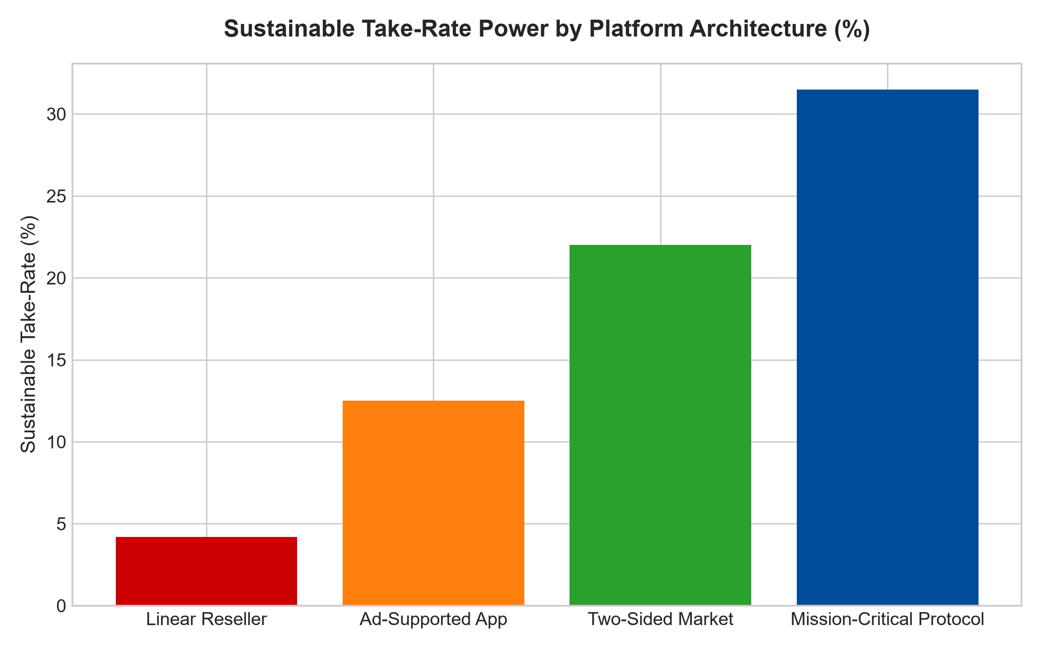
1. The Self-Reinforcing Liquidity Flywheel
The operational engine defending a platform moat is liquidity density. Consider a global financial exchange, a centralized commercial auction platform, or an international digital app store. Buyers assemble on the platform solely because that is where the deepest pool of sellers and listings resides. Conversely, sellers willingly pay listing fees and transaction commissions solely because that is where the aggregate global liquidity of prospective buyers is concentrated.
A prospective challenger attempting to compete with the platform faces the classic cold-start paradox: buyers will not join a market that lacks listings, and sellers will not post inventory on a platform devoid of buyers. Even if a challenger offers zero transaction fees and superior user software interfaces, they cannot overcome the sheer gravity of existing market liquidity. The incumbent platform commands an insurmountable coordination monopoly.
2. High Operating Leverage and Capital-Light Compounding
From a corporate finance perspective, a platform moat delivers extraordinary return on invested capital because it completely decouples top-line transaction volume from internal capital expenditures. In a linear manufacturing company, expanding sales by five hundred percent requires constructing massive new factories, purchasing fleets of delivery vehicles, and borrowing hundreds of millions in working capital.
In an elite digital or transactional platform, processing ten million daily transactions requires virtually the same core software code, database architecture, and executive management team as processing two million transactions. Incremental gross margins routinely exceed eighty-five percent. Free cash flow conversion approaches perfection, allowing the platform to return vast capital to shareholders through compounding dividends and opportunistic share repurchases.
3. Take-Rate Pricing Power and Ecosystem Captivity
The ultimate proof of a platform moat is the durability of its take-rate, the percentage cut of total gross merchandise volume that the orchestrator retains as pure revenue. Fragile, commoditized platforms that offer only basic matching services suffer from disintermediation: users connect once on the platform and subsequently execute transactions off-platform to bypass commissions.
A wide-moat platform completely prevents disintermediation by embedding essential, irreplaceable services into the transaction flow. By providing automated escrow clearing, regulatory compliance certification, proprietary fraud protection algorithms, and integrated insurance underwriting, the platform ensures that participants cannot afford to step outside the walled garden. The take-rate is perceived not as a friction tax, but as an indispensable operational insurance premium, allowing the incumbent to raise take-rates incrementally without provoking customer attrition.
4. MPLY and the Curation of Toll-Booth Monopolies
Passive broad market index funds are excessively exposed to capital-heavy linear businesses that struggle with inventory obsolescence, raw material inflation, and low return on equity. Over long macroeconomic horizons, these cyclical entities dilute shareholder returns.
The Strategy Shares Monopoly ETF (MPLY) applies an active, high-conviction screening methodology that isolates the premier platform toll booths of global commerce. By allocating capital toward businesses that command captive transaction rails, zero inventory liability, and immense operating leverage, MPLY captures defensive, all-weather cash flows backed by real, mission-critical economic utility.
Investors interested in discovering how actively managed strategies isolate dominant platform moats and unassailable economic toll booths can examine the Strategy Shares Monopoly ETF (MPLY) at https://strategysharesetfs.com/mply/.
5. Frequently Asked Questions
Q1: What is the primary difference between a network effect and a platform moat?
A network effect is the underlying economic dynamic (where a product becomes more valuable as user count grows). A platform moat is the complete commercial architecture (including multi-sided market infrastructure, embedded proprietary services, payment rails, and take-rate governance) that monetizes and defends that network effect over multi-decade horizons.
Q2: How do platform moats perform during macroeconomic inflationary periods?
Platform moats are natural inflation hedges. Because their revenue is earned as a percentage take-rate of total transacted gross merchandise volume, when the prices of underlying goods and services increase with inflation, the platform's revenue automatically compounds higher without requiring any incremental capital expenditure or inventory investment.
6. Sources
Morningstar, Digital Platforms & Economic Moat Methodology: https://www.morningstar.com/articles/moat-research
Harvard Business Review, Pipeliens to Platforms: Surviving the Shift: https://hbr.org/1979/03/how-competitive-forces-shape-strategy
#platformmoat #EconomicMoats #NetworkEffects #QualityInvesting #MPLY

