Article 17:
How Cross-Selling Can Deepen Customer Relationships
In the evaluation of corporate growth strategies, market observers frequently fixate on headline new customer acquisition metrics. Corporate earnings calls frequently highlight gross new logo additions while paying lip service to existing account penetration. However, seasoned institutional capital allocators recognize that aggressive new customer acquisition is often the least efficient way to compound enterprise value. Real compounding durability and impenetrable economic moat construction are driven by a cross selling competitive advantage.
A structural cross-selling advantage is not simply an aggressive sales department attempting to bundle unrelated products onto an invoice. Authentic cross-selling occurs when an enterprise leverages an existing, highly trusted operational relationship to introduce complementary modules, services, or workflow solutions that solve adjacent client pain points. Because the master service agreement, legal terms, vendor payment infrastructure, and data integrations are already established, the marginal customer acquisition cost of the secondary product collapses to near zero.
As a client embeds four, five, or six integrated solutions from a single corporate vendor, the cost and operational risk of departing multiplies exponentially. The client becomes structurally captive, driving net revenue retention well beyond one hundred and twenty percent. Isolating enterprises that leverage disciplined cross-selling to cement corporate dominance is a core operational focus of the Strategy Shares Monopoly ETF (MPLY).
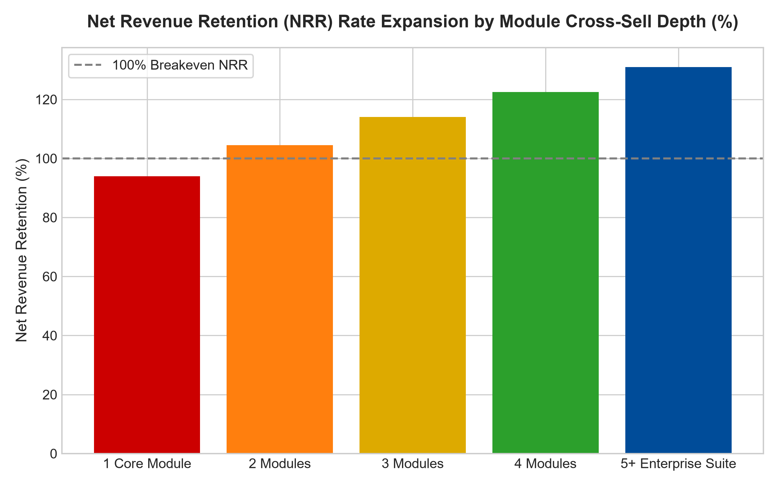
1. The Economics of the Vanishing Acquisition Cost
To comprehend the financial power of cross-selling, investors must analyze the customer acquisition cost (CAC) equation. For a standalone software or industrial vendor, acquiring an enterprise client requires a nine-to-twelve month corporate sales cycle, substantial executive dinners, multi-thousand dollar proof-of-concept trials, and heavy legal compliance negotiations. The initial customer acquisition cost often consumes the first two to three years of client gross profit.
Conversely, an incumbent vendor that already provides the client's core database or primary accounting system can introduce an adjacent analytics or cybersecurity module with a simple digital addendum. The sales cycle collapses from twelve months to forty-eight hours, and the customer acquisition cost is functionally zero. Every dollar of incremental cross-sold revenue flows directly into operating income, producing astronomical incremental return on invested capital that standalone competitors cannot survive against.
2. Operational Workflow Weaving and Customer Captivity
Beyond raw financial efficiency, cross-selling transforms a simple commercial vendor into an indispensable enterprise nervous system. When a corporate client purchases only a payroll software application, migrating to a cheaper competitor is an inconvenient but manageable transition. The payroll department can run parallel systems for two weeks and execute the switch with minimal operational trauma.
However, when that same corporate client purchases payroll, employee health benefits administration, corporate expense management, enterprise identity access, and internal communication tooling from that identical provider, departure is completely impossible. The data fields across those modules are inextricably interwoven. Replacing the vendor would require ripping out five core administrative departments simultaneously, introducing massive operational failure risk. The customer remains permanently captive, granting the vendor pristine multi-decade pricing power.
3. Organic Growth Decoupled from Macroeconomic Cycles
A profound benefit of commanding a cross selling competitive advantage is the resulting independence from broad macroeconomic market cycles. In periods of economic contraction, prospective corporate clients freeze new vendor onboardings and slash software trial budgets. Pure new-customer acquisition engines grind to a painful halt, triggering brutal revenue misses and margin collapse.
In stark contrast, an enterprise with a deep cross-selling architecture generates consistent organic revenue growth simply by mining its existing, captive customer directory. Because existing clients are actively seeking to eliminate fragmented vendors and reduce administrative vendor overhead, the dominant incumbent can offer bundled consolidation packages that expand aggregate account revenue while saving the client money. Net revenue retention remains firmly above one hundred and ten percent, shielding shareholder cash flows during severe downturns.
4. MPLY and the Curation of Multi-Product Fortresses
Passive market index funds are indiscriminate, holding hundreds of fragile point-solution vendors that sell a single narrow feature. Over long market horizons, these narrow vendors are routinely crushed or commoditized when comprehensive platform titans introduce competing cross-sell modules.
The Strategy Shares Monopoly ETF (MPLY) bypasses these fragile single-product companies through active fundamental scrutiny. By targeting enterprises that possess extensive multi-product enterprise suites, high cross-sell adoption velocities, and industry-leading net retention rates, MPLY concentrates capital in highly defensive corporate fortresses. These businesses generate predictable, recession-proof cash flows that support sustained long-term capital compounding.
Investors seeking to explore how actively managed quality strategies identify companies with deep cross-selling moats and superior customer captivity can review the Strategy Shares Monopoly ETF (MPLY) at https://strategysharesetfs.com/mply/.
5. Frequently Asked Questions
Q1: What quantitative metrics best demonstrate a successful cross-selling strategy?
Institutional analysts prioritize Net Revenue Retention (NRR), average modules utilized per enterprise account, and cross-sell customer acquisition cost payback period. Elite cross-sellers consistently report NRR rates exceeding one hundred and twenty percent alongside a steady year-over-year increase in accounts utilizing four or more distinct product categories.
Q2: How does cross-selling protect corporate gross profit margins during an inflation spike?
When an enterprise provides a consolidated multi-product suite, it can introduce contractual price adjustments distributed across several discrete product lines rather than imposing a single jarring price hike on a single product. Clients view the overall suite value as indispensable and absorb the adjustments without triggering account cancellation.
6. Sources
Morningstar, Enterprise Software & Switching Costs Valuation: https://www.morningstar.com/articles/moat-research
Harvard Business Review, The Discipline of Enterprise Cross-Selling: https://hbr.org/1979/03/how-competitive-forces-shape-strategy
#crossselling #EconomicMoats #CustomerCaptivity #QualityInvesting #MPLY

