Article 18:
What Is a Local Monopoly? Examples and Investor Considerations
When retail market participants and political commentators hear the word monopoly, their imaginations naturally conjure images of sprawling global technology conglomerates or international energy cartels dominating headlines across Washington and Brussels. However, seasoned institutional equity investors recognize that some of the most lucrative, recession-resilient, and durable competitive moats in global commerce operate entirely below the national radar. These commercial fortresses are classified in fundamental equity research as a local monopoly.
A local monopoly occurs when an enterprise commands absolute market share and pricing power within a tightly circumscribed geographic zone, typically due to extreme physical transport costs, restrictive municipal permitting ordinances, or strict geological asset scarcity. Across a five, ten, or thirty-mile operational perimeter, the local incumbent faces zero viable competition. Customers located within that perimeter have no rational economic alternative other than transacting directly with the incumbent on the incumbent's terms.
Because freight logistics make importing competing heavy materials or municipal services from outside the zone economically impossible, the local monopolist enjoys immense pricing power and superior EBITDA margins without attracting federal antitrust intervention. Isolating these unassailable geographic fortresses forms an indispensable pillar of the quality curation process behind the Strategy Shares Monopoly ETF (MPLY).
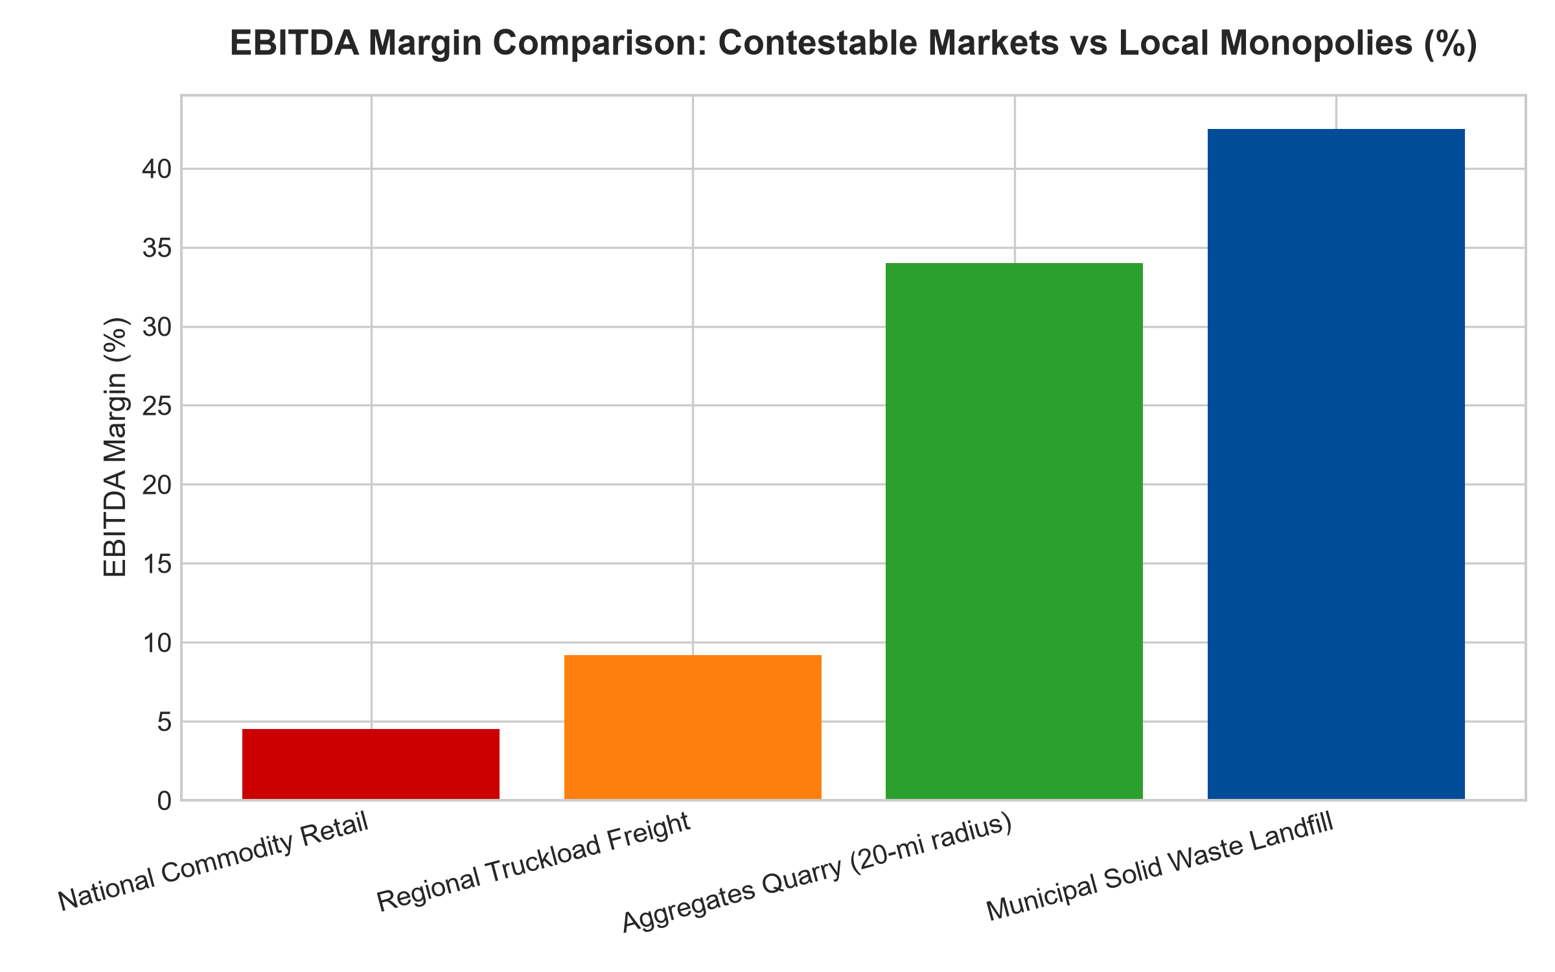
1. The Economics of Heavy Bulk Materials (The 25-Mile Rule)
The classic industrial manifestation of a local monopoly is found in aggregates quarrying: the mining and crushing of crushed stone, gravel, and sand essential for road building, bridges, and commercial concrete construction. Aggregates are heavy, low-value-to-weight bulk materials. The cost of transporting a ton of crushed stone via dump truck increases rapidly with every additional road mile traversed.
Beyond a transport radius of approximately twenty to thirty miles, the logistics freight cost of hauling stone exceeds the original production value of the material itself. Consequently, a quarry operator that holds the only permitted crushed-stone deposit within a specific metropolitan corridor possesses an absolute geographic monopoly over every highway, hospital, and commercial development constructed within that zone. A competitor located fifty miles away cannot undercut the incumbent's pricing, because the trucking freight penalty makes their delivered stone prohibitively expensive.
2. Permitting Scarcity and NIMBY Regulatory Fortresses
A second vital defensive barrier sustaining local monopolies is the insurmountable hurdle of municipal regulatory permitting. In municipal solid waste landfills, concrete batching plants, specialized scrap metal recycling centers, and asphalt processing plants, local zoning boards strictly restrict new facility approvals.
Due to intense Not-In-My-Backyard (NIMBY) political sentiment from surrounding suburban homeowners, securing environmental permits and municipal zoning authorization to establish a new commercial landfill or quarry can take two to three decades, if it is approved at all. The incumbent's existing, grandfathered operational permit functions as an irreplaceable, legally sanctioned economic asset. Capital cannot replicate it, venture funds cannot disrupt it, and local municipalities must pay the incumbent's non-negotiable disposal tipping fees year after year.
3. Exceptional Free Cash Flow and Pricing Autonomy
From a corporate valuation perspective, local monopolies generate corporate financial statements that resemble regulated municipal utilities, yet operate without statutory return caps. Because the cost of aggregates or waste disposal is typically a minor fraction of a contractor's overall multi-million dollar construction budget, price elasticity of demand is exceptionally low.
The local monopolist can institute annual price hikes of eight to twelve percent without triggering volume loss. Contractors will grumble, but they cannot halt a fifty-million dollar bridge project over a marginal increase in crushed-rock prices. Operating margins compound into the high thirties, generating pristine, all-weather free cash flow that management can deploy into acquiring neighboring local monopolies or distributing as growing dividends.
4. MPLY and the Strategic Aggregation of Local Toll Roads
Passive market index funds are overwhelmingly weighted toward hyper-competitive, nationally exposed consumer and digital companies that engage in brutal price-cutting wars every day. These contestable businesses carry substantial downside volatility during economic contractions.
The Strategy Shares Monopoly ETF (MPLY) bypasses commoditized markets by seeking out businesses that have methodically rolled up hundreds of local geographic monopolies into a unified corporate structure. By investing in dominant operators of local quarries, permitted waste corridors, and geographically captive industrial hubs, MPLY captures defensive, inflation-protected cash flows that are mathematically immune to technological obsolescence.
Investors interested in discovering how institutional analysts identify local monopolies, permitting moats, and durable physical cash flows can examine the Strategy Shares Monopoly ETF (MPLY) at https://strategysharesetfs.com/mply/.
5. Frequently Asked Questions
Q1: How do local monopolies avoid federal antitrust regulatory intervention?
Federal regulatory bodies like the FTC and DOJ historically focus their scrutiny on national market concentration and nationwide market share metrics. Because a local quarry or municipal landfill operator commands a tiny fraction of national aggregate production, it rarely triggers federal antitrust thresholds, even though it exercises absolute monopolistic pricing power within its twenty-mile local perimeter.
Q2: What is the primary operational risk to a local monopoly?
The primary risk is severe, localized population or infrastructure disinvestment. If construction activity completely halts within a specific metropolitan zone, quarry and concrete demand will temporarily decline. However, maintenance of existing roads and municipal infrastructure guarantees a solid baseline of non-discretionary cash flow even during regional downturns.
6. Sources
Morningstar, Building Materials & Environmental Services Moat Valuation: https://www.morningstar.com/articles/moat-research
Harvard Business Review, The Anatomy of Local Market Monopolies: https://hbr.org/1979/03/how-competitive-forces-shape-strategy
#localmonopoly #EconomicMoats #AggregatesMoat #QualityInvesting #MPLY

