Article 19:
Licensing Advantages as a Barrier to Competition
In the competitive marketplace, an entrepreneur with sufficient venture capital, talent, and computational power can challenge almost any standard commercial enterprise. They can design an attractive consumer product, deploy paid digital marketing campaigns, and construct automated fulfillment centers. However, there exists an elite category of commerce where capital, talent, and technology are utterly powerless without a sovereign stamp of governmental approval. In these specialized sectors, a statutory licensing barrier to entry establishes a legal moat that mathematically outlaws unlicensed competition.
A licensing moat is not merely a common local business registration. True licensing advantages occur when a sovereign regulatory authority restricts the total number of operational licenses issued within a jurisdiction, creates an multi-year administrative gauntlet requiring hundreds of millions of dollars in unrecoverable compliance testing, or mandates exclusive operating concessions over public infrastructure.
When the state effectively caps the number of market participants by law, the licensed incumbents operate as legally protected oligopolies or sanctioned monopolies. They extract consistent economic rents and exercise pricing power completely free from the threat of venture-backed market saturation. Identifying corporations that hold irreplaceable statutory licenses forms a vital investment thesis for the Strategy Shares Monopoly ETF (MPLY).
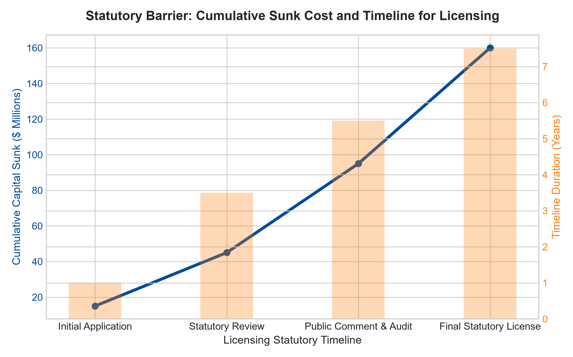
1. The Power of Numerically Capped State Charters
The most potent manifestation of a licensing advantage occurs when the governing authority establishes a numerical cap on the total licenses permitted to exist. Consider commercial gaming casinos, specialized financial exchange clearinghouses, sovereign credit rating agencies, or interstate commercial utility transmission corridors.
If a state government establishes that only four commercial casino licenses will ever be granted within a metropolitan jurisdiction, a prospective competitor cannot enter the market regardless of how luxurious a resort they propose to build. The physical asset without the state charter is commercially worthless. The four licensed incumbents divide the multi-billion dollar metropolitan market among themselves in an unbreachable oligopoly, insulating their cash flows and return on invested capital from competitive dilution.
2. The Multi-Year Sunk Cost Gauntlet
In industries where licenses are theoretically open to new applicants, such as advanced nuclear facility operation, commercial avionics certification, and clinical pharmaceutical manufacturing, the licensing process is intentionally designed as an endurance test of regulatory capital. Navigating safety verifications, environmental impact statements, public utility commission reviews, and statutory audits routinely requires five to eight years and over one hundred and fifty million dollars in unrecoverable expenditures.
A venture syndicate underwriting a prospective challenger faces an untenable financial proposition: spending tens of millions of dollars over seven years with zero guarantee that regulatory approval will ever be awarded at the end of the process. This severe regulatory uncertainty acts as an insurmountable deterrent, suffocating prospective competitive capital before it can ever reach the market. The licensed incumbent enjoys complete commercial serenity behind its legal barricades.
3. Concessions and Long-Duration Infrastructure Monopolies
Another vital dimension of licensing advantages is the long-duration exclusive concession. Municipal and national governments routinely grant exclusive thirty, fifty, or ninety-nine year operating licenses to private consortia to manage commercial toll roads, international airports, deepwater container ports, and municipal water utilities.
Under these statutory concession agreements, the private operator is legally granted the exclusive right to collect user tolls across that infrastructure corridor, with contractual inflation-linked rate escalators embedded into statutory law. Competing parallel toll roads or airports are legally prohibited. The concessionaire holds an unbreachable economic monopoly whose cash flow predictability mirrors sovereign debt, yet generates equity-like returns.
4. MPLY and the Strategic Selection of Legally Protected Monopolies
Passive market indices are heavily weighted toward easily contestable technology and consumer manufacturing firms that can be disrupted by upstarts overnight. When competition intensifies, their operating margins collapse.
The Strategy Shares Monopoly ETF (MPLY) differentiates itself by selectively identifying businesses that hold irreplaceable state licenses, sovereign charters, and exclusive infrastructure concessions. By concentrating capital in corporations that enjoy legal barriers to entry backed by government authority, MPLY delivers institutional-grade capital protection and reliable, inflation-resistant dividend generation across all market environments.
Investors seeking to explore how actively managed strategies evaluate statutory licensing barriers and sovereign concessions can review the Strategy Shares Monopoly ETF (MPLY) at https://strategysharesetfs.com/mply/.
In corporate finance and equity research, statutory licensing advantages represent the ultimate barrier against technological disruption. Even the most aggressive venture-backed artificial intelligence or automation platforms cannot legally deploy services into restricted sectors without obtaining state approval. The licensed incumbent operates with complete regulatory certainty, allowing management to deploy capital into long-term infrastructure improvements and consistent shareholder dividend increases with total peace of mind.
5. Frequently Asked Questions
Q1: Can a government abruptly revoke a company's statutory operating license?
In developed, rule-of-law jurisdictions with strong constitutional property rights protections, arbitrary license revocation is virtually non-existent without catastrophic criminal misconduct. Furthermore, because licensed incumbents provide essential public utilities and generate vital tax revenues, governments operate in de facto administrative alignment with the incumbent.
Q2: How do licensing barriers protect investors during stagflation?
Many statutory licenses and infrastructure concessions feature explicit legal CPI escalators, permitting the incumbent to raise user tariffs in lockstep with national inflation without risking customer attrition, preserving real economic returns when other corporate profits contract.
6. Sources
Morningstar, Regulated Industries & Legal Moat Analysis: https://www.morningstar.com/articles/moat-research
Harvard Business Review, The Political Economy of Competitive Moats: https://hbr.org/1979/03/how-competitive-forces-shape-strategy
#licensingbarrier #EconomicMoats #RegulatedMonopolies #QualityInvesting #MPLY

