Article 20:
How Scarce Infrastructure Can Create Monopoly-Like Economics
In macroeconomics and institutional capital allocation, investors frequently search for businesses capable of generating high cash returns regardless of which technological innovations prevail or which political party holds power. While software algorithms and digital consumer applications capture speculative market attention, they remain perpetually susceptible to rapid obsolescence. In stark contrast, an enterprise anchored by a scarce infrastructure monopoly controls physical assets so geographically vital and commercially irreplaceable that modern civilization cannot function without them.
A scarce infrastructure monopoly is established when an enterprise controls an exclusive physical corridor of commerce: a transcontinental freight railroad, an interstate natural gas pipeline network, a deepwater maritime port terminal, or a regulated high-voltage electrical transmission grid. These physical assets were assembled over decades, benefiting from historical land grants, continuous rights-of-way, and environmental approvals that can never be replicated in the modern era.
Because building a parallel rail corridor or duplicate pipeline through dense urban centers and protected environmental preserves is physically, legally, and financially impossible, the incumbent infrastructure operator holds an absolute commercial toll gate. It extracts predictable, non-discretionary user tariffs on every ton of grain, barrel of energy, or kilowatt of electricity moving across its rails. Isolating these irreplaceable hard-asset fortresses is the definitive mandate of the Strategy Shares Monopoly ETF (MPLY).
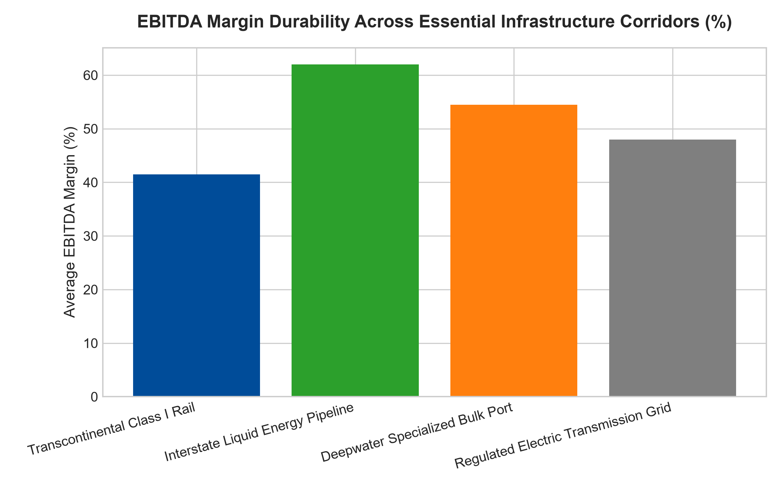
1. The Impossibility of Physical Rights-of-Way Duplication
To comprehend the absolute permanence of a scarce infrastructure monopoly, one must examine the legal and physical reality of continuous rights-of-way. Consider a Class I transcontinental freight railroad whose network of steel tracks cuts through mountain passes, bridges major rivers, and directly enters the industrial cores of every major metropolitan harbor in North America.
Attempting to assemble a competing continuous right-of-way today would require negotiating with tens of thousands of private landowners, navigating decades of environmental lawsuits under the National Environmental Policy Act, and securing thousands of municipal permits. The legal opposition alone would consume a generation. Even if sovereign approval were miraculously obtained, the construction cost would exceed one hundred billion dollars, resulting in a disastrous return on invested capital. The existing railroad network is mathematically permanent; it faces zero physical competition.
2. Extreme Operating Leverage and Toll-Booth Economics
Once a scarce infrastructure corridor is fully constructed and operational, its financial dynamics transform into a perpetual cash machine. The overwhelming majority of operating expenses are fixed: track maintenance, pipeline cathodic corrosion monitoring, and basic facility oversight.
Consequently, every incremental freight car attached to a train or every incremental barrel pumped through a pipeline flows almost entirely into operating profit. Operating margins routinely exceed fifty percent. Because shippers have no alternative mode of transport capable of matching the bulk freight efficiency of rail or pipeline (hauling bulk commodities via highway trucks is four to five times more expensive per ton-mile), the infrastructure operator exercises immense pricing autonomy, passing through fuel and labor inflation with effortless precision.
3. Inflation Immunity and Real Asset Compounding
During protracted periods of macroeconomic inflation, traditional manufacturing and service corporations suffer severe margin compression as their input and labor costs surge while customer price resistance stiffens. Scarce physical infrastructure assets, by contrast, act as premier inflation fortresses.
Because their physical assets were assembled with historical, pre-inflation dollars, their depreciation expenses remain anchored to the past while their contractual tariff rates increase alongside CPI indices. The real replacement cost of their asset base inflates higher every year, permanently locking out prospective challengers while expanding the incumbent's intrinsic enterprise value. The asset functions as a perpetual inflation-protected annuity that compounds shareholder capital across entire generations.
4. MPLY and the Allocation to Essential Real Monopolies
Passive broad market index funds are excessively exposed to commoditized businesses with low physical barriers to entry that can be easily undercut or displaced by disruptive technology. These holdings experience severe earnings volatility during economic downturns.
The Strategy Shares Monopoly ETF (MPLY) bypasses commoditized businesses by applying an active, high-conviction screening methodology. MPLY concentrates capital in companies that own and operate the indispensable physical infrastructure of modern commerce. By targeting businesses that control irreplaceable commercial corridors, pricing power, and non-discretionary cash flows, MPLY delivers institutional-grade capital protection and dependable, long-term wealth compounding across all market environments.
Investors interested in discovering how active portfolio management evaluates scarce physical infrastructure and monopolistic economic moats can examine the Strategy Shares Monopoly ETF (MPLY) at https://strategysharesetfs.com/mply/.
5. Frequently Asked Questions
Q1: How do scarce infrastructure monopolies perform during broad economic recessions?
While cyclical industrial shipment volumes may experience minor contractions during a recession, the vast majority of goods transported across critical infrastructure (such as grain, municipal water, coal for baseload power, and heating energy) are non-discretionary essentials. Shippers must move these materials to survive, ensuring that the infrastructure operator maintains healthy cash flows and uninterrupted dividend distributions even during severe downturns.
Q2: Are scarce infrastructure monopolies at risk from technological obsolescence?
Physical transport of atoms is fundamentally governed by the laws of physics. While digital software can be easily replaced by new software, software cannot transport fifty thousand tons of grain across the Rocky Mountains or pump millions of barrels of refined fuels to major metropolitan centers. Physical infrastructure corridors remain the most technologically immune assets in capitalism.
6. Sources
Morningstar, Infrastructure & Transportation Moat Valuation: https://www.morningstar.com/articles/moat-research
Harvard Business Review, The Enduring Power of Hard Infrastructure Moats: https://hbr.org/1979/03/how-competitive-forces-shape-strategy
#scarceinfrastructure #EconomicMoats #InfrastructureMonopolies #QualityInvesting #MPLY

