Article 21:
What Is a Protected Market and How Does It Work?
In neoclassical economic textbooks, markets are assumed to be open arenas where capital flows frictionlessly, prices clear competitively, and abnormal profits are swiftly eroded by new entrants. However, institutional equity investors operating in real-world capital markets understand that the greatest fortunes in financial history are rarely built in open, contestable markets. Real long-term compounding and unshakeable margin stability are found inside a protected market.
A protected market is a commercial environment where legal statutes, sovereign regulatory mandates, astronomical capital requirements, or national security restrictions structurally prevent outside competitors from participating. In an open market, an incumbent must fight daily price wars against low-cost foreign producers and venture-backed challengers. In a protected market, the law, geography, or national policy guarantees that only a tiny, pre-approved syndicate of licensed operators may conduct business.
Because entry is legally or physically impossible, the licensed incumbents enjoy complete pricing autonomy, contractual cash flow predictability, and extraordinary return on invested capital. Identifying corporations that operate behind sovereign legal and statutory protections is a central pillar of the active quality strategy executed by the Strategy Shares Monopoly ETF (MPLY).
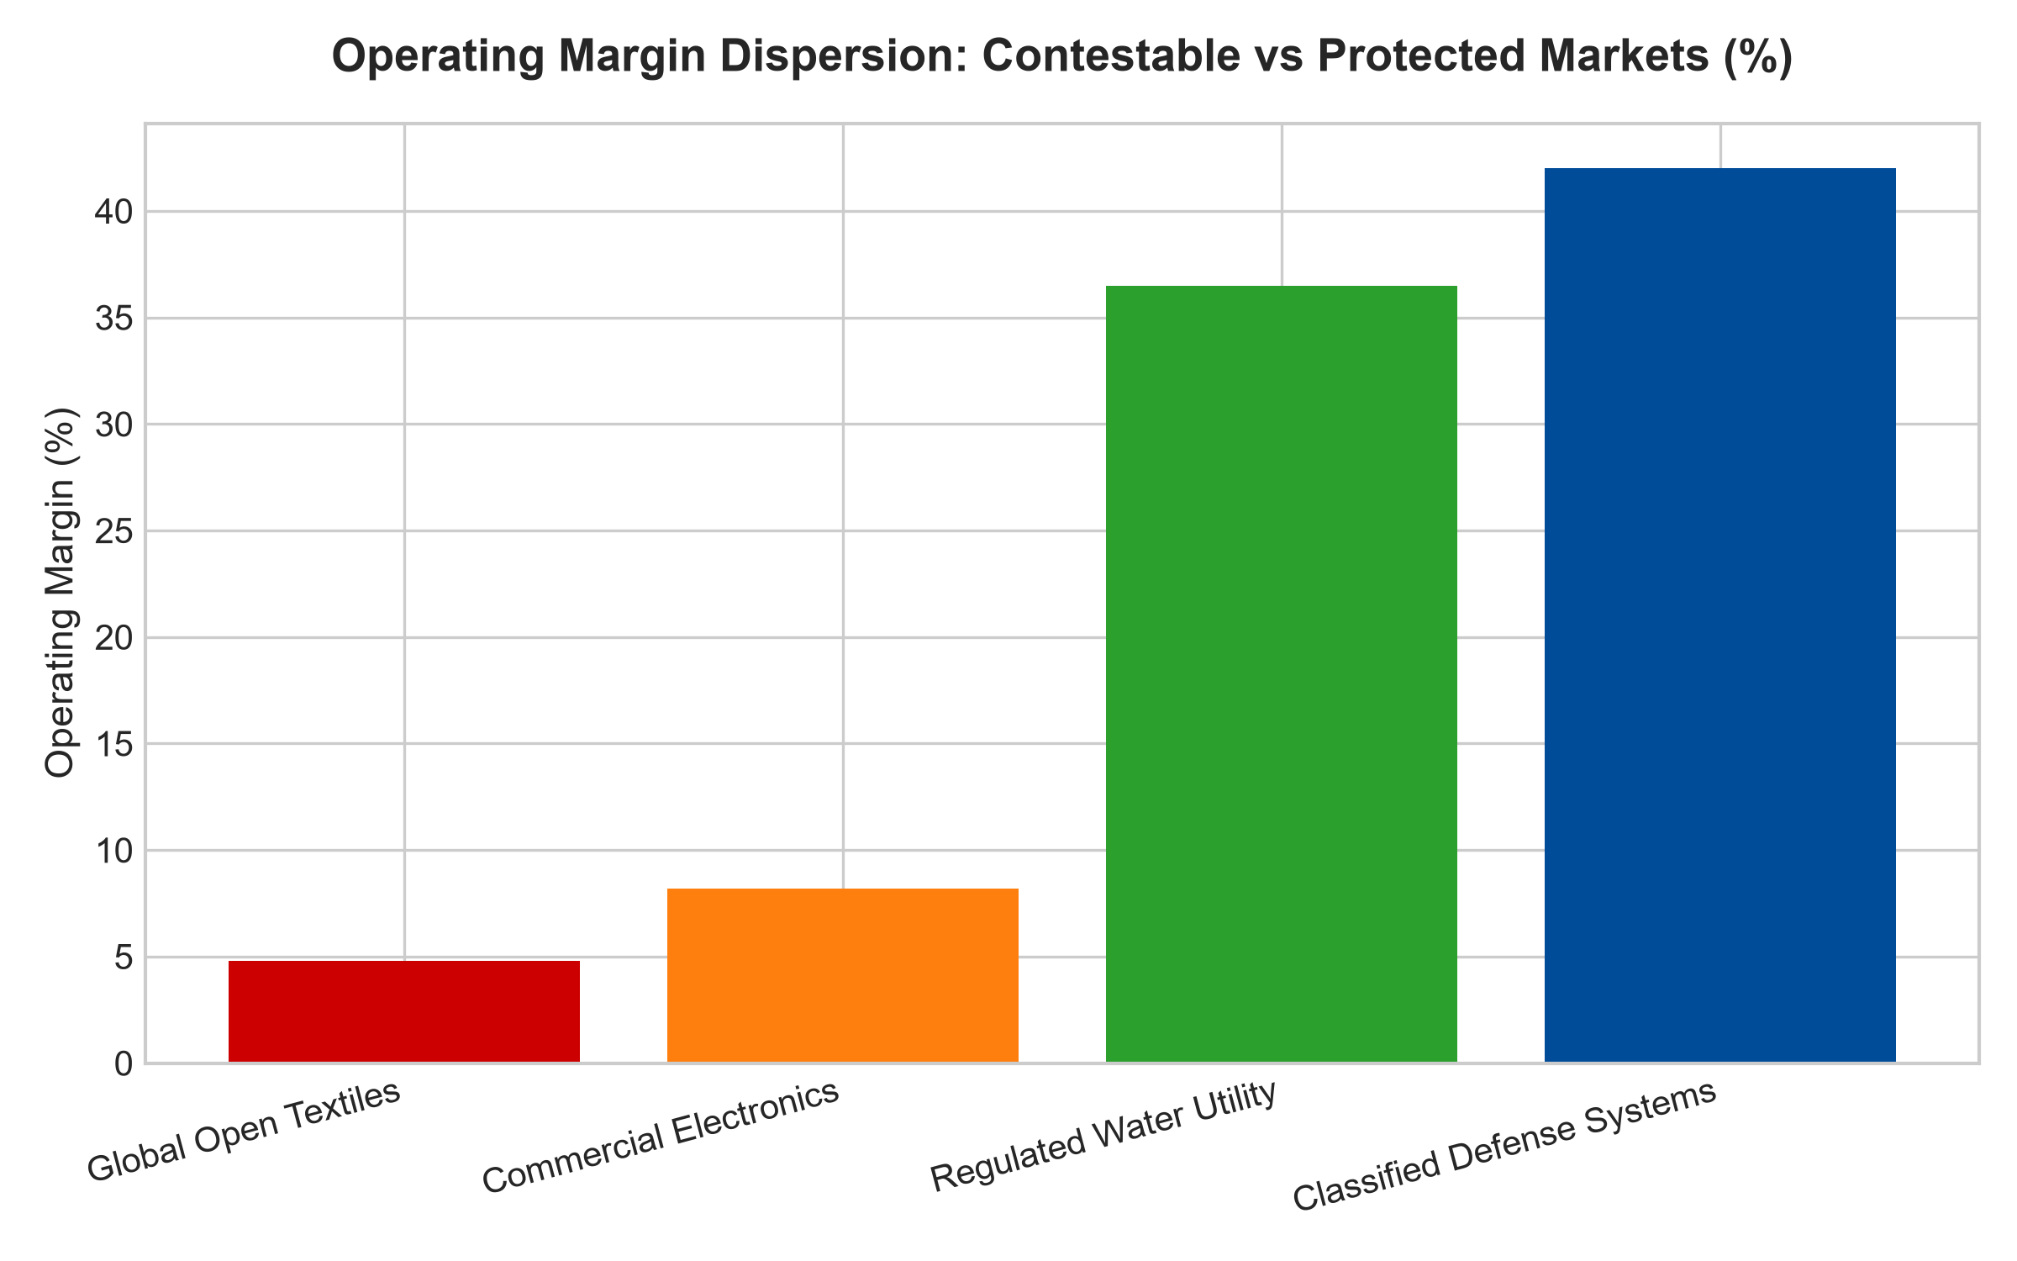
1. The Statutory Architecture of Protected Commerce
The most absolute form of a protected market is created by sovereign legislation. Consider national cabotage laws, specialized defense contracting regulations, and sovereign pharmaceutical patent exclusivity. Under federal maritime statutes such as the Jones Act in the United States, all commercial waterborne cargo transported between domestic ports must be carried on vessels built, owned, and flagged by domestic operators. Foreign maritime conglomerates with massive fleets and low-cost labor are legally prohibited from competing.
Consequently, domestic shipping operators within this corridor operate within a totally protected market. They are completely insulated from international rate wars, allowing them to establish pricing structures that guarantee healthy operating margins across every phase of the macroeconomic cycle. The statutory framework converts what would otherwise be a commoditized freight business into an unbreachable economic monopoly.
2. Security Clearances and the Classified Perimeter
In aerospace, intelligence surveillance, and advanced defense hardware, market protection is reinforced by national security classifications and institutional vetting. Developing next-generation radar systems or nuclear submarine propulsion architectures requires top-secret facility clearances, specialized engineering personnel, and decades of audited compliance track record.
A commercial software giant or venture-backed robotics startup cannot simply bid on classified defense programs, regardless of technological brilliance. The sovereign government will not entrust national survival to unproven commercial vendors. The incumbent defense contractors operate in a de facto protected market where cost-plus contracts, long-term procurement visibility, and guaranteed profit margins eliminate standard business failure risk.
3. Macroeconomic Inelasticity and Pricing Autonomy
From a corporate valuation standpoint, enterprises operating within protected markets trade at premium multiples because their cash flows exhibit near-zero price elasticity. In municipal water utilities or specialized hazardous waste disposal corridors, customers have zero legal or practical ability to substitute alternative providers.
When inflation accelerates, the protected operator passes through increased operating costs via contractual rate adjustments or regulated tariff escalators with zero threat of customer defection. The business does not need to engage in defensive discounting or expensive brand marketing to defend its market share. Cash flows compound with utility-like predictability, delivering pristine balance sheet strength across all economic cycles.
4. MPLY and the Strategic Selection of Protected Fortresses
Passive market index funds are heavily concentrated in highly vulnerable, open consumer tech and retail corporations that can be disrupted by foreign competitors or rapid cultural shifts overnight. When macroeconomic pressures mount, these contestable businesses suffer brutal margin compression.
The Strategy Shares Monopoly ETF (MPLY) differentiates itself by selectively identifying businesses that operate within legally, physically, and statutorily protected markets. By concentrating capital in corporations that enjoy legal barriers to entry and sovereign insulation from competition, MPLY delivers institutional-grade capital preservation and dependable, multi-decade cash flow compounding.
Investors interested in discovering how actively managed strategies evaluate protected markets and statutory barriers to entry can examine the Strategy Shares Monopoly ETF (MPLY) at https://strategysharesetfs.com/mply/.
From an institutional portfolio allocation perspective, protected markets provide unmatched downside insulation during systemic liquidity panics. Because these enterprises operate under statutory mandates or sovereign security charters, their contractual revenues remain immune to private-sector capital expenditure freezes. Debt markets treat their senior bonds with near-sovereign confidence, granting them access to low-cost financing to fund ongoing infrastructure modernizations regardless of prevailing macroeconomic tightness.
5. Frequently Asked Questions
Q1: What is the primary difference between a protected market and a natural monopoly?
A natural monopoly arises from physical and capital economics (such as a freight rail corridor where building a second parallel track is economically irrational). A protected market is established primarily through legal, statutory, or regulatory barriers (such as national security clearances, government charters, or legislative cabotage restrictions).
Q2: How do protected markets perform during severe economic downturns?
They demonstrate exceptional resilience. Because the goods and services provided within protected markets are almost universally essential public utilities, critical defense systems, or legally mandated infrastructure, government agencies and captive customers continue funding contractual obligations without interruption.
6. Sources
Morningstar, Regulated Industries & Protected Moat Valuation: https://www.morningstar.com/articles/moat-research
Harvard Business Review, The Political Economy of Competitive Strategy: https://hbr.org/1979/03/how-competitive-forces-shape-strategy
#protectedmarket #EconomicMoats #RegulatedMonopolies #QualityInvesting #MPLY

