Article 22:
How Standards Can Create Competitive Lock-In
In technological architecture, global telecommunications, industrial engineering, and corporate software development, competitive supremacy is often achieved not by selling the most popular gadget, but by defining the invisible rules of interoperability. When an enterprise establishes its proprietary protocol, file format, or technical specification as the undisputed industry standard, it constructs an unassailable standards competitive advantage. Competitors find themselves forced to design products that conform to the incumbent's rules, while paying licensing tolls on every unit sold.
A standards-based moat is uniquely powerful because it operates through collective coordination friction. Once an entire global ecosystem of engineers, enterprise clients, hardware manufacturers, and regulatory bodies aligns around a specific technical architecture, departing from that architecture requires universal consensus. An individual corporation cannot simply adopt an alternative standard; doing so would immediately sever compatibility with suppliers, customers, and regulatory compliance networks.
This dynamic transforms a proprietary standard into a perpetual economic toll road. The standard owner captures frictionless licensing royalties and impenetrable customer retention without assuming inventory or manufacturing risk. Isolating companies that control de facto global industry standards is a foundational quantitative principle of the Strategy Shares Monopoly ETF (MPLY).
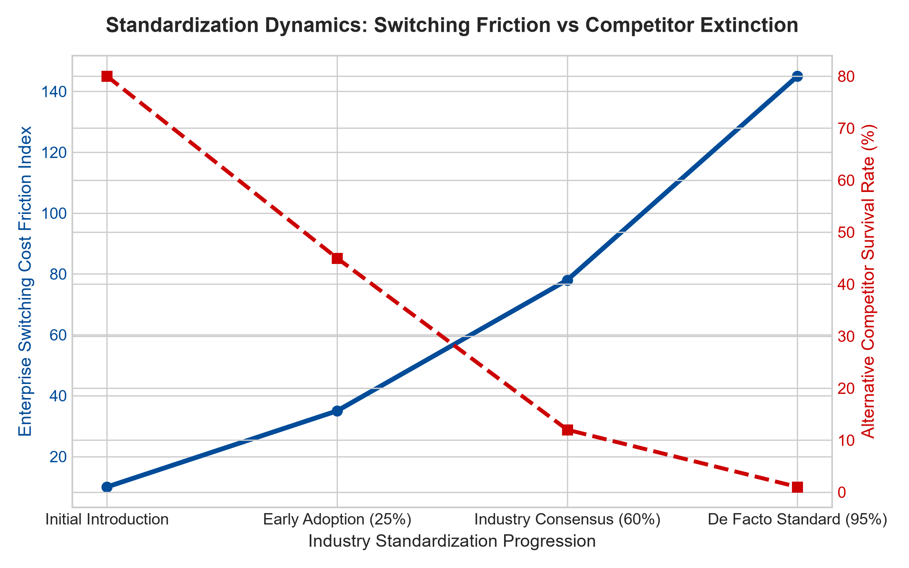
1. The Invisibility and Durability of De Facto Formats
Consider the history of technical computing and digital media: document formats, digital typography standards, wireless connectivity protocols, and specialized financial messaging networks. When a proprietary document format or financial transaction protocol becomes the global standard, it becomes embedded in university curricula, professional licensing examinations, and corporate operating manuals.
Millions of professionals spend decades mastering the keystrokes, formulas, and operational workflows of that specific system. If a competing software vendor introduces a faster, cheaper alternative that uses an incompatible format, enterprise chief information officers will categorically reject it. The cost of retraining thousands of employees and the catastrophic risk of formatting errors during multi-million dollar transactions far outweighs any marginal software subscription savings. The standard functions as an unbreachable psychological and operational wall.
2. Standard Essential Patents (SEPs) and Toll-Booth Royalties
In wireless cellular communications, semiconductor memory design, and high-speed data transmission, standards are formalized through global international standards-setting bodies. Enterprises that pioneer fundamental research contribute their patented technologies to the standard, securing what are legally designated as Standard Essential Patents (SEPs).
Once a cellular or data standard is ratified globally, it is legally and physically impossible to manufacture a conforming smartphone, connected automobile, or cellular base station without utilizing those essential patents. Every hardware manufacturer on earth must license the patent portfolio from the standard owner, paying a percentage royalty on every device shipped. The patent holder collects massive, high-margin royalty streams while assuming zero manufacturing liability, generating extraordinary return on equity.
3. Network Interoperability and Ecosystem Entrenchment
Beyond legal patents, standards moats are fortified by the network dynamics of ecosystem interoperability. When thousands of independent third-party hardware accessories and software plug-ins are engineered specifically to integrate with an incumbent's standard architecture, a massive complementary ecosystem is forged.
A prospective challenger attempting to introduce an alternative standard faces a catastrophic barrier: they must convince thousands of independent developers and accessory manufacturers to simultaneously re-engineer their entire product catalogs for an unproven platform. The incumbent's standard enjoys self-reinforcing network gravity that mathematically extinguishes competition before it can achieve market traction.
4. MPLY and the Allocation to Industry Standard Monopolies
Broad market index funds hold countless hardware assemblers and commoditized software vendors that are perpetually caught in brutal price wars, paying heavy licensing royalties to standard owners. Over multi-year investment horizons, these price-takers suffer chronic margin erosion.
The Strategy Shares Monopoly ETF (MPLY) differentiates itself through an active, high-conviction screening mandate. MPLY specifically targets the undisputed architects and owners of global industry standards. By concentrating capital in corporations that control the essential rules of digital and physical commerce, MPLY captures high-margin licensing royalties and unassailable customer retention across all economic environments.
Investors interested in discovering how actively managed strategies identify companies possessing de facto industry standards and durable monopoly power can review the Strategy Shares Monopoly ETF (MPLY) at https://strategysharesetfs.com/mply/.
In corporate strategy and patent valuation, standards-based moats represent the highest form of intellectual property durability. Unlike discrete product patents that can be engineered around by creative competitors, a ratified standard essential patent cannot be bypassed without violating global interoperability laws. The standard owner sits at the center of the industrial ecosystem, collecting non-negotiable royalty payments on every commercial deployment while maintaining absolute pricing power.
5. Frequently Asked Questions
Q1: Can an open-source standard destroy a proprietary standards moat?
Open-source standards can commoditize basic utility layers, but dominant commercial incumbents routinely build proprietary enterprise governance, automated compliance tooling, and specialized security protocols on top of open standards, transforming the open substrate into a captive commercial standard.
Q2: How do standard-setting patent holders maintain pricing power under FRAND commitments?
While standard-setting bodies require essential patents to be licensed on Fair, Reasonable, and Non-Discriminatory (FRAND) terms, top-tier patent holders command immense negotiating leverage. Because licensees cannot manufacture products without the patents, standard owners consistently secure lucrative multi-year licensing deals that generate billions in pure free cash flow.
6. Sources
Morningstar, Intellectual Property & Standards Moat Research: https://www.morningstar.com/articles/moat-research
Harvard Business Review, The Art of Standards Wars: https://hbr.org/1979/03/how-competitive-forces-shape-strategy
#standardsadvantage #EconomicMoats #StandardEssentialPatents #QualityInvesting #MPLY

