Article 23:
How Mission-Critical Software Can Create Switching Costs
In the realm of enterprise software investing, retail market participants frequently treat all software-as-a-service (SaaS) businesses as interchangeable subscription vehicles. However, institutional equity allocators understand that software exists across an acute spectrum of corporate indispensability. There is software that enhances worker convenience, such as messaging applications or collaborative whiteboards, and there is software that functions as the central nervous system of global commerce. Real compounding durability is found strictly inside mission critical software switching costs.
Mission-critical software operates as the foundational substrate of an enterprise: core bank ledger accounting, hospital surgical scheduling, airline flight crew dispatch, and manufacturing enterprise resource planning (ERP). If a messaging application crashes for twenty-four hours, corporate productivity dips slightly. If a core bank ledger or airline dispatch software fails for ten minutes, millions of dollars in capital evaporate, regulatory bodies launch immediate enforcement investigations, and public trust is irreparably shattered.
Because the catastrophic penalty of software failure is existential, enterprise executive committees will never substitute a proven mission-critical software architecture simply to save a modest percentage on annual licensing fees. The customer is structurally captive, granting the software incumbent unyielding pricing power across multi-decade horizons. Isolating these unassailable software monopolies is a core analytical priority for the Strategy Shares Monopoly ETF (MPLY).
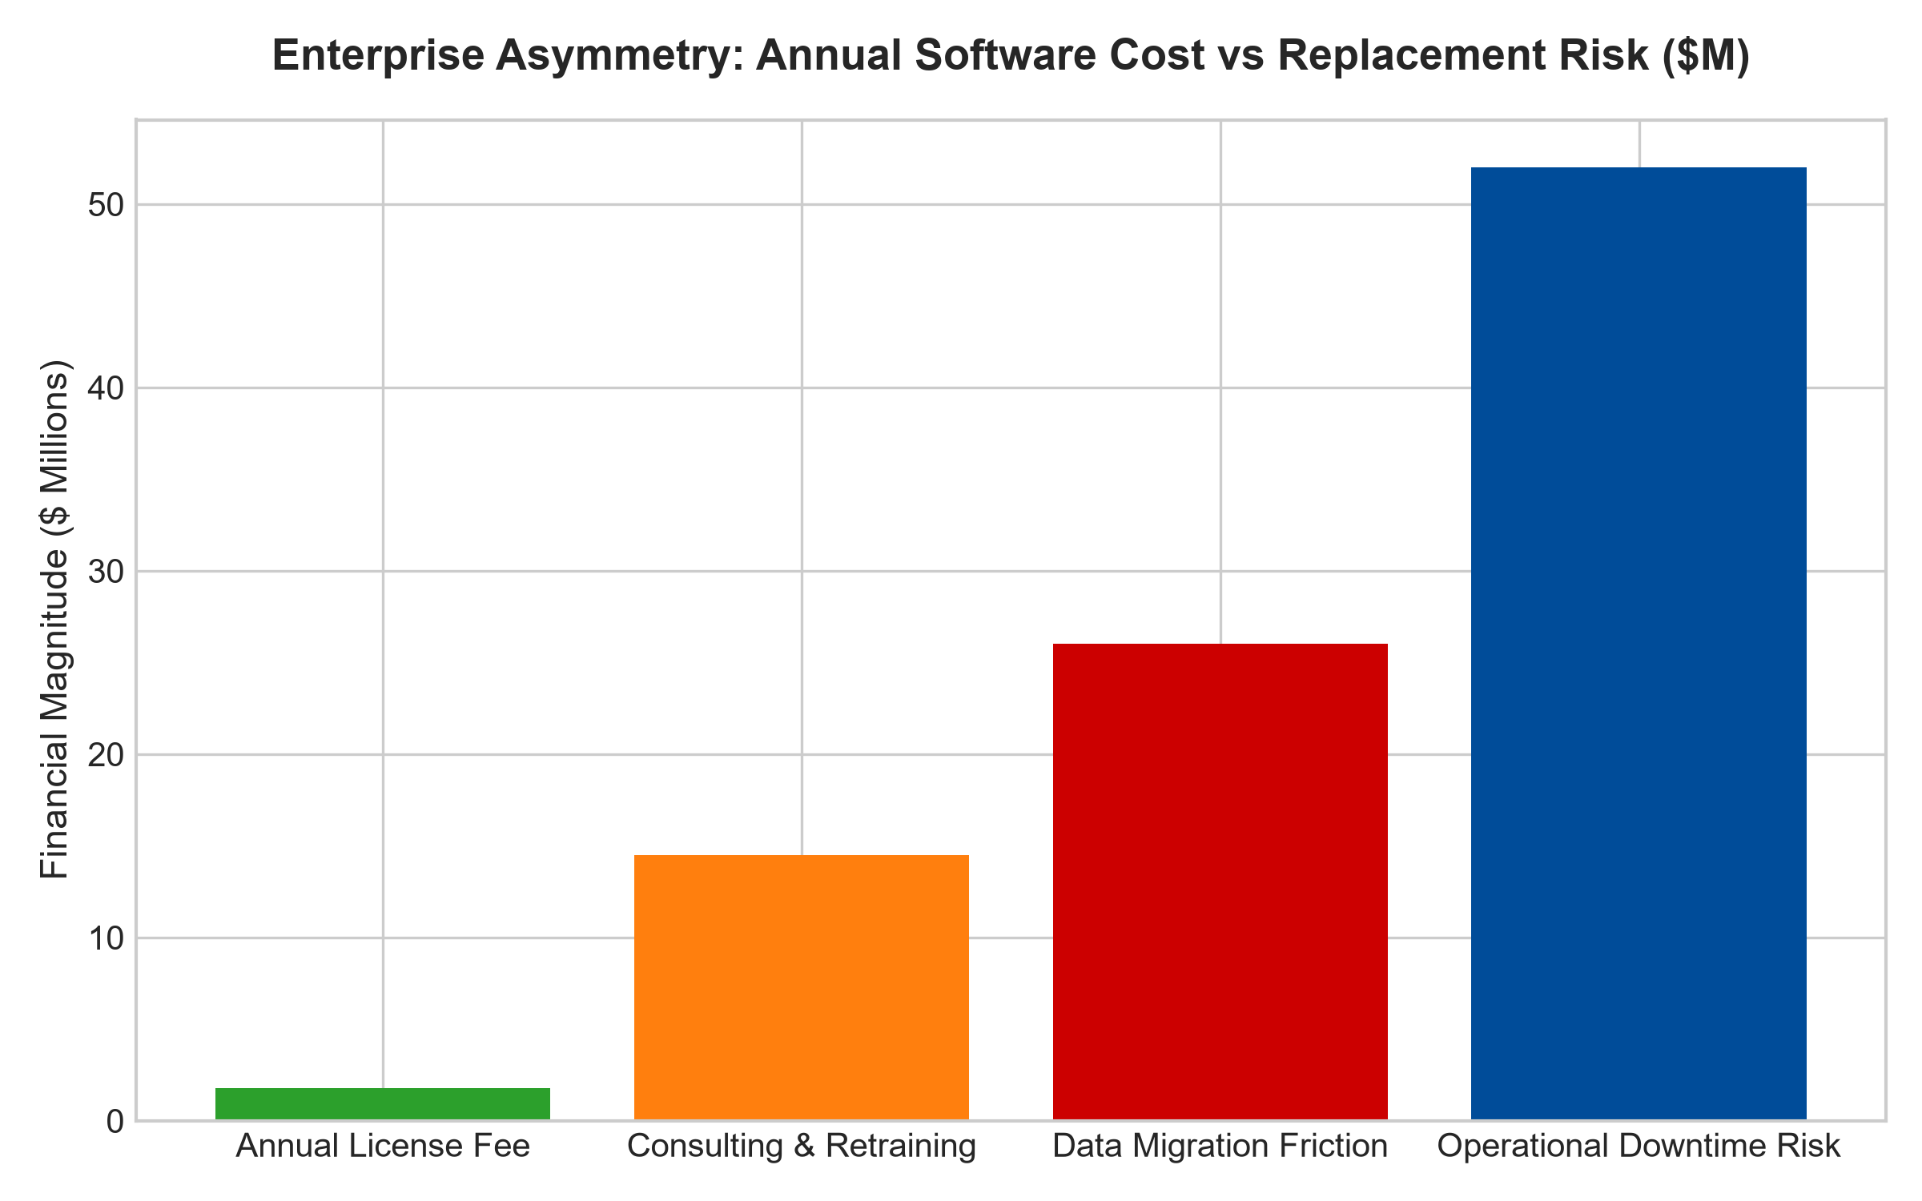
1. The Devastating Asymmetry of the Replacement Calculation
To comprehend the permanence of a mission-critical software moat, investors must analyze the quantitative asymmetry confronting an enterprise Chief Information Officer (CIO). An annual subscription to a core ERP or specialized tax compliance software engine might cost an enterprise two million dollars annually.
A venture-backed software challenger might approach the CIO offering a modern, cloud-native replacement at half the price, promising annual savings of one million dollars. However, the true economic cost of replacing an embedded mission-critical software architecture is catastrophic. Migrating decades of historical transactional data, rewriting custom application interfaces, and retraining thousands of global employees routinely costs between thirty and fifty million dollars in specialized systems integrator consulting fees.
More terrifyingly, there is an inherent five-to-ten percent probability that the migration fails catastrophically, corrupting customer balances or halting global supply chains. No rational executive will risk their professional career and a multi-million dollar business failure to save one million dollars on a software license. The incumbent software vendor possesses absolute, mathematical pricing power.
2. Regulatory Mandates and Audit Traceability
A second vital pillar defending mission-critical software moats is the statutory regulatory framework. In sectors such as life sciences, aerospace design, and financial clearing, regulatory authorities mandate strict historical audit trails and validated computational accuracy.
Regulatory compliance officers know that the incumbent software architecture has been audited and approved by statutory bodies for over twenty years. Introducing an unproven software platform requires undergoing multi-year validation audits and re-certifying entire compliance architectures. The incumbent software is not merely a technical utility; it has been codified into the legal and regulatory definition of operational compliance, extinguishing competitive threats.
3. Programmatic Contractual Price Escalation
Because mission-critical software incumbents face near-zero customer churn, they operate with exceptional pricing autonomy. While consumer-facing software providers struggle to institute modest price increases, mission-critical enterprise vendors routinely embed contractual price escalators of six to eight percent annually.
The enterprise client absorbs these price adjustments without hesitation because the software expense remains a tiny fraction of total operating revenues, yet protects the entirety of corporate operations. Net revenue retention consistently hovers between one hundred and ten and one hundred and twenty percent, generating organic cash flow compounding with zero incremental marketing overhead.
4. MPLY and the Allocation to Mission-Critical Software Moats
Passive broad market index funds are indiscriminate, holding hundreds of unprofitable, low-retention software point-solutions that are vulnerable to rapid obsolescence and customer churn. Over full economic cycles, these speculative entities dilute investor capital.
The Strategy Shares Monopoly ETF (MPLY) differentiates itself by applying an active, institutional conviction mandate. MPLY specifically targets the undisputed mission-critical software monopolies of modern commerce. By allocating capital toward businesses that command captive enterprise ledgers, irreplaceable workflow integration, and contractual pricing power, MPLY delivers defensive, all-weather cash flows backed by real, non-discretionary economic utility.
Investors interested in exploring how actively managed quality strategies isolate mission-critical software moats and durable monopoly cash flows can review the Strategy Shares Monopoly ETF (MPLY) at https://strategysharesetfs.com/mply/.
Furthermore, institutional analysts evaluate the organizational psychology of enterprise software lock-in. When hundreds of corporate departments have integrated their daily reporting, compliance workflows, and employee performance metrics into a central software suite, the internal organizational friction of switching is practically insurmountable. Enterprise leadership will continuously approve mid-single-digit price increases rather than risk internal corporate rebellion and operational chaos.
5. Frequently Asked Questions
Q1: Can artificial intelligence or automated coding agents eliminate mission-critical software moats?
Artificial intelligence accelerates software code generation, but it cannot alter the institutional risk aversion of enterprise procurement committees. Even if AI generates a replacement codebase in minutes, the operational risk of migrating decades of proprietary data and re-architecting validated regulatory compliance trails remains entirely unchanged.
Q2: What metrics confirm that an enterprise software company possesses a mission-critical moat?
Key metrics include Gross Revenue Retention (GRR) exceeding ninety-six percent, customer lifetime value spanning decades, and low single-digit sales and marketing expense as a percentage of total recurring revenue.
6. Sources
Morningstar, Enterprise Software Moats & Switching Costs Analysis: https://www.morningstar.com/articles/moat-research
Harvard Business Review, The High Cost of Enterprise Switching: https://hbr.org/1979/03/how-competitive-forces-shape-strategy
#missioncriticalsoftware #EconomicMoats #SwitchingCosts #QualityInvesting #MPLY

