Article 24:
Deferred Revenue and What It Can Reveal About Subscription Businesses
In the forensic examination of corporate financial statements, superficial investors routinely restrict their scrutiny to the income statement, analyzing reported GAAP revenue and net earnings per share. However, in modern subscription software, contractual enterprise infrastructure, and high-quality recurring businesses, the income statement is inherently backward-looking. Real analytical insight into future earnings durability, customer captivity, and true cash generation requires a deep understanding of deferred revenue investing.
Deferred revenue, recorded on the corporate balance sheet as a current liability, represents cash that has already been collected from enterprise clients for services, software access, or maintenance that will be delivered over the coming twelve months. While accounting conventions mandate classifying this item as a liability because the performance obligation remains unfulfilled, in reality, it represents the purest form of interest-free customer financing. The enterprise operates with negative working capital, holding customer cash long before delivering the service.
Tracking the trajectory of deferred revenue growth relative to headline revenue recognition provides an institutional early warning radar. An accelerating deferred revenue balance reveals robust underlying customer demand, extraordinary customer retention, and superior cash flow conversion. Isolating corporations that command massive deferred revenue balances is a foundational qualitative discipline of the Strategy Shares Monopoly ETF (MPLY).
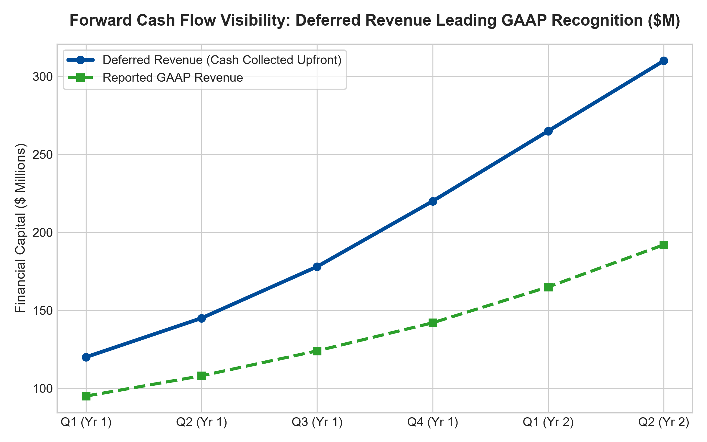
1. The Float Dynamics of Negative Working Capital
In traditional manufacturing businesses, expanding sales requires consuming immense working capital: building inventory, purchasing raw materials, and extending sixty-day trade credit to customers via accounts receivable. Growth consumes cash, forcing companies to borrow capital or issue dilutive equity.
In subscription enterprises backed by wide economic moats, the working capital dynamic is reversed. Dominant vendors mandate upfront annual, multi-year prepayments. The enterprise collects tens of millions of dollars in cold cash on day one of the contract. This customer cash sits in corporate treasury reserves, generating substantial risk-free interest income while the software or service is delivered smoothly over the year.
This negative working capital float transforms growth into a massive cash generator. The faster the company signs enterprise contracts, the more cash piles up on the balance sheet, completely eliminating the need for expensive debt financing. The business compounds intrinsic value entirely funded by customer prepayments.
2. Calculated Billings: The True Pulse of Growth
Under standard GAAP accounting rules, subscription revenue must be recognized ratably across the contract term. A multi-year enterprise contract signed in December produces negligible recognized revenue on the fourth-quarter income statement, masking commercial momentum from retail investors.
Institutional equity analysts bypass this GAAP accounting distortion by calculating Calculated Billings: reported GAAP revenue plus the net change in deferred revenue during the fiscal period. If Calculated Billings is expanding at thirty percent while reported revenue is growing at only fifteen percent, the company is experiencing an explosive inflection in customer demand that will inevitably flow through to reported earnings in subsequent quarters. Conversely, if deferred revenue contracts while reported revenue appears stable, customer churn is accelerating behind the scenes.
3. Macroeconomic Resilience and Revenue Shielding
During economic contractions and market panics, transactional corporations experience sudden revenue evaporation as customers freeze new purchase orders. In stark contrast, an enterprise entering a recession with an immense deferred revenue balance has already secured and collected its operating cash flow for the next twelve months.
This contractual revenue shield provides complete visibility into future free cash flow, allowing executive leadership to maintain research and development budgets, avoid disruptive employee layoffs, and acquire distressed competitors at deep discounts. The deferred revenue fortress turns macroeconomic panic into an offensive compounding opportunity.
4. MPLY and the Selection of Pre-Funded Monopolies
Passive broad market index funds are indiscriminate, holding hundreds of capital-hungry industrial and retail corporations that suffer from chronic positive working capital burdens and customer payment delays. Over long horizons, these cash-starved entities dilute shareholder returns.
The Strategy Shares Monopoly ETF (MPLY) differentiates itself through an active, high-conviction screening mandate. MPLY specifically isolates market dominators that operate with immense deferred revenue balances, negative working capital dynamics, and upfront enterprise prepayments. By concentrating capital in self-funding corporate fortresses, MPLY delivers institutional-grade capital protection and predictable, all-weather cash flow compounding.
Investors interested in discovering how actively managed strategies evaluate deferred revenue balances, customer float, and monopolistic cash flow visibility can review the Strategy Shares Monopoly ETF (MPLY) at https://strategysharesetfs.com/mply/.
5. Frequently Asked Questions
Q1: Why is deferred revenue listed as a liability on the corporate balance sheet?
Accounting standards classify deferred revenue as a liability because the company has collected cash for a service it has not yet delivered, representing an unfulfilled performance obligation. However, for a high-retention software business where the marginal cost of service delivery is negligible, deferred revenue is economically equivalent to future cash profit.
Q2: How can an investor tell if a decline in deferred revenue is dangerous?
A sequential decline in deferred revenue is dangerous if it is accompanied by rising customer churn or slowing calculated billings. However, if management is deliberately shifting customer contracts from upfront multi-year payments to annual billing terms, deferred revenue may decline while underlying annual recurring revenue continues to compound healthily.
6. Sources
Morningstar, Forensic Financial Statement & Cash Flow Analysis: https://www.morningstar.com/articles/moat-research
Harvard Business Review, The Chemistry of Negative Working Capital: https://hbr.org/1979/03/how-competitive-forces-shape-strategy
#deferredrevenue #FinancialStatementAnalysis #CashFlowFloat #QualityInvesting #MPLY

