Article 25:
Backlog vs Revenue: How Investors Can Read Future Business Activity
In fundamental equity valuation and institutional credit analysis, historical revenue numbers report only where an enterprise has been, not where it is going. A corporation reporting record revenue in the current quarter may be hurtling toward severe operational distress if its incoming orders have evaporated. Conversely, a company experiencing temporary supply chain delivery bottlenecks may possess immense unrecognized intrinsic value if its contractual order pipeline is overflowing. For capital allocators demanding forward cash flow certainty, analyzing backlog vs revenue is the definitive quantitative discipline.
Order backlog represents the total dollar value of legally binding, contracted customer orders that have been formally committed but not yet recognized as revenue on the income statement. When evaluated alongside current recognized revenue through the book-to-bill ratio, backlog provides an institutional roadmap of multi-year operational activity. A massive, multi-year backlog transforms a cyclical industrial or aerospace manufacturer into an ultra-defensive annuity stream.
Because customers have legally committed capital and deposited non-refundable progress payments, the enterprise can plan multi-year capital expenditures, negotiate preferred raw material pricing, and weather economic recessions with total confidence. Isolating corporations that command massive backlog coverage ratios is a central stock-selection criterion for the Strategy Shares Monopoly ETF (MPLY).
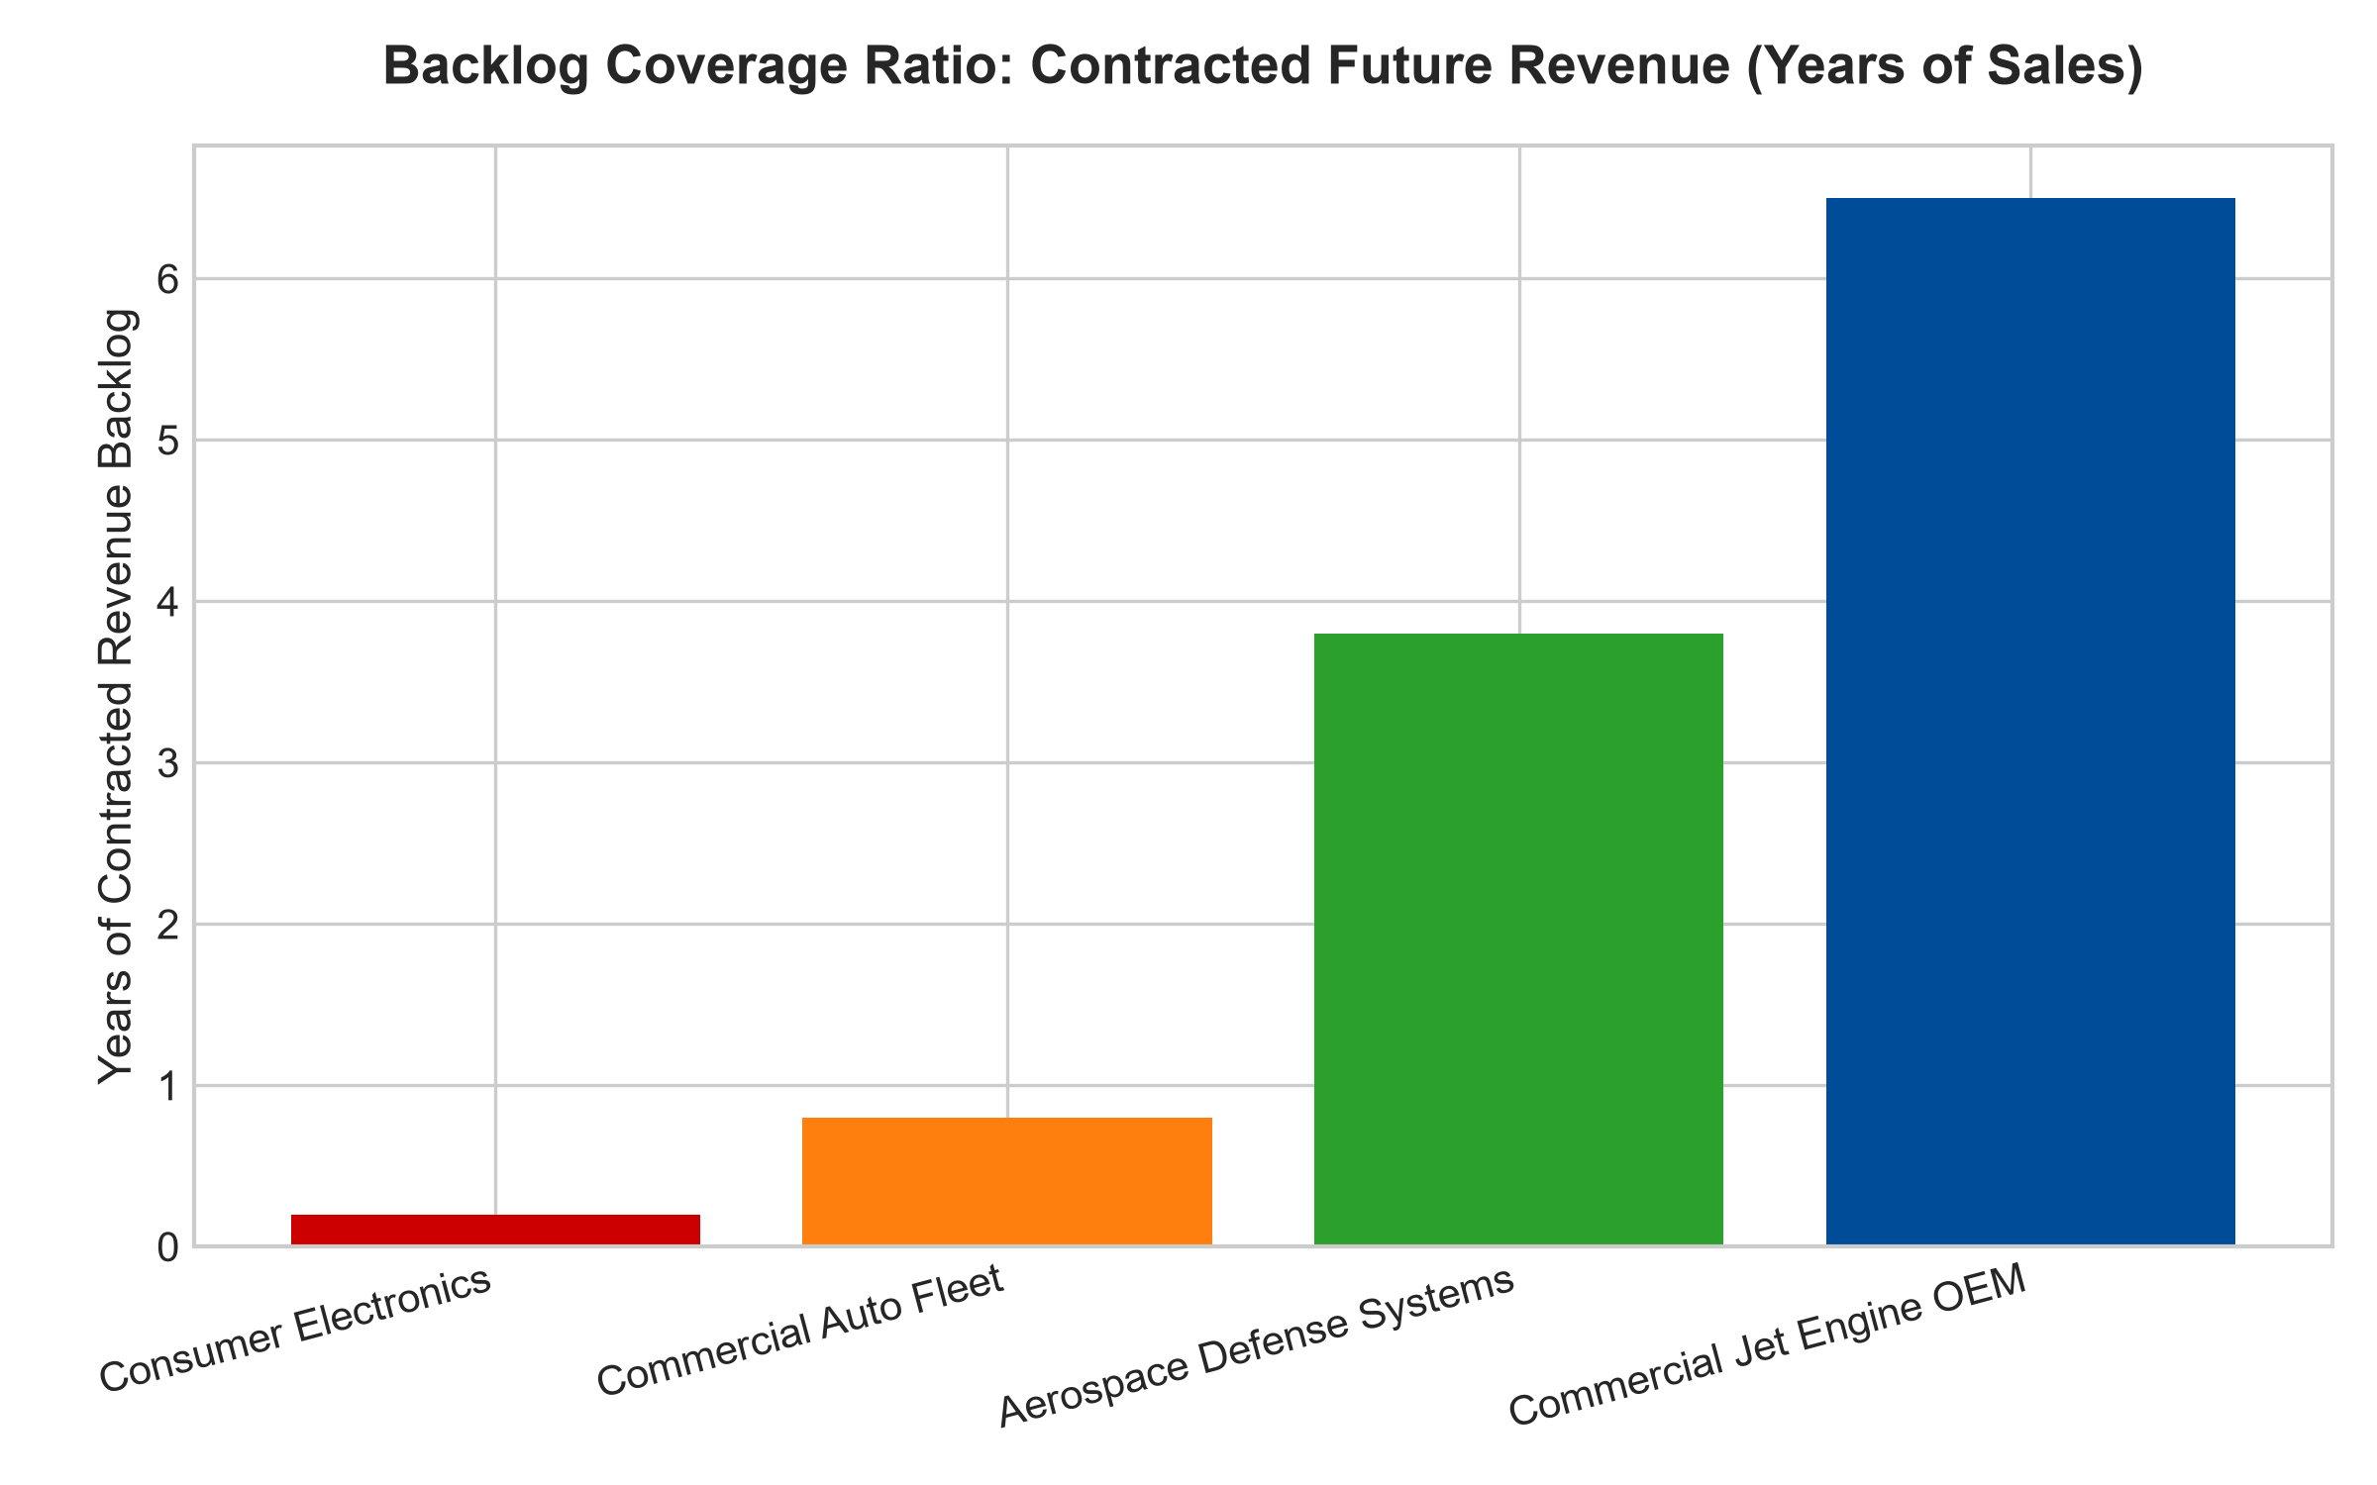
1. The Book-to-Bill Ratio as an Early Warning Indicator
The primary mathematical metric used by institutional analysts to evaluate backlog health is the book-to-bill ratio: the dollar value of new binding orders received in a fiscal period divided by the total revenue recognized in that same period. A book-to-bill ratio above 1.0 indicates that demand is outstripping operational delivery capacity, expanding the backlog and guaranteeing future revenue growth.
Conversely, a book-to-bill ratio falling below 1.0 serves as a critical warning that current recognized revenue is consuming the existing order pipeline faster than new customer commitments are arriving. Sophisticated institutional managers do not wait for reported quarterly revenue to decline; they detect the deceleration in the book-to-bill ratio quarters in advance, reallocating capital away from vulnerable businesses before market consensus catches up.
2. Multi-Year Coverage and Cancellation Penalties
A critical qualitative distinction in backlog analysis is distinguishing between firm, legally enforceable contractual backlogs and soft, cancelable letters of intent. In consumer goods or commercial construction, uncommitted order backlogs can evaporate overnight during an economic contraction as clients cancel projects without penalty.
In elite wide-moat sectors, such as commercial jet engine manufacturing, semiconductor lithography systems, and specialized naval defense shipbuilding, backlogs represent binding statutory contracts accompanied by non-refundable progress milestones. In commercial aviation, for example, dominant airframe manufacturers boast firm order backlogs spanning seven to nine years of current annual production capacity. An airline attempting to cancel an order forfeits millions in deposits and loses its production delivery slot for a decade. The backlog functions as an unbreachable multi-year cash flow fortress.
3. Operating Leverage and Supply Chain Optimization
From a corporate operations perspective, a massive backlog coverage ratio unlocks extraordinary manufacturing efficiencies. In transactional manufacturing, plants must fluctuate production schedules unpredictably, enduring expensive overtime labor during demand spikes and wasteful idle factory overhead during lulls.
When a corporation possesses four or five years of firm backlog coverage, factory operations are leveled into an optimized, continuous assembly rhythm. The enterprise locks in multi-year raw material purchase agreements at massive bulk discounts, driving gross profit margin expansion. Furthermore, because management possesses total visibility into future factory utilization, capital expenditures are deployed with surgical precision, elevating return on invested capital to elite levels.
4. MPLY and the Allocation to High-Backlog Monopolies
Passive market index funds hold countless transactional consumer and commodity corporations that possess near-zero order backlogs. When macroeconomic contractions strike, their revenues collapse abruptly, dragging down portfolio returns.
The Strategy Shares Monopoly ETF (MPLY) differentiates itself by applying an active, high-conviction mandate. MPLY selectively targets market leaders that command immense, legally binding backlogs spanning multiple years of guaranteed production. By allocating capital toward businesses with unmatched cash flow visibility and multi-year customer commitments, MPLY delivers institutional-grade capital protection and predictable, long-term wealth compounding.
Investors interested in discovering how actively managed quality strategies evaluate backlog coverage, book-to-bill ratios, and durable monopoly power can examine the Strategy Shares Monopoly ETF (MPLY) at https://strategysharesetfs.com/mply/.
In fundamental credit analysis and bankruptcy risk modeling, backlog coverage serves as the primary quantitative cushion protecting enterprise solvency. When an industrial corporation enters a deep macroeconomic contraction with three to four years of firm, non-cancelable order backlog, its fixed debt service and employee payroll remain fully funded. The business can maintain operational stability and acquire distressed rivals at the market trough while competitors face insolvency.
5. Frequently Asked Questions
Q1: Can a company have too much order backlog?
Yes. If an enterprise possesses a backlog spanning more than eight to ten years and lacks the operational capability to expand production capacity, frustrated customers may eventually seek alternative providers or develop in-house capabilities. The optimal backlog balance provides three to five years of firm forward coverage while maintaining operational delivery discipline.
Q2: How does inflation impact fixed-price order backlogs?
In poorly managed businesses, long-term fixed-price backlogs can lead to severe margin compression if raw material costs surge. However, dominant wide-moat monopolists specifically embed contractual CPI and materials escalation clauses into their long-term contracts, ensuring that inflation costs are passed through directly to the client.
6. Sources
Morningstar, Aerospace & Industrial Backlog Valuation: https://www.morningstar.com/articles/moat-research
Harvard Business Review, Managing Order Backlogs for Strategic Advantage: https://hbr.org/1979/03/how-competitive-forces-shape-strategy
#backlogvsrevenue #BookToBillRatio #CashFlowVisibility #QualityInvesting #MPLY

